General structure of the report
Sections and subsections need to be numbered
Use Harvard referencing system (APA format)
Standard declaration
Recommended order:
- Front Cover
- Title Page
- Abstract
- Acknowledgements
- Table of Contents
- List of Figures (where applicable)
- List of Tables (where applicable)
- List of Acronyms
- THE REPORT ITSELF
- References (& Bibliography)
- Appendices
- Back Cover
Work needs to be copyrighted: Copyright © 2016 De Montfort University. All rights reserved.

Introduction
Background
The field of Machine Learning has been relaunched with the increase in popularity of Deep Learning. This has been possible for the increase in computational power, with massively-parallel processing leading the charge [1] [2], allowing researchers to explore more complex models for learning.
Convolutional Neural Networks have attracted recent attention, particularly in image recognition and classification [3] [4]. Part of its success is they are very efficient at reducing the complexity of feedforward fully-connected networks
Aside from being used on their own, CNNs have also been incorporated as part of a broader approach in Deep reinforcement learning, where they perform well approximating reward functions [5].
Continuing with the tradition of using games as a test bed for AI [6], recent times have seen an important milestone being reached: Go, a game well known for the complexity of its game space, saw the first computer to defeat the human world champion in a 5-games match [7]. AlphaGo guides its play using tree search in combination with Deep Networks –networks with multiple and complex hidden layers- to evaluate game nodes.
Moreover, the AI community is focusing more than ever on competitive events to develop algorithms to play games based on Deep Learning [8] [6]. One such competitions is ViZDoom [9], which restricts the inputs from the world exclusively to visual information from the rendered scene. CNNs and Deep RL are ideally placed for this type of scenarios.

Aim
The aim of this project is to use Deep Learning methods to design and implement a ViZDoom controller. Due to the restrictions of the framework, the agent will only receive information from the world in two forms: 1) visual data from the rendered screen; and 2) character data such as ammo, weapon selected, health status, etc. The agent will be required to perform actions such: 1) navigating through a 3D maze; 2) attack other agents, and 3) stay alive.
The focus will be to explore the suitability of Evolutionary algorithms for the optimisation of convolutional networks -with particular interest on the NEAT algorithm [10]- in a complex, real-time scenario based on visual input.

Relevant publications
The foundation of this project is to use Neural Networks as a means to effectively interpret image data to control a game bot. In the literature this is commonly referred as neurovisual control. Authors have proposed neurovisual solutions for games such as Quake II [11] with moderate success in defined scenarios. The Quake II controller consists of a fully connected recurrent network that uses a retina-like input image –more resolution in the centre- to successfully learn how to find and kill enemies. One of the contributions of this paper is the semi-supervised learning process used to train the network, whereby a non-visual neural net is evolved first and then used to train the neurovisual network.
With the increase in popularity of Convolutional Networks, far more effective in the domain of image classification, authors have started using them to guide game play in different forms. Mnih et al [5] describe an enhancement of traditional reinforcement learning by using a convolutional network as its value function. The CNN uses raw pixel data as input, outputting an estimation of the future reward. The paper also proposes an efficient way of training such networks (DQN) and demonstrates it to be successful when playing a collection of Atari 2600 games, some to a level higher than humans.
Given the level of complexity of CNNs, its depth and the type of layers involved (convoluted, pooling / downsampling, fully-connected, etc), one of the key issues is how to create a network topology that optimises the target function. Although this has traditionally been tackled by handcrafting a layout [12], several authors have started to make use of automatic optimisation techniques to fine-tune entire networks, with evolutionary strategies at the forefront [13] [14].
The basis for this project is the Neuro Evolution of Augmented Topologies algorithm [10], an algorithm that uses an evolutionary process to optimise a neural network architecture. By automating the topology design, NEAT can efficiently produce highly optimised network layouts. The evolutionary process uses three types of mutation operators: 1) modify any of the network’s weights; 2) add or remove units to the network; and 3) add or remove connections between units.
Although NEAT was designed to optimise the topologies of feedforward networks, some derived evolutionary algorithms have already been applied in the domain of Deep Learning. Of particular interest is the work by Koutnik [14], which shows how neuroevolution is used to scale-up a network architecture used in reinforcement learning to create a driving policy in TORCS.
From a theoretical perspective, Maul and Bargiela [15] discuss neuroevolution opportunities for deep neural networks, comparing standard and cooperative evolutionary methods to propose general guidelines for the technique. Verbancsics and Harguess [16] suggest the combination of evolved networks using HyperNEAT (a modification of NEAT) with other Machine Learning techniques to improve performance.

Objectives and deliverables
- To explore the suitability of Evolutionary algorithms for the optimisation of deep neural networks in a complex, real-time, large decision space scenario.
- To use the findings to implement visual controllers to complete task-specific scenarios in ViZDoom.

Intro from article

The Open Racing Car Simulator (TORCS) has become an important tool for AI researchers interested in the development of autonomous driving strategies. Its pseudo-realistic simulation of racing events –physics, damage, engineering setup, etc.- together with the ease to design and implement new driving policies have contributed to its popularization, spawning multiple competitions where researchers submit their drivers to competitive tournaments [1] [2]. Previous successful submissions include Finite State modular approaches [3], fuzzy-based controllers [4], coevolution strategies for fine tuning car parameters [5] and feedforward neural networks that learn by imitation [6].
Most of the previous approaches use accurate track information –such as width of the current segment and distance to track limits-, opponent metrics –such as angle between our car and next driver- and any other data that is available in the TORCS environment. However, as humans we drive fundamentally based on local information available to us via our senses –mainly sight. Efforts to restrict the amount of data provided to drivers are seen in [1], though they still pre-process the information making drivers passive receptors of sensory information. The aim of this project is to investigate the feasibility of an autonomous driver that uses visual-only information to navigate tracks in TORCS.
Strategies that use visual input have been applied in a few scenarios: from neurovisual control of a Quake II bot [7] to an attempt to General Game Play for Atari videogames [8]. In the driving domain, one of the first implementations to use visual information as the main input for steering is ALVINN [9], a system for land vehicles that uses a 3 layer recurrent neural network to process input from a camera and a laser ranger to produce a recommended steering direction. In the TORCS environment, [10] showed how a recurrent neural network layout could be constructed using evolutionary algorithms to navigate –steer, accelerate and brake- a simple track using visual information. Although showing promise, these strategies are somewhat simplified in either the nature of the input –ALVINN uses distance sensors to aid visual input- or its complexity –simple network topologies, the TORCS driver performs only on a particular predesigned track. Those simplifications were imposed in no small part due to the high dimensionality nature of the visual input and the computational expense of processing it in real time. Nowadays those limitations are being overcome with the advent of massive parallel computation and the use of GPUs for General Purpose programming (GPGPU) [11] [12].
Taking advantage of the power of massive parallel computation, machine learning techniques have been brought to a new level in a domain called Deep Learning, including more complex models in Reinforcement learning, genetic algorithms and most of all neural networks. Deep neural network models have been shown to be ideal to process complex visual data [13], particularly in image classification [14] and pattern recognition [15] [16].
Convolutional Neural Networks (CNNs) are one such models; they consist of a series of partially-connected layers with local connectivity and shared weights to allow detecting patterns irrespective of their position in the image. CNNs are naturally good at feature extraction using multiple local maps that arise from the original image.
Recent advances in game AI can be attributed to the application of deep CNNs (with multiple layers) to decision making: deep reinforcement learning to play Atari games [18] and the newsworthy AlphaGo computer player that defeated the world champions [17] using deep neural networks as evaluation function on Go boards to predict their value in an attempt to shorten the tree search.

TITLE: ?

Table of Contents
List of Figures 6
List of Tables 7
Acknowledgements 7
1.Introduction 8
1.1.Overview 8
1.2.MOTIVATION 9
1.3.OBJECTIVES 9
1.4.SCOPE 9
2.Literature review 10
3.Design proposal 18
4.Experimental design 26
5.Results 29
5.1.Feature extractor evolution 29
5.2.Network controller evolution 33
5.2.1.Nature of the output function 33
5.2.2.Neuroevolutionary algorithm and action selection 35
5.3.Comparison benchmark 37
6.Research findings and analysis 38
7.Conclusions and further work 39
8.References 40
9.Appendix 43

List of Figures
Figure 1. General Evolutionary Algorithm 11
Figure 2. Direct vs indirect encoding 11
Figure 3. Example of a CNN 14
Figure 4. Overview of the two-steps Neural Network approach 19
Figure 5. CNN for the Feature Extractor 20
Figure 6. Direct encoding of a CNN 20
Figure 7. Variation operators for the custom GA 21
Figure 8. Evaluation of Feature Extractor candidates 26
Figure 9. Euclidean distance Fitness measurement 26
Figure 10. Shannon average Fitness measurement 27
Figure 11. Shannon binary Fitness measurement 27
Figure 12. Controller neural network topology 28
Figure 13. Floor plans and images of the ViZDoom scenarios employed 29
Figure 14. Some ViZDoom elements 30
Figure 16. Learning graphs per fitness measurement and feature vector length 35
Figure 17. Total rewards per fitness measurement and feature vector lengths 40
Figure 18. Shooting rewards across fitness measurements and feature vector lengths 40
Figure 19. Total rewards using euclidean distance 41
Figure 20. Shooting rewards using euclidean distance 42
Figure 21. Learning graph Sigmoid vs Linear activation 42
Figure 22. Total rewards for Sigmoid and Linear output activation function alternatives 43
Figure 23. Shooting rewards for Sigmoid and Linear output activation function alternatives 43
Figure 24. Learning graph for NE algorithms and action selection policies 45
Figure 25. Total rewards for NE algorithms and action selection policies 45
Figure 26. Shooting rewards for NE algorithms and action selection policies 46
Figure 27. Evolutionary solution compared to benchmark alternatives 46

List of Tables
Table 1. Performance comparison Sigmoid vs Linear output functions 35
Table 2. Performance comparison of NE algorithms and action selection policies 37

Acknowledgements

Introduction

Overview
Games as a test-bed for Artificial Intelligence; from Deep Blue beating Kasparov, to Watson winning Jeopardy and AlphaGo finally mastering Go, machine learning continues to reach milestones previously considered unachievable.
Algorithms capable of learning to successfully play many complex games already exist: TORCS drivers (references) using Neural networks to navigate around a race track; StarCraft (StarCrsft AI competition in GIG) bots to handle resource management, attack and defend and other strategies. But they tend to rely on internal game / engine data, or preprocessed information -such as exact distances to beacons, position of opponents, etc.
Importance of visual input in how humans interact with the world. But issue with high dimensionality and inherent complexity of images (different illumination, general object recognition, different colours, objects not in a specific position or orientation...)
Resurgence of machine learning thanks to massive parallel processing (GPGPU) to form Deep Learning, reducing the dimensionality issue. CNNs are a new model that has been made possible thanks to the increase in computation, with very notable examples in the recent past -AlphaGo, Atari general player.
Other than the type of input, humans and other animals tend to learn from their environment on a reward / punishment basis. Researchers have used that intuition in a learning model called Reinforcement Learning. The agent knows its current state and the set of actions available, and it receives a reward in some states. The challenge is to learn an optimal policy (sequence of actions) that would yield the maximum final reward.
Traditional RL (Q-tables) quickly becomes infeasible with very large state-action spaces (such as the ones using visual input or continuous actions). Authors have introduced the use of CNNs as function approximators for Q-tables with very promising results -but in relatively simple scenarios (either set of actions was not big, or the scenario was somehow restricted), and network structure is fixed.
Problem statement: CNNs not have been widely explored in complex continuous decision spaces (near-infinite state-actions). Training and optimising CNNs is complex and requires massive amounts of data -supervised, or RL which generates its own training data. Could evolutionary strategies aid in the optimisation of CNNs for real time decision making to offer a viable alternative within RL scenario?
This work explores the EA alternative to train and tune a CNN to be used in a complex real-time scenario (3D Doom) using visual-only input and rewards from the environment, and compares it to both supervised CNN training and Deep-Q-Learning.

MOTIVATION

OBJECTIVES
To explore the suitability of Evolutionary algorithms for the optimisation of deep neural networks in a complex, real-time, large decision space scenario.
To use the findings to implement visual controllers to complete task-specific scenarios in ViZDoom.

SCOPE
The aim of this project is to use Deep Learning methods to design and implement a ViZDoom controller. Due to the restrictions of the framework, the agent will only receive information from the world in two forms: 1) visual data from the rendered screen; and 2) character data such as ammo, weapon selected, health status, etc. The agent will be required to perform actions such: 1) navigating through a 3D maze; 2) attack other agents, and 3) stay alive.
The focus will be to explore the suitability of Evolutionary algorithms for the optimisation of convolutional networks -with particular interest on the NEAT algorithm [10]- in a complex, real-time scenario based on visual input.

Literature review
Evolutionary algorithms as a family of algorithms that use the core principles of natural evolution to train and tune models:
- General process → initial population; individuals' fitness is evaluated in the scenario they perform, and based on that they are given a probability to go to the next generation; mutation and crossover as variation mechanisms that allow a population to improve.

Figure 1. General Evolutionary Algorithm
- Genotype vs phenotype → encoding of the solution and the solution itself need not to be one and the same. Direct encoding (most common, genome contains a description of the NN and its weights) vs indirect encoding (genome contains rules on how to construct the NN).
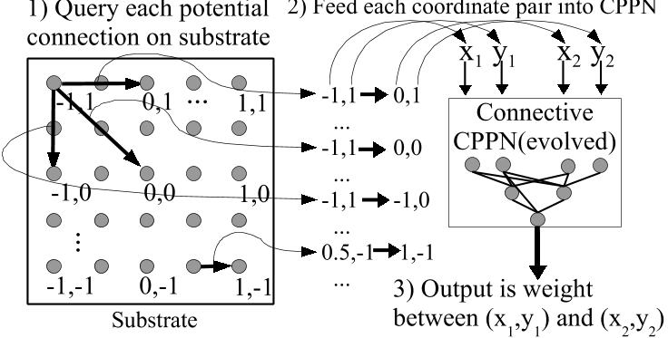
Figure 2. Direct (left) vs indirect (right) encoding of a genotype for EAs. Source image A Hypercube-based Indirect Encoding for Evolving Large-scale Neural Networks).
Direct encoding
1010100
0000101
Genotype
Phenotype
84
5
Indirect encoding
- Several types depending on the way they introduce variability (mutation only, mutation + crossover), parent selection to go to the next generation / reproduce (tournament based, ranking based, elitism)
- evolutionary programming (1965) only mutation
- genetic algorithms (1970's, Holland, DeJong, Goldberg) crossover, mutation, parent selection based on fitness
- Evolution strategy (1970s' Rechengerb and Schwefel) parents are selected at random and evolutionary parameters are evolved together with individuals
- Swarm intelligence → individuals move based on a moving operator that makes use of other individuals info (only one parent)
- Differential evolution (1995 by Storn and Price. Mutation prior to crossover, then one-to-one spawning (survivor selection, if the new solution is better, keep it, otherwise remove it)
EAs for neural networks
- genetic algorithms to evolve weights of a fixed network. A GA can be made to evolve the encoding which results in evolving a neural network → neuroevolution; fixed architecture
- TWEANS → neuroevolution of weights and topologies;
  - challenges for TWEANS: 1) competing conventions [when combining two different networks representing disparate behaviour leads to worse result; this is mostly due to symmetry and other structural factors that lead to behaviour, which are broken when combined]; 2) protecting innovation for long enough to allow weights of a new structure to evolve and be optimised; 3) evolve minimal solutions [starting at random may leave with overly-complex structures that won't allow for a global optimal solution to be found]
  - Examples of TWEANS → NEAT, CoSyNE
- NEAT [1]⁠
- Direct graph encoding of neurons and links
- Uses mutation and crossover to evolve both the weights of the network and its topology -by adding or removing units in the graph
- How NEAT tackles those challenges: 1) (competing conventions) innovation numbers to identify genes -which are then allowed to crossover; 2) (protecting innovation) speciation and boosting novel solutions, punishing old ones; 3) (evolving minimal nets) starting from extremely simple solutions (no hidden units)
- NEAT improvements: 1) HyperNEAT [2]⁠uses an indirect encoding (substrate) to store the neural network structure and weights. The substrate is itself a network (Compositional Pattern Producing Network) that can produce connectivity patterns. This approach increases the size of networks that can be produced with NEAT. 2) ES-Hyper-NEAT [3]⁠ is an improvement of Hyper-NEAT where the substrate is also evolved and not fixed; 1 and 2 work well specifically when there are structural relationships in the input to be exploited (symmetry, repetition, etc.) 3) FS-NEAT [4]⁠ is a simplified version of NEAT that starts with a minimal topology: only a few inputs connected to outputs, and allowing evolution to include more inputs as a mutation operator -showed that it can reach NEAT performance with less inputs, or features.
Using visual input normally brings high dimensionality issues that make the direct use of neuroevolution impractical. Traditionally, visual input is simplified somehow → Dimension reduction and Feature extraction / detection
- Dimension reduction survey [5]⁠
- motivated by the breakdown of statistical models when using high-dimensional datasets
- assumption: not all the variables in a dataset may be as important
- Principal component analysis → linear (but improvements for non-linear have been suggested) combination of variables into features
- Factor analysis → assumes there is an underlying common feature that influences several measured variables (and hence it can be abstracted into one)
- Projection pursuit → another linear method but it can incorporate higher than second order information
- Multidimensional scaling → reduce dimensions but keep relative distance between observations
- Neural networks and genetic algorithms also used
- Feature extraction / detection alternatives
- feature selection (only use a subset from the input set) vs feature extraction (transforming the available features into new ones)
- genetic algorithms in feature extraction [6]⁠ presents an alternative to linear transformation for feature extraction using GAs. A feature vector that transforms the original input set is evolved, its fitness calculated based on classification accuracy (supervised process)
- Mostly a supervised process (not suited for unsupervised feature extraction)
- One example of unsupervised feature extractor for the visual domain is [7]⁠ which will be analysed in depth in the proposed approach section

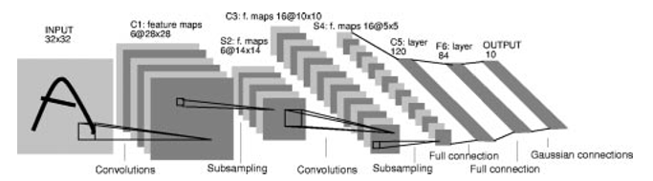
Figure 3. Example of a Convolutional Neural Network with several layers taken from LeNet-5 (LeCun source)

Convolutional Neural Networks (http://cs231n.github.io/convolutional-networks/) as a means to automatically process the features of an image within a neural network
- Biological inspiration → receptive fields of the cat's visual cortex
- In essence they are like regular networks in that each layer transforms a volume of activations to another one through a differentiable function. But they assume the input is an image, and normally 3 dimensional (width, height and depth, or number of channels). For the most part they do not operate on a fully-connected basis like normal NNs.
- Three common types of layers: convolutional, pooling (up or downsampling) and fully-connected (like regular networks, each unit has links to all units in the next layer)
- Each conv layer contains a set of filters or kernels. The number of filters is commonly referred to as the depth of the layer. During a forward pass, each filter is convolved (or slided) along the activation volume (usually 3D) and produces a 2-dimensional activation map, which is then fed to the next layer. Typically, each convoluted layer receives a multidimensional activation volume and outputs a collection of 2-dimensional maps. Crucially in conv layers is the concept of local connectivity, i.e. each neuron only receives signal from a region of the input (the size of the filter). Another important concept is parameter sharing, which allows convolutional networks to detect features irrespective of their position or orientation in the image. This is also what makes them scalable when compared to fully-connected networks. Within a convolutional slice -i.e. for each depth value in the layer- all neurons share weights and bias.
- Deep CNNs now possible thanks to massively-parallel computation
- Successful use in highly visual tasks (multi-image classification[8]⁠, handwriting recognition[9]⁠ , approximation function in games [10], [11]⁠)

In an unsupervised game scenario where the only information the agent gets is visual input and reward values from the environment, the most common approach is to perform some sort of reinforcement learning

- Definition and explanation of traditional reinforcement learning → an agent that learns from its interactions with the environment through trial and error, in a task that involves a sequence of actions. Formally, at any time t the agent is said to reside in state s(t), from which it performs action a(t); the environment assigns a numerical reward r(st) and changes the state to s(t+1) = d(s(t),a(t)), and do so until s(t) is a terminal state (task has been finished). In RL, the agent must learn a policy that maps states and actions π : S → A; the optimal policy π* is defined as the policy that gives the maximum reward to the agent π* = argmax V(s), for all s -V(s) is the cumulative reward. Usually a discount rate is used to reduce rewards overtime
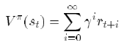
- There are two main approaches to learning the optimal policy: Policy search (which maintain an explicit representation of the policy, which is modified through search operators) vs value function search (they approximate the V function to determine the best action given the state). Policy-space search is well suited for EA algorithms (find the best policy for all states), whereas value function search is better suited for Temporal Difference (examples below).
- In TD, observed reward values from consecutive states are used to update the predictions made by the agent over said reward using the following update rule (α is the learning rate and r(t) the immediate reward):
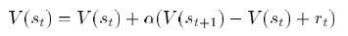
- The agent selects its next action based on its current predictions, choosing always the action associated with the highest reward for the current state. Alternatively a Q function has been proposed (Watkins, 1989 and Watkins and Dayan, 1992) Q(s,a) = r(s) + V(d(s,a)), that uses immediate reward and the reward from the optimal action on next step. The Q-function is then updated using the following:
- Comparison of EA and TD for RL if needed [12]⁠
- Example of combination of both approaches: NEAT+Q [13]⁠:
  - evolving value functions that are then evaluated on their ability to learn using Q-learning
  - NEAT evolves network structure that is later used in TD to learn weights. TD fitness is used to select the best networks
  - Shows good results in relatively simple scenarios, but the authors acknowledge the learning is orders of magnitude slower (high sampling, as each NEAT solution needs to be TD trained); cannot be practically used in a large continuous state-action space

Deep-Q-Network using CNNs in a RL scenario[10], [14]⁠⁠
- Using a CNN to approximate the state-action reward values in a complex RL environment -multiple games, using raw visual data
- Uses a variation of Q-learning with experience replay (each batch training is done with a random selection of the experience replay memory; smooths the training distribution reducing problems with correlated data); trained with Stochastic Gradient descent (batched backpropagation showed to avoid overfitting by training in small batches at a time)
- Input 210x160 RGB image, output is the actions / buttons to be pressed; image is pre-processed (downscaled to 84x84 and to grayscale)
- Used a constant network topology and hyperparameters with no game-specific knowledge
- The CNN (DQN) receives the preprocessed image (four last frames) and outputs a Q-value per action; 3 convolution layers (16 8x8, 32 4x4) and two fully connected (256). 4 to 18 outputs (1 per possible action)
- Results show good performance on 49 games (often better than humans, always better than any alternative, HyperNEAT, Sarsa)

EA for RL approaches overview
- EA as an effective tool for RL tasks [15]⁠
  - copes well with partial observability of the state
  - can be easier to find representation for agent's solution -only state-best action required, no need for all state-action pairs)
  - simple way to tackle large continuous action spaces
- basis for evolutionary algorithms in RL[16]⁠.
  - Often use of Neural nets as function approximators for state-action reward predictions
  - Single (evolve a single chromosome / solution) and distributed [17]⁠ (discretising the decision policy into sub-goals) representations exist
- limitations:
  - online learning is difficult or impossible
  - hard to remember rare states -as if something does not have sufficient impact (low evolutionary pressure) it will be removed or not included

Previous Genetic algorithm approaches to evolve deep neural networks
- Using GAs to assist [18]⁠
  - Using GA to assist the training of an autoencoder; similar approach in [19]⁠
  - Autoencoders are NN that have #inputs == #outputs; with #hidden < #input/#output, to force the network to learn high levels of representations for the input; goal is to output what the network receives as input (hence autoencoders).
  - Normal GA is performed; the fitness of individuals is measured as the MSE of the network; candidates are ranked and worse solutions eliminated; top solutions are trained using backpropagation, and crossover/mutation to replace eliminated candidates.
  - Tested with MNIST dataset (28x28 images), topology of 784x500x250x100x50; each layer is trained separately
  - 1.44% classification error rate (better than comparison SVM
- Genetic algorithm to evolve an unsupervised feature extractor [7]⁠
  - Uses a CNN to compress the features of an image to a feature vector
  - MaxPoolingConvolutional NN topoligy: 4 Conv-MaxPooling pairs with 10 2x2 filters / kernels, outputs 3 values (features), input the saturation plane of the image (hue, saturation, brightness); evolved using simple GA to maximise the diversity as measured by the min + average distance of the feature vectors from each of the images to the rest of the dataset
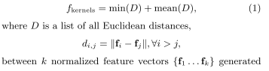
  - The features are fed to a RNN that is trained using CoSyNE (coevolution) to maximise the distance travelled on the track, maximum speed of the car, minimise damage taken. Final output is 3 values -left, right and acceleration/brake.
  - Performance below than hardcoded policies (olethros, bt, berniw, tita and inferno) but all of them use internal TORCS information. Can complete the course and its mirror image, but no info on different tracks.
- Evolving a feature extractor using HyperNEAT[20]⁠
  - Struggles to perform image classification, but good as a feature extractor that other algorithms can use
  - Similar to NEAT+Q, where HyperNEAT evolves the structure and the fitness is measured by first training and then testing the candidate. The second ML is a standard ANN that takes the features and outputs the image class and it's trained using backpropagation (supervised)
  - Tested for the MNIST dataset, compares performance of standard HyperNEAT (fully connected substrate), CNN HyperNEAT (not fully connected, like LeNet) and both variants as feature extractors (with an ANN appended at the end); best performance is CNN HyperNEAT + ANN
  - Interesting results, but they involve supervised training -not available in our domain; also impractical training times for large continuous state-action spaces

ViZDoom environment as a test bed for RL algorithms using exclusively visual input.[21]⁠
- An attempt at creating a test-bed framework for RL in complex visual tasks
- Environment is a version of the Doom game based on Zdoom modified for RL tasks -agents interact with the world giving sequences of commands, the world provides the state of the game (variables and raw image buffer) and returns the reward based on the action (if anything) and the total episodic reward
- Information available → image buffer, in-game variables such as health, ammo, armour; allows for shaping rewards
- Previous results → authors have tested standard DQN satisfactory (Q-learning using CNN as function approximator for Q-values with experience replay); used skipframe rate to speed up training without compromising performance (often improves it)
- Good results in two scenarios (basic and health gathering). Performance on basic is good but the task is simple; health gathering average performance does not solve the task -survive for 1 minute; though best result does solve it

Design proposal
The main idea is to explore and evaluate the use evolutionary algorithms to aid the training and tuning of deep networks. The control of an agent in a high-dimensional complex visual environment (ViZDoom) is used as a test task.

Other authors [22]⁠ have showed that direct neuroevolution of weights and topologies to fully evolve a visual controller network struggle to produce results.

We are also interested on an algorithm that finds a solution for the complex task in reasonable times in a completely unsupervised manner. Hence approaches such as NEAT+Q [13]⁠ -extremely long training times for simple tasks- and HyperNEAT feature extractor [20]⁠ -uses supervised methods to train and evaluate candidate solutions- are unaffordable.

Our approach involves reducing the high dimensionality of the visual problem using feature extraction techniques so a neuroevolution algorithm can be applied on a reduced set of features to produce the controller. This work explores the application of EA to both processes: automatic feature extraction from raw image data; and the tuning and training of a controller.

In a practical level, the proposed algorithm attempts to evolve the weights and (partially) the structure of a CNN to control an agent on a complex 3D scenario based on visual input.
- The convoluted part of the network (feature extraction) has a fixed topology and the weights are evolved using a custom GA
- The last part of the network (controller evolution) -partially connected layers- is evolved using neuroevolution; both weights and topology are tuned.
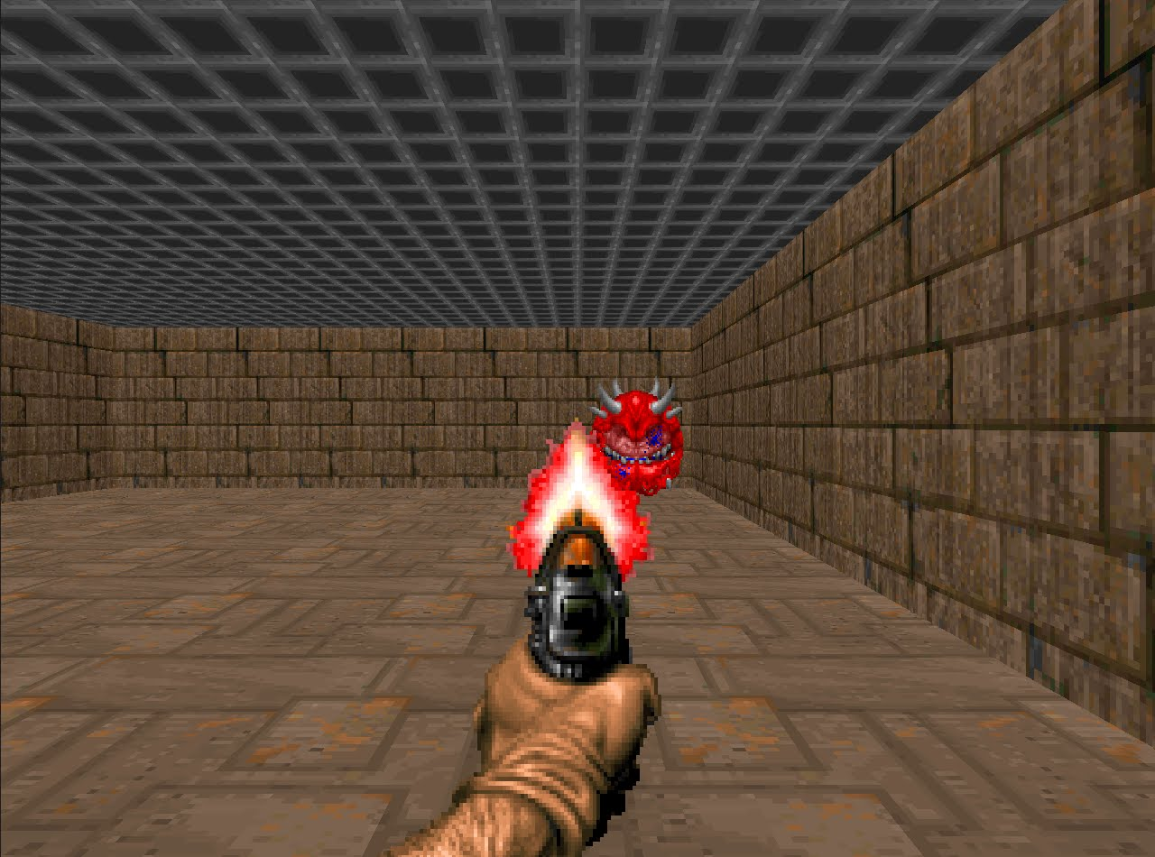
Figure 4. Overview of the two-steps Neural Network approach, with a Feature Extractor and a Controller for ViZDoom agents
Feature
extractor
Controller
Action
Deep CNN
Neural Network
Raw pixel data

Feature extraction
- Following the ideas from [7]⁠ to evolve a set of features from images in an unsupervised fashion, but in a much more complex scenario –use of RGB images (as opposed to single saturation channel), richer decision space (not only left/right and accelerate/brake on a track, but detect different objects [pick up items, health packs, enemies] and navigate a maze).
- Use of a CNN to produce a feature vector -a small number of features- from a raw image.

Figure 5. CNN architecture used for the Feature Extractor
18 kernels 7x7
Subsampling
24 kernels 4x4
Subsampling
Fully connected MLP (128 x features)
RGB image
32 kernels 3x3
Subsampling

- This differs from image compression techniques such as autoencoders; by reducing an image to a small set of features, the algorithm forces the CNN to learn to focus on important elements, losing less relevant information
- CNN topology is fixed (inspired by ViZDoom [21]⁠): 3 Conv-MaxPool pairs with 18 7x7, 24 4x4 and 32 3x3. MaxPool downsamples x2; followed by 1 fully connected layer (128) and the outputs. All layers use a ReLU activation function
- A custom GA is used to train the weights of the CNN. Direct encoding of the weights -each solution contains a chromosome per layer that stores the weights. Mutation (of individual weights: randomise or add a random quantity) and crossover (only interchange of whole chromosomes allowed to minimise the competing convention problem) is used during evolution. Parameters: mutation rate 0.35; elite ratio 0.05; population size 100. Epochs: 400
==
[0.1, 1.3, 0, 1,0.6,0.02,-0.9,-0.05...,0.27]
[0.2, 0.7, 0, 0,-0.6,1.02,-3.9,0.04...,0.06]
...
[-0.1, 0.3, 0, -1,-0.6,1.02,-0.09,-0.08...,0.32]
Figure 6. Direct encoding of a CNN for the custom genetic algorithm

Figure 7. Variation operators for the custom GA (mutation and recombination)
Mutation operators
[0.1, 1.3, 0, 1,0.6,0.02,-0.9,-0.05...,0.27]
[0.1, 1.3, 0, 1,0.6,-1.18,-0.9,-0.05...,0.27]
[0.1, 1.3, 0, 1,0.6,0.57,-0.9,-0.05...,0.27]
Replacement
Modification (+0.55)
Reset
[-0.1, 0.3, 0, -1,-0.6,1.02,-0.09,-0.08...,0.32]
Recombination
[0.1, 1.3, 0, 1,0.6,0.02,-0.9,-0.05...,0.27]
[0.2, 0.7, 0, 0,-0.6,1.02,-3.9,0.04...,0.06]
Parent A
[0.2, 2.7, 1, 0,0.01,0.07,-0.6,-0.5...,0.22]
[0.6, 0.1, 0, 0,-0.3,4.01,-0.11,0.4...,0.02]
Parent B
[0.1, 1.3, 0, 1,0.6,0.02,-0.9,-0.05...,0.27]
[0.6, 0.1, 0, 0,-0.3,4.01,-0.11,0.4...,0.02]
- Talk about how the algorithm takes the TWEAN challenges into account: competing conventions (mitigated by only allowing crossover at the layer level), but since it is not evolving the topology itself, the problems of protecting innovation and evolving minimal solutions are mitigated.
  - Phenotype-genotype mapping is done to conserve phenotype similarity to genotype similarity, suggested for optimal EA (Holland, 1975 in EA for RL)
- Trained on an unlabelled collection of images representing the different elements that an agent encounters in the scenario (enemies, pickup items, health packs).
- A key aspect of a GA is what is used to evaluate candidate solutions, i.e. what is the fitness function and hence what are going to be the evolutionary pressures that will drive the process. In [7]⁠ they use a distance-based measurement that encourages solutions that classify test images as points in an n-dimensional space (n = #features) to be as sparse as possible. An version of vector distance is evaluated: using a linear function as activation for the output layer (values range from -R to R).

- We evaluate this and compare to a different measurement based on the well known Shannon diversity index[23]⁠, originally proposed to quantify the entropy in strings of text and commonly used in ecology as a way of quantifying how diverse and ecosystem is -i.e. more species and an equal distribution in terms of number of individuals per species would lead to a high Shannon index. A quality of a good feature extractor is one that produces a distinct set of values when certain elements appear in the image. If we make the features have values between 0 and 1 using a sigmoid function, we can then use the weighted average of those values to determine the final species that image belongs to (if there are 16 features, the image can belong to species 0 to 15); then use the Shannon index to quantify the diversity of the candidate solution over the training set, and measure its fitness based on that -solutions that spread the images into as many species as possible and with equal distribution will be considered better.
- An alternative to the weighted average is using binary encoding to determine the species the image belongs to. Forcing the feature values to be either 0 or 1; the feature vector is interpreted as a binary number, which is then read in decimal to determine the species. Eg.: 0001 would be species 1, whereas 1001 would be categorised as species 9.
- DIAGRAM OF HOW EACH MEASUREMENT FUNCTION WORKS
- The fitness function and the size of the feature vector are tested to determine the best approaches

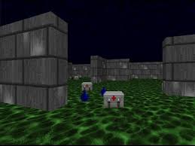
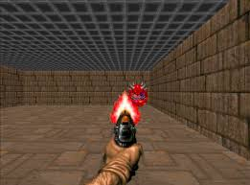
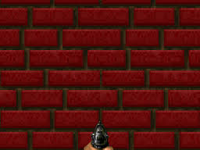
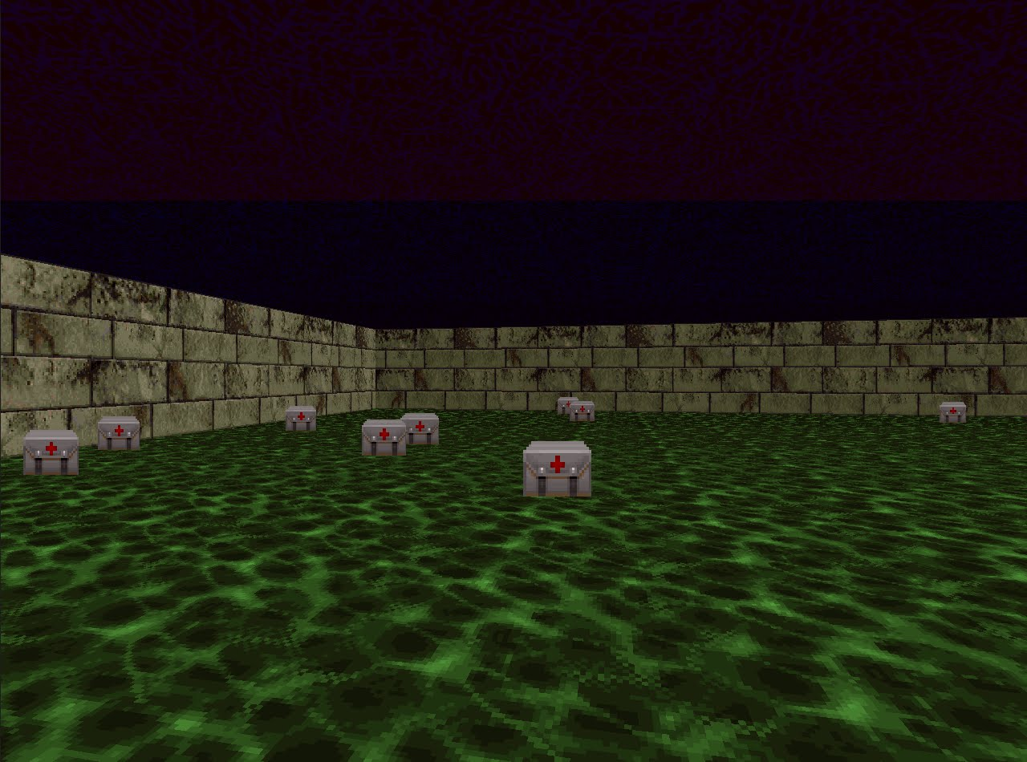
FE
[-1,1,0,0.03,0.7,-0.5]
[-0.1,0,1,0.03,0.3,0.5]
[-1,0,1,0.03,0.9,-0.5]
[0.1,0,0,0.17,0.3,0.6]
Training image set
Output features per image
7.1
Total fitness
Fitness
measurement
Feature extractor candidate
Figure 8. Evaluation of Feature Extractor candidates over a set of training images.

A = [-1,1,0]
B = [-1,0,1]
C = [-1,1,1]
D = [0,0,0]
Distances
Average: 1.329
Min: 1
Fitness = min + average = 1.329 + 1 = 2.329
Image feature vectors

Figure 9. Fitness measurement based on euclidean distance

Figure 10. Fitness measurement based on Shannon index, species calculated as the average of feature vector
A = [1,0,1,0]
B = [0,1,0,0]
C = [0,1,0,0]
D = [0,0,1,0]
Image feature vectors
Average Species assignment
= 0.562335
Proportion ¾ of species 2
Proportion of ¼ of species 3
Shannon index

Figure 11. Fitness measurement based on Shannon index, species calculated as the binary encoding of the feature vector
A = [1,0,1,0]
B = [0,1,0,0]
C = [0,1,0,0]
D = [0,0,1,0]
Image feature vectors
Binary species assignment
= 1.03972
Proportion ¼ of species 2 and 10
Proportion of ½ of species 4
Shannon index

Controller evolution
- The problem is modelled as a Reinforcement Learning task where the goal is to find the best policy to map feature vectors and actions in the scenario -since we are using EA and not TD, we are searching the policy space and not the value function space.
- This work evaluates the use of NEAT (and its variants) to produce a (possibly recurrent) neural network whose input is the feature vector produced by the Feature Detector network evolved by the GA and outputs the action to be taken at each decision point. Two variants are tested: basic NEAT and FS-NEAT (Feature selection NEAT), which starts with only some inputs connected to the network.
Feature vector
1
0
-1
0.5
-0.7
0
0
1
1
0
0
0
0
0
0
0
Do action with index 0 (turn left)
Evolved Neural network
Figure 12. Example of a neural network topology evolved to control a ViZDoom agent by using a feature vector as input

- Each candidate solution is evaluated by letting it control an agent in a ViZDoom scenario; the total reward gathered is used as its fitness. Each scenario awards rewards differently. To help with the credit assignment problem (identify actions that led to high rewards or high punishments from a single final reward value), shaping rewards are introduced for performing actions that are deemed as positive (picking up health packs or ammo):
  - Health gathering: surviving +1 per tick, +100 per health pack picked, -100 per poision picked. Description: player is placed on a maze and can move left/right, forward/backward; the scenario randomly places health packs and poison vials in the maze.
  - Pursuit and gather: killing an enemy +100, surviving +1 per tick, -35 per bullet used, +75 per health pack picked, +50 per ammo picked. Description: similar to defend the centre, but the player can move around the room; health packs and ammo kits are scattered around the scenario.
  - Both health gathering and pursuit and gather scenarios introduce a constant poisoning to the player to discourage solutions from remaining standing still -hence solutions that explore and pick health packs are favoured.
  - Careful consideration is taken when designing scenarios to avoid the evolutionary algorithm to take advantage of geometrical exploits (eg.: if health packs are placed always near walls, an undesirable exploit would be to find a wall and go along it, ignoring everything else); or regularity exploits (eg.: enemies placed in a regular interval from the player, for instances always spawning in front of the initial position; an undesirable behaviour of standing still and constantly shooting could arise). Both examples of exploits were found quickly when this considerations were not taken.
- Parameters: population size 100, elite ratio 0.1, crossover rate = 0.7, mutation rate 0.25 (add, remove link, modify weight, add/remove unit), speciation (disjoint and excess 1.0, weight 0.4) and innovation protection (young age 5, young boost 1.5). Hidden units have ReLU activation function, signed sigmoid for output; a linear output is also compared.
- The action is selected using argmax function on all output units. Other arrangements are evaluated as well: instead of one unit per action, having one unit per decision (one unit to decide left/right, one unit to decide forward, one unit to decide whether to shoot).
- Limitations → recurrent links are allowed to arise, but only 1 level recursion is allowed (since we only do the forward pass 4 times); this allows for output to hidden recursion, or hidden to input. 2 hidden layers are allowed.

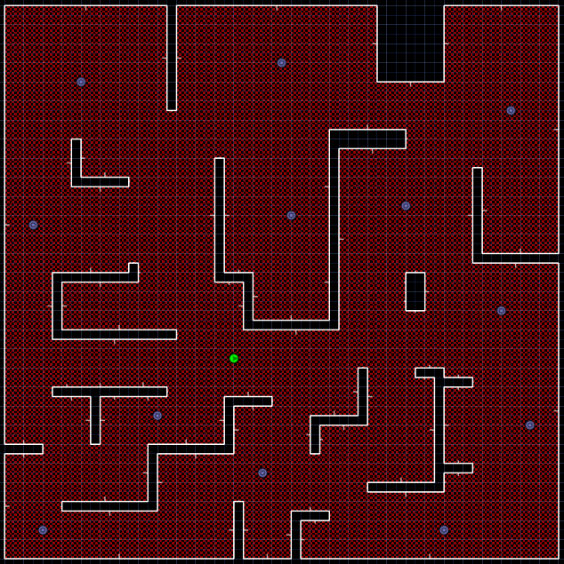
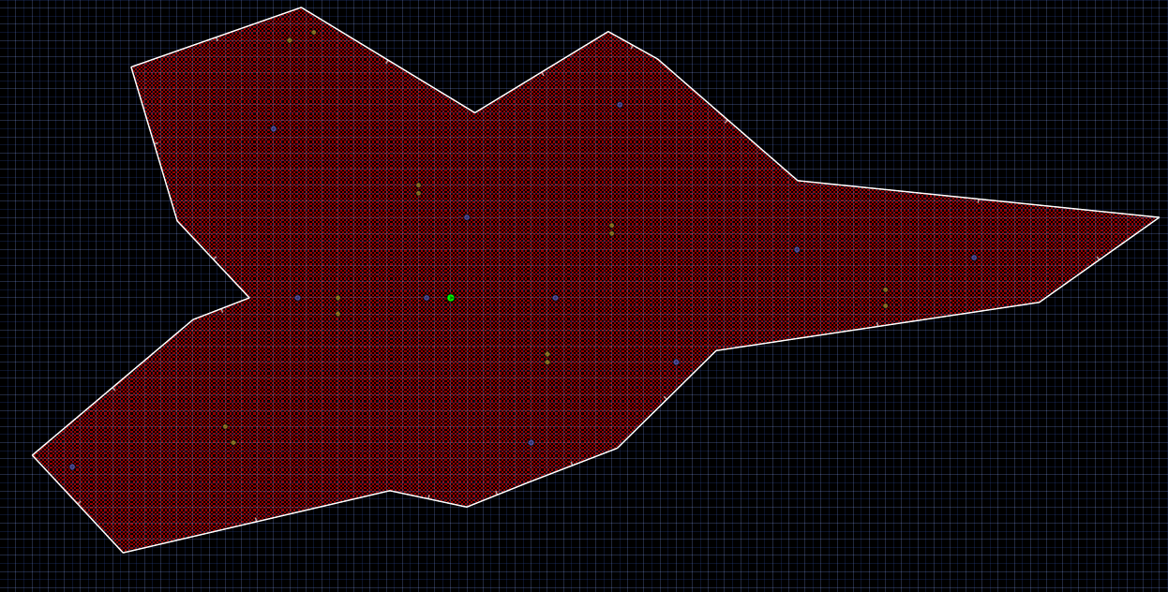
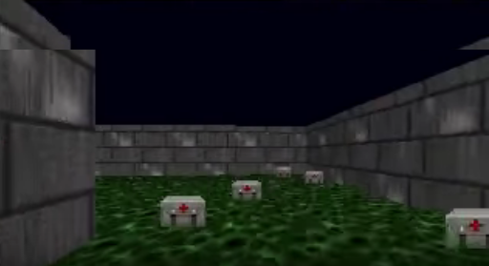
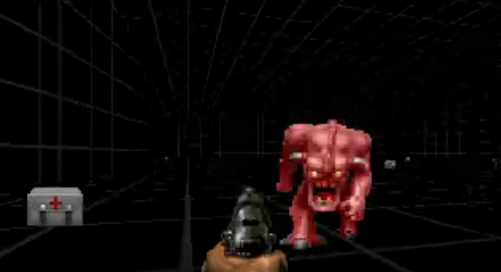
Figure 13. Floor plans and screenshots of the two ViZDoom scenarios employed. Left: health gathering scenario; right: pursuit and gather



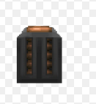

Figure 14. Some ViZDoom elements that the agent needs to learn to differentiate; from left to right: ammo clip, demon and health pack.

Rationale for the choice of deep learning framework → Keras
- Comprehensive API that offers simple and comprehensible access to many deep neural network functionality that is useful: functional layers (fully connected, recurrent, convoluted, locally connected, etc.); learning algorithms (backpropagation, stochastic gradient descent)
- Fast as it can run on GPU as well as many CPU cores
- Based on Theano -solid standard- and TensorFlow.
- Easy to use directly in ViZDoom -python interface.
- Other options: Theano and TensorFlow (in which keras is based), Caffe (complex to setup and configure, hyperparameters cannot be easily configured programmatically), Lasagne (less comprehensive than keras), Torch (does not have a python interface)

Experimental design

FRAMEWORKS (VIZDOOM, KERAS)
TASKS (scenarios)
ASSUMPTIONS / DECISIONS
EXPERIMENTAL DESIGN
For simplicity, only one weapon (pistol) and one enemy type (demon) are considered:
- Pistol was chosen as it requires the agent to have perfect aim (no splash damage, no own damage)
- Demon enemy was chosen as it is visually less complex (mostly pink), only deals melee attacks -no range.
The bulk of the testing is done on a single scenario -pursuit and gather:
- Offers high complexity to solve it -requires killing enemies and collect health packs to survive, also avoid enemies and pick ammo.
- For simplicity → combinatorial explosion with testing all solutions in the 3 scenarios
- The other scenarios are used to test final performance of the best candidate solution -to compare it to other algorithms (full RL, partial RL and supervised CNN)
Testing conditions to ensure statistical significance: each trial is repeated 5 times and the results are averaged.
Skiprate of 3 throughout training and testing to accelerate the training process -shown to affect positively the process in [21]⁠
Evaluation of the evolution of the Feature Extraction / Detection algorithm:
- GA parameters (mutation rate 0.35 -reset value, add value- novelty mutation rate 0.001 -reset a layer or sublayer-, population size 100, elite ratio 0.05 and run for 400 generations, crossover limited to multiple point exchange of layers
- 3 candidate solutions are tested, depending on the fitness measurement and hence the evolutionary pressure: distance (with linear output function), shannon diversity (with binary encoding and average weights to determine species); all of them are compared to a random generated network -baseline.
- To assess the importance of the size of the feature vector, 3 different lengths for each candidate solution are tested: 8, 16 and 32.
- Since candidate solutions are trained in an unsupervised manner and using different fitness measurements, direct comparison is not possible. To compare them, each individual FD is used to train a Controller using standard settings:
  - NEAT to drive the evolutionary process, using winner-takes-all action selection (each output unit represents an action), signed sigmoid output function [-1,1] for the controller network, standard NEAT parameters (population size 100, mutation rate 0.25, crossover rate 0.70, mutation operators add, remove, modify link, add, modify neuron unit, elite ratio 0.1, run for 230 generations)
  - Standard rewards to evolve: +100 killing, +1 per tick survived; shaping rewards: -35 shooting, +75 health pack, +50 ammo. Shaping rewards are only used to aid evolution, but are not counted when assessing performance. To measure the fitness of a solution, 2 full runs on the scenario are done (between 20 and 34 seconds each)
  - To make the final comparison, two sets of data are compared:
    - Learning graph: comparing the fitness of the best and average solution per generation; focus is on improved fitness over generations.
    - Performance graph: the best of each generation is evaluated 4 times in the scenario (shaping reward not counted); focus is on improved performance over generation
Evaluation of the evolution algorithm for the Controller
- The best candidate (size of feature vector and fitness measurement) from the FD trials is selected to carry out further experimentation on the evolution of the Controller
- The goal is to quantify the effect of certain parameters / design decisions on the evolution of the Controller in the final performance of an agent.
- Tests:
- NEAT vs FS-NEAT → see if some of the features are redundant
- winner-takes-all action selection vs axis-based action → see if the networks can be more compact and use structural information (left-right axis) allowing certain features to determine subactions (see enemy, shoot) in a more succinct fashion.
- Network output function: signed sigmoid vs linear → see the impact of the output function on performance
- All done in pursuit and gather scenario, with all parameters shared (except the variable being tested).
- To avoid combinatorial explosion of experiments, the tests are done sequentially: first network output, then NEAT vs FS-NEAT with and without winner-takes-all action selection.
- Learning graph and performance graphs are used to compare performance
Compare overall performance with:
  - Supervised CNN -training a CNN using data gathered from a human player on the scenario (state-action pairs, i.e. pixel data-action)
  - Full Reinforcement learning CNN -DQN with replay memory.
  - (only if enough time) Reinforcement learning using the feature vector from the feature extractor as input for a fully connected feed-forward network.
  - To do this comparisons, the two scenarios are used (health gathering and pursuit and gather); 5 repetitions for statistical significance; performance is measured as the average score (and st. dev) over 100 episodes
  - Describe the testing conditions and parameters -same deep network for all solutions, standard parameters to train
    - Supervised CNN: stochastic gradient descent (batch 64), 1000 training epochs
    - Full-RL: batch size 32, e-greedy strategy (decaying epsilon), 5000 training steps per epoch, 100 epochs, replay memory size 10000, learning rate 0.00001
  - For the comparison to be meaningful, only the best candidate of each approach is compared against the others -for supervised cnn and full RL there is only one candidate (after all training), but for the EA strategy the latest best champion is selected (the highest scoring generation champion from the last 10 generations).

Results
Feature extractor fitness function test:
- random, vector distance, shannon average, shannon binary
- show aggregate for 8, 16 and 32 separately
- fitness graph and performance graphs (totals per vector size and per fitness measure)
- graphs should show average data and information about standard deviation

Controller evolution test:
- output function sigmoid vs linear
- FS-NEAT vs NEAT
- output selection (winner-takes-all vs axis-based)
- show fitness graph and performance graphs
- graphs showing average data and info about standard deviation

Comparison test:
- Supervised CNN
- Full RL (DQN)
- FD-RL
- Only average score over 100 games and st dev (x5 repeated process for statistical significance)
- For DQN and FD-RL, plot performance graph every 5000 training epochs (?) → 100 games; for supervised CNN, plot fitness graph (?)

Feature extractor evolution
Learning graphs to compare the improvement throughout training for different feature vector lengths and using different fitness measurements. Each value shows the best fitness per generation

Figure 16. Learning graphs per fitness measurement and feature vector length

Performance graphs comparing the improvement of the controllers throughout the evolutionary process. Each value corresponds to the performance of the best individual on each generation (as measured by the average score over 4 games)

For simplicity, only the best across all lengths is shown (8 – shannon binary, 16 – shannon average and 16 - distance)

REWARD ONLY (time alive and killing)

Figure 17. Total rewards per fitness measurement and feature vector lengths

ONLY SHOOTING REWARD

Figure 18. Shooting rewards across fitness measurements and feature vector lengths

The best is euclidean distance 16. For completion, the same graphs are shown for all distance measurements (8, 16 and 32).

REWARD ONLY

Figure 19. Total rewards for all feature lengths using euclidean distance

SHOOTING ONLY

Figure 20. Shooting rewards for all feature lengths using euclidean distance

Observation → Distance 16 outperforms any other alternative fitness measurement and feature vector length

Network controller evolution
Using distance 16 feature extractor, determine the impact of certain design decisions on the neuroevolution of the controller. Three experiments are run:
- Nature of the output function (sigmoid vs linear)
- Neuroevolutionary algorithm employed: FS-NEAT vs NEAT
- Action selection method (winner-takes-all action selection vs axis-based action)

Nature of the output function
Learning graph shows linear ascending

Figure 21. Learning graph for alternatives using Sigmoid vs Linear output activation functions
Performance graphs on reward only(left) and shooting only (right)

Figure 22. Total rewards for Sigmoid and Linear output activation function alternatives

Figure 23. Shooting rewards for Sigmoid and Linear output activation function alternatives
Comparison of the best candidate solution over 100 trials (best is the highest total reward on the last 30 generations)

Table 1. Performance comparison Sigmoid vs Linear output functions on 100 trial scenarios
Although the results are very similar, linear is considered better because:
- Learning graph is ascending as opposed to the stabilised sigmoid
- Overall reward is higher even though shooting seems to be the same

Neuroevolutionary algorithm and action selection
All combinations are tested:
- NEAT with winner-takes-all action selection
- NEAT with axis-based action
- FS-NEAT with winner-takes-all action selection
- FS-NEAT with axis-based action
Learning graphs → NEAT is run the standard 230 generations; FS-NEAT is allowed to run for 650 generations to allow complex structures to be formed -FS-NEAT evolves the network topology and also selects the inputs; it is run 650 generations as this allows topologies with complexity equivalent to NEAT at 230 stage.

Figure 24. Learning graph comparing neuroevolutionary algorithms and action selection policies
Performance graphs for reward only (left) and shooting reward only (right)

Figure 25. Total rewards for different Neuroevolutionary algorithms and action selection policies
Figure 26. Shooting rewards for different Neuroevolutionary algorithms and action selection policies

Direct comparison of best (highest total reward in last 30 generations) on 100 trials.

Table 2. Performance comparison of different neuroevolutionary algorithms and action selection policies on 100 trials

Comparison benchmark
The performance of the evolutionary strategy is compared to a supervised cnn approach and a DQN reinforcement learning approach.

Figure 27. Evolutionary solution compared to benchmark alternatives

Research findings and analysis

Highlight what feature extractor fitness measure gives the best results
- Contrast the fitness graphs based on totals for each vector size (random, distance, shannons for each) and per fitness measure (8,16,32 for each)
- Compare random baseline to any method -is there any method worse or as bad as random? Do random solutions solve the scenario? What do they tend to do?
- As well as empirical data, describe performance on the scenario for representative cases
- Contrast performance graphs -comparing to baseline random- based on totals for each vector size (random, distance, shannons for each) and per fitness measure (8,16,32 for each).
- When discussing shannon binary take into consideration early exit from FD training (when it reaches maximum diversity).
- For all tests, a mention of the complexity of the networks evolved in terms of number of units and links

Discuss how the process does not always yield as successful controllers / feature extractors
- Min and max performance on the 5 different trials
- Describe the behaviour of best / worse in qualitative (observation of gameplay) and quantitative (scores, focus on killing vs picking up stuff...) terms

More complex scenarios issues → Problems with rocket launcher and other enemies (DoomPlayer with different colours)

Conclusions and further work

Conclusions and further work
- Looking at co-evolution and distributed methods to evolve Fds and Controllers (Larranaga and Lozano, 2002; Hansen et al, 2003; Rubinstein and Kroese, 2004).
- Limitations of EA (EA for RL): online training, rarely visited states (sections of the genome that would react to them accummulate mutations as there is not evol pressure over them)
- Using evolutionary function approximation (combination of EA and TD [15]⁠ or other hybrid methods (XCS using learning classifier systems)
- Limitations on generalisation: problems with rocket launcher and other enemies (DoomPlayer with different colours)

References
[1] K. O. Stanley and R. Miikkulainen, “Evolving Neural Networks through Augmenting Topologies,” Int. Secur., vol. 6, no. 2, pp. 209–217, 2003.
[2] K. O. Stanley, D. B. D’Ambrosio, and J. Gauci, “A hypercube-based encoding for evolving large-scale neural networks.,” Artif. Life, vol. 15, no. 2, pp. 185–212, 2009.
[3] S. Risi and K. O. Stanley, “An Enhanced Hypercube-Based Encoding for Evolving the Placement, Density, and Connectivity of Neurons,” Artif. Life, vol. 18, no. 4, pp. 331–363, 2012.
[4] S. Whiteson, P. Stone, K. O. Stanley, R. Miikkulainen, and N. Kohl, “Automatic Feature Selection in Neuroevolution,” Proc. 2005 Conf. Genet. Evol. Comput. - GECCO ’05, no. June, p. 1225, 2005.
[5] I. K. Fodor, “A survey of dimension reduction techniques,” Library (Lond)., vol. 18, no. 1, pp. 1–18, 2002.
[6] H. Zhang, P. Mazumder, L. Ding, and K. Yang, “Dimensionality Reduction Using Genetic Algorithms Michael,” IEEE Trans. Evol. Comput., vol. 4, no. 2, pp. 472–480, 2000.
[7] J. Koutník, J. Schmidhuber, and F. Gomez, “Evolving deep unsupervised convolutional networks for vision-based reinforcement learning,” Proc. 2014 Conf. Genet. Evol. Comput. - GECCO ’14, pp. 541–548, 2014.
[8] Y. Wei, W. Xia, M. Lin, J. Huang, B. Ni, J. Dong, Y. Zhao, and S. Yan, “HCP: A Flexible CNN Framework for Multi-label Image Classification,” IEEE Trans. Pattern Anal. Mach. Intell., vol. 8828, no. XX, pp. 1–1, 2015.
[9] Y. LeCun, L. Bottou, Y. Bengio, and P. Haffner, “Gradient-based learning applied to document recognition,” Proc. IEEE, vol. 86, no. 11, pp. 2278–2323, 1998.
[10] V. Mnih, K. Kavukcuoglu, D. Silver, A. a Rusu, J. Veness, M. G. Bellemare, A. Graves, M. Riedmiller, A. K. Fidjeland, G. Ostrovski, S. Petersen, C. Beattie, A. Sadik, I. Antonoglou, H. King, D. Kumaran, D. Wierstra, S. Legg, and D. Hassabis, “Human-level control through deep reinforcement learning,” Nature, vol. 518, no. 7540, pp. 529–533, 2015.
[11] V. Mnih, A. P. Badia, M. Mirza, A. Graves, T. P. Lillicrap, T. Harley, D. Silver, and K. Kavukcuoglu, “Asynchronous Methods for Deep Reinforcement Learning,” arXiv, pp. 1–28, 2016.
[12] P. Stone, P. Stone, M. Vcloso, M. Vcloso, P. Riley, P. Riley, R. R. S. Sutton, A. Di Pietro, L. While, L. Barone, G. Kuhlmann, P. Stone, M. Chen, K. Dorer, E. Foroughi, F. Heintz, Z. Huang, S. Kapetanakis, K. Kostiadis, J. Kummeneje, J. Murray, I. Noda, O. Obst, P. Riley, T. Steffens, Y. Wang, X. Yin, T. Walker, M. E. Taylor, P. Stone, S. Whiteson, N. Kohl, R. Miikkulainen, P. Stone, M. E. Taylor, S. Whiteson, P. Stone, J. Y. Tao, D. S. Li, N. Tanaka, S. Arai, P. Stone, G. Kuhlmann, M. E. Taylor, Y. Liu, T. Jung, D. Polani, S. Kalyanakrishnan, Y. Liu, P. Stone, G. Bouchard, A. Iscen, U. Erogul, R. G. Ramani, P. Viswanath, B. Arjun, J. H. Metzen, M. Edgington, Y. Kassahun, F. Kirchner, S. Devlin, M. Grześ, D. Kudenko, R. G. Ramani, R. Subramanian, P. Viswanath, K. Miyazaki, R. Kobayashi, H. Kobayashi, Y. Horima, S. Shirakawa, N. Yata, T. Nagao, S. Whiteson, M. E. Taylor, P. Stone, P. Verbancsics, K. O. Stanley, R. Ramya, J. Lowell, S. Grabkovsky, K. Birger, T. Sawa, T. Watanabe, J. Leng, C. P. Lim, S. Devlin, M. Grze, #347, D. Kudenko, Y. Gao, F. Toni, L. A. Celiberto, J. P. Matsuura, R. L. De Màntaras, R. A. C. Bianchi, P. Stone, S. Kelly, and M. I. Heywood, “Comparing Evolutionary and Temporal Difference Methods in a Reinforcement Learning Domain Matthew,” Proc. Genet. Evol. Comput. Conf., pp. 1321–1328, 2006.
[13] S. Whiteson and P. Stone, Evolutionary Function Approximation for Reinforcement Learning, vol. 7, no. AI05-320. 2006.
[14] V. Mnih, K. Kavukcuoglu, D. Silver, A. Graves, I. Antonoglou, D. Wierstra, and M. Riedmiller, “Playing Atari with Deep Reinforcement Learning,” arXiv:1312.5602, pp. 1–9, 2013.
[15] S. Whiteson, “Evolutionary Computation for Reinforcement Learning,” Reinf. Learn. State Art, vol. 12, no. c, pp. 325–355, 2012.
[16] D. E. Moriarty, D. E. Moriarty, A. Schultz, A. Schultz, J. Grefenstette, and J. Grefenstette, “Evolutionary algorithms for reinforcement learning,” J. Artif. Intell. Res., vol. 11, no. 3, pp. 241–276, 1999.
[17] F. Gomez, J. Schmidhuber, and R. Miikkulainen, “Accelerated Neural Evolution through Cooperatively Coevolved Synapses,” J. Mach. Learn. Res., vol. 9, pp. 937–965, 2008.
[18] O. E. David, T. Aviv, and I. Greental, “Genetic Algorithms for Evolving Deep Neural Networks,” Proc. Companion Publ. 2014 Annu. Conf. Genet. Evol. Comput., pp. 1451–1452, 2014.
[19] J. D. Lamos-Sweeney, “Deep Learning Using Genetic Algorithms,” Rochester Inst. Technol., 2012.
[20] P. Verbancsics and J. Harguess, “Generative NeuroEvolution for Deep Learning,” arXiv1312.5355 [cs], pp. 1–9, 2013.
[21] M. Kempka, M. Wydmuch, G. Runc, J. Toczek, and W. Jaśkowski, “ViZDoom: A Doom-based AI Research Platform for Visual Reinforcement Learning,” arXiv:1605.02097v1 [cs.LG], 2016.
[22] M. Hausknecht, J. Lehman, R. Miikkulainen, and P. Stone, “A Neuroevolution Approach to General Atari Game Playing,” vol. 6, no. 4, pp. 1–18, 2013.
[23] C. E. Shannon, “A mathematical theory of communication,” Bell Syst. Tech. J., vol. 27, no. July 1928, pp. 379–423, 1948.

Appendix

Total rewards for all fitness measurement alternatives with feature vector length 8

Total rewards for all fitness measurement alternatives with feature vector length 16

Total rewards for all fitness measurement alternatives with feature vector length 32

Average total reward for Health Gathering scenario on 100 trials

Average total reward for Pursue and gather scenario on 100 trials

