PENETRATION TESTING REPORT
FOOTPRINTING & NETWORK SCANNING PHASES
W2-PM-FINAL | CYBERSECURITY | NETWORKWALKS
Pentester Name  (Cybersecurity Professional) | Ian Bungei Imbayi
Program/Batch | Networkwalks Cybersecurity & Ethical Hacking Program  Batch: B083
Date | 20 September 2026
Modules completed | W2-PM1 (Footprinting with Multiple Kali Tools)  W2-PM5 (Network Scanning with Zenmap)
Client/Target | 1. networkwalks.com (the course's designated lab target)  2. My own Windows network (192.168.5.0/24)
Permission secured from client? | Yes
Phases covered | Phase 1: Reconnaissance & Footprinting  Phase 2: Scanning & Network Discovery  Phase 3-5: Upcoming modules

1. Liability Disclaimer
Every activity described here was carried out only on systems that I own, or on systems I was authorised to test. This report is prepared for education and research. None of it should be used to break the law. Networkwalks, its instructors and its authors accept no responsibility for how this knowledge is applied; the person who acts carries the responsibility for what they do. In most countries, accessing a system without permission is a criminal offence even when nothing is damaged, and it can lead to prosecution, fines, loss of employment and a lasting record.

2. Introduction
This report documents two practical modules from Week 2 of the Networkwalks Cybersecurity & Ethical Hacking program. W2-PM1 is a footprinting exercise against the public website networkwalks.com using six Kali Linux utilities. W2-PM5 is a host-discovery exercise on a local subnet using Zenmap, the graphical front end of Nmap. Taken together they follow the route a security tester normally takes: first gather what the outside world can see about a target, then work out which machines are alive on a network.
The footprinting work was done from Kali Linux and the scanning work from a Windows PC running Zenmap. For each task I record the command, what it returned, and why the result matters to an attacker (and therefore to a defender). The matching screenshot for every step is in Section 8.

3. Tools Used
The table below lists the tools used in this report and what each one was used for.
Tool | Purpose
Kali Linux & Windows | Operating systems used to carry out the reconnaissance and scanning work.
whois | Looks up domain registration data: registrar, key dates and name servers.
whatweb | Fingerprints the website: web server, CMS, plugins, scripts and IP address.
nslookup | Resolves the domain name to an IP address through DNS.
curl -I | Fetches only the HTTP response headers from the site.
wafw00f | Checks whether a Web Application Firewall sits in front of the site.
dnsrecon | Enumerates DNS records: NS, MX, SPF/TXT and SRV.
Zenmap (Nmap GUI) | Scans the subnet to list live hosts, IP addresses, MAC addresses and open ports.
Windows CMD (ipconfig) | Reveals local IP addresses, subnet masks, gateways and MAC addresses.

4. Activities Performed

4.1 Footprinting & Reconnaissance
I footprinted networkwalks.com with six Kali Linux tools: whois, whatweb, nslookup, curl, wafw00f and dnsrecon. I ran them on 18 September 2026. Each tool exposes a different slice of the target, and the results only become useful when they are read together.
whois. The registration record shows the domain is registered through GoDaddy. It was created on 6 November 2019, last updated on 12 November 2025 and is set to expire on 6 November 2027. The name servers are ns6135.hostgator.com and ns6136.hostgator.com, which tells an observer that the site is hosted with HostGator. The record also carries the usual client transfer, update, renew and delete locks, and DNSSEC is listed as unsigned.
whatweb. The plain HTTP address answers with a 301 redirect to HTTPS. The HTTPS pages reveal an Apache server running WordPress 7.1.1 with the WP Download Manager 3.3.58 plugin, plus jQuery 3.7.1, Google Tag Manager and an HttpOnly session cookie. The output also leaks the server IP address (192.232.216.135) and a contact email address, info@networkwalks.com.
nslookup. Using Google's resolver (8.8.8.8), the domain resolved to 192.232.216.135, returned as a non-authoritative answer.
curl -I. Requesting only the headers returned HTTP/2 200 with the server identified as Apache, an x-nginx-cache header and an x-endurance-cache-level header, which show caching in front of WordPress. A Link header pointed to the WordPress REST API root at /wp-json/, and the session cookie was set with the Secure and HttpOnly flags.
wafw00f. After two requests, the tool concluded that the site sits behind a ModSecurity (SpiderLabs) Web Application Firewall.
dnsrecon. The enumeration returned the SOA record and the two name servers, ns6135.hostgator.com (50.87.144.87) and ns6136.hostgator.com (192.232.216.131). It flagged an error on both: recursion is enabled on the name servers. The mail exchanger is mail.networkwalks.com at 192.232.216.135, matching the A record, and the SPF record (v=spf1 with a, mx, an ip4 entry and an include of websitewelcome.com) ends in ~all. A Google site-verification TXT record and _autodiscover._tcp SRV records pointing to cPanel's email discovery service on port 443 were also listed. A DNSSEC query returned no answer.

4.2 Network Scanning with Zenmap
For the second module I used Zenmap (Nmap 7.991) to map a local network. The tasks were to find my own IP address and subnet, discover the live hosts, record their IP and MAC addresses, and view the network topology.
I began with ipconfig in Windows CMD. My Wi-Fi adapter has the address 10.111.9.12 with the mask 255.255.0.0 and the gateway 10.111.0.1, which is a shared /16 network of 65,536 addresses. It is not my network and I have no permission to test it, so I did not scan it. Instead I switched on the Windows Mobile Hotspot and scanned that network, which I control. Its virtual adapter (Microsoft Wi-Fi Direct Virtual Adapter #2) has the address 192.168.5.1 with the mask 255.255.255.0 and the MAC address 36-F3-9A-5A-2D-2D, so the subnet is 192.168.5.0/24.
With one device connected to the hotspot, I entered 192.168.5.0/24 as the target in Zenmap and ran the Quick scan profile (nmap -T4 -F 192.168.5.0/24) on 20 September 2026. It scanned 256 addresses in 13.71 seconds and found two live hosts:
IP address | MAC address | Notes
192.168.5.1 | 36-F3-9A-5A-2D-2D | My own PC (MAC from ipconfig /all); ports 80, 135, 139, 445, 3306 and 5357 open
192.168.5.182 | 6A:A8:51:47:D8:2D | Device connected to the hotspot; vendor shown as Unknown; all 100 scanned ports closed

Nmap could not name a vendor for 192.168.5.182 because its MAC address is locally administered, meaning it is randomised rather than burned in by a manufacturer. Phones commonly do this to protect privacy. The quick scan also checks the 100 most common ports, and it showed that my own PC has HTTP, RPC, NetBIOS, SMB, MySQL and WSDAPI ports open on the hotspot-facing address.
Finally, I opened the Topology tab. It shows the localhost node linked to 192.168.5.1 (drawn in yellow, a host with three to six open ports) and to 192.168.5.182 (drawn in green, a host with fewer than three open ports).

5. Risk Analysis / Impact
From the information gathered during footprinting and scanning, I identified the following potential risks.
# | Risk / Finding | Evidence / Observation | Potential Impact | Risk Level
1 | Software and versions disclosed | WhatWeb reported WordPress 7.1.1, WP Download Manager 3.3.58, Apache and jQuery 3.7.1 | Exact version numbers let an attacker look up matching public vulnerabilities and prioritise targets | ● Medium
2 | Origin server IP visible | Nslookup and WhatWeb both returned 192.232.216.135 | Enables direct scanning of the host and discovery of other sites sharing the address | ● Low
3 | Verbose HTTP headers | Curl -I showed the Apache banner, cache headers and a Link header pointing to /wp-json/ | Helps fingerprint the stack and exposes the REST API as an extra entry point to enumerate | ● Low
4 | WAF product identifiable | Wafw00f named ModSecurity (SpiderLabs) | An attacker can research bypass techniques for that specific product | ● Low
5 | DNS setup exposed; recursion enabled on name servers | DNSRecon listed NS, MX, SRV and TXT records and flagged recursion enabled on both name servers | Maps the mail and hosting setup; open recursion can be abused for DNS amplification attacks | ● Medium
6 | Soft-fail SPF and unsigned DNSSEC | SPF record ends in ~all; WHOIS shows DNSSEC as unsigned | Spoofed mail may still be delivered, and DNS answers cannot be cryptographically verified | ● Low
7 | Public contact addresses | WhatWeb leaked info@networkwalks.com; WHOIS lists a registrar abuse contact | Useful targets for phishing and social-engineering attempts | ● Low
8 | Every hotspot host discoverable | Zenmap found two live hosts in 192.168.5.0/24 in 13.71 seconds | One sweep lists all connected devices; a rogue device could hide among them unnoticed | ● Medium
9 | Services reachable on my PC | The scan found ports 80, 135, 139, 445, 3306 (MySQL) and 5357 open on 192.168.5.1 | Any device joined to the hotspot can reach file sharing, RPC and a database service on my PC | ● Medium
Risk level key: ● Critical ● Medium ● Low
These are observations from reconnaissance and host discovery, not confirmed vulnerabilities.
Both modules were limited to collecting information, finding live hosts and a quick check of common ports. I did not exploit anything or try to validate a vulnerability.
For that reason, seeing a software version, an IP address, an open port or a DNS record does not mean the system is weak. Confirming a real vulnerability would need further testing under proper authorisation.

6. Recommendations
Based on what these exercises showed, I suggest the following improvements:
- Limit what the website reveals
Remove generator meta tags and version strings, and disable any banner or header that names software versions without a real need.
- Patch WordPress, plugins and themes promptly
Apply updates as soon as they are released and follow the security advisories for WordPress and WP Download Manager.
- Tighten HTTP headers and the REST API
Trim unnecessary response headers and restrict the /wp-json/ endpoints that do not have to be public.
- Audit DNS records on a schedule
Confirm that every published record is still needed, and ask the DNS host to switch off recursion for outside queries on the name servers.
- Strengthen email authentication
After testing, move the SPF policy from ~all to -all, add DKIM and DMARC, and consider enabling DNSSEC.
- Keep the WAF enabled and tuned
ModSecurity already blocks careless probes; keep its rule set current and treat it as one layer, not the only one.
- Scan your own network regularly
Run periodic host-discovery scans so you always know what is connected to the LAN.
- Follow up on unfamiliar devices and keep records
Verify any unexpected host at once, and keep the device inventory and topology diagram up to date.
- Limit services on exposed interfaces
Bind MySQL to localhost, turn off file sharing on hotspot and public networks, and use the Windows firewall to restrict inbound connections.
- Test only with authorisation
Run reconnaissance and scans only against systems you own or have written permission to assess.

7. Conclusion
In Week 2 of the Cybersecurity & Ethical Hacking program I completed two practical modules, one on footprinting and one on network scanning.
In the footprinting module I used six Kali Linux tools against networkwalks.com. whois gave me the registrar, dates and name servers; whatweb and curl exposed the software stack; nslookup revealed the IP address; wafw00f identified the firewall; and dnsrecon mapped the DNS and mail setup.
In the scanning module I used Zenmap to find the live hosts and record their IP and MAC addresses. Because my Wi-Fi is a shared network I am not authorised to scan, I ran the scan on my own Windows hotspot instead, and viewed the resulting topology.
The main lesson is how much can be learned before any exploitation takes place. Careful reading of public data and network replies already builds a detailed picture of an environment, and the same picture is available to defenders who run these tools on their own systems.
I also learned that findings are only useful when they are documented well: what was done, what was found, what it means, what risk it creates and how to reduce that risk.
Lastly, reconnaissance and scanning must stay inside an authorised scope. Everything here was done as part of the assigned educational lab.

8. Evidences Collected
Note: Figures 1 to 6 were captured during the footprinting run on 18 September 2026. Figures 7 to 9 were captured during the Zenmap scan on 20 September 2026.
Figure 1: whois networkwalks.com (domain registration record)
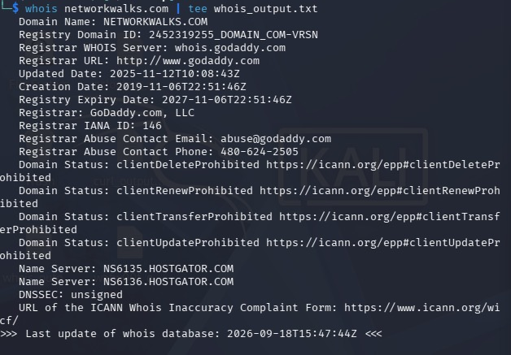
Figure 2: whatweb networkwalks.com (web technology fingerprint)
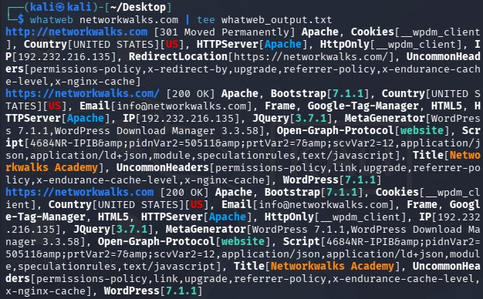

Figure 3: nslookup networkwalks.com (DNS resolution)
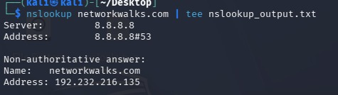
Figure 4: curl -I https://networkwalks.com (HTTP response headers)
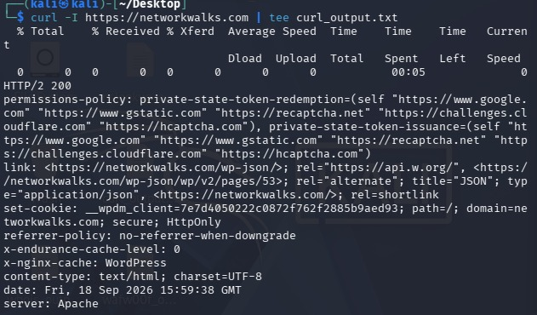
Figure 5: wafw00f networkwalks.com (WAF detection)
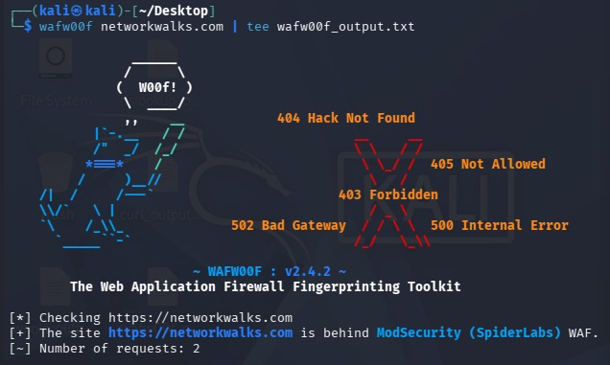

Figure 6: dnsrecon -d networkwalks.com (DNS enumeration)
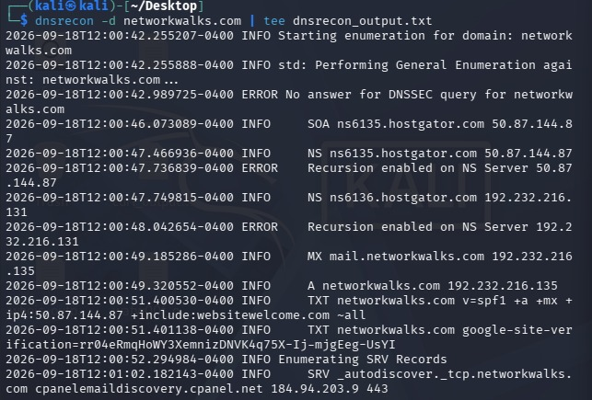
Figure 7: ipconfig /all (Mobile Hotspot adapter: IP address, subnet mask and MAC address)
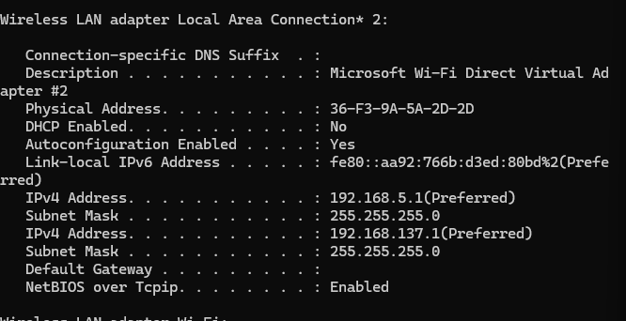

Figure 8: Zenmap Quick scan of 192.168.5.0/24 (nmap -T4 -F)
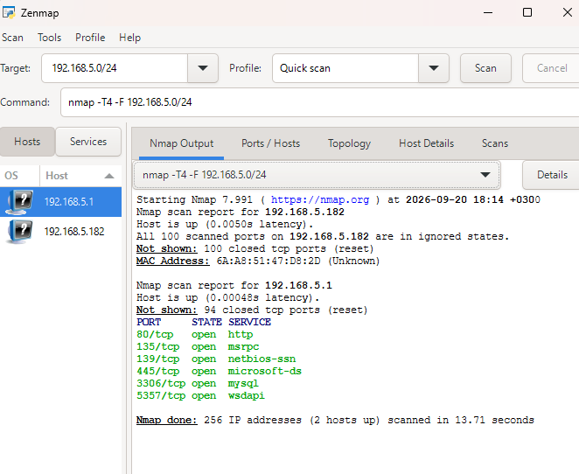
Figure 9: Zenmap topology view
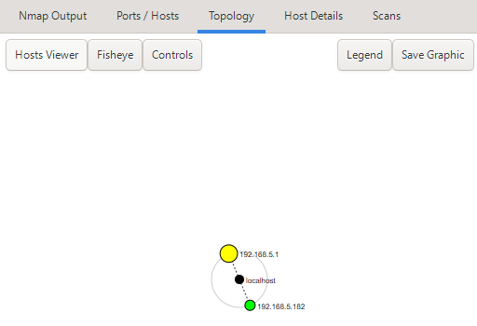
-End-
Author
Ian Bungei Imbayi
Cybersecurity & Ethical Hacking student, Networkwalks
Project Information
Program Name: Cybersecurity program at Networkwalks | Week: 02 | Repository: GitHub [add link]

