LINUX ESSENTIALS (PART-A ASSIGNMENT)

BY ARINZE UNAIGWE

1. For each of the following commands, identify whether it is associated with the Debian packaging system or the Red Hat packaging system: *Dpkg, rpm, apt-get, yum, dnf*

Answer:

Debian Packaging System: Dpkg, apt-get

Red-Hat packaging system: rpm, yum, dnf

1. Write and pass 10 Linux command with the explanation of what they can be used for. Pass the command and screen shot their output, all in a work document

Answer:

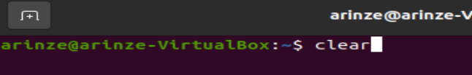

Clear command – clears previous commands on the terminal screen.

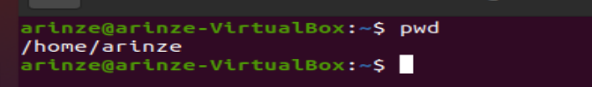

Pwd – Print working directory – tells me the directory I am currently working in



Ls – lists the folders and files in a given directory



Touch – create empty files in a directory

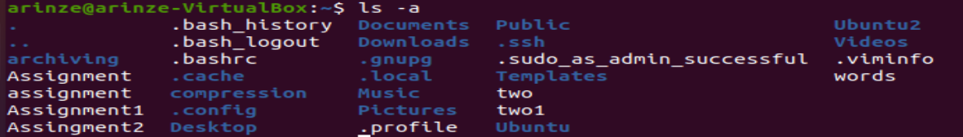

Ls -a – list all files and folders including hidden files

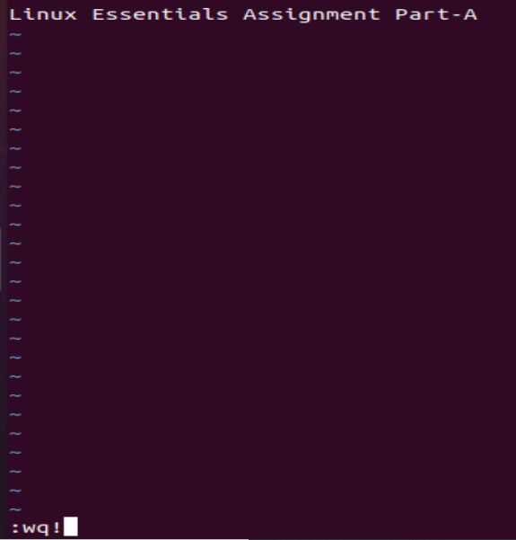

:wq! – Used to save and quit after editing a document



Vim – used to open a file in an editable environment



Cat – Used to read the content of a file



Echo – display a line of text



Man – Manual on any command

1. Create a local variable number.

ii. Create an environment variable ORDER, using one of the methods we have used in classes.

iii. Display both the variable names and their contents.

iv. What are the scopes of the previously created variables?

Answer

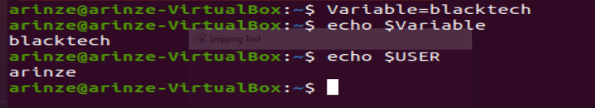

* 1. Create a local variable no_lines and assign the number of lines found in the /etc/passwd file. Hint: Investigate the command wc and command substitution and don’t forget about quotation marks.
  2. Create an environment variable ME. Assign the USER variable’s value to it.
  3. Append the HOME variable’s value to ME, having the : delimiter. Display the contents of the ME variable.
  4. Using the date example, create a variable called today and assign the date for one of the time zones.
  5. Create another variable called today1 and assign the system’s date to it.

Answers

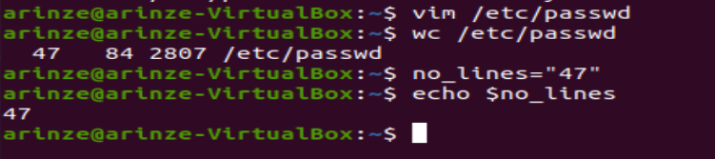

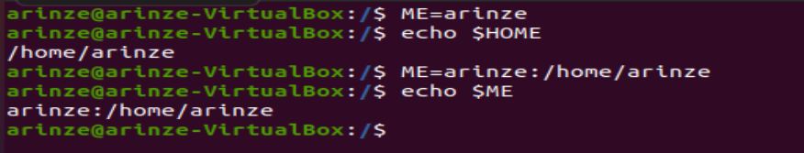





1. Using the ls command with 5 different options, pipe the 5 the output of the operations into a single text file and submit the text file.

