N . B h a r a t h k u m a r

1 9 2 0 1 1 4 4 4

Software Quality assurance

C S A 3 8 2 1

D R. J. VELMURGAN

Experiment no 1:

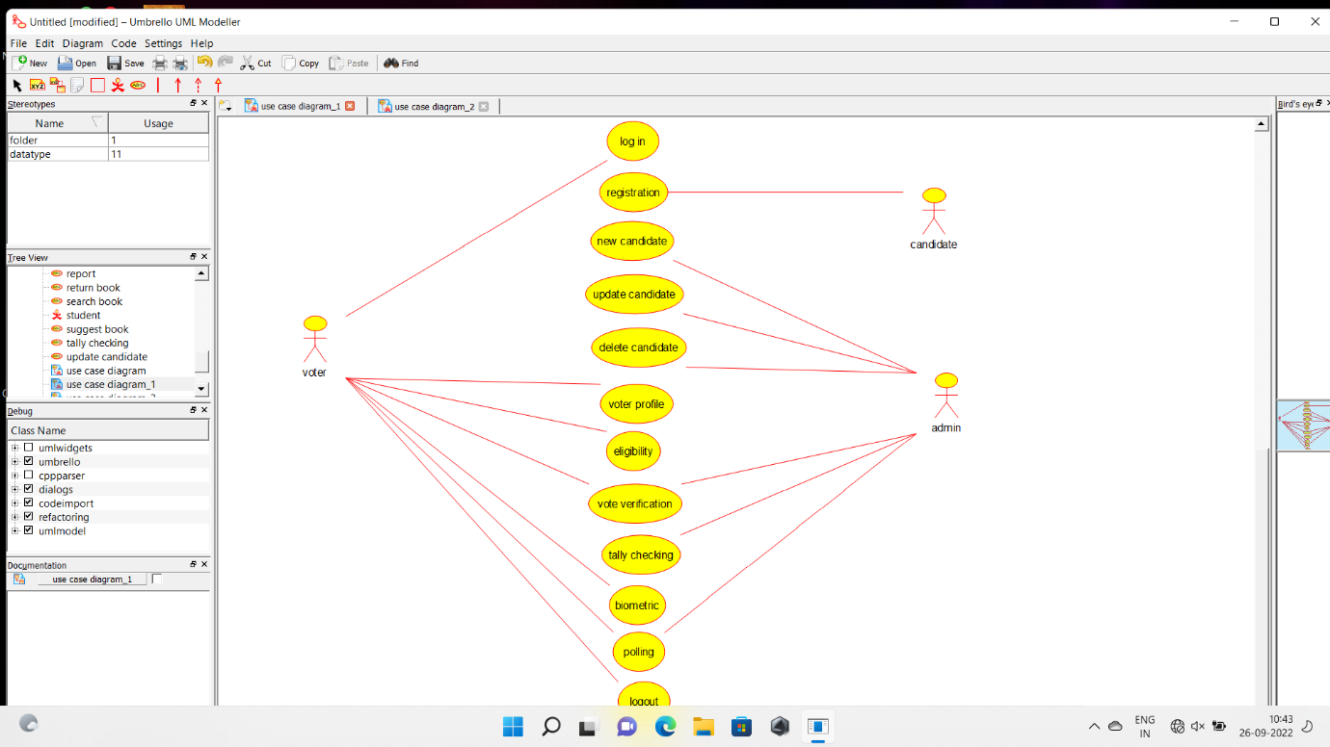

Experiment no 2

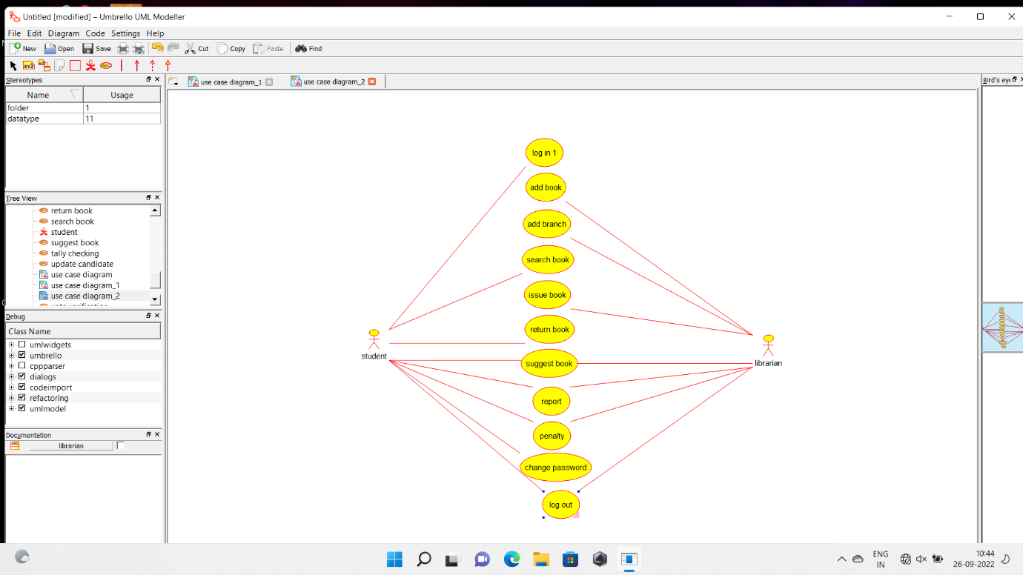

Experiment no 3

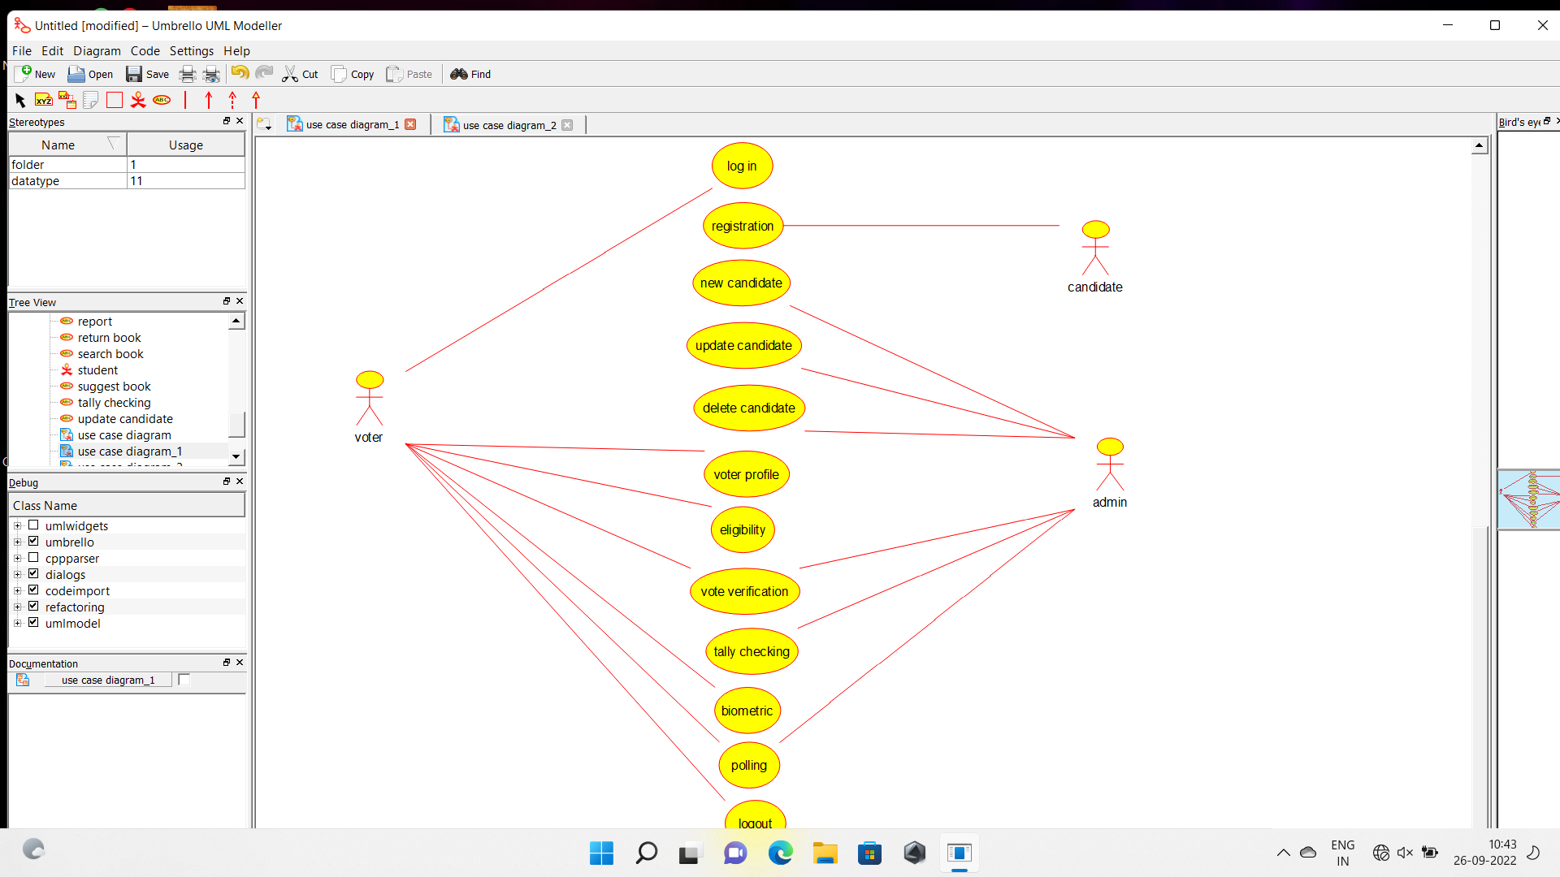

Experiment no 4

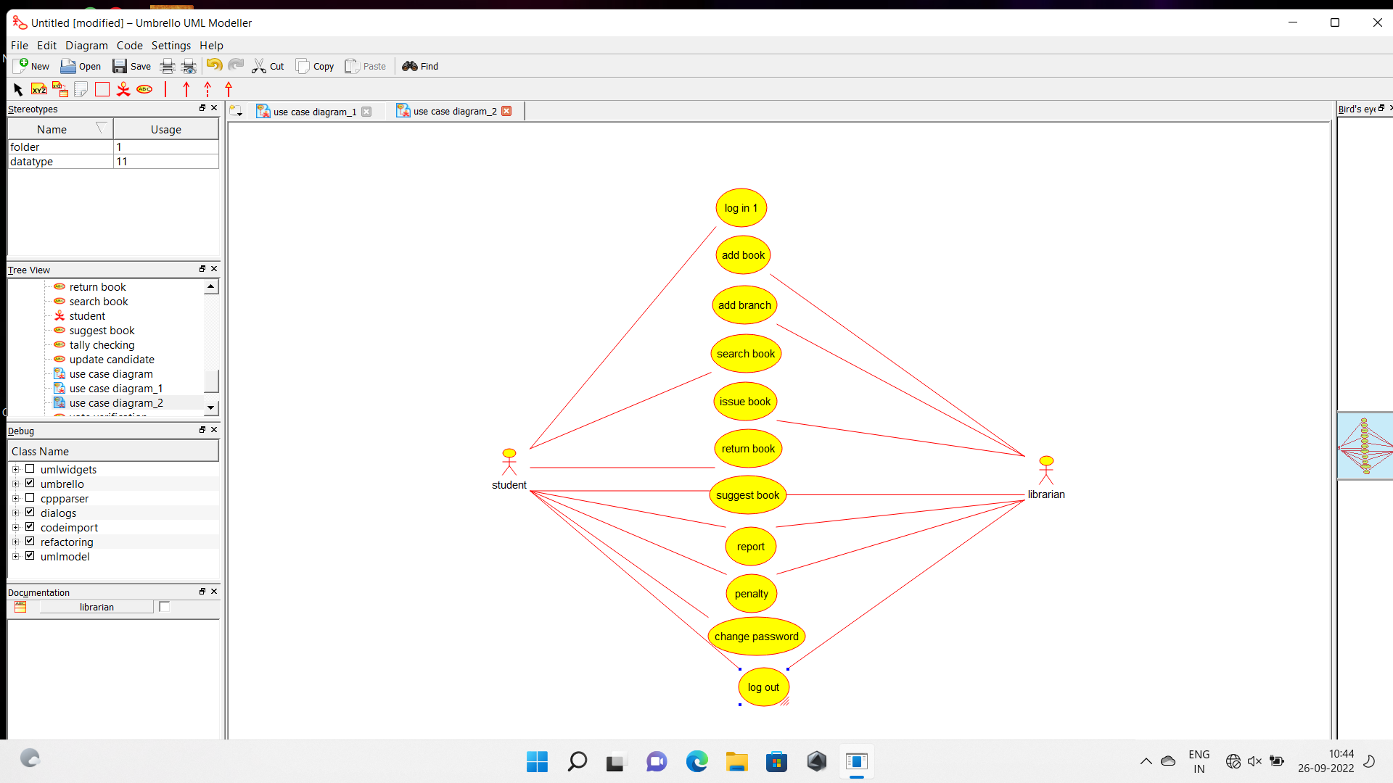

EXPERIMENT NO 5

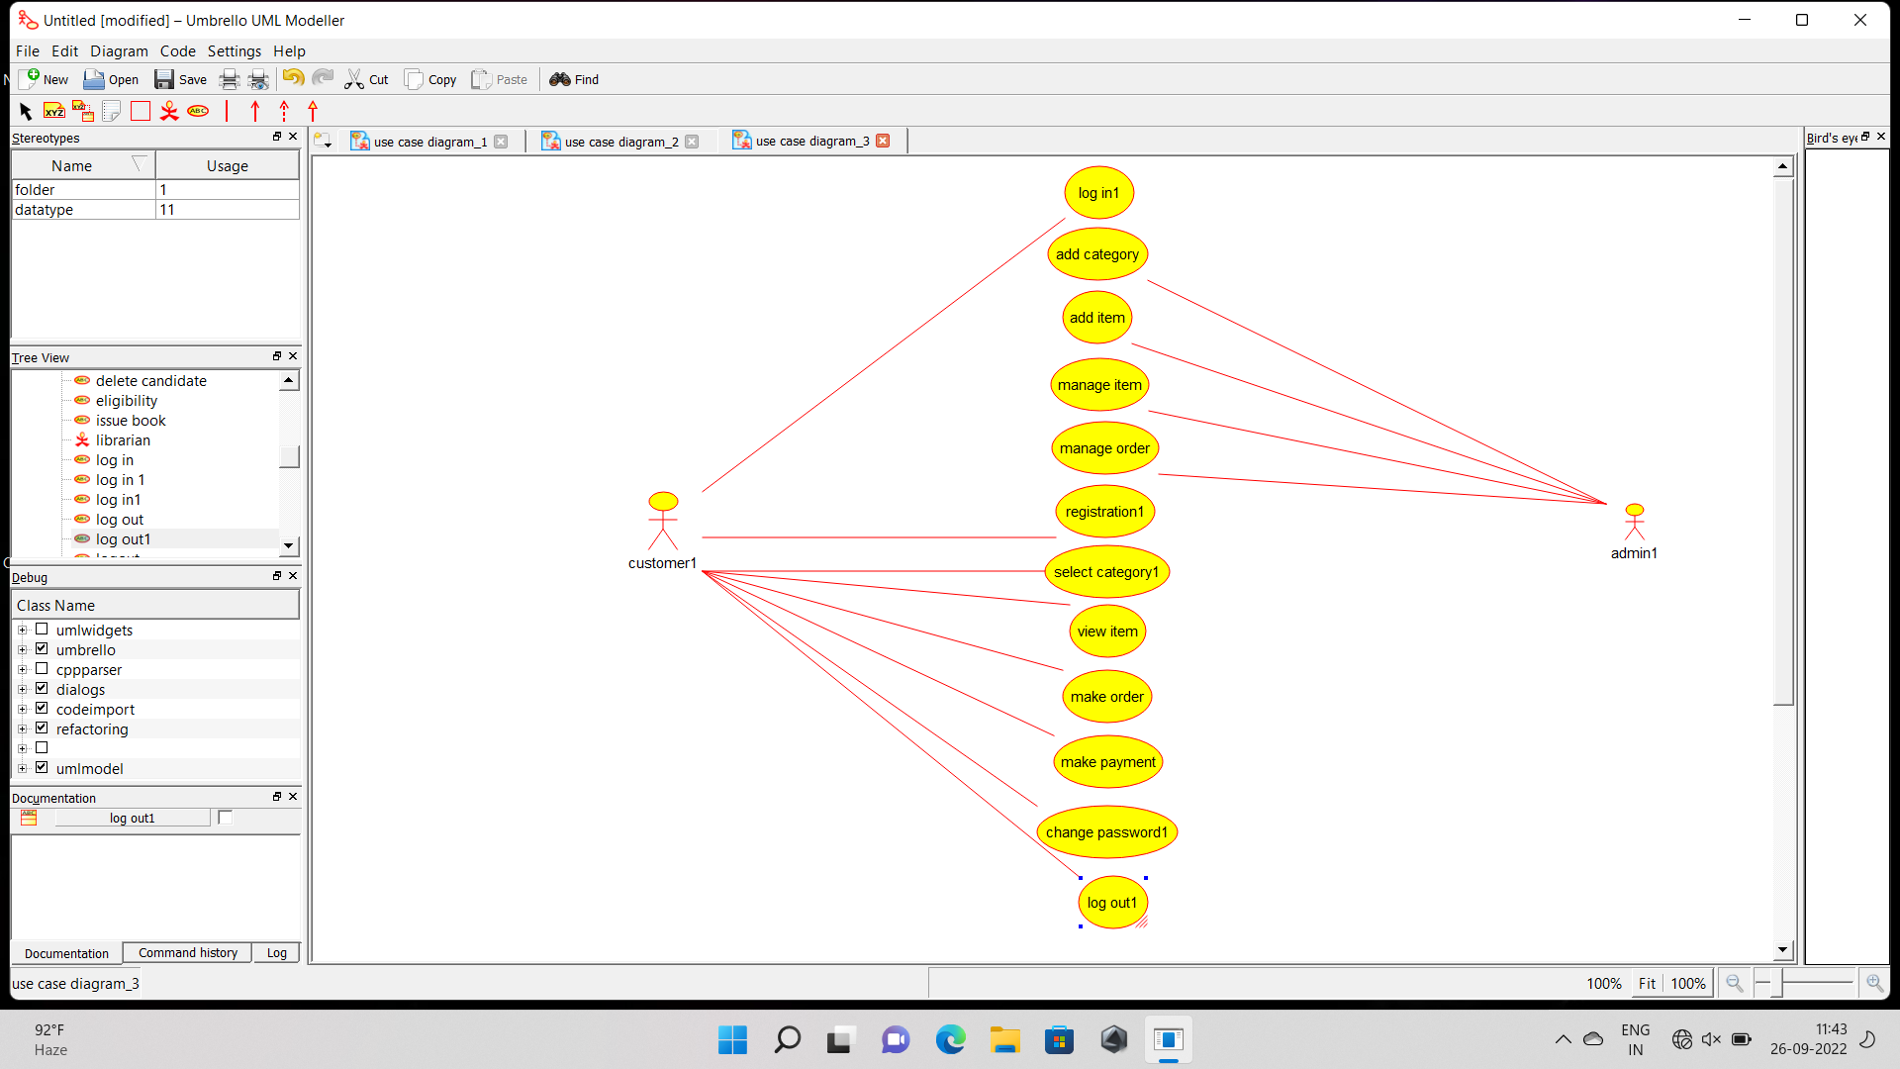

EXPERIMENT NO 6

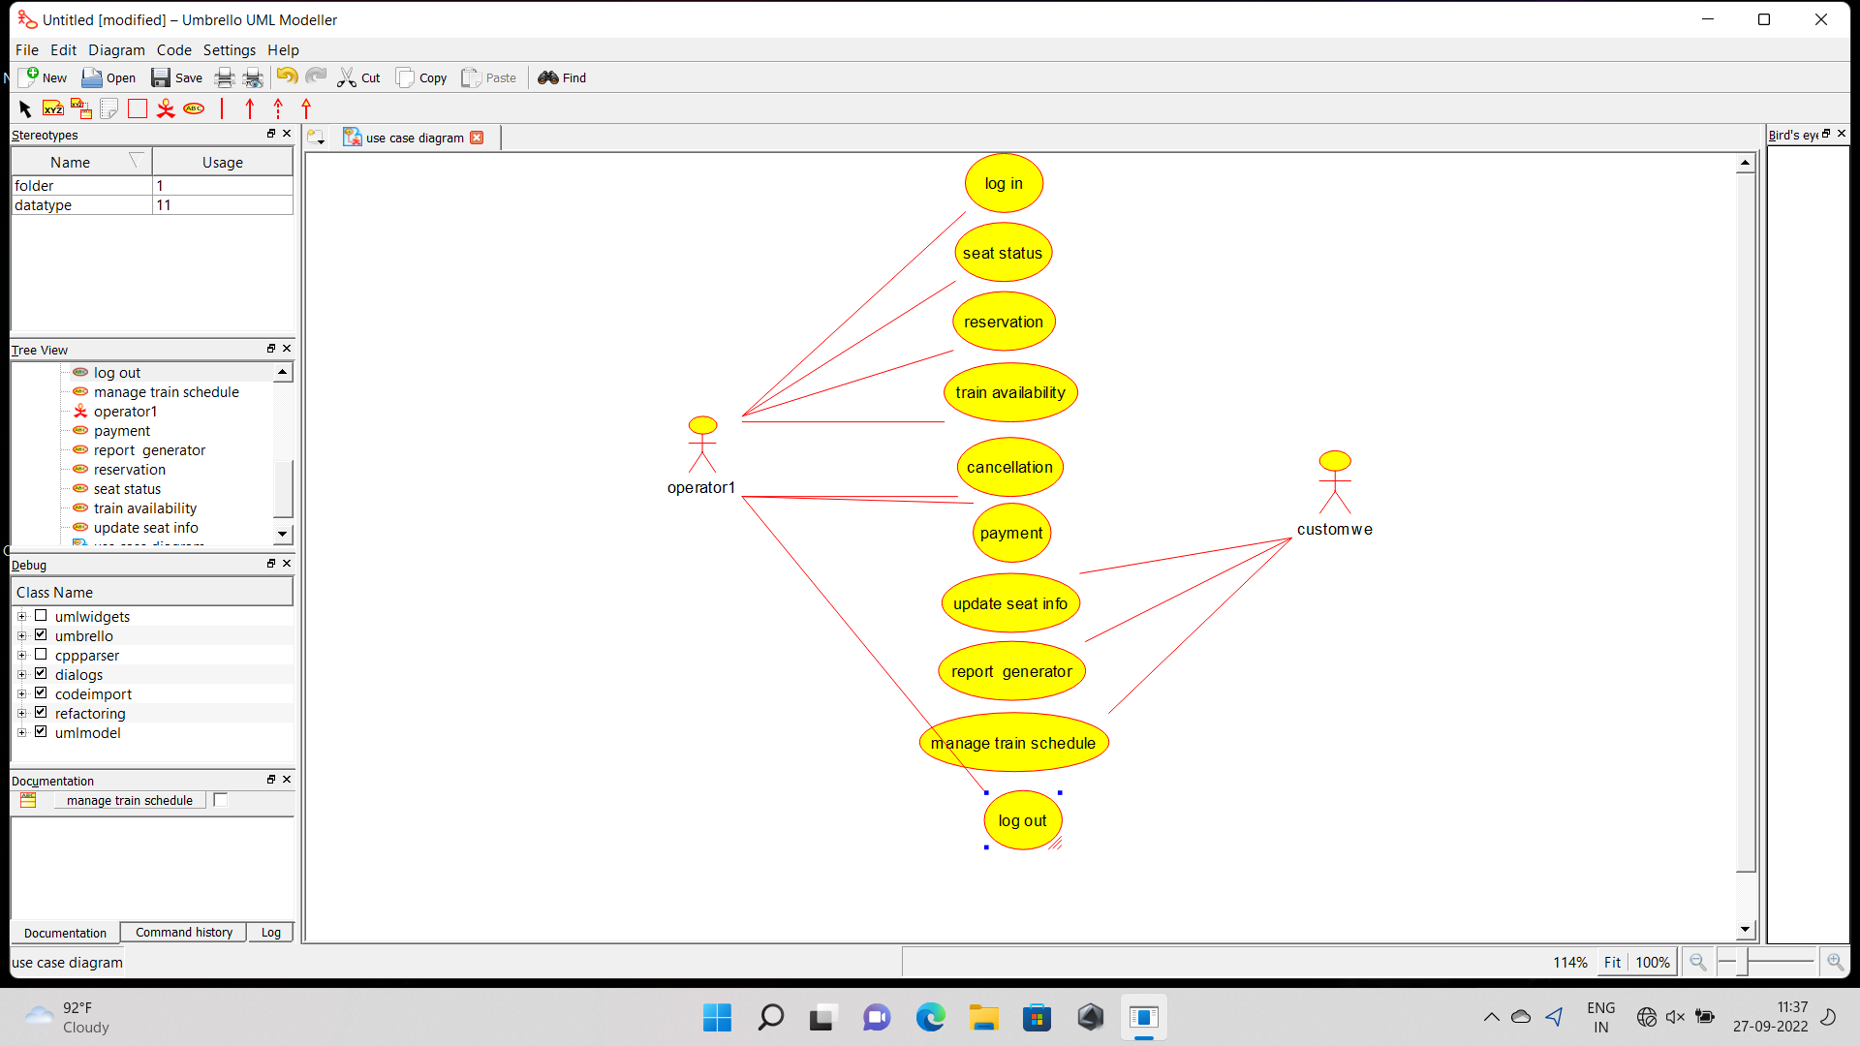

EXPERIMENT NO 7

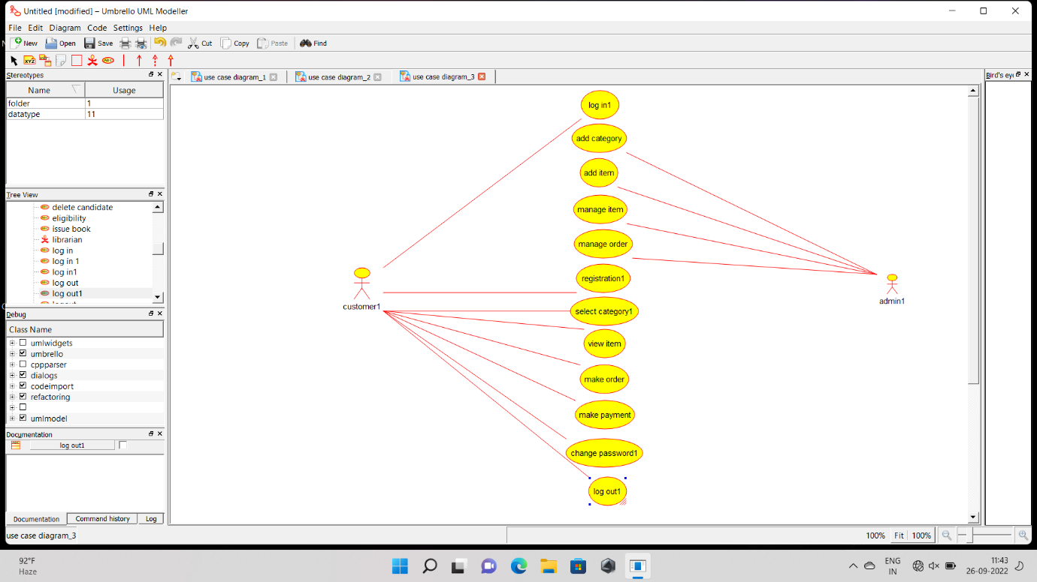

EXPERIMENT NO 8



EXPERIMENT NO 9



EXPERIMENT NO 10



EXPERIMENT NO 11

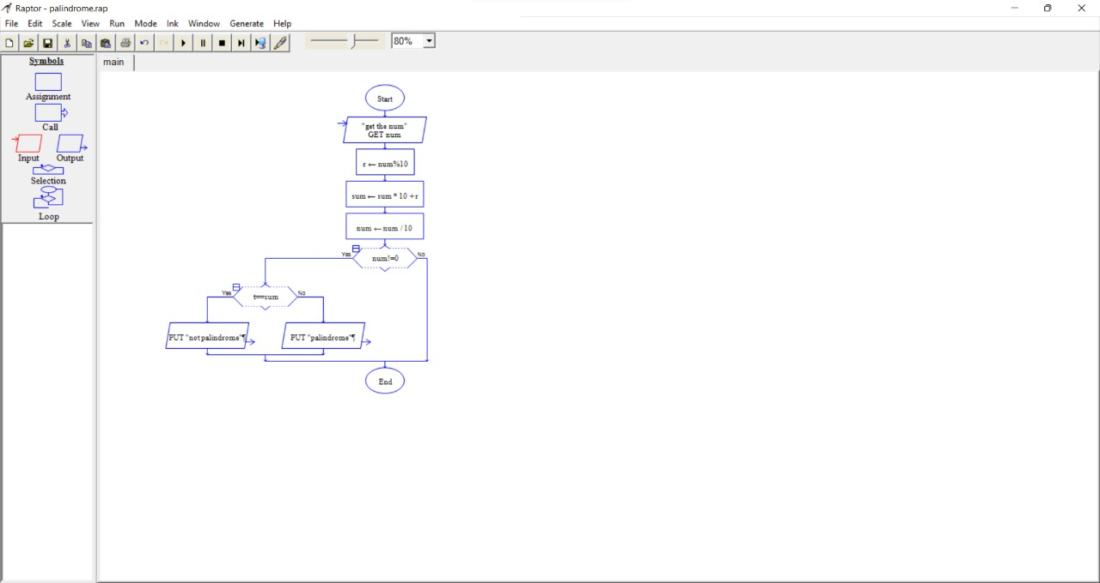

EXPERIMENT NO 12

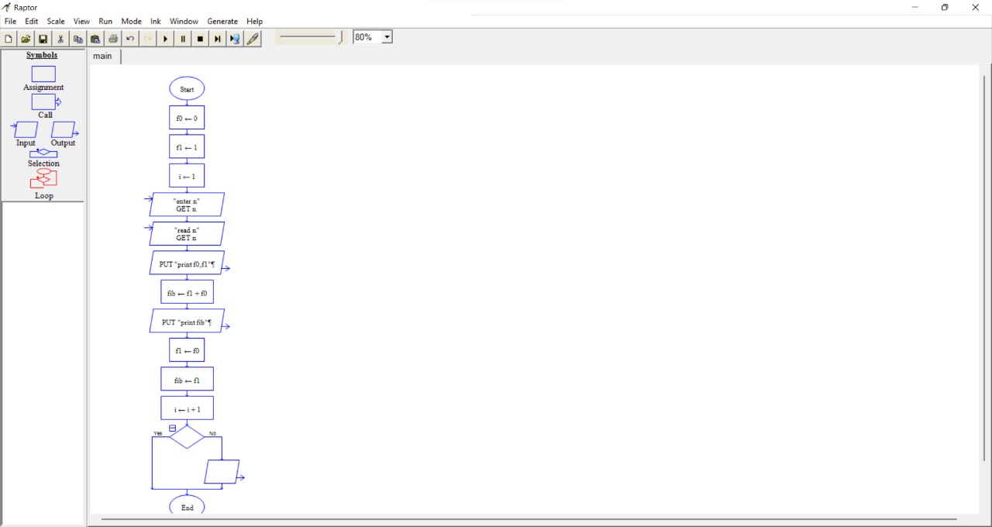

EXPERIMENT NO 13

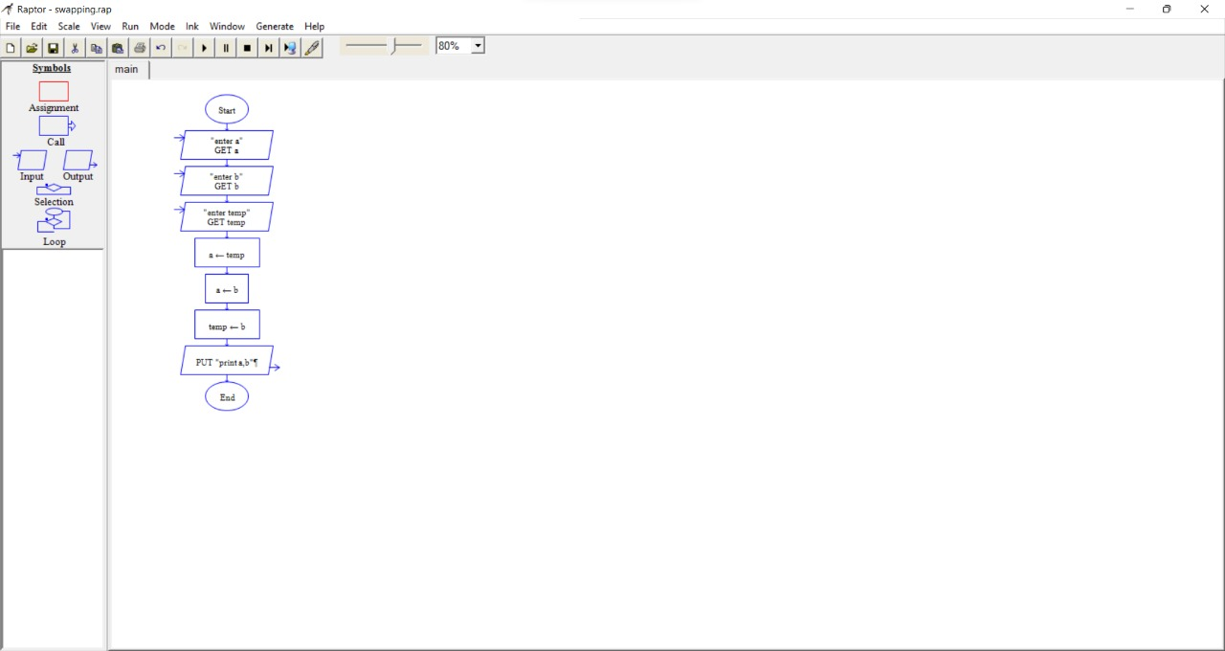

EXPERIMENT NO 14

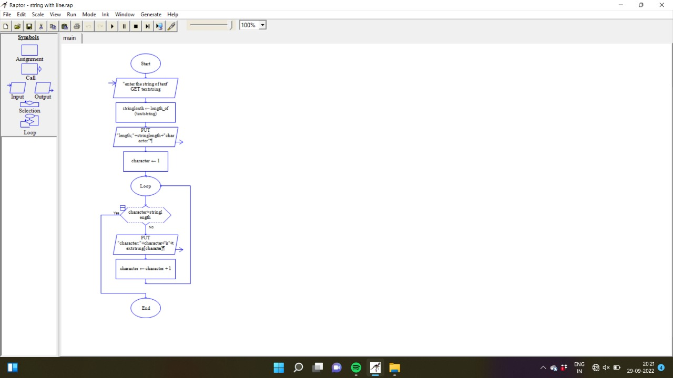

EXPERIMENT no 15

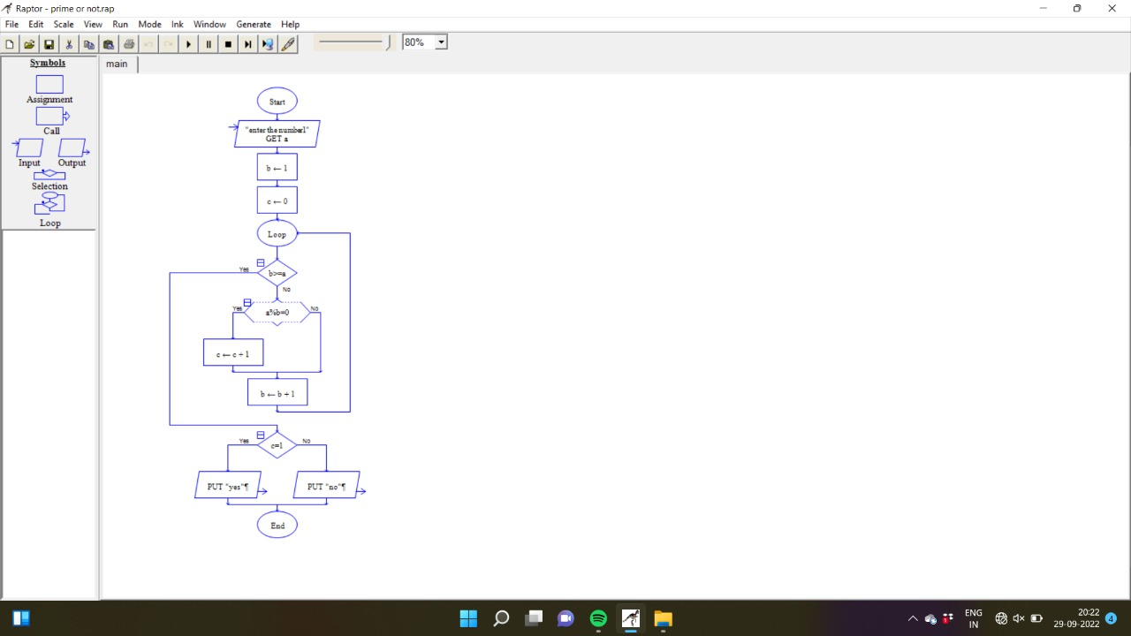

EXPERIMENT no 16

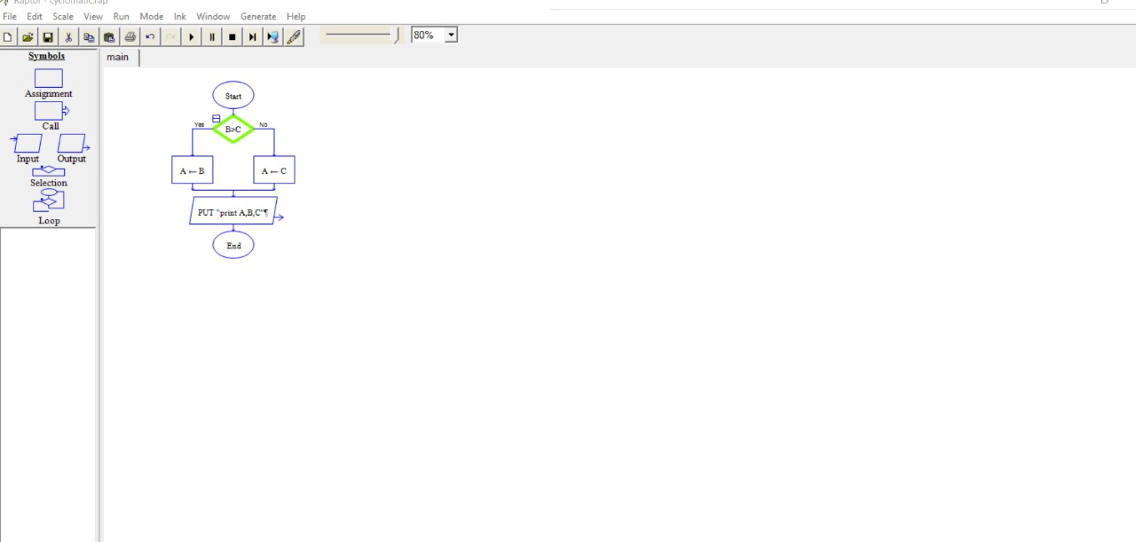

EXPERIMENT no 17

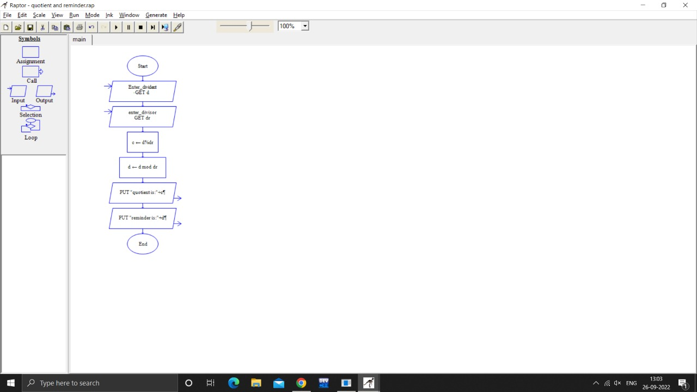

EXPERIMENT no 18

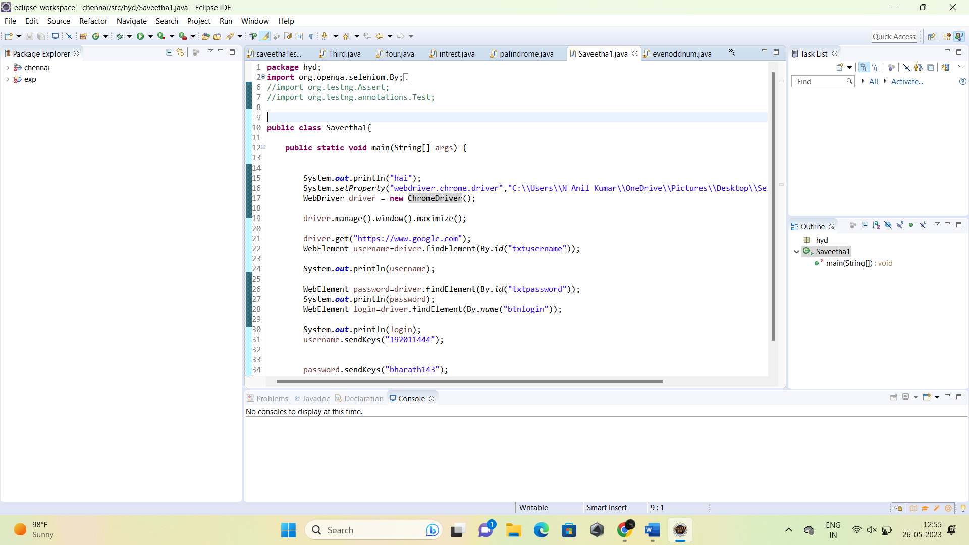

EXPERIMENT no 19

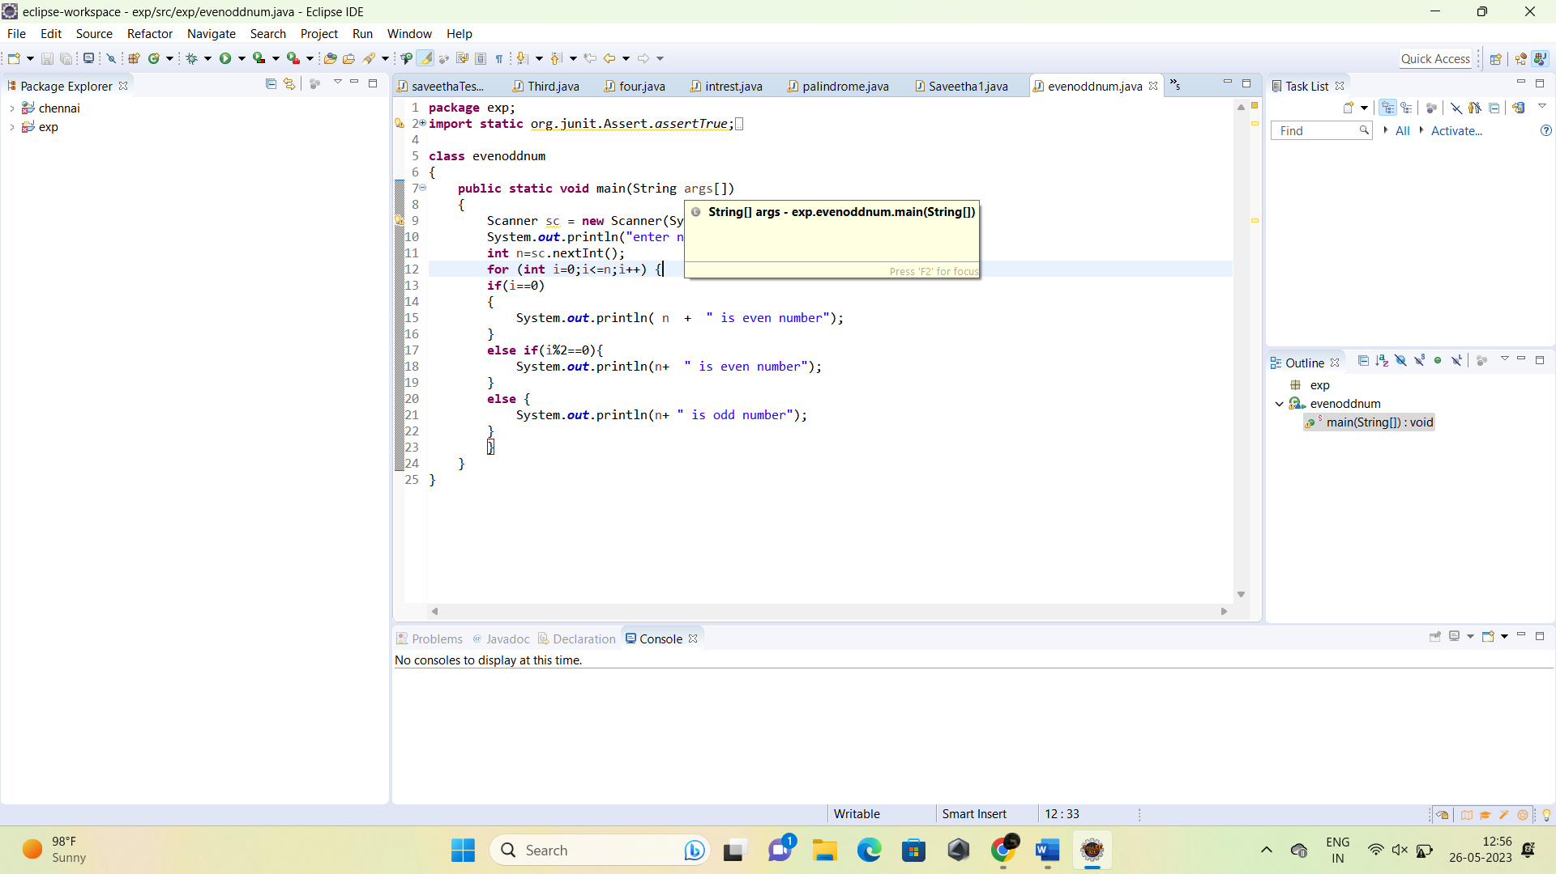

EXPERIMENT no 20

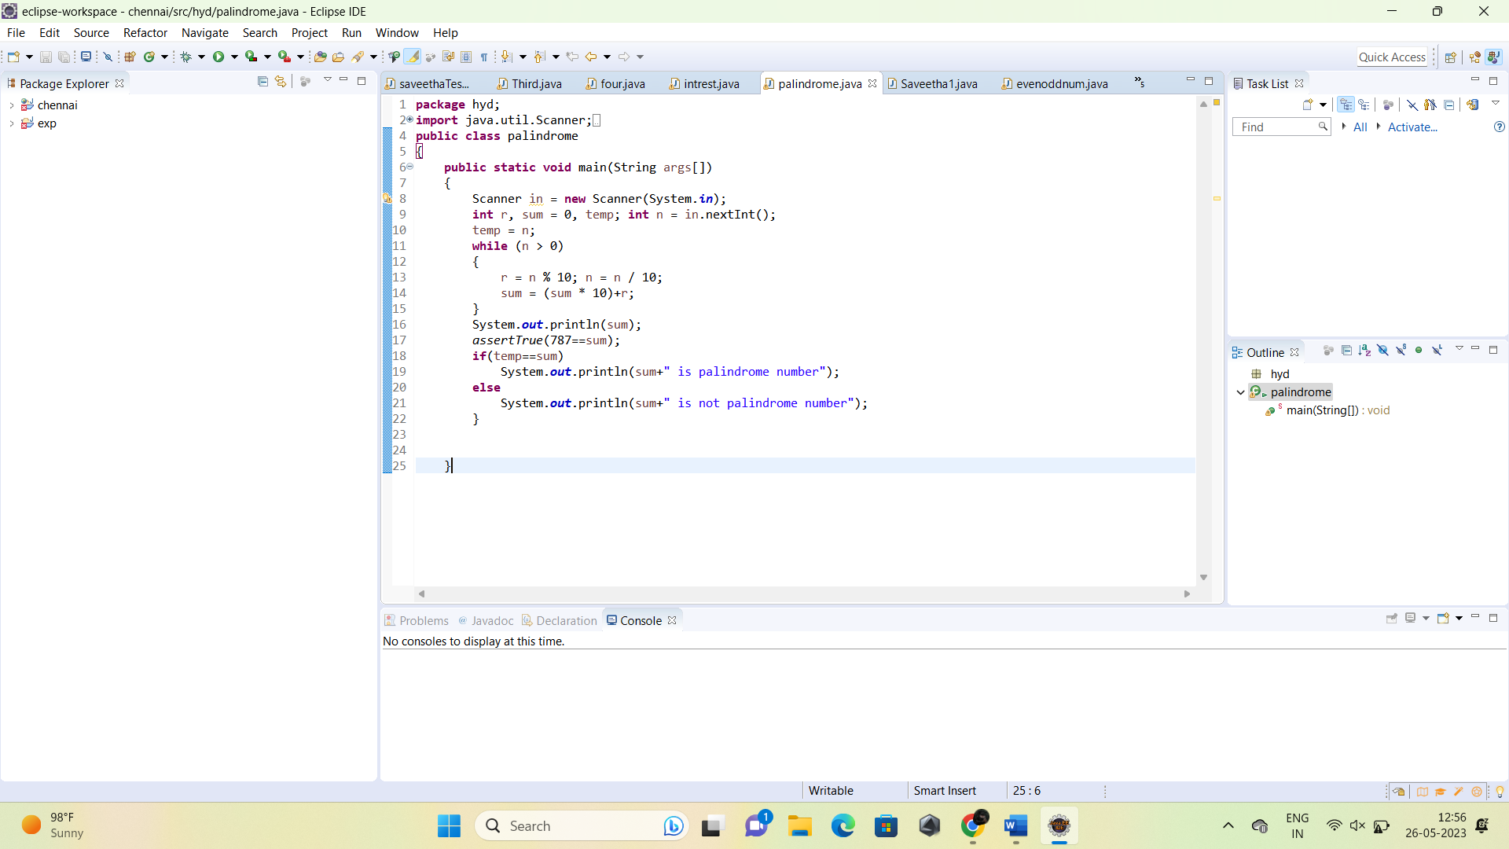

EXPERIMENT no 21

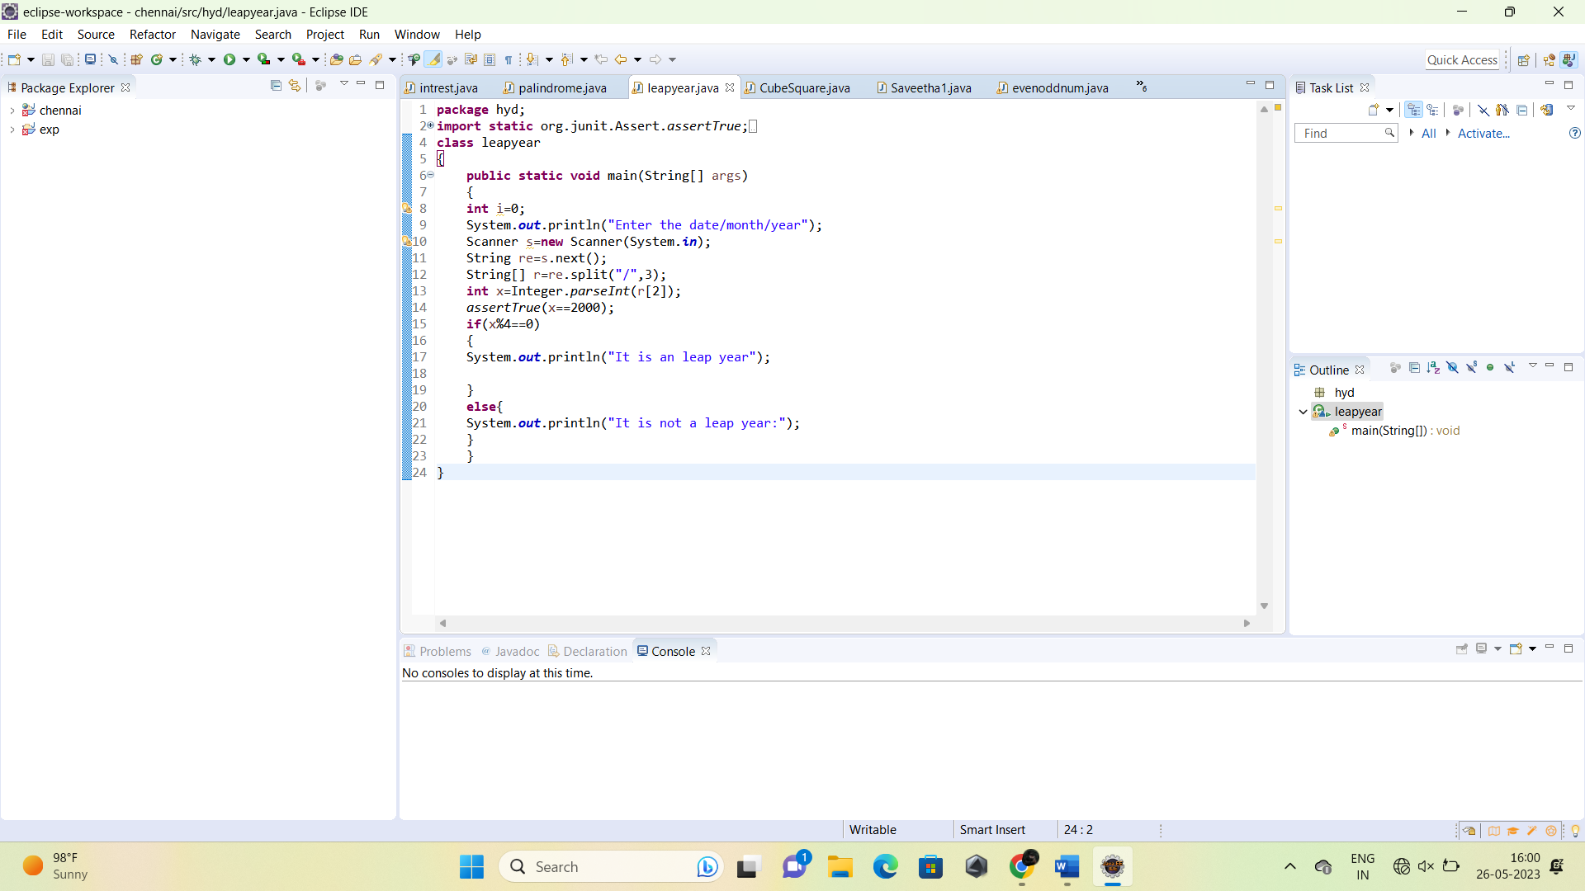

EXPERIMENT no 22

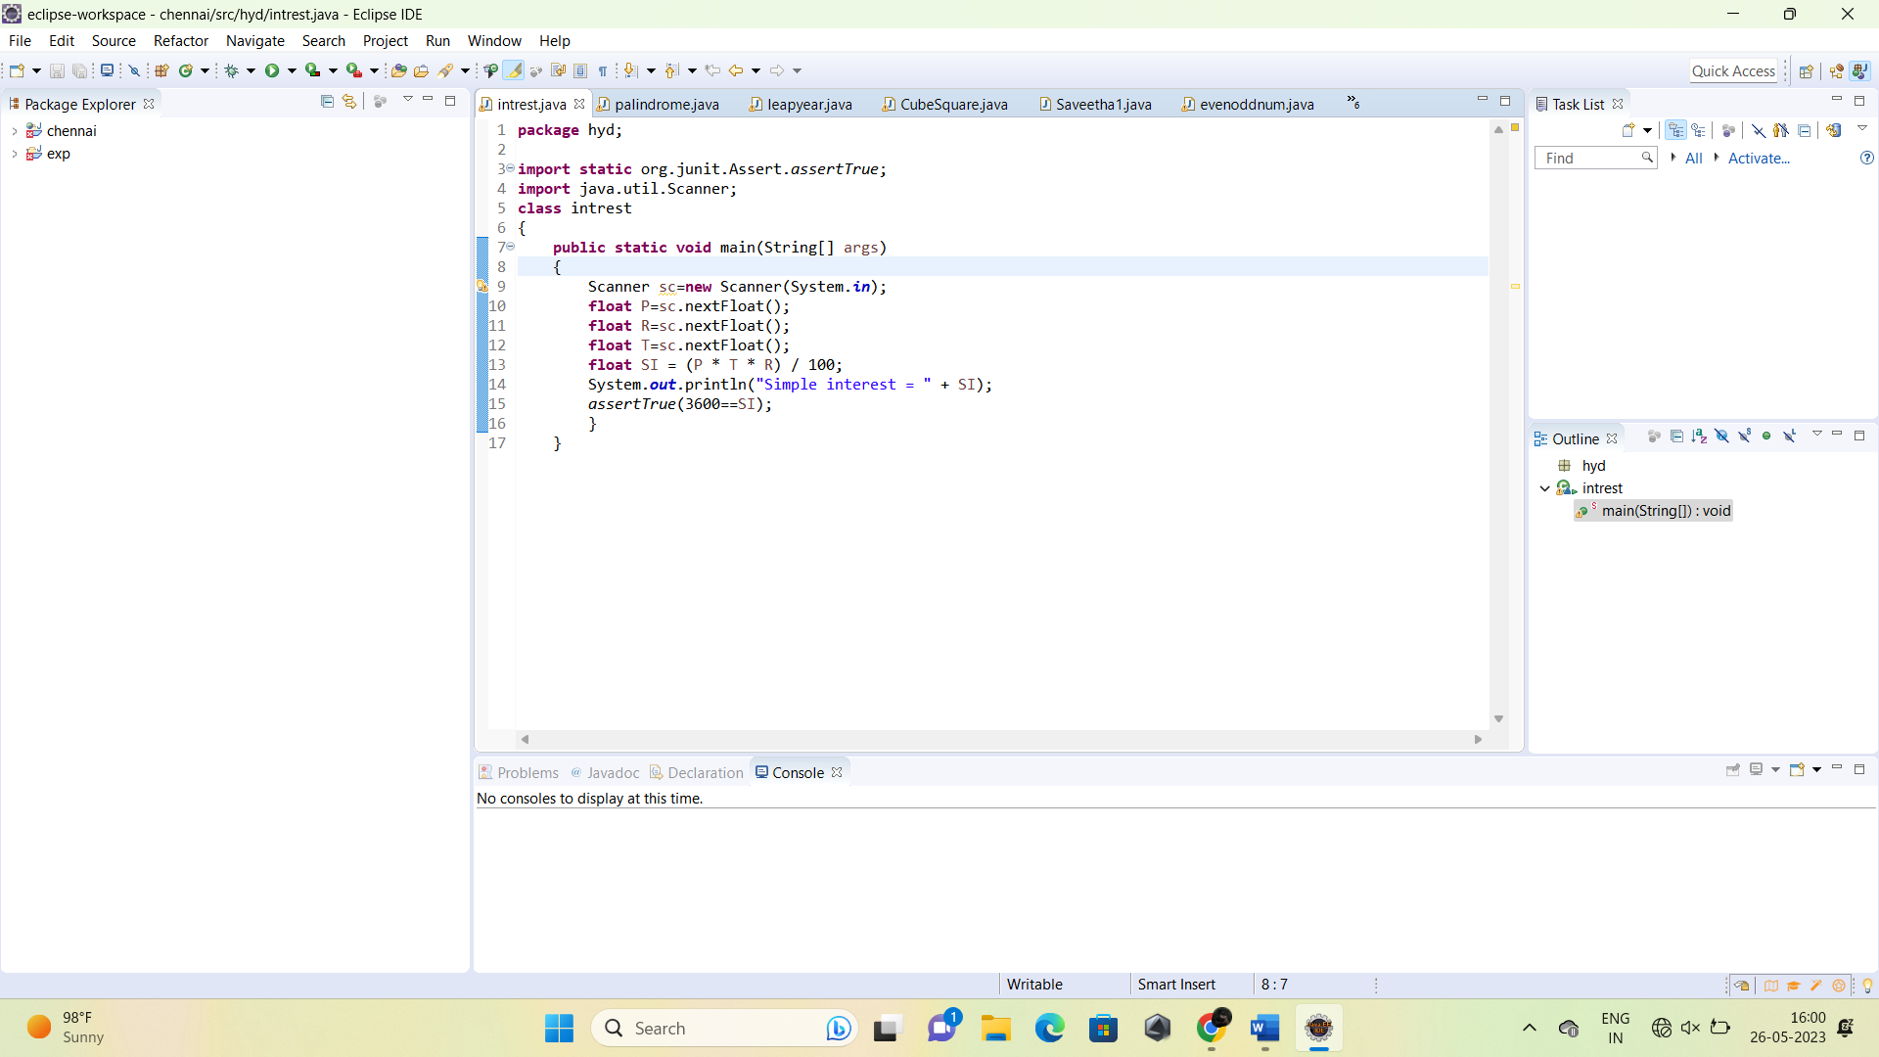

EXPERIMENT no 23

