

Team name: **Batman**

Team members: **Nadya, Vlado, Galin, Niki**

Problem: **Audio&Video Store**

URL: <http://batmanstore.codeplex.com/>

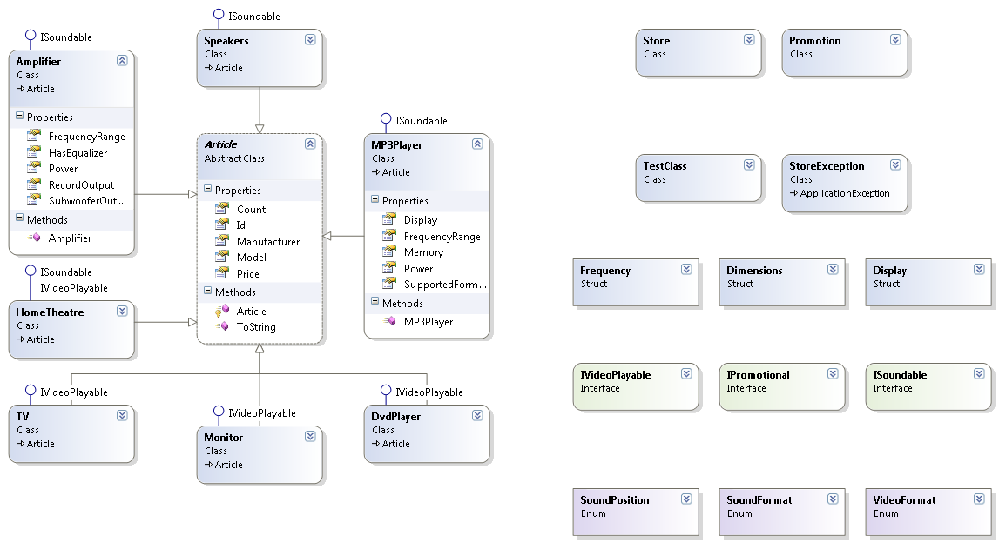

1. **Design pattern:** Singleton – we have only one instance of the store.
2. **Abstract class:** Article – it will be inherited by our articles in the store. It’s mandatory fields are:

* Manufacturer
* Model
* Price
* Count

1. **Interface:** ISounable – used for Audio Articles.

Implements:

* Power – volume
* Frequency

1. **Interface:** IVideoPlayable – used for Video Articles

**Implements:**

* VideoFormats – supported video formats
* Display
* .PlayVideo();

1. **Interface:** IPromotional – used for discounting price

* Discount()

1. **Struct:** Dimensions – used for the Display dimensions. Implements Display’s:

* Height
* Width
* Depth

1. **Struct:** Frequency – used for the range of audio frequency

* Lower boundary
* Higher boundary

1. **Struct:** Display – used for the display specifications

* Colors
* Size

1. **Exception:** StoreException – throwing user-friendly exceptions

* **("The article is out of stock");**
* **("Batman store is bankrupt!");**

1. **AudioClasses:** MP3Player, Speakers, Amplifier

* **Inherits :** Article
* **Implement :** ISoudnable

1. **VideoClasses:** DvdPlayer, Monitor, TV

* **Inherits:** Article
* **Implement:** ISoundable

1. **Class Promotion -** every article can be in Promotion for several days with discount. Implements:

* StartDate of Promotion
* EndDate of Promotion
* PromotedArticle
* Discounted Price

1. **Enumerations: SoundFormat., VideoFormat**
2. **Store Functionalities:**

* **Load(Article article) –** loads an instance of article to the store. when we add a totally new article for the store/manufacturer AND model/ this event triggers a method and add it to **List<Promotions>**
* **Sell(Article article) –** sells an article from the store. Decreasing it’s quantity. If quantity is 0 – **throw new StoreException();**
* **GetQuantity(Article article) –** returns the quantity of given article.
* **.ShowAllPromotions(); -** printing all promotions;