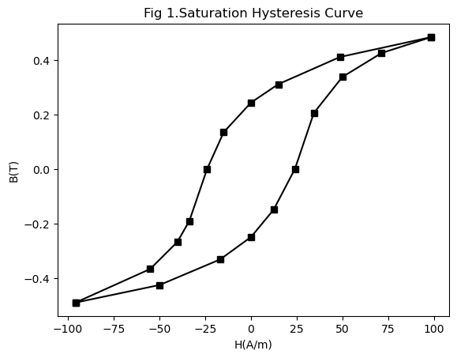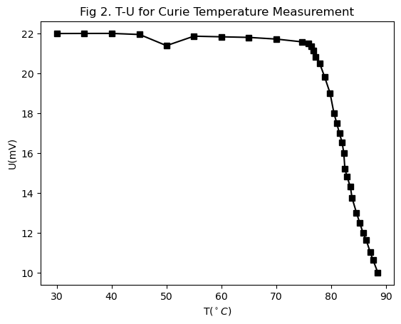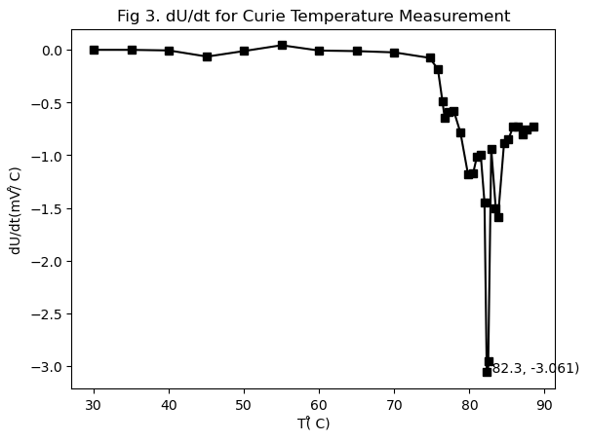

Table 1. 测量饱和磁滞回线

|  |  |  |  |
| --- | --- | --- | --- |
| **UR1(mV)** | **UC(mV)** | **B(T)** | **H(A/m)** |
| 0 | 32.75 | 134.9242 | 0 |
| -319.6 | 0 | 0 | -95813.7 |
| 162 | -64.79 | -266.923 | 48566.39 |
| 166.3 | 99.68 | 410.664 | 49855.5 |
| 328.3 | -60.52 | -249.332 | 98421.89 |
| -183.6 | -89 | -366.664 | -55041.9 |
| -56.16 | 103.2 | 425.1658 | -16836.3 |
| 41.04 | -118.9 | -489.847 | 12303.49 |
| 237.6 | 75.47 | 310.9231 | 71230.71 |
| -49.68 | -80.46 | -331.481 | -14893.7 |
| -112.3 | 49.84 | 205.332 | -33666.7 |
| 49.68 | -46.28 | -190.665 | 14893.69 |
| -79.92 | 81.88 | 337.3312 | -23959.4 |
| 114.4 | 117.4 | 483.6673 | 34296.27 |
| 79.92 | -103.2 | -425.166 | 23959.42 |
| -166.3 | 59.1 | 243.4816 | -49855.5 |
| -133.9 | -36.31 | -149.591 | -40142.2 |

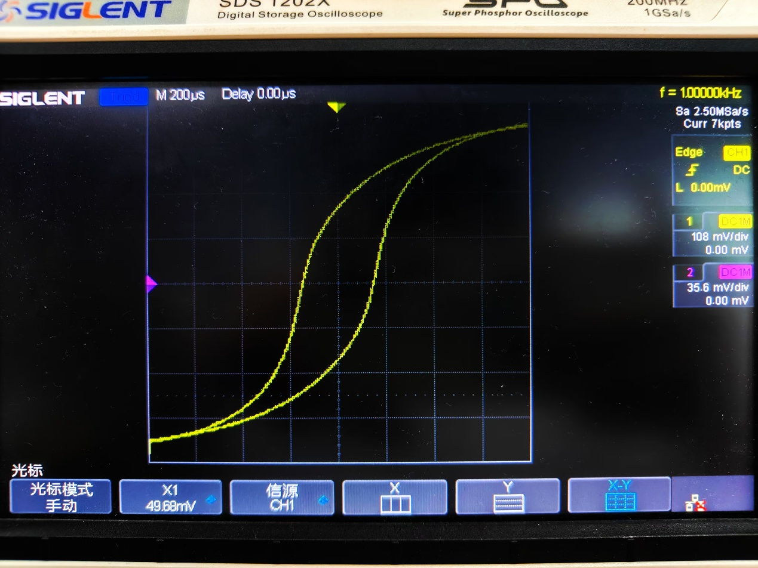

Table 2. 测量居里温度

|  |  |  |
| --- | --- | --- |
| **T(̊ C)** | **U(mV)** | **dU/dt(mV/̊ C)** |
| 30 | 22.005 | 0.0006 |
| 35 | 22.008 | 0.0005 |
| 40 | 22.01 | -0.00504 |
| 45.1 | 21.956 | -0.06337 |
| 50 | 21.397 | -0.0107 |
| 55 | 21.871 | 0.0443 |
| 60 | 21.84 | -0.0061 |
| 65 | 21.81 | -0.0114 |
| 70 | 21.726 | -0.02349 |
| 74.7 | 21.586 | -0.07563 |
| 75.8 | 21.491 | -0.18254 |
| 76.4 | 21.35 | -0.485 |
| 76.7 | 21.167 | -0.64375 |
| 77.2 | 20.817 | -0.59226 |
| 77.9 | 20.508 | -0.57594 |
| 78.8 | 19.834 | -0.78494 |
| 79.8 | 19.009 | -1.17836 |
| 80.5 | 18.011 | -1.16688 |
| 81 | 17.52 | -1.011 |
| 81.5 | 17 | -0.995 |
| 82 | 16.525 | -1.45 |
| 82.3 | 16 | -3.061 |
| 82.5 | 15.213 | -2.95917 |
| 82.9 | 14.81 | -0.94117 |
| 83.5 | 14.305 | -1.505 |
| 83.8 | 13.754 | -1.58769 |
| 84.6 | 13.015 | -0.88637 |
| 85.2 | 12.5 | -0.84583 |
| 85.8 | 12 | -0.73 |
| 86.4 | 11.624 | -0.72447 |
| 87.1 | 11.037 | -0.7974 |
| 87.6 | 10.653 | -0.75284 |
| 88.5 | 10 | -0.72556 |