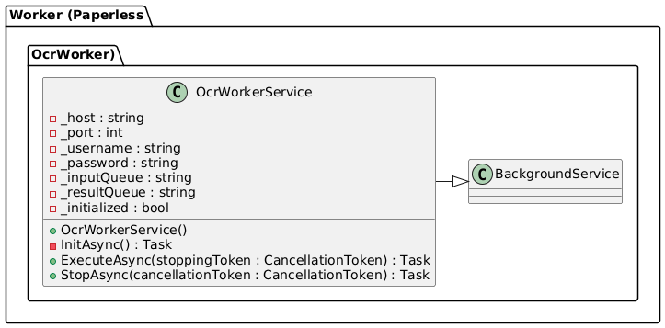
OCR Worker – current design (Sprint 3)
API / Integration Layer (current)
The OCR Worker is implemented as a single hosted service: OcrWorkerService : BackgroundService. It is responsible for integrating with RabbitMQ and simulating OCR processing.
- Reads RabbitMQ connection settings and queue names from environment variables.
- Connects to RabbitMQ and declares the input queue (e.g. paperless.ocr.input) and result queue (e.g. paperless.ocr.results).
- Subscribes to the input queue.
- Deserializes incoming JSON messages to extract DocumentId and DocumentTitle.
- Generates a fake OCR summary string for the document.
- Publishes the result as a JSON message to the result queue.
- Uses log4net for logging and ACK/NACK semantics for reliable processing.
At this stage, all logic (message handling and “OCR simulation”) is implemented inside OcrWorkerService; there is no separate business service class yet.
OCR Worker – planned business layer (future sprints)
Business Layer (planned, not yet implemented)
In later sprints, the OCR Worker will be refactored to separate infrastructure from OCR domain logic:
- A dedicated OcrProcessingService will encapsulate:
  - Retrieving the original document from MinIO (via an IFileStoreClient).
  - Invoking a real OCR engine to extract text.
  - Building a domain model for OCR results (OcrResult, ResultModel).
  - Publishing the result to RabbitMQ or calling the Paperless REST API for persistence.
OcrWorkerService will then focus solely on message consumption and delegation, while OcrProcessingService will implement the actual OCR workflow.

