Use Case for Sprint 6: Users with Authentication and Sessions
Primary Actor: User
Goal: The user can authenticate and maintain an active session to access only their own documents and searches.
Preconditions:
- User account exists (registered or seeded).
- REST API is reachable.
Postconditions (success):
- A valid session exists (session token/cookie issued).
- Subsequent requests are authorized and associated with the user identity.
Main Flow (happy path):
- User opens Web UI.
- User enters username/password.
- Web UI sends POST /api/auth/login.
- REST API validates credentials against the user store (PostgreSQL).
- REST API creates a session record (Session entity) and issues a session token.
- Web UI stores token (cookie or Authorization header).
- User calls protected endpoints (upload, list, search).
- REST API authorizes requests using the session token and determines UserId.
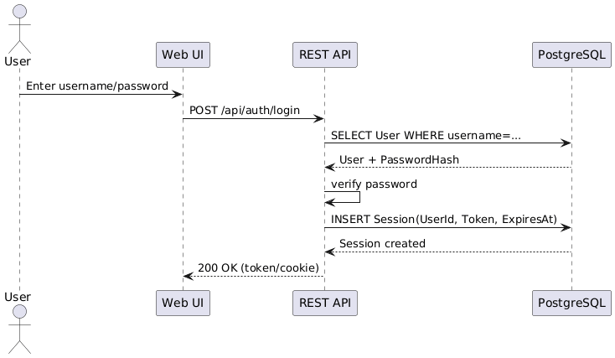
Alternative Flows:
- Invalid credentials: return 401, no session created.
- Session expired: return 401; user must login again.
- Logout: POST /api/auth/logout invalidates session.
Security / Constraints:
- Session token is random and unguessable.
- Session has expiration (ExpiresAt).
- All document operations enforce “user owns document”.

2) Domain Model Documentation (Users + Sessions)
New Entities
User
- Id : Guid
- Username : string (unique)
- PasswordHash : string
- CreatedAt : DateTimeOffset
Session
- Id : Guid
- UserId : Guid (FK)
- Token : string
- CreatedAt : DateTimeOffset
- ExpiresAt : DateTimeOffset

