Create an ec2-instance
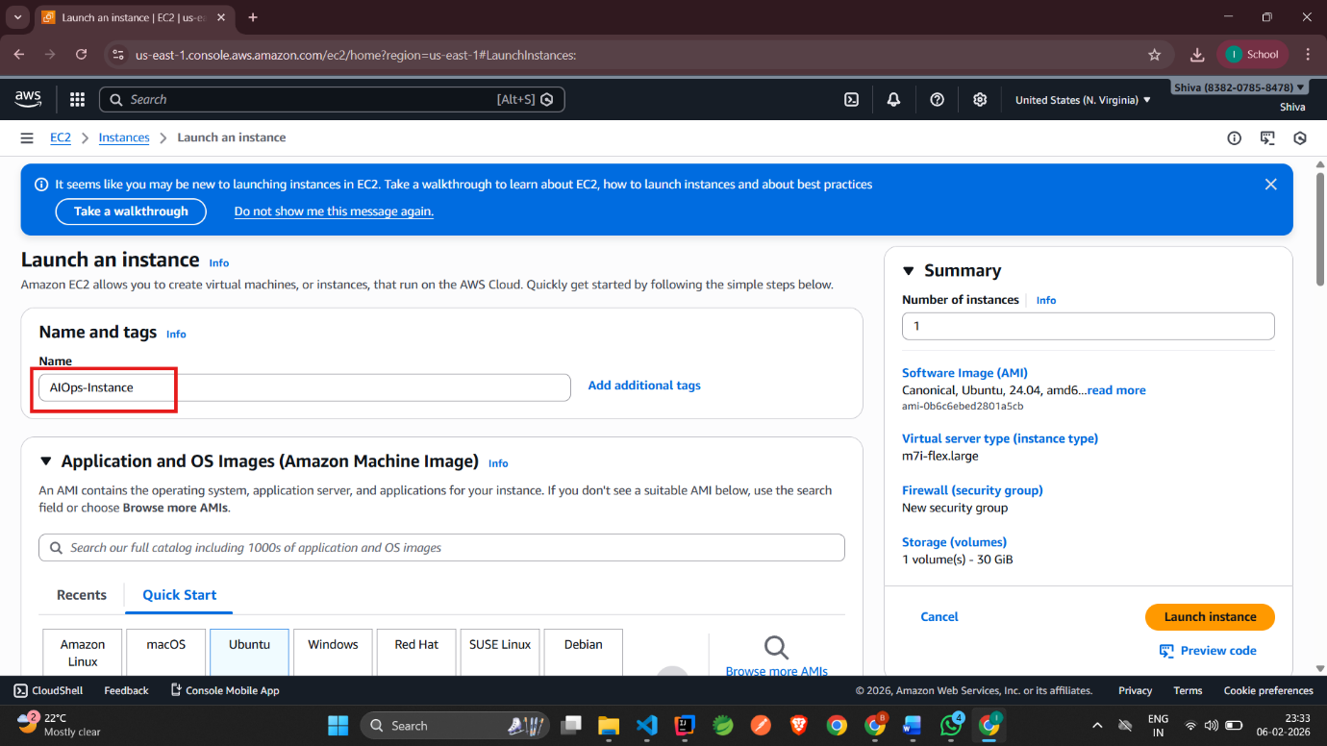

Select OS
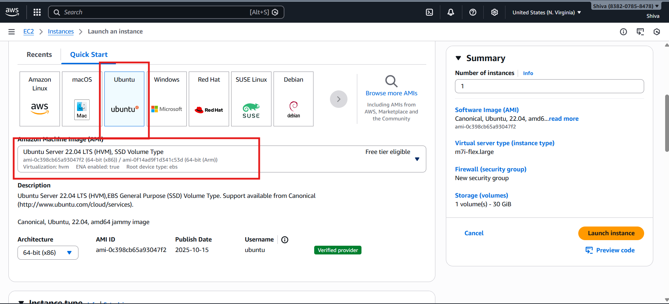

Select instance type ( at least t3 medium ) and create a key pair and select
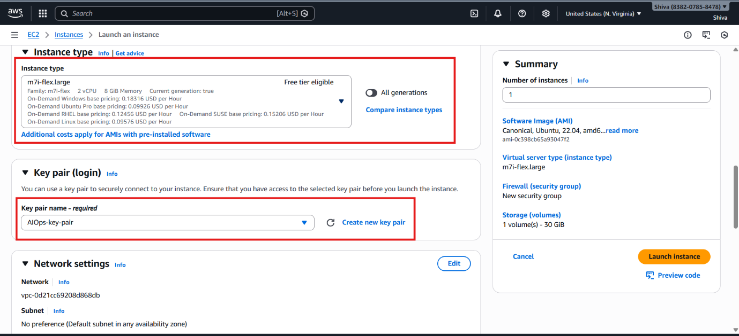

Select storage(30-40 GiB) because Prometheus, logs need storage and launch instance
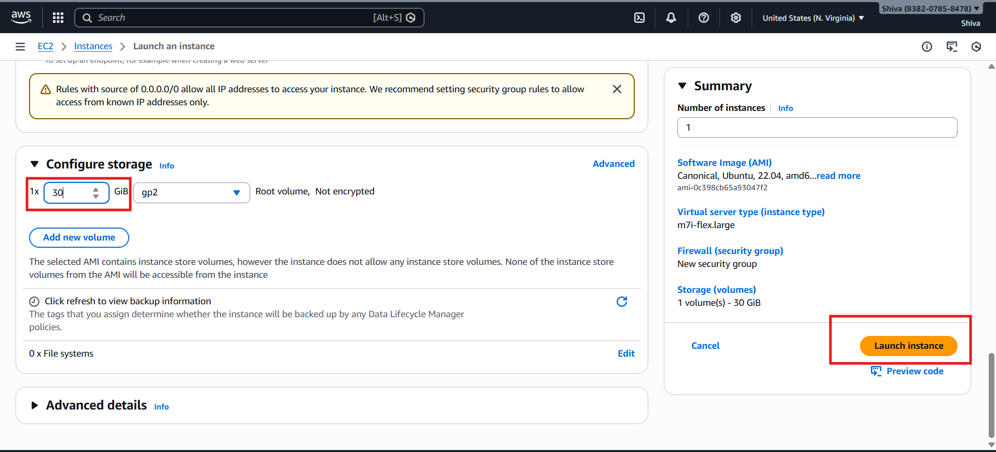

We can see Instance is running then select the instance and click on connect or use mobaXterm to connect and interact with instance.
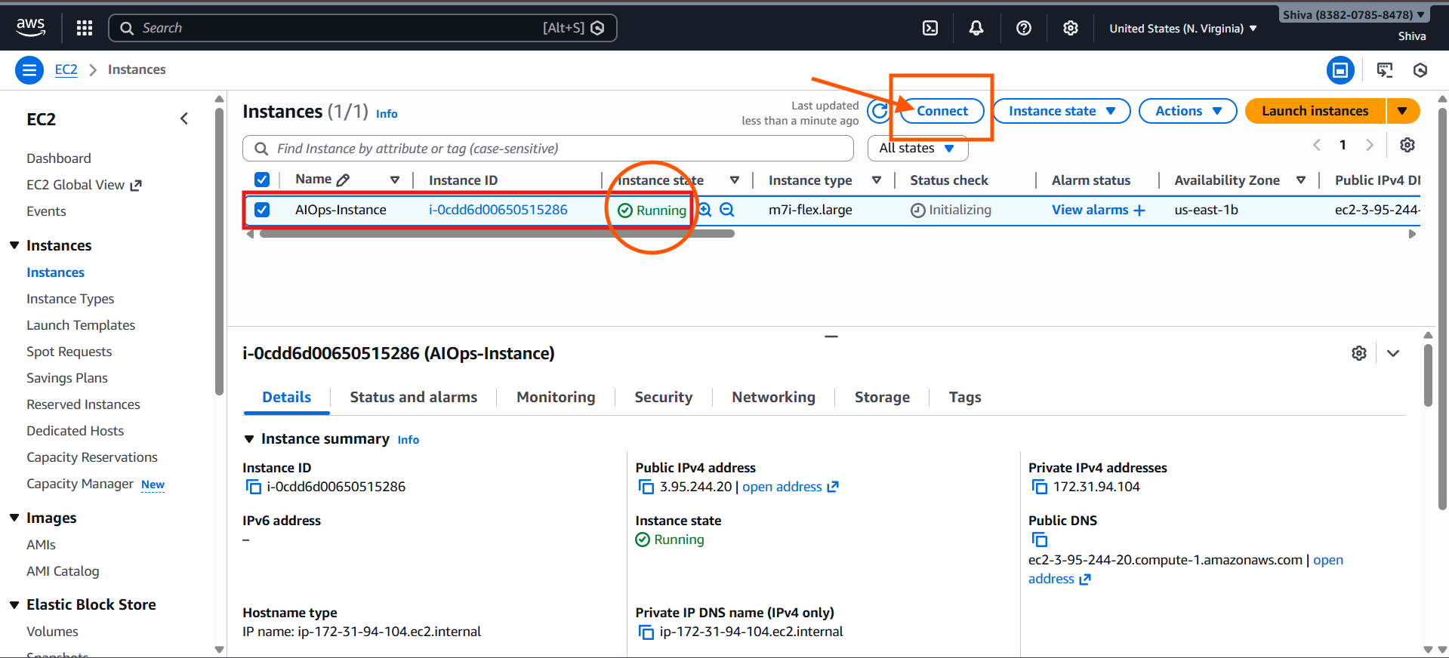
After clicking on connect click on connect again
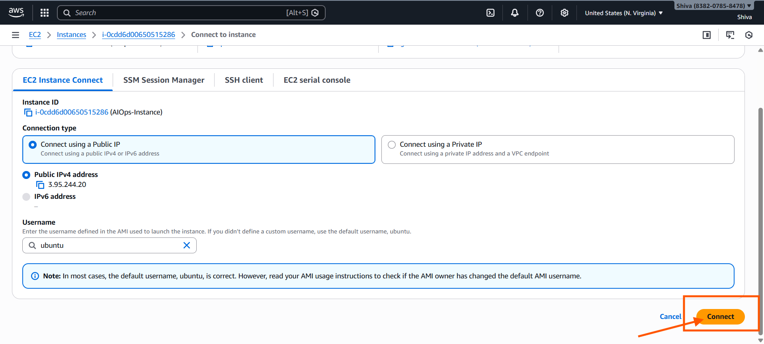
We can see the console
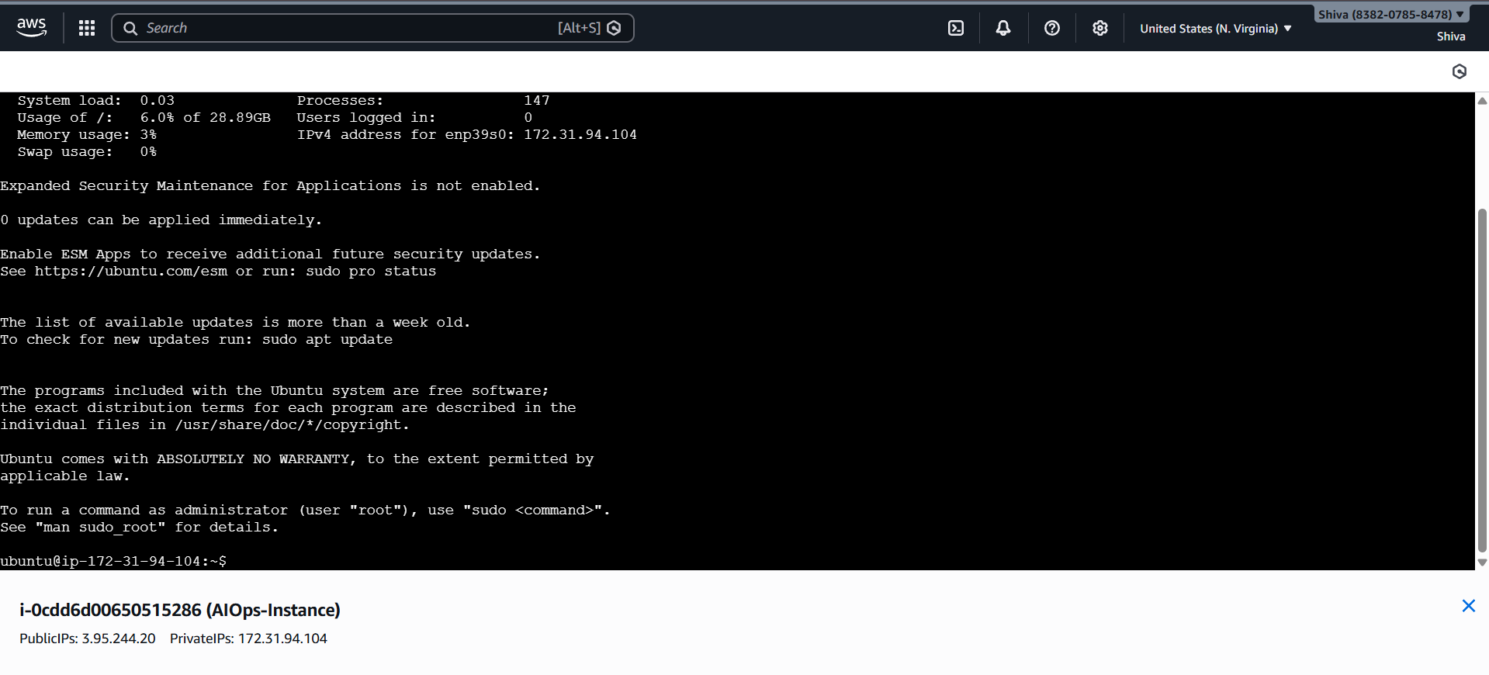
Run below commands ( To update and install below softwares )
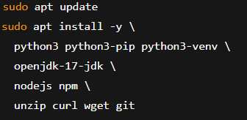
Check whether they are installed sussessfully:
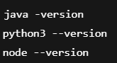
We need to create a folder structure like below:
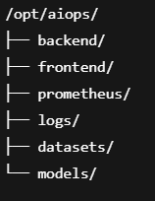
Simply run below to commands to create above structure and give ownership:
Clone your spring boot app:
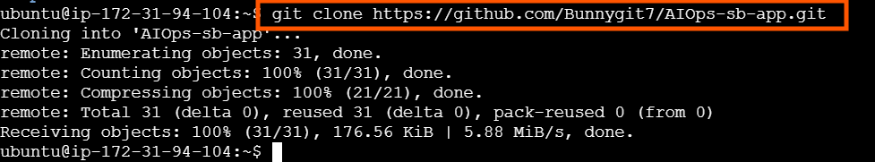
Check whether app is cloned:
Move the cloned spring boot app to a separate folder in /opt/aiops
Edit the logs path in application.yaml in spring boot app:
Press “i” to go to insert mode change path and press “esc “then “:wq!”
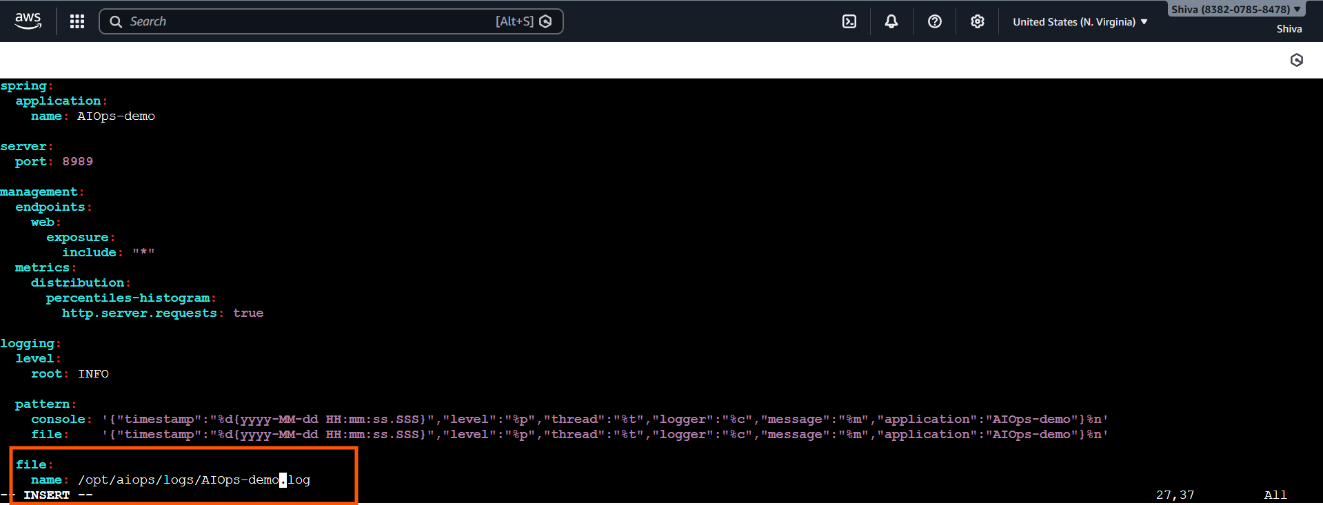
Install maven: (build tool)
Check maven is installed :
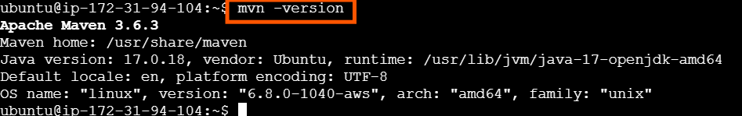
Now using maven build the spring app:
Then check the target folder is created in that jar is created

To run the jar:
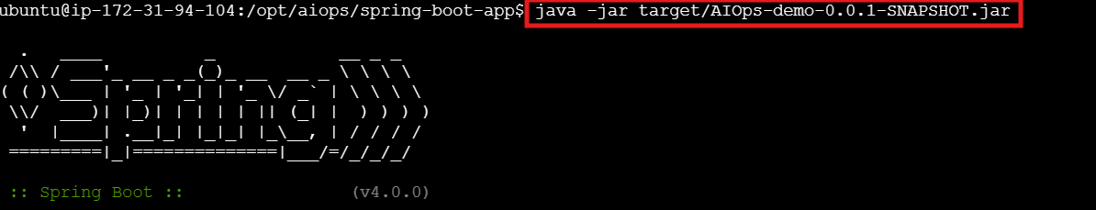
Now edit inbound rules for this instance:
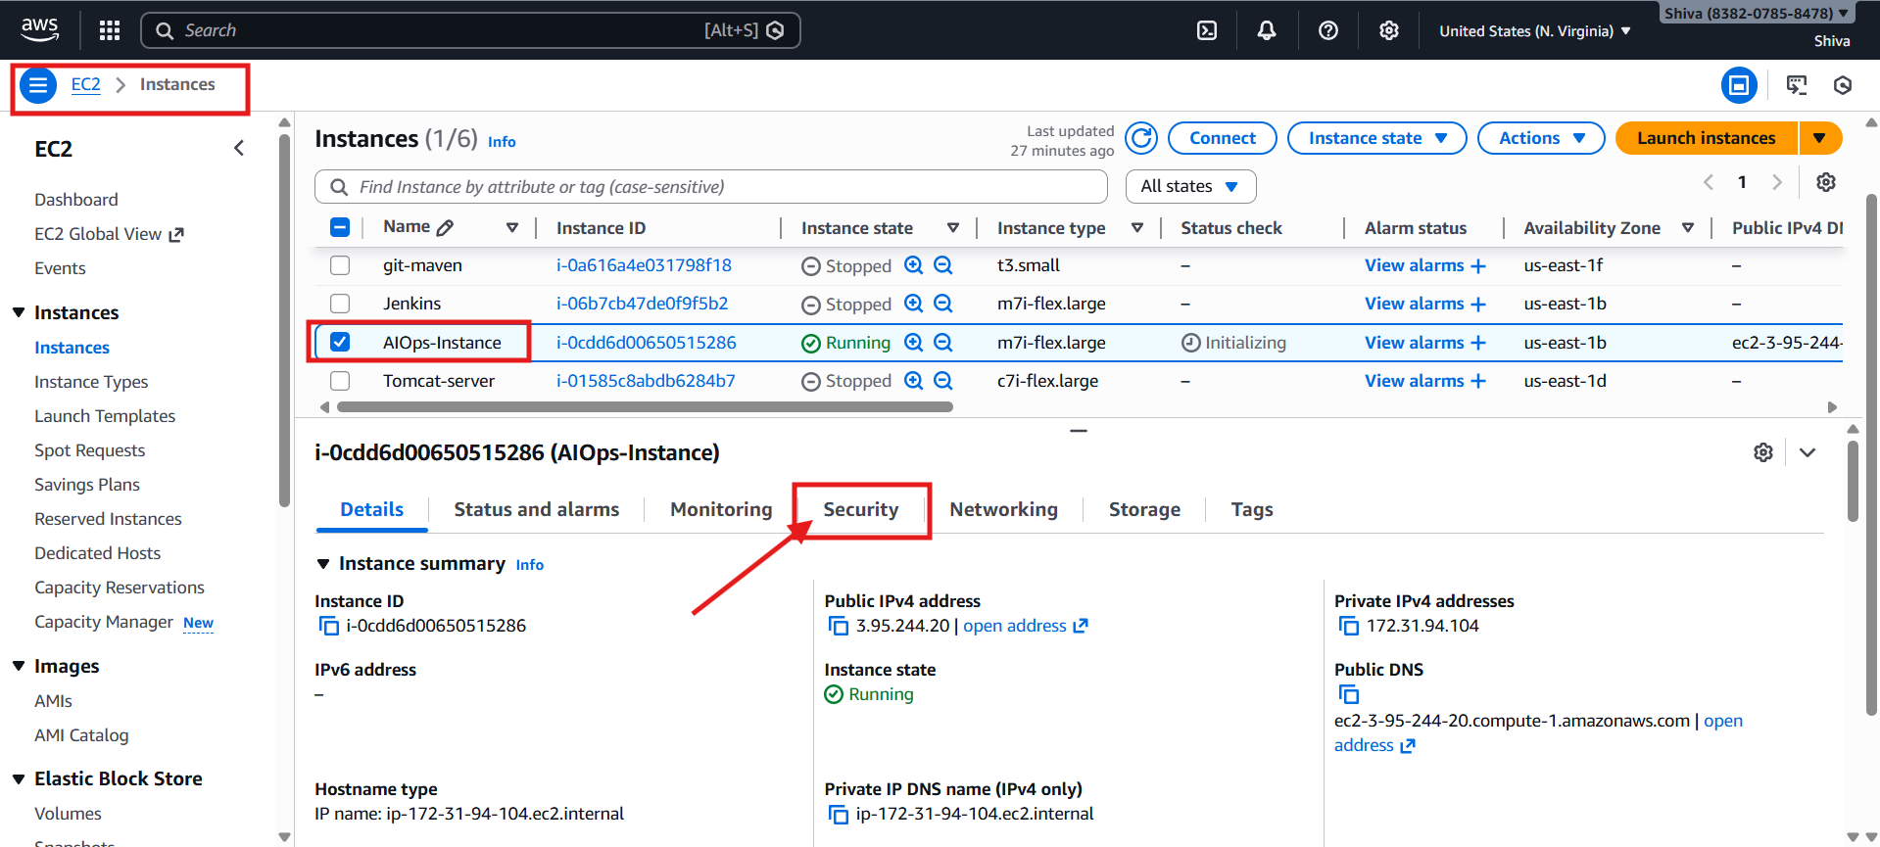
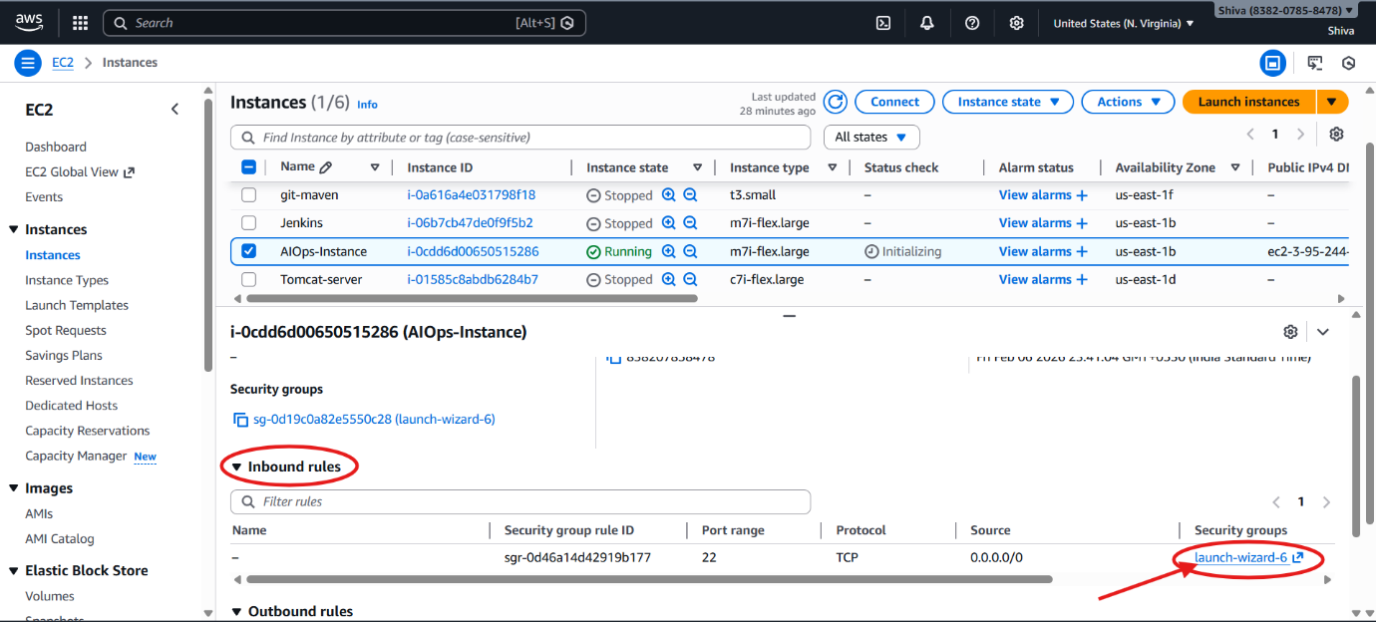
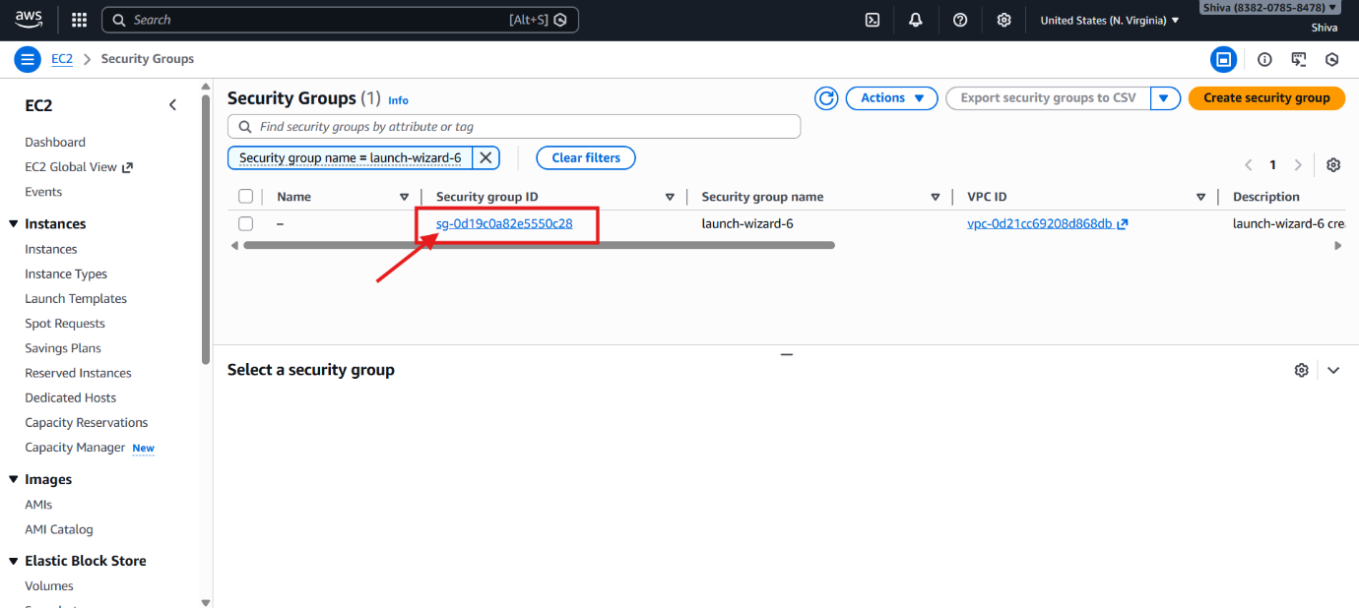
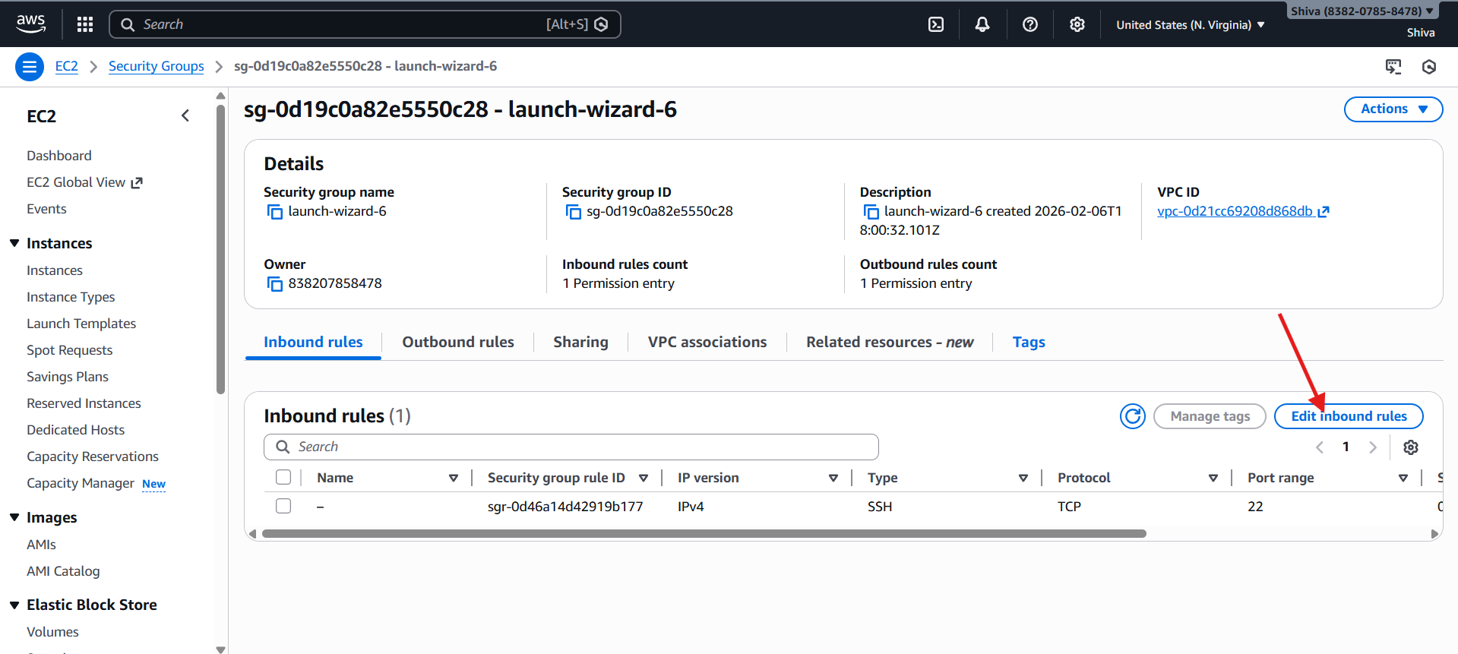
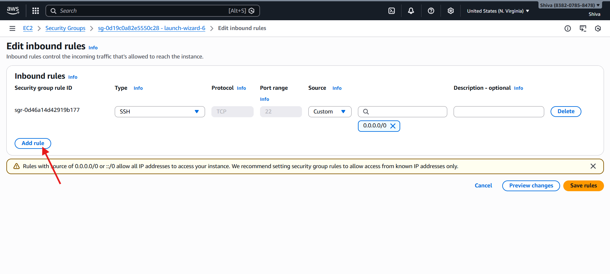
Now add below listed rules and click on save rules: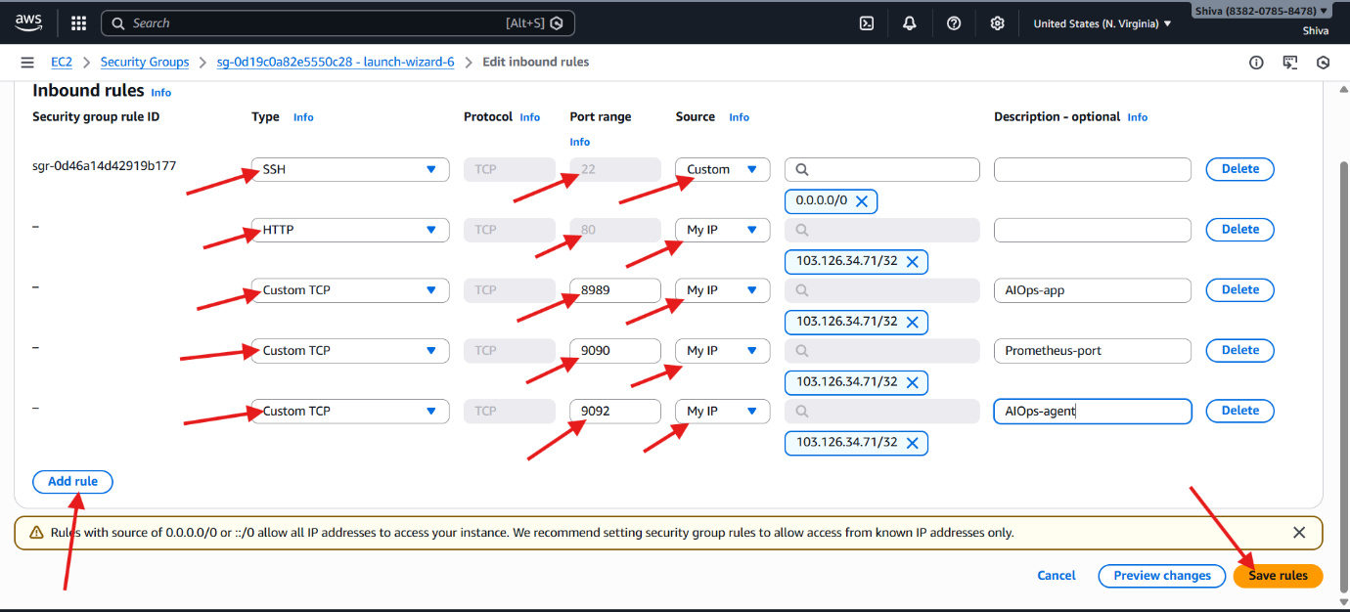

Now check whether the spring boot app is accessible: http://<EC2-publicIP>:port/api
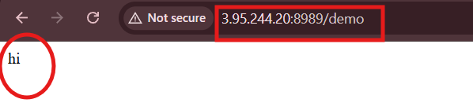
Install Prometheus: run below commands one by one
cd /opt/aiops/prometheus
wget https://github.com/prometheus/prometheus/releases/download/v2.49.1/prometheus-2.49.1.linux-amd64.tar.gz
tar -xvf prometheus-*.tar.gz
Edit Prometheus.yml as mentioned in below pictures
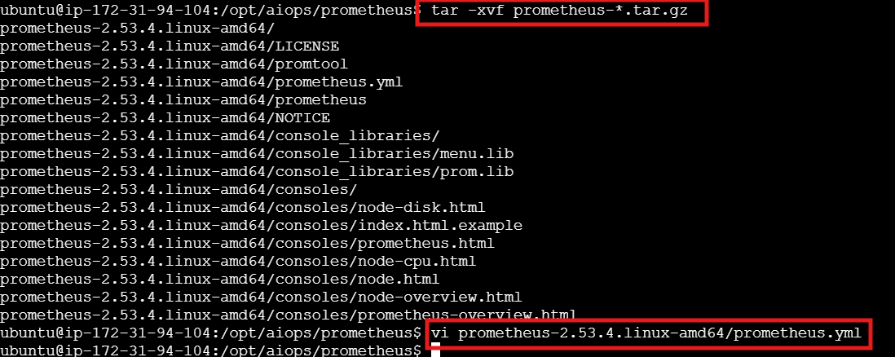
It can be localhost since all are running in same instance
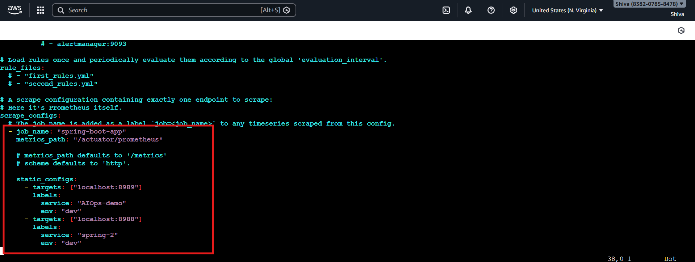
Go to Prometheus folder and run using congif file :
cd prometheus-*
./prometheus --config.file=prometheus.yml

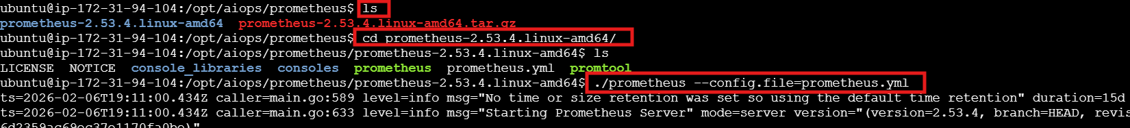

Check and execute any promQL : http://<ec2-ip>:9090
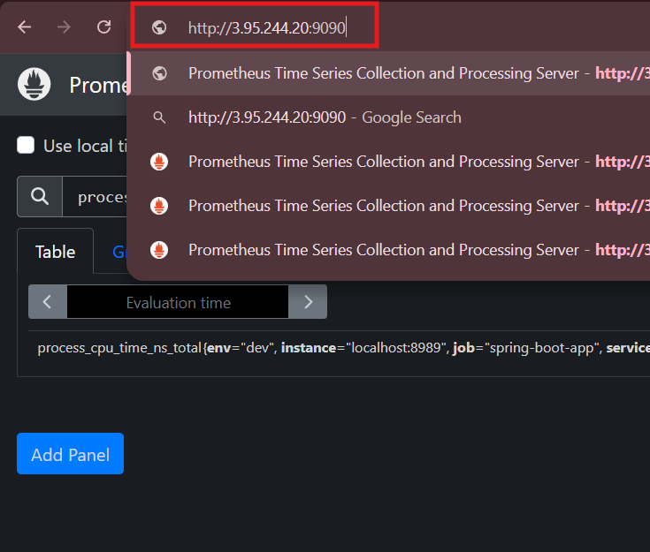

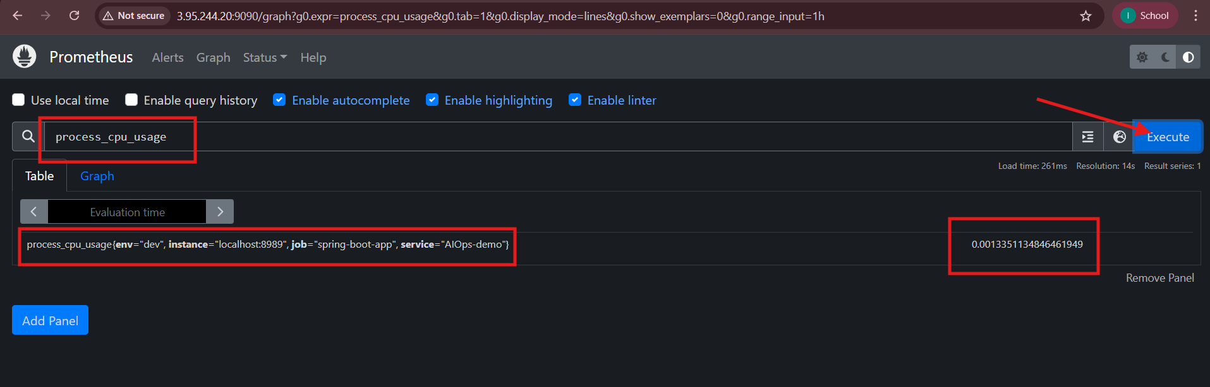
Clone backend app (python agents) and change below highlighted paths in app2.py
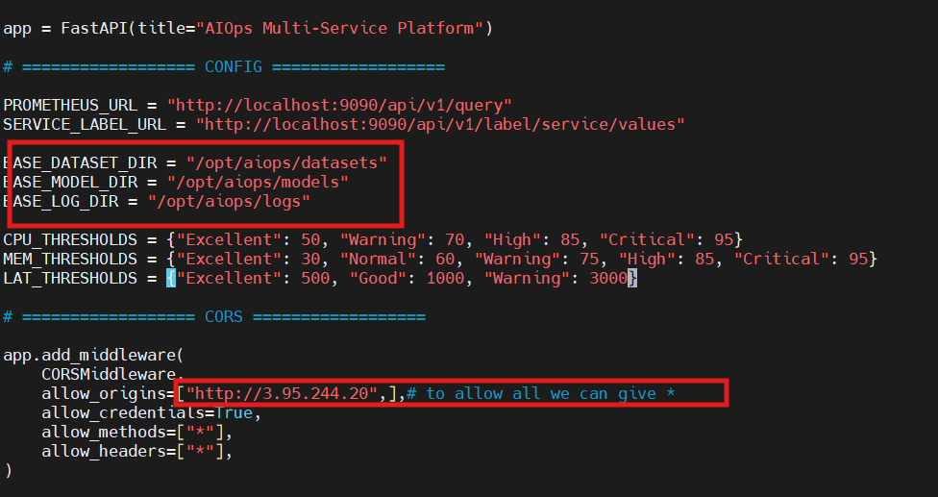
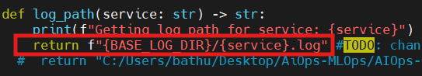
Create virtual environment in backend folder and activate it:
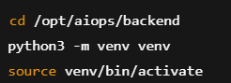
Install below libraries:
check
Run AIOps agent:
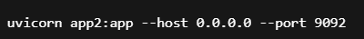
Clone frontend and move it to frontend folder and change like below:
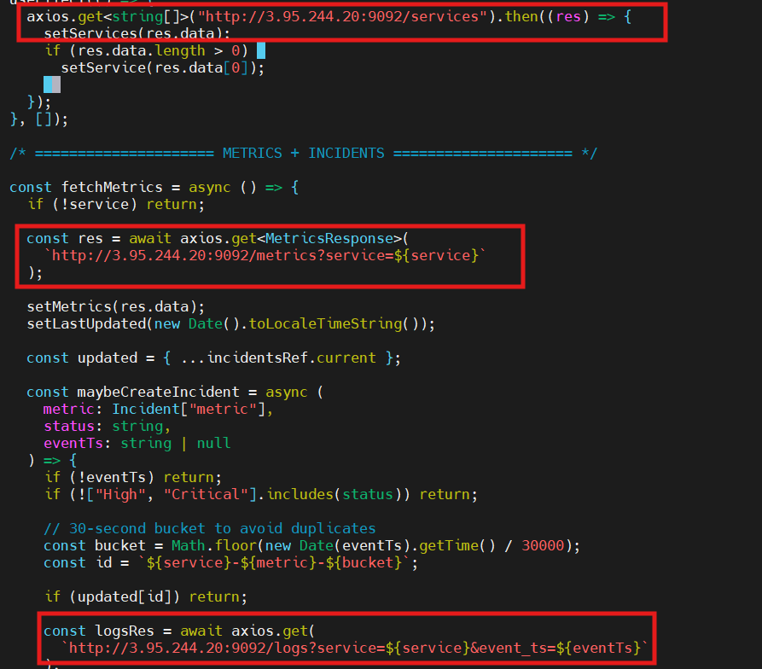
Go to frontend app folder and run below commands
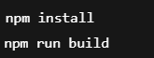
Check whether node version is above 18 (node -v) so that we don’t get any build errors
Install nginx and copy the dist folder files to /var/www/html (simply run below commands one by one)
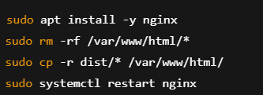
Now try to access the frontend using: http://<ec2-publicIP>
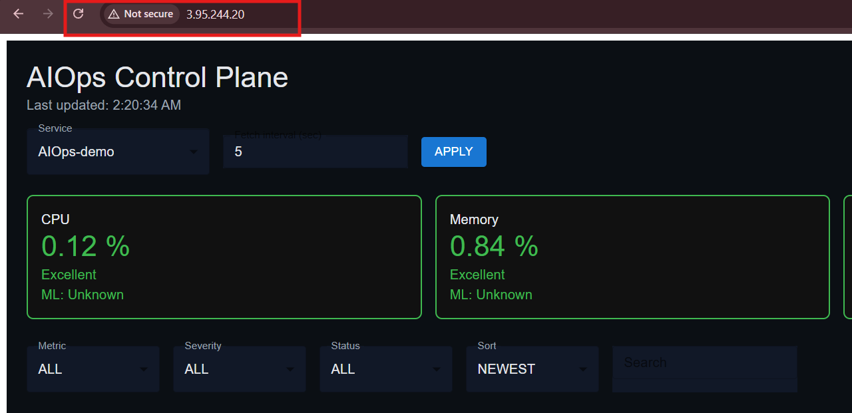

Note: Every time you restart or stop and start the instance again, we need to change the ec2-publicIP because it changes on every restart. To overcome this, we can attach an elastic IP to instance so that it will be fixed and doesn’t change (but billable).

