# COMP3000 Computing Project

## 2021/2022

### Project Title

CryptoShare

### Links

Source code: <https://www.github.com/Xtrendence/CryptoShare>

### Project Vision

After searching the Google Play Store and Apple App Store, it became clear that apps that offer the ability to manage your finances, track your income, and help you budget don't take into account your investments, and if they do, they simply ask you for your profits and losses, and use that to calculate how much money you have. By doing it this way, a lot of potential automation is left on the table, and the user has to manually update this information, and keep track of their investments. The apps that track their investments are usually separate from the income and budgeting apps, and are also usually either for tracking cryptocurrencies or stocks rather than both. My solution is an app called CryptoShare, where investors can track their cryptos and stock shares they hold, and include both of these when it comes to income management and budgeting. The app would offer them a way to track the value of their assets, view market data, and record transactions. Aside from this, they can set up recurring events that provide them with income, such as cryptocurrency mining and staking, or stock dividends paid out to them for holding certain assets. In addition, the API and all user data is self-hosted, and the app would be completely open-source. Existing solutions are often proprietary, and users have no way to verify their data is actually safe, and considering the confidentiality of financial data, it’s important users can retain control of their data. By collating all this information, the main functionality of the app can be used, which is a chat bot with Natural Language Processing capabilities that is able to help the user manage their finances. It can record transactions, provide price updates and alerts, or simply tell the user if they can afford to buy a pizza for the weekend while taking their income, spending habits, and overall net worth into account. The goal is to outsource financial stress to an AI.

### Risk Plan

While there’s no identifiable risks when it comes to delivering a minimum viable product, a few can be considered when it comes to the more advanced features of the software and app. Despite already being proficient at using most of the libraries, frameworks and languages in the project’s tech stack, there are some that I’ve never used before, namely GraphQL, SQLite, “node-nlp”, and NeutralinoJS.

As a result, there’s a chance there might be issues with the use of such technologies including bugs or other unwanted behavior. Furthermore, the AI functionality of the app involves some techniques I’m unfamiliar with at the time of writing this. To combat these risks, precautions will be taken to ensure the product is fully functional and meets as many requirements as possible, such as having fallback approaches I’m already familiar with in case I fail to implement the more convoluted aspects of the project. There’d be an extensive research and planning period at the start of the project as well to ensure the project has a clear and defined roadmap from the very beginning, and that there aren’t any sudden surprises later on. One other risk is a personal and medical one; I’ve been experiencing some pain in my right arm’s nerve, and have been unable to code for longer amounts of time. I’ve already considered this when designing the Gantt chart though, and do not expect it to be a major problem.

### Proposed Gantt chart

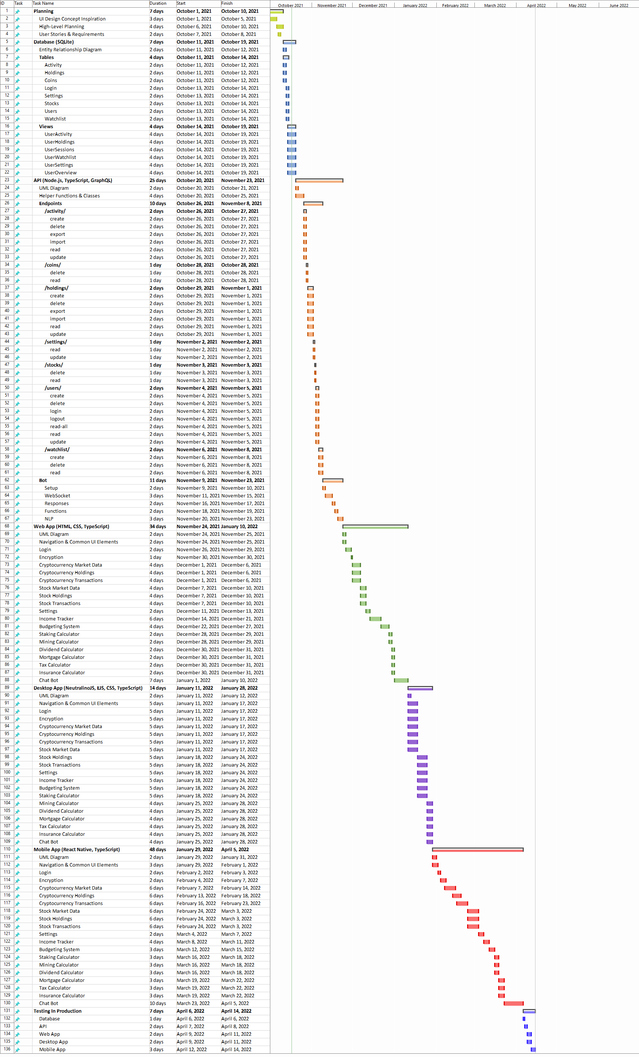

High Quality Version <https://github.com/Xtrendence/CryptoShare/blob/main/docs/GanttChart/GanttChart.gif>

### Keywords

Cryptocurrency, Stocks, Investments, Income, Finance, Financial App, Budgeting, NLP, AI, Chat Bot, React Native, SQLite, HTML, CSS, JS, JavaScript, TypeScript, Khodadad, Nouchin, Xtrendence, Adrian, Encryption, CryptoShare, Money, GraphQL, NeutralinoJS.