BLAST output to file
Acceptance test
Run a BLAST tool and save the output of the best matches to your sequence.
Acceptance criteria
File with BLASTP output is created and saved in a folder specified by the user.
User is on main screen and presses one of the BLAST buttons
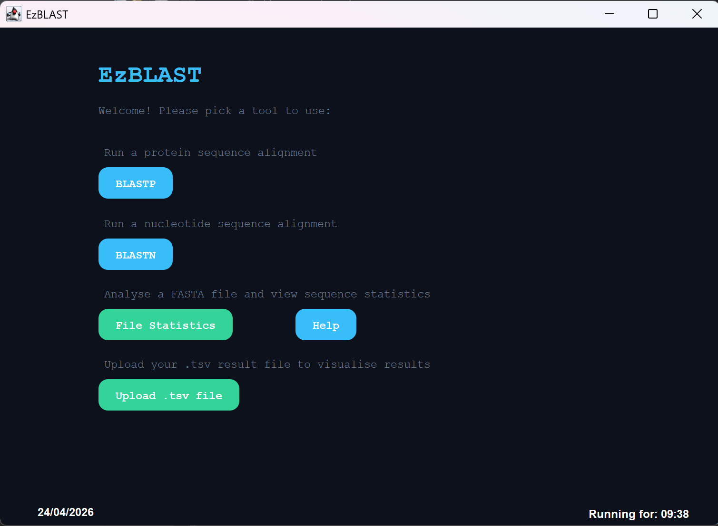
User is on the BLASTP screen
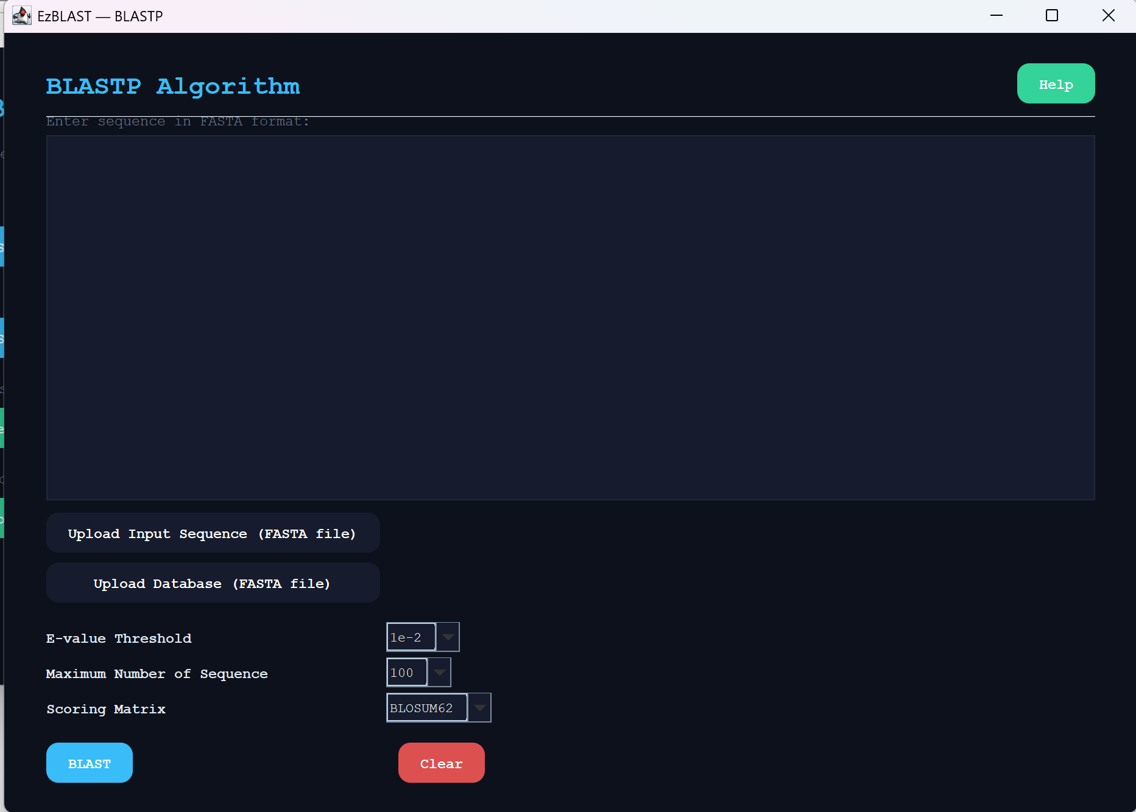
Indicate the files and database
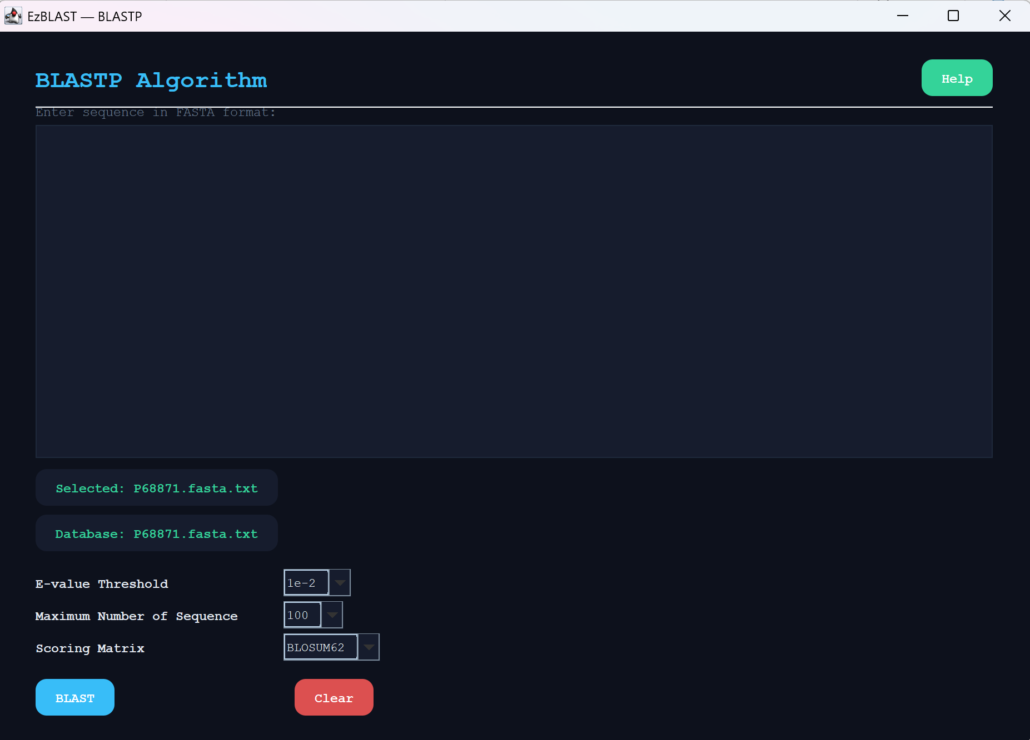
An output is created
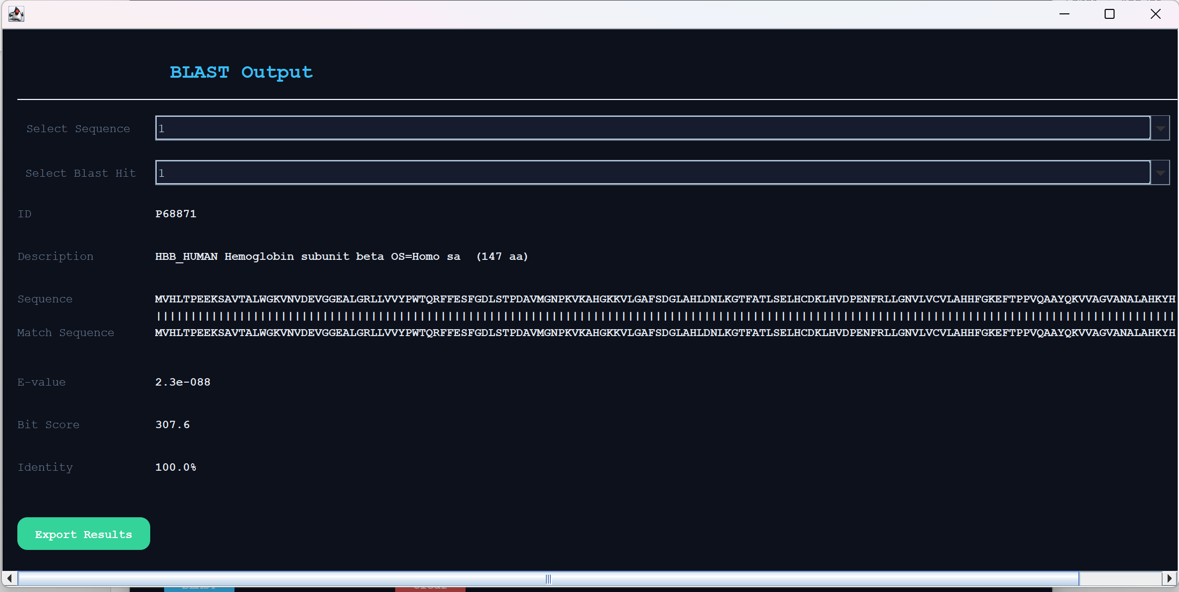
The user saves their file with an automatic file name suggestion
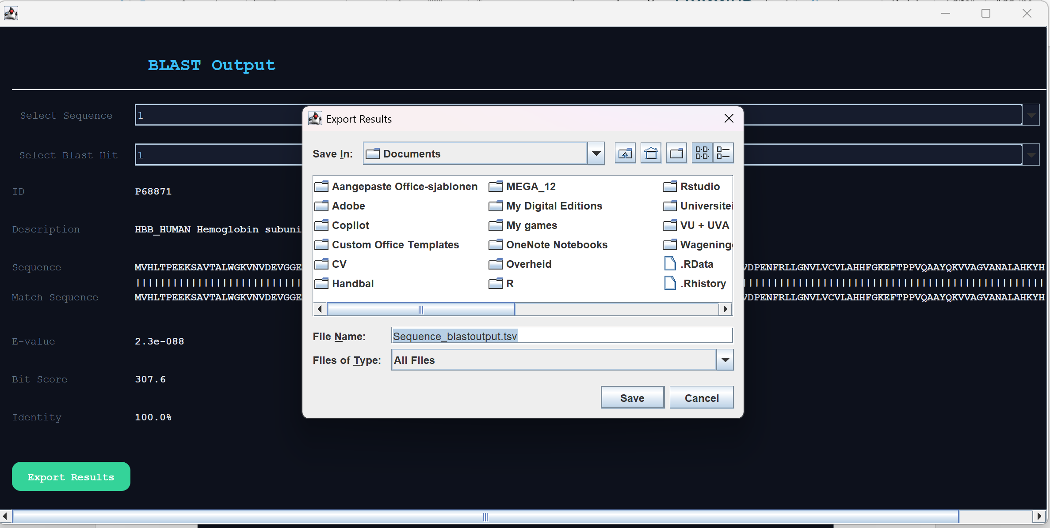
And the file exists
