Acceptance test for user story:
- Current date on main screen
Acceptance criteria:
The current date is displayed on the main screen of the application after the programme is started.
Step 1: Open the application
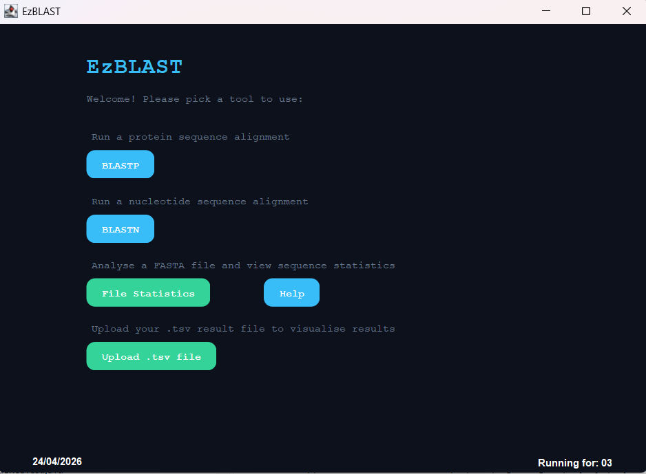
Step 2: The date is shown on the bottom left on the main screen.
Therefore, the acceptance test passed.

