Easy GUI design for sequence analysis

Acceptance test description
The user can roam through the software and try out many options, without creating bug, and can find help along the way at every step during the process.

Acceptance criteria
User can go to any page they click on without creating errors. There is a help option anywhere the user goes. If the user makes a mistake, the program indicates what the mistake is.

User is on the main page and sees all options, including a help button for the ‘File statistics’.
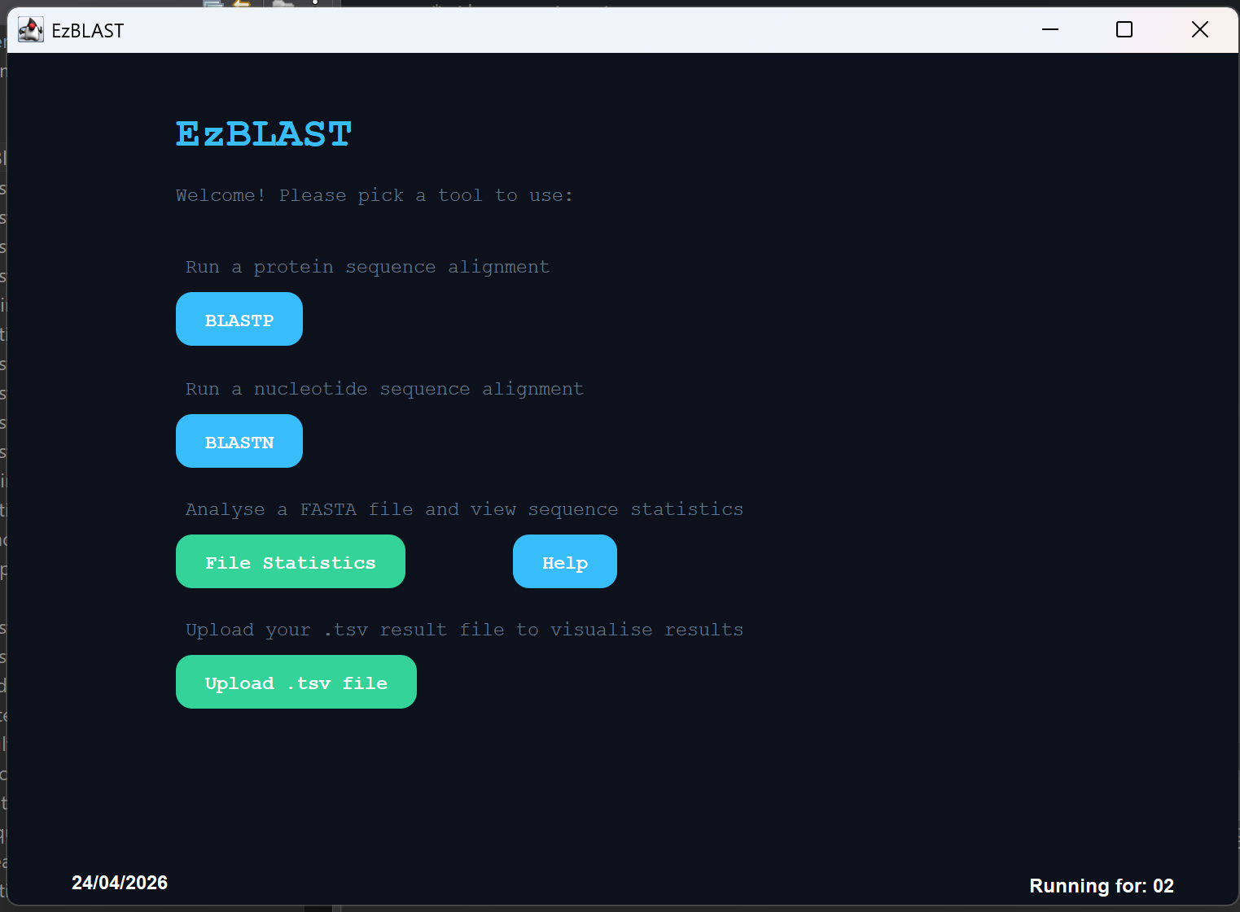

When clicking on BLASTP, the user opens the BLASTP screen and can find help or run their sequence.
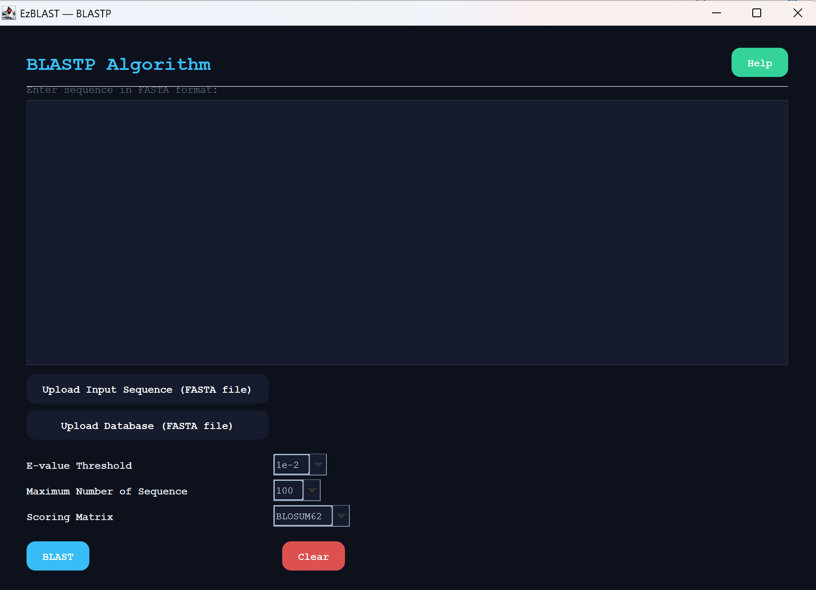

The user choose help
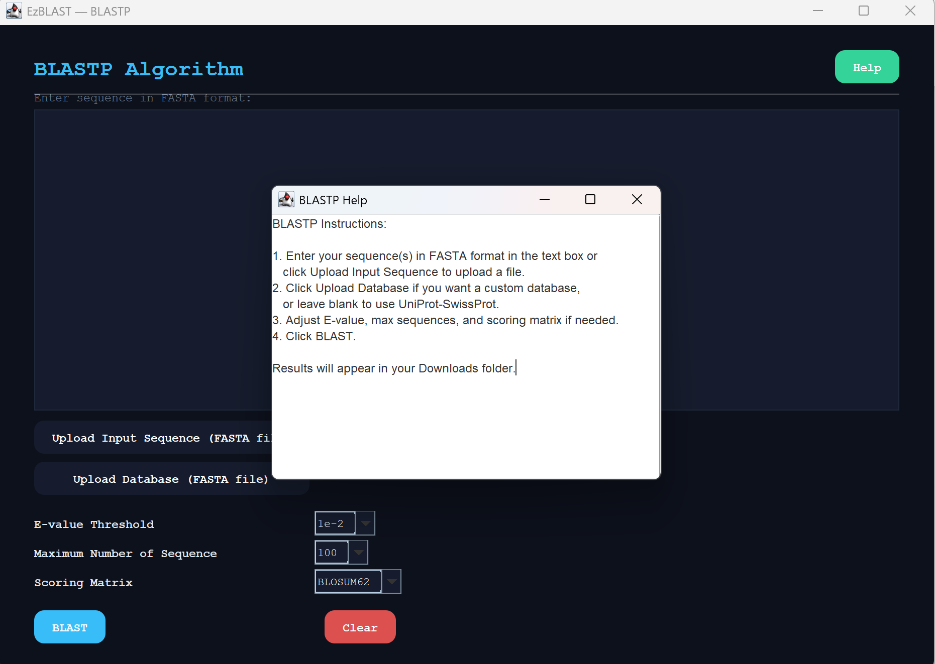

The user has created an output
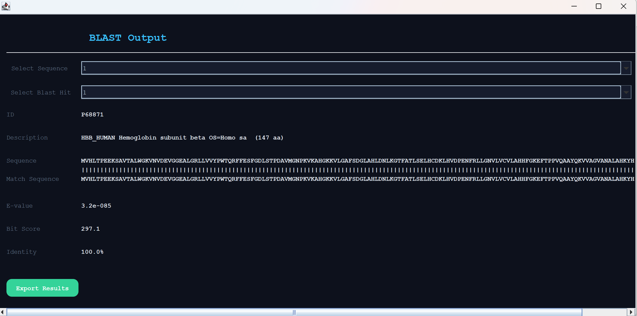

User has saved output
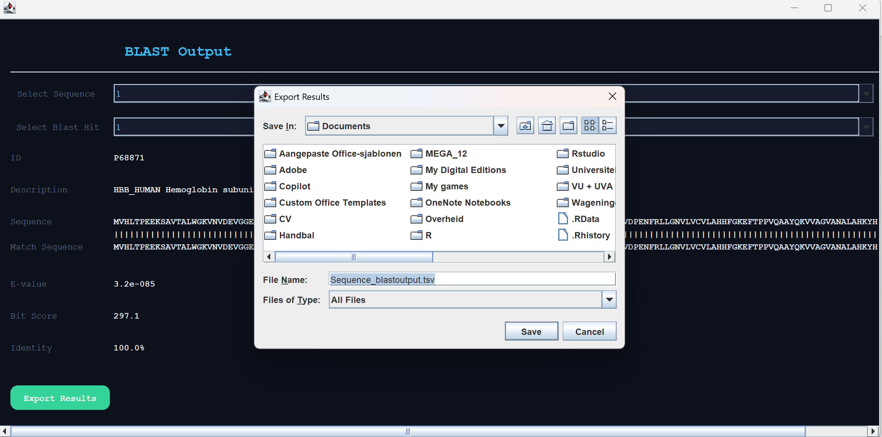

The same is true for the BLASTN button, so we do not share the elaborate explanation here.

User clicks on the File Statistics button or help. Help button first

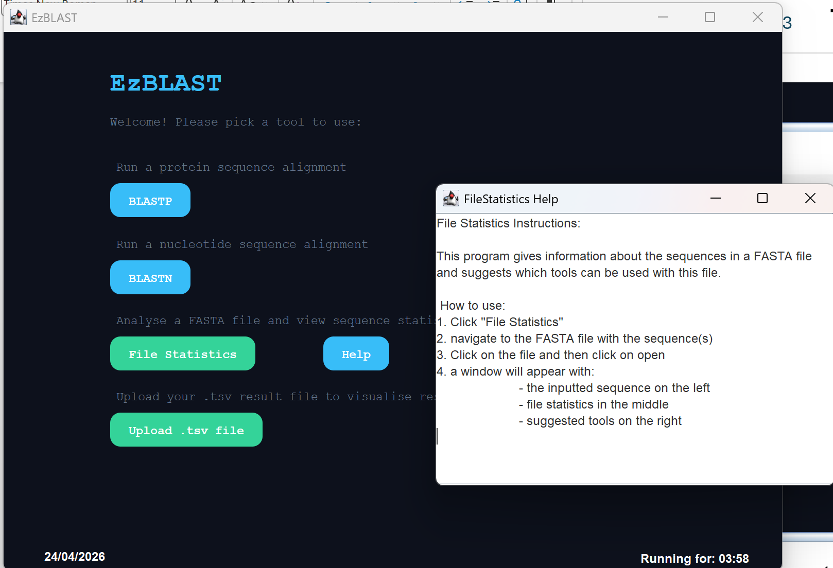

When clicking on the File Statistics button the user is prompted to select a file.
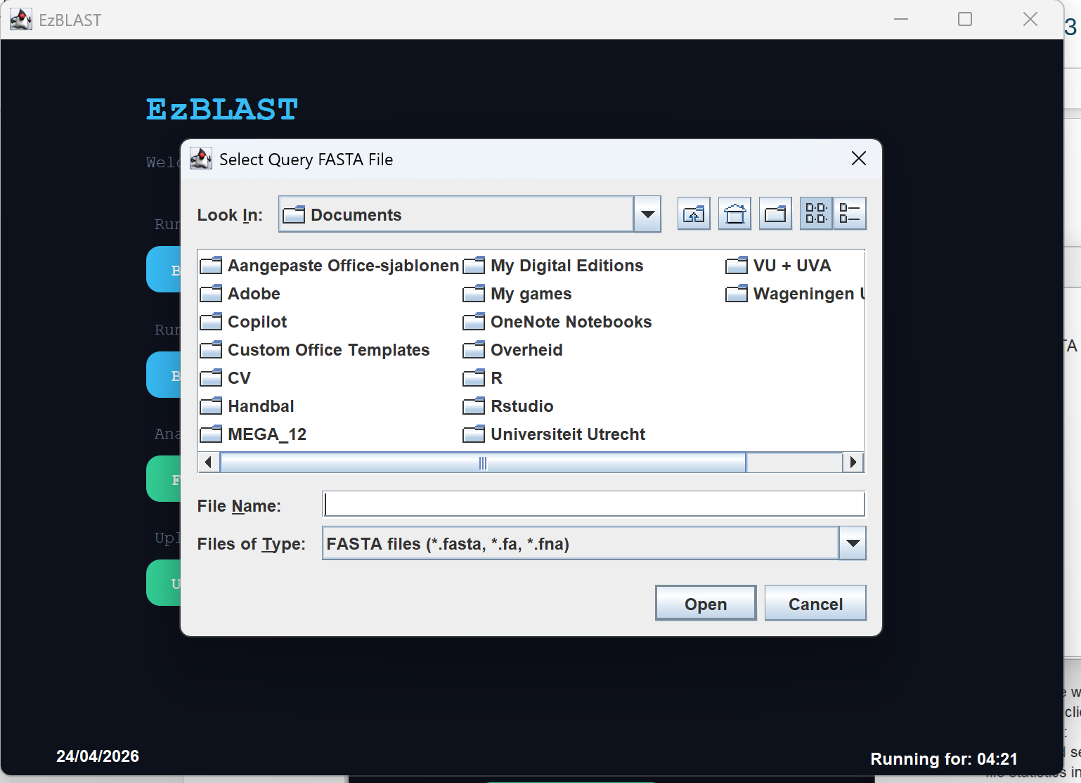

User selects a wrong file (has to be FASTA construction, but the chosen file does not have that. The error code is informative.
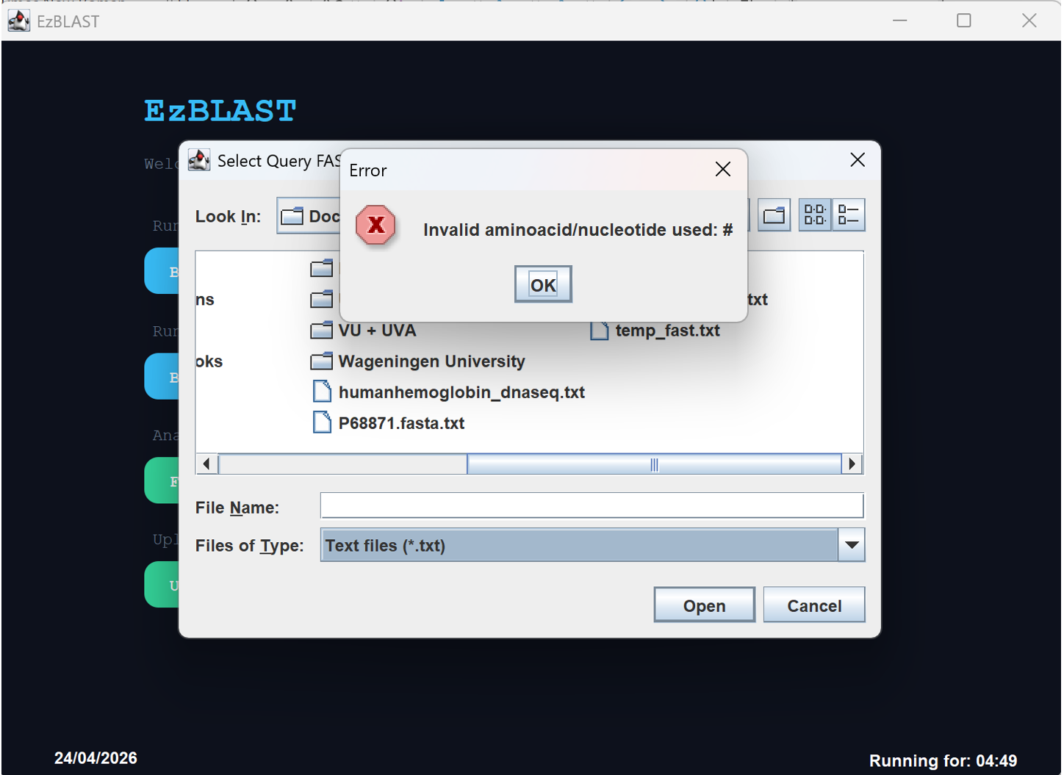

User has now chosen a correct file and sees their DNA sequence contents with a referral to BLASTN that can analyze these types of sequences.
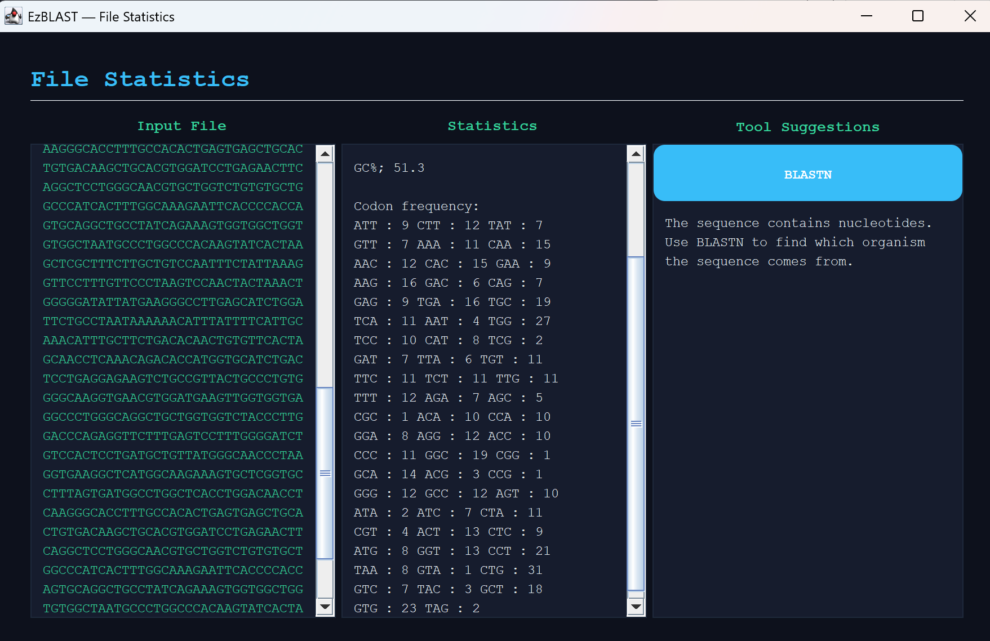

And a BLASTN screen pops up when pressing this button.
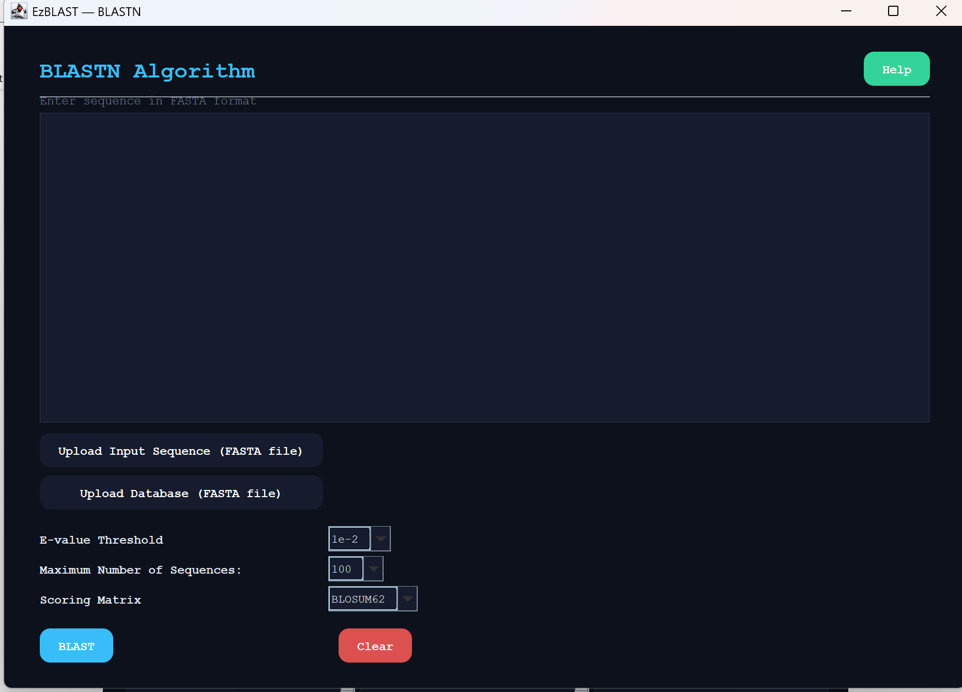

The same happens when the user uploads a protein sequence file, but then a BLASTP button referring to BLASTP tool shows up at the same location as the BLASTN button. To prevent repetition, this is not shown here.

The user now selects the upload .tsv files button
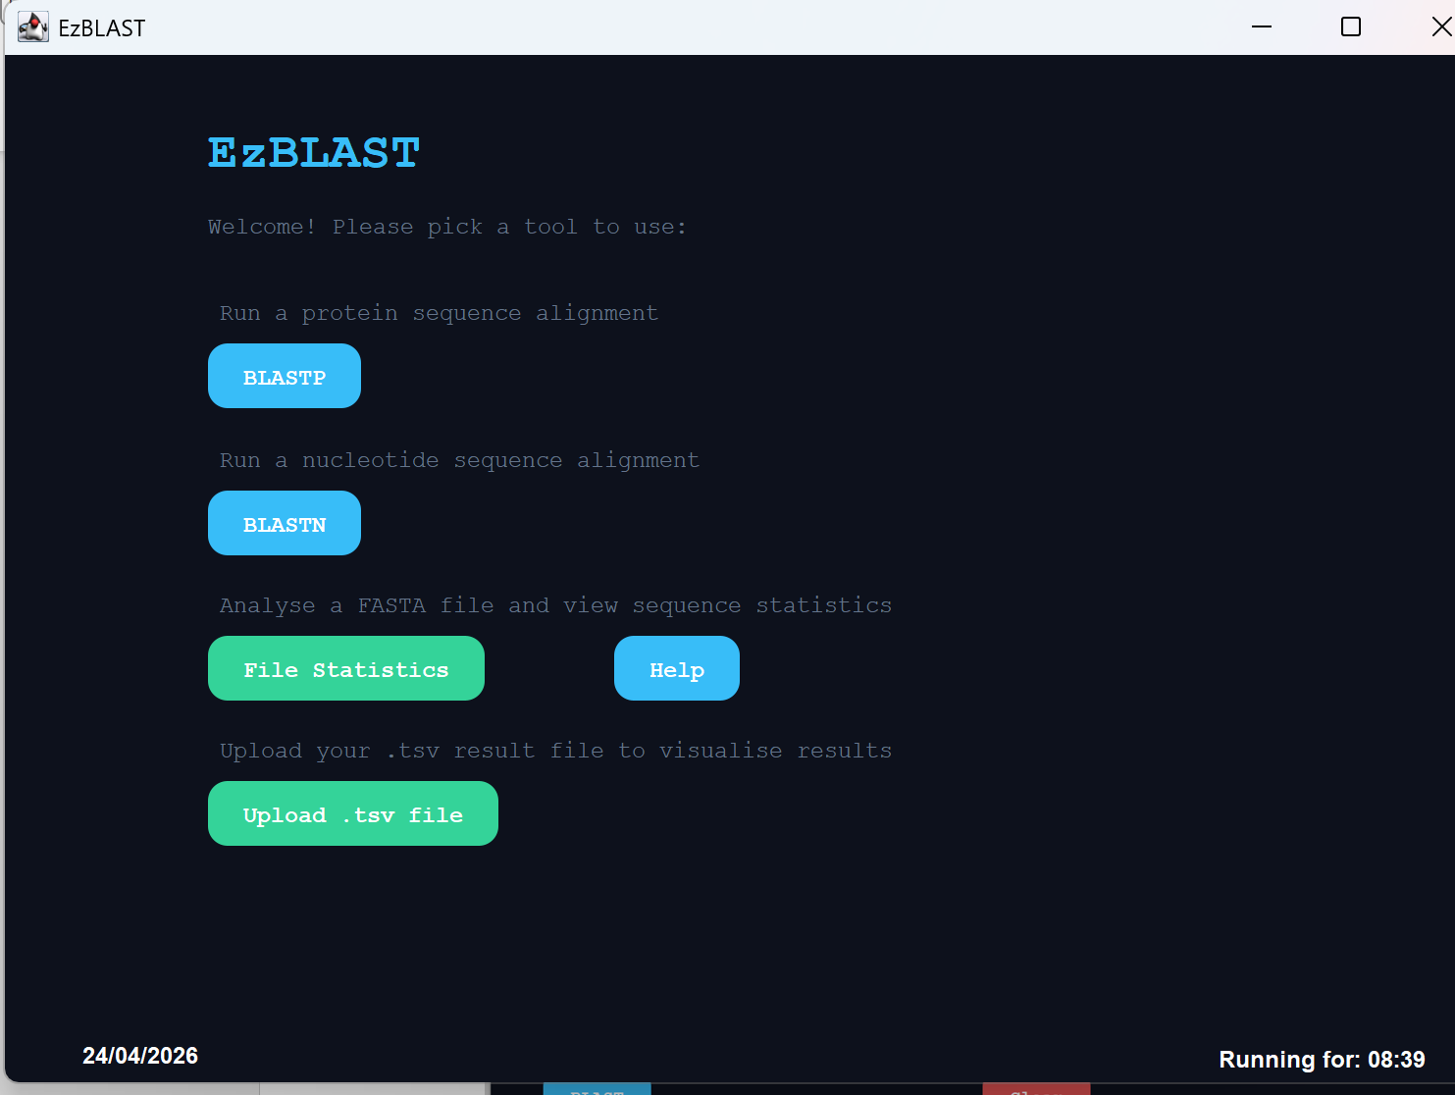

User has to select a file
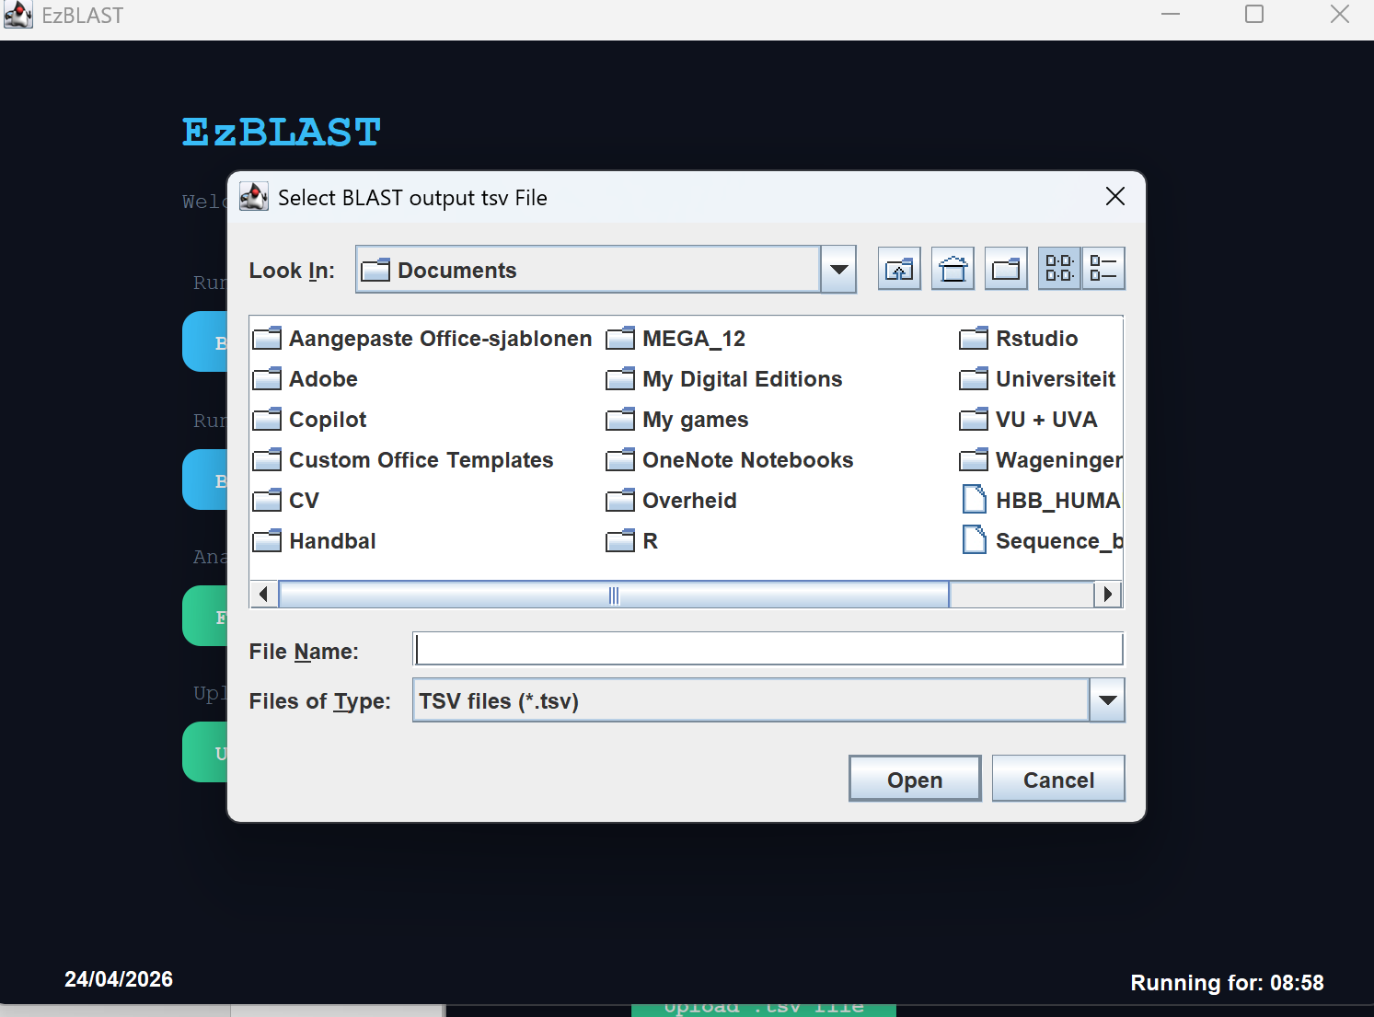

The user can look at his old results again
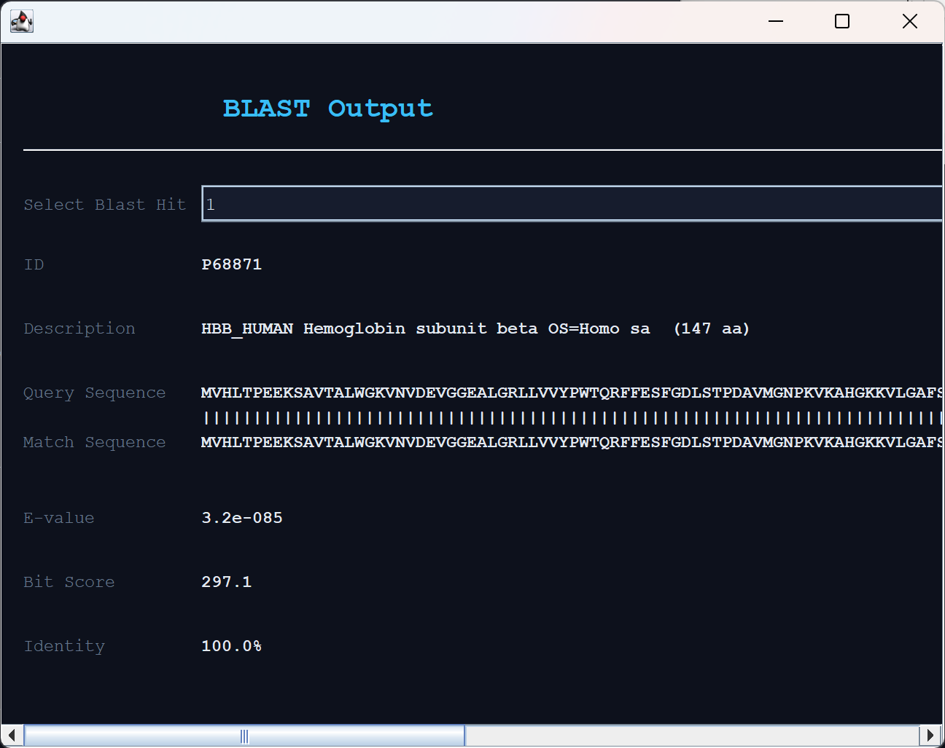

At every step, the user could intuitively walk through the buttons or ask for help. Additionally, if the user makes an error then a feedback screen pops up.

