Acceptance test for user story:
- Time elapsed since open application
Acceptance criteria:
The time elapsed since the application is opened is shown on the main screen and updates every second.
Step 1: open the application:
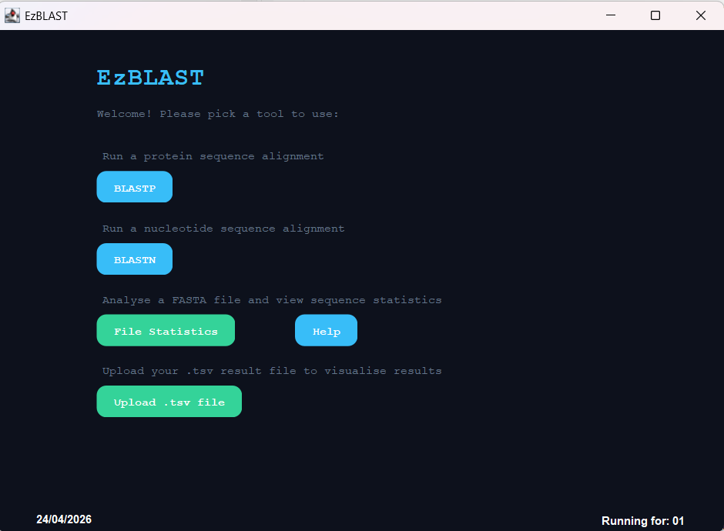
Step 2: the time elapsed since opening the application is shown at the bottom right of the main screen by: Running for:
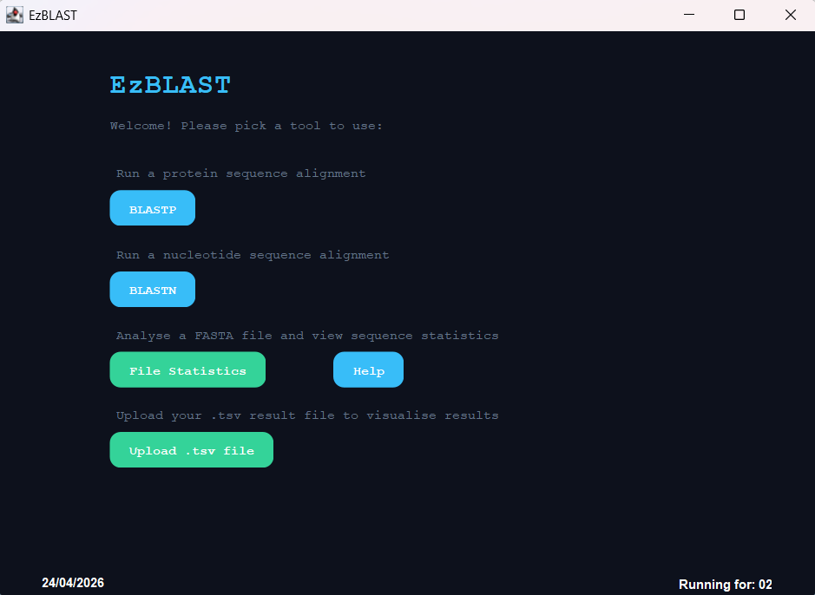
In the first window it was running for 1 second. In the second window it was running for 2 seconds.
Therefore, the acceptance test passes.

