Blast run message
Acceptance test
Show a screen that indicates the BLAST tool is running
Acceptance criteria
The tool should actually be running and create an output. The window does not show up if the tool is not running.
User is on the main screen
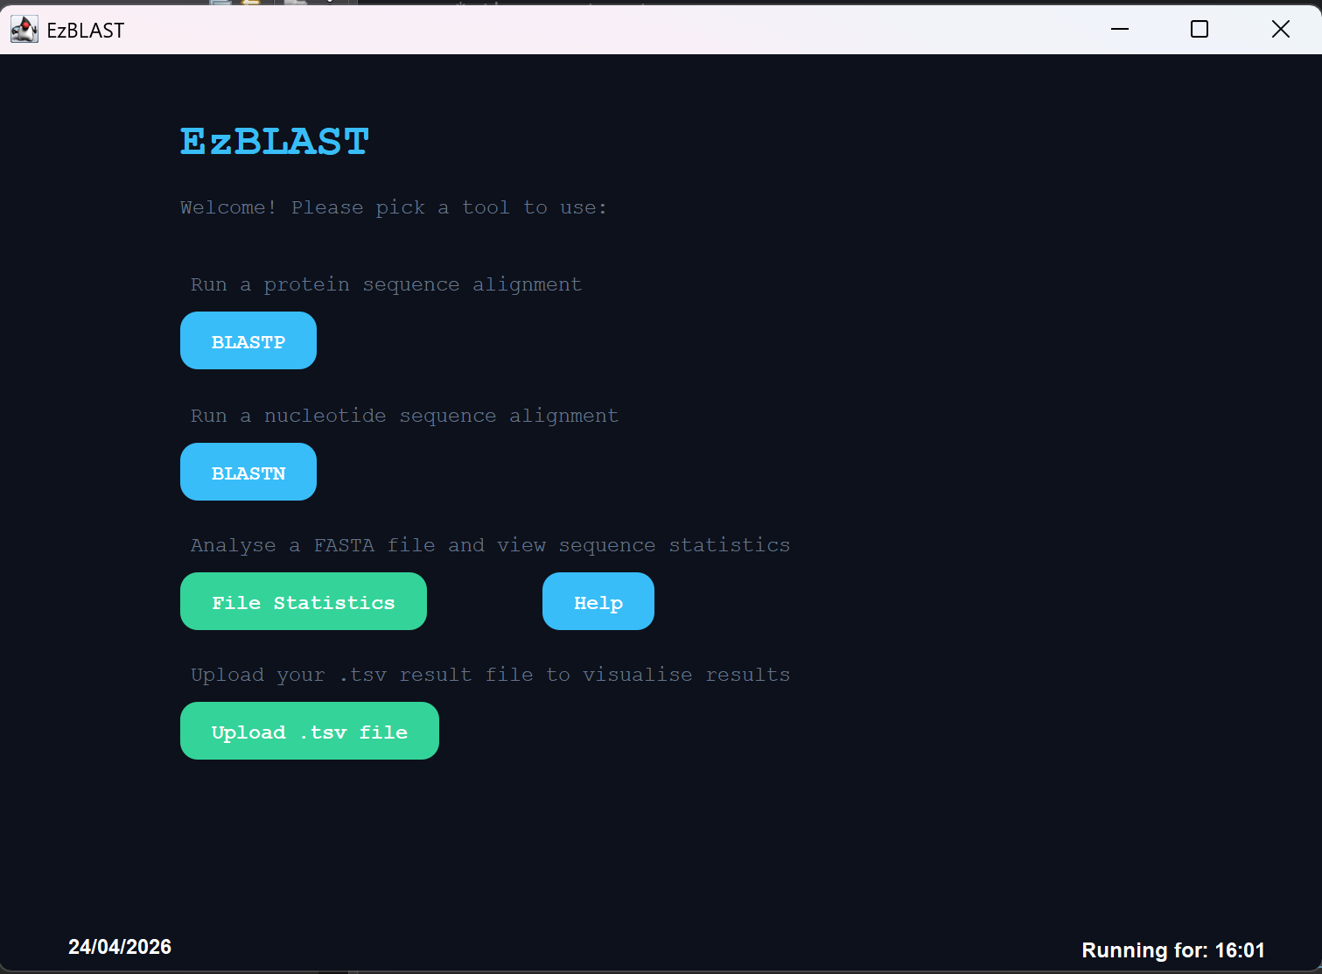
The user selected blastp and provides a database and query sequence file
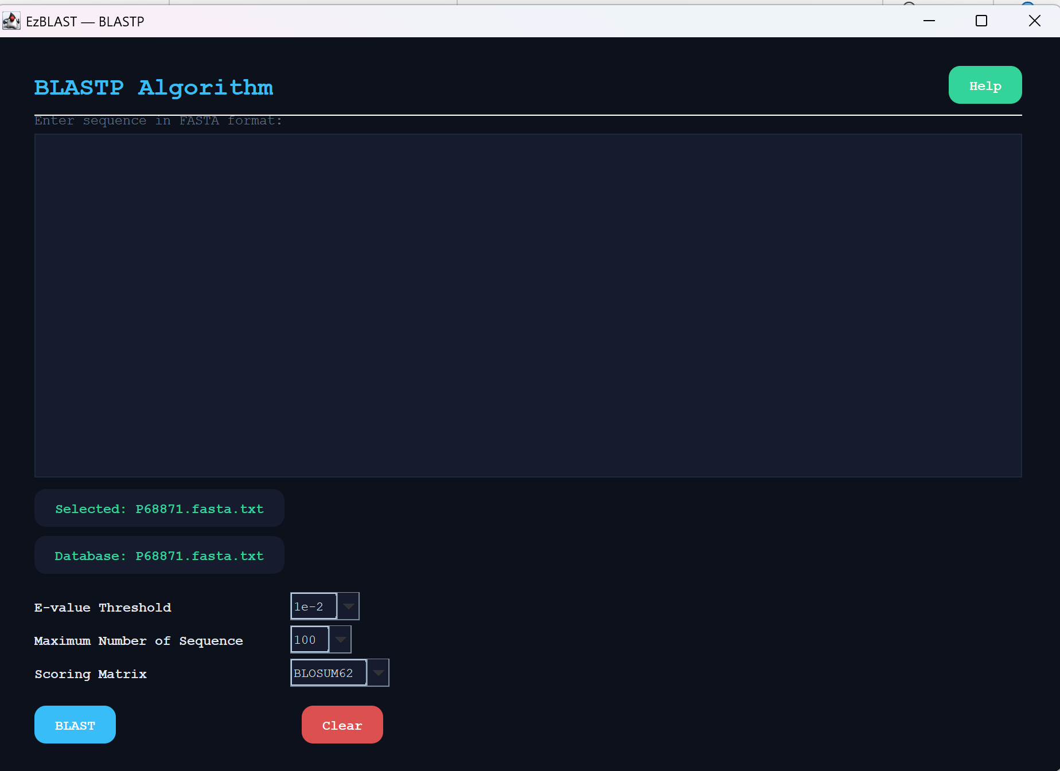
The user sees the program is running
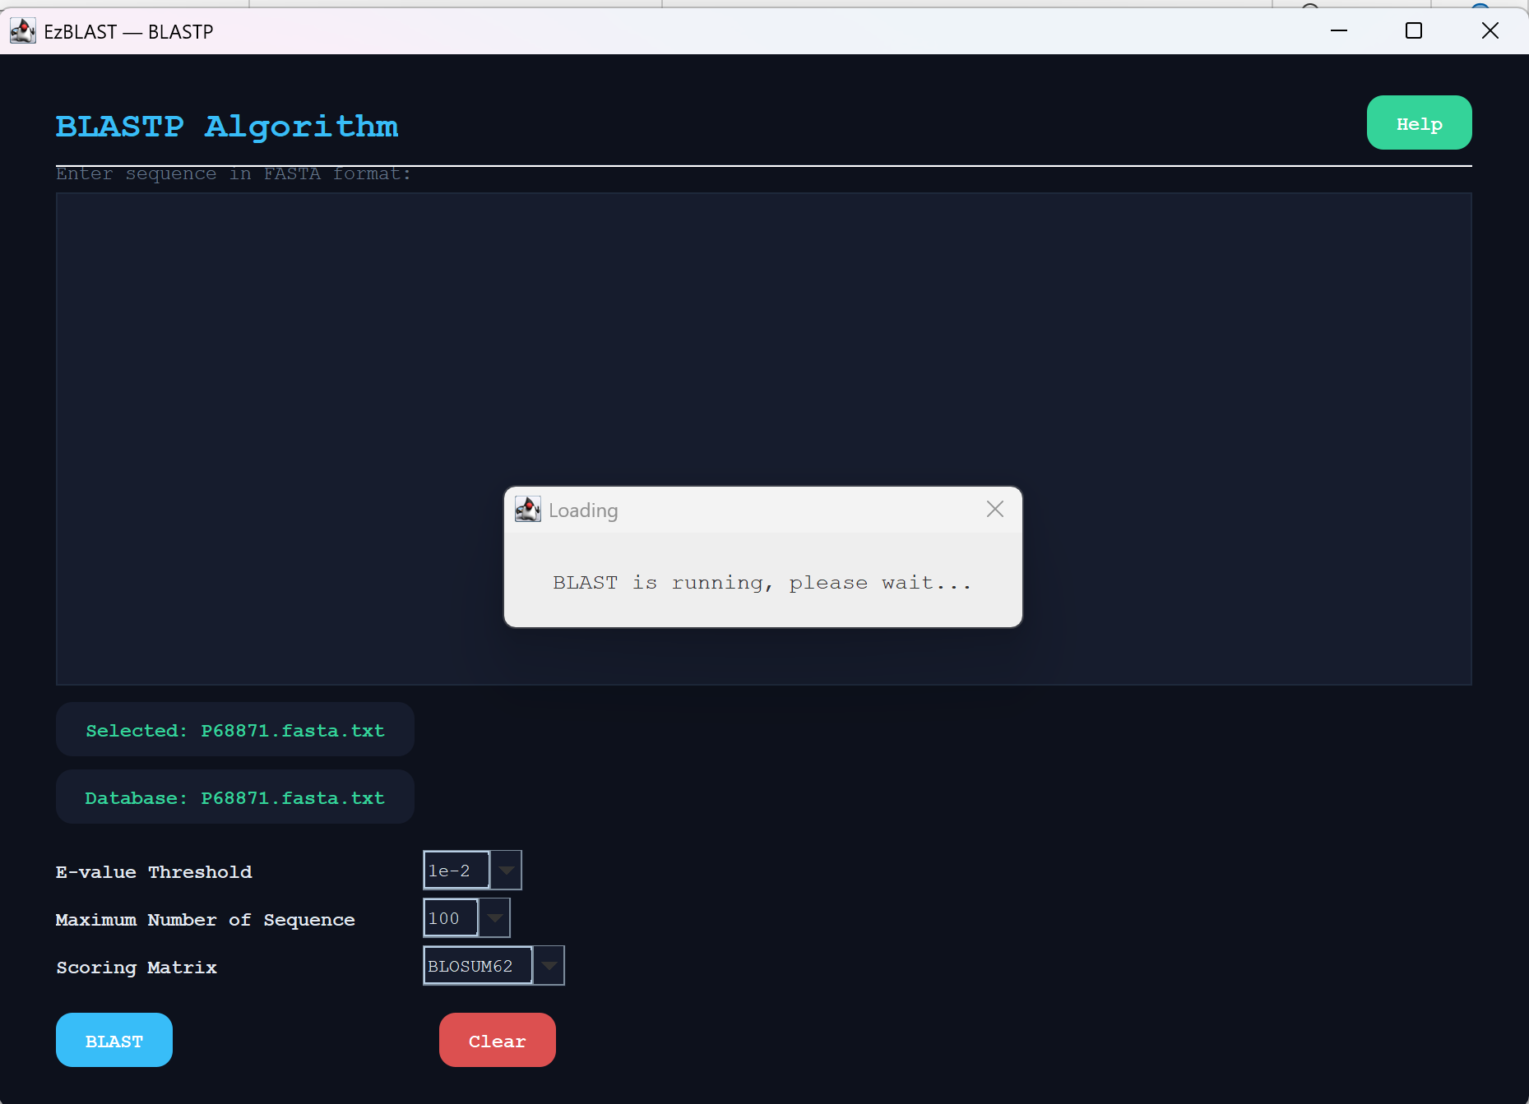
The program run successfully
