Upload fasta file
Acceptance test;
Upload a sequence by uploading a file to the program
Acceptance criteria;
The file to be a fasta file. A fasta at the end of the file name or structure of FASTA. S
User is on the main screen
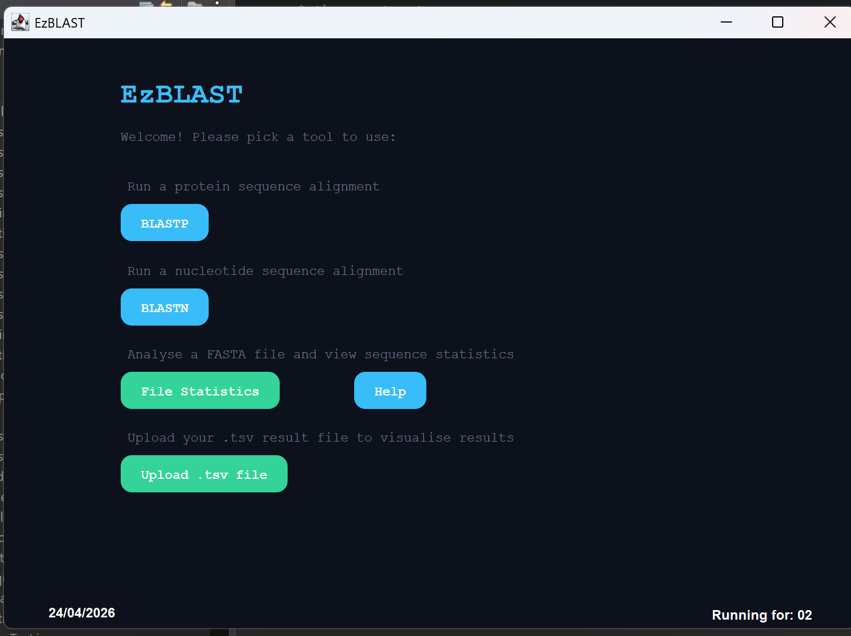
User chooses File Statistics and a file explorer page opens up
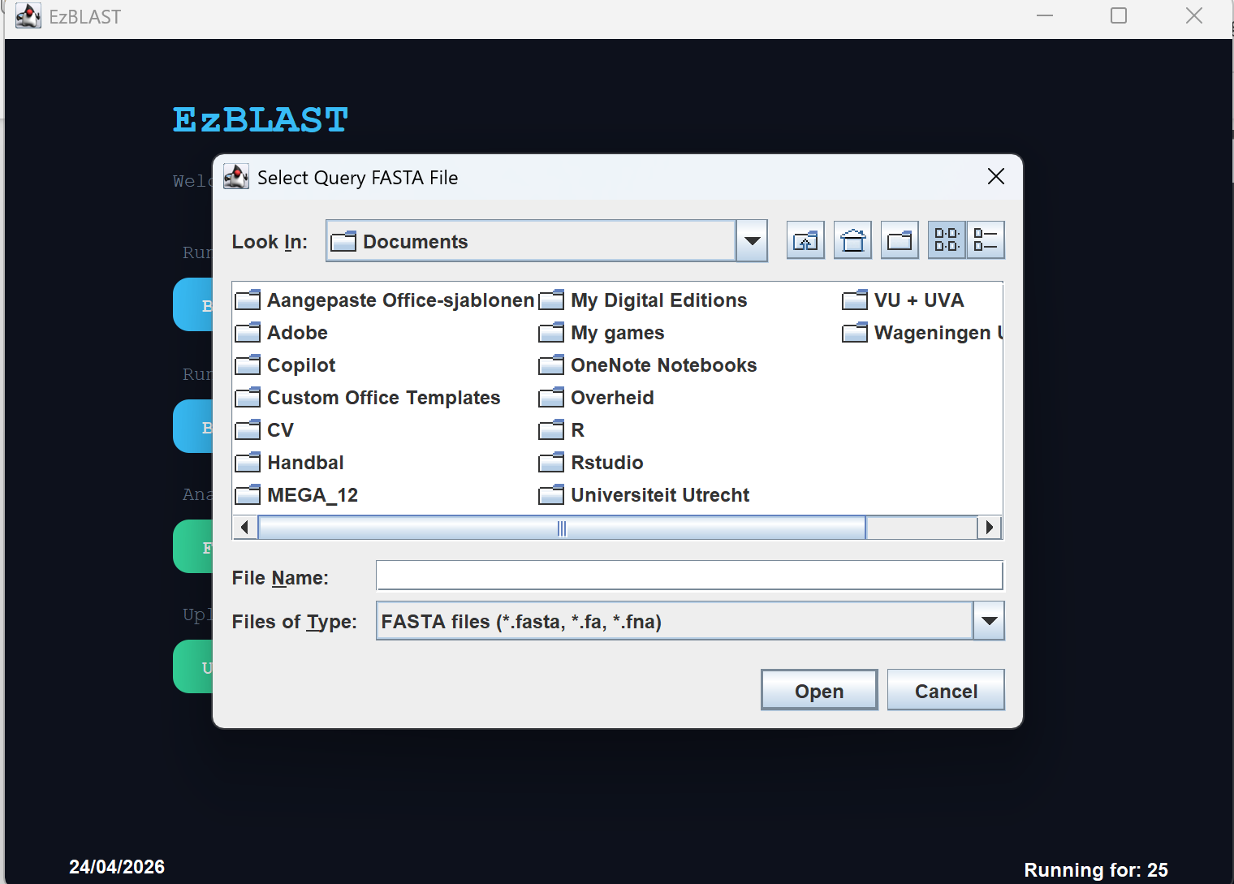
The user can find files with a .fasta-like extension. .txt extension or any other file type (but the file needs the correct structure. The user selects a protein file here.
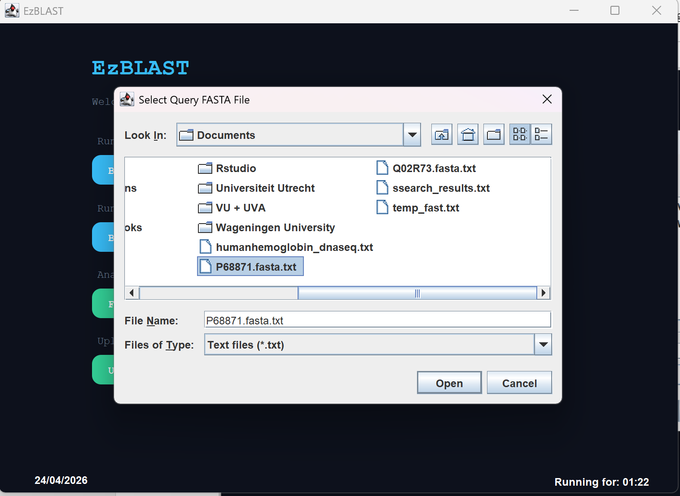
And the program runs the Statistics tool flawlessly.
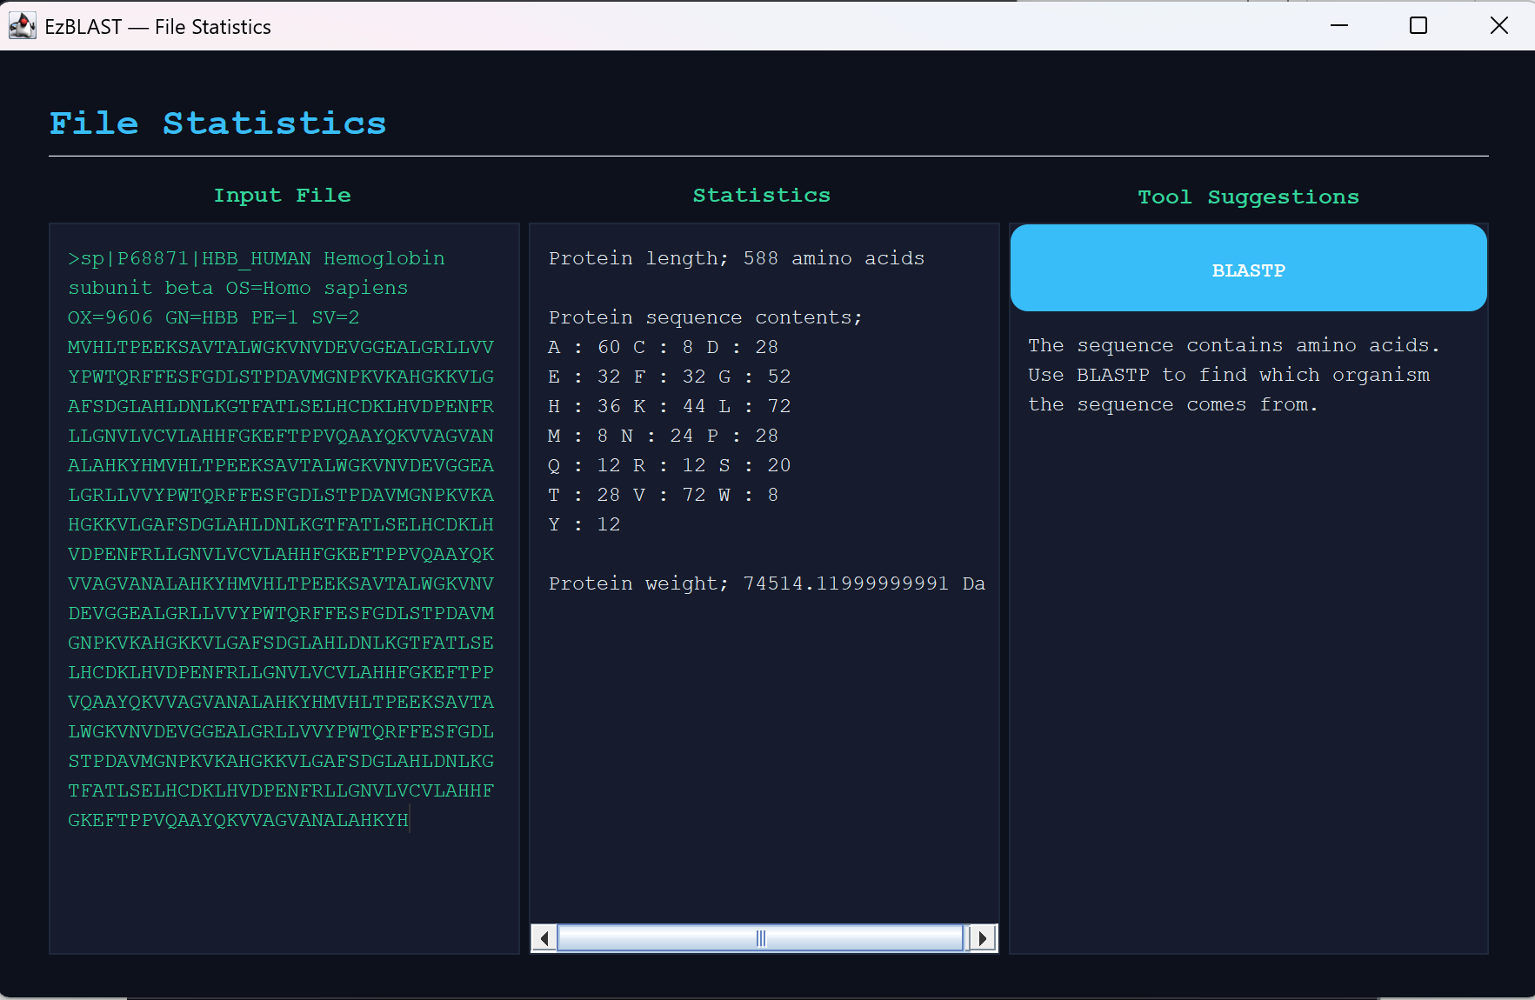
Had the user given an improper file like here;
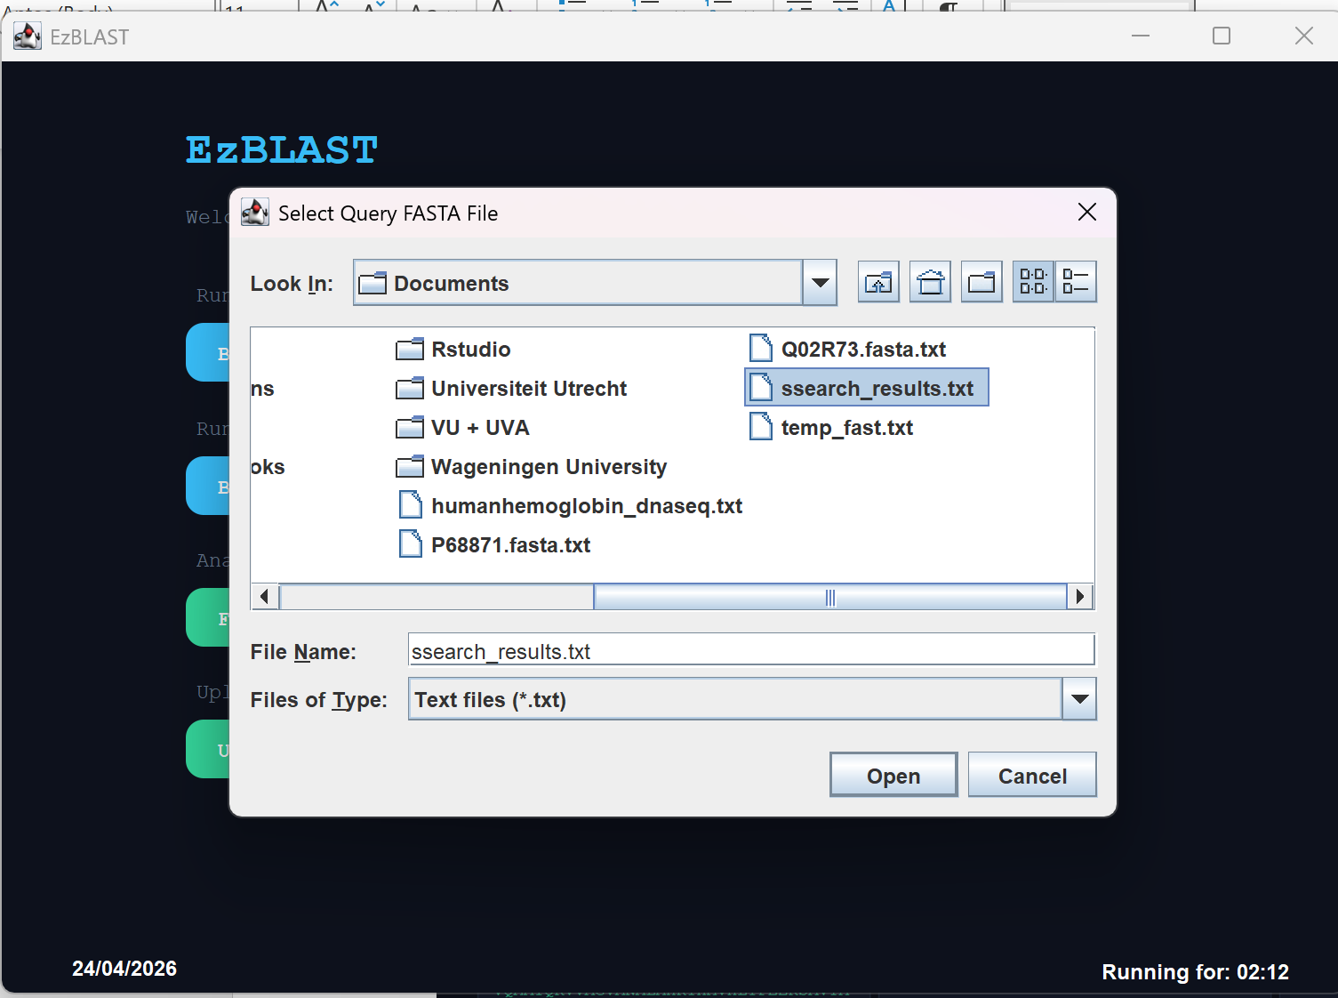
Then an error pops up.
