**Serialiation and Deserialization:**

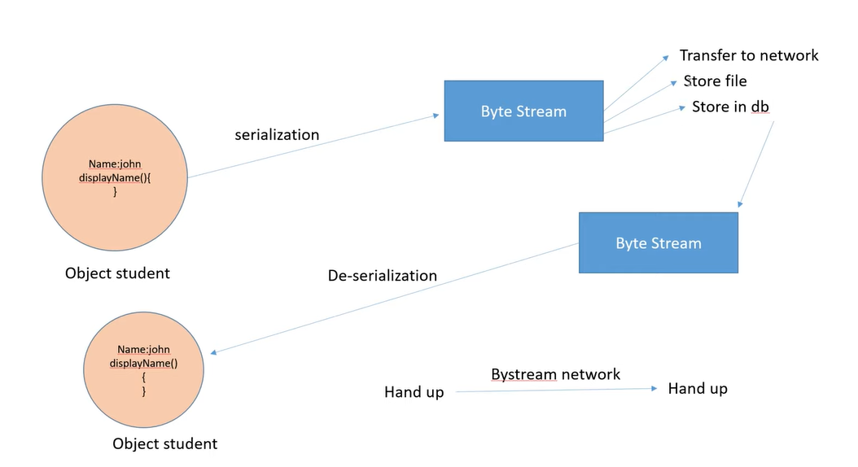

In Java, the **Serializable** interface is used to mark a class so that its objects can be **converted into a byte stream**. This process is known as **serialization**. When a class implements the Serializable interface, it indicates that the objects of that class can be serialized and deserialized, which is helpful for saving objects to a file, sending them over a network, or caching them.

**Key Concepts of Serializable**

1. **Serialization**: The process of converting an object into a byte stream, which can then be stored in a file, transferred over a network, or saved in memory for future use.
2. **Deserialization**: The reverse process of converting a byte stream back into a copy of the original object, reconstructing the object's state.

**How Does Serializable Work?**

* The Serializable interface is a **marker interface**, meaning it doesn’t have any methods. It serves as a signal to the Java Virtual Machine (JVM) and ObjectOutputStream that the class can be serialized.
* When an object is serialized, its state (the values of its fields) is converted into a byte stream.
* When the object is deserialized, the byte stream is used to recreate the object in memory, retaining its original state.

**Why Use Serialization?**

Serialization is useful for a variety of scenarios, such as:

1. **Persistence**: Saving the state of an object to a file or database so that it can be restored later.
2. **Communication**: Transferring objects over a network, for example, in Remote Method Invocation (RMI) or socket programming.
3. **Caching**: Storing the state of objects in memory for performance reasons.
4. **Deep Cloning**: Creating deep copies of objects by serializing and deserializing them.

**How to Make a Class Serializable**

To make a class serializable, the class must implement the Serializable interface.

**Explanation of the Example:**

1. **Employee Class**: The Employee class implements the Serializable interface, making its objects eligible for serialization.
2. **Serialization**:
   * The ObjectOutputStream is used to write the employee object to a file named employee.txt.
   * This process converts the object into a byte stream and saves it to the file.
3. **Deserialization**:
   * The ObjectInputStream reads the employee.txt file and converts the byte stream back into an Employee object.
   * The deserialized object retains the same state as the original.

**Important Considerations for Serialization**

1. **serialVersionUID**:
   * It’s recommended to define a serialVersionUID field in a serializable class.
   * This is used to ensure version compatibility during the deserialization process. If the class definition changes and no matching serialVersionUID is found, a InvalidClassException is thrown.
   * Example:

private static final long serialVersionUID = 1L;

1. **Transient Fields**:
   * Fields marked with the transient keyword are **not serialized**.
   * Use transient for sensitive information (like passwords) or fields that can be recalculated.
   * Example:

private transient String password; // This field will not be saved during serialization

1. **Static Fields**:
   * Static fields belong to the class, not to an instance, and hence are **not serialized**.
   * Only the instance fields of an object are serialized.
2. **Inheritance**:
   * If a superclass implements Serializable, then all its subclasses are automatically serializable.
   * If a class doesn’t implement Serializable, any attempt to serialize its object will result in a NotSerializableException.
3. **Customization**:
   * You can customize the serialization and deserialization processes by defining special methods in your class:
     + private void writeObject(ObjectOutputStream oos) throws IOException
     + private void readObject(ObjectInputStream ois) throws IOException, ClassNotFoundException

**Use Cases of Serialization**

* **Storing User Sessions**: Save and retrieve the state of user sessions in web applications.
* **Sending Objects Over a Network**: Transfer objects in distributed applications (e.g., RMI, message queues).
* **Deep Cloning**: Create deep copies of objects by serializing and deserializing them.
* **Caching**: Store and retrieve cached objects in memory.

**Limitations of Serialization**

* **Performance Overhead**: Serialization can introduce overhead in terms of time and memory usage.
* **Security Risks**: Deserializing untrusted data can lead to security vulnerabilities (e.g., arbitrary code execution).
* **Versioning Issues**: Changes to class definitions can cause InvalidClassException if serialVersionUID is not managed properly.

**Summary**

* The Serializable interface allows an object’s state to be converted into a byte stream and vice versa.
* Serialization is useful for saving objects to files, sending objects over a network, or deep cloning.
* Implementing Serializable is straightforward but should be used cautiously due to performance, security, and version compatibility concerns.
* If we change serialVersionUID after executing SerializableExample.java and then run DeserializableExample.java then it will give exception(runtime)

java.io.InvalidClassException: com.swapnil.serialization.Employee; local class incompatible: stream classdesc serialVersionUID = 2, local class serialVersionUID = 1

* If we remove Serializable from class then it will give exception (runtime)

java.io.NotSerializableException: com.swapnil.serialization.Employee

* If we remove ClassNotFoundException then it will give exception

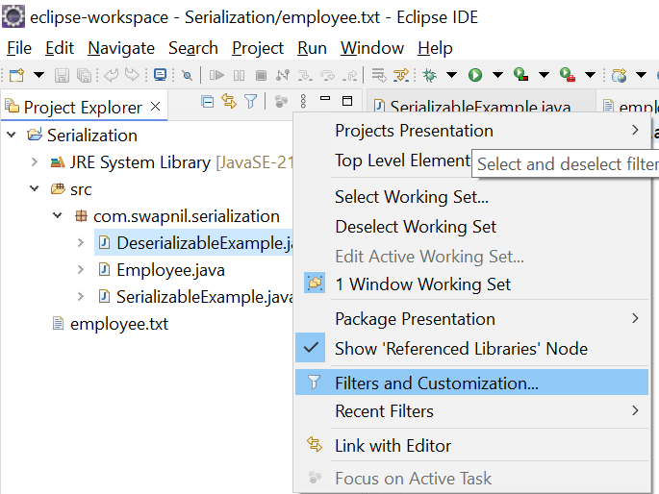

Uncheck .* resources so that files are visible in eclipse project explorer.