Booking.uz

Travel smarter

**U1810264 Khusniddinov Shamsiddin**

**U1810059 Khakimov Bunyod**

**U1810273 Yokubov Bakhtiyor**

**U1810157 Salimov Otabek**

**GitHub** <https://github.com/iuthub/ip-group-project-dirty-bits.git>

**Web site** <https://dirty-booking.000webhostapp.com/>

**Main purpose of the company is to provide easy and fast hotel**

**reservation services for everyone.**

Visitor can search hotels, view list of them, view About Page, login/register.

Registered and logged in User can search hotels, view list of hotels, make a hotel reservation, choosing room, dates and cancel hotel reservation.

Admin can create/add/modify hotels, search and view list of hotels, make/view/cancel hotel reservation.

Target users – people who travel a lot and need booking system.

**Members:**

1. Project functionality analyzed and discussed by Bakhtiyor Yakubov.
2. Design analyzed, created by Otabek Salimov.
3. Data-base analyzed and DB scheme created, report made by Shamsiddin Khusniddinov.
4. Main functionality implemented by Bunyod Khakimov.

**Logins and Passwords:**

**User Accounts**

Login: [b.obramov@student.inha.uz](mailto:b.obramov@student.inha.uz)

Pass: password

Login: [salimovotabek0404@mail.ru](mailto:salimovotabek0404@mail.ru)

Pass: qwertyuiop

**Admin Accounts**

Login: [b.khakimov@student.inha.uz](mailto:b.khakimov@student.inha.uz)

Pass: password

Login: [o.salimov@student.inha.uz](mailto:o.salimov@student.inha.uz)

Pass: password

**Database scheme with relations**

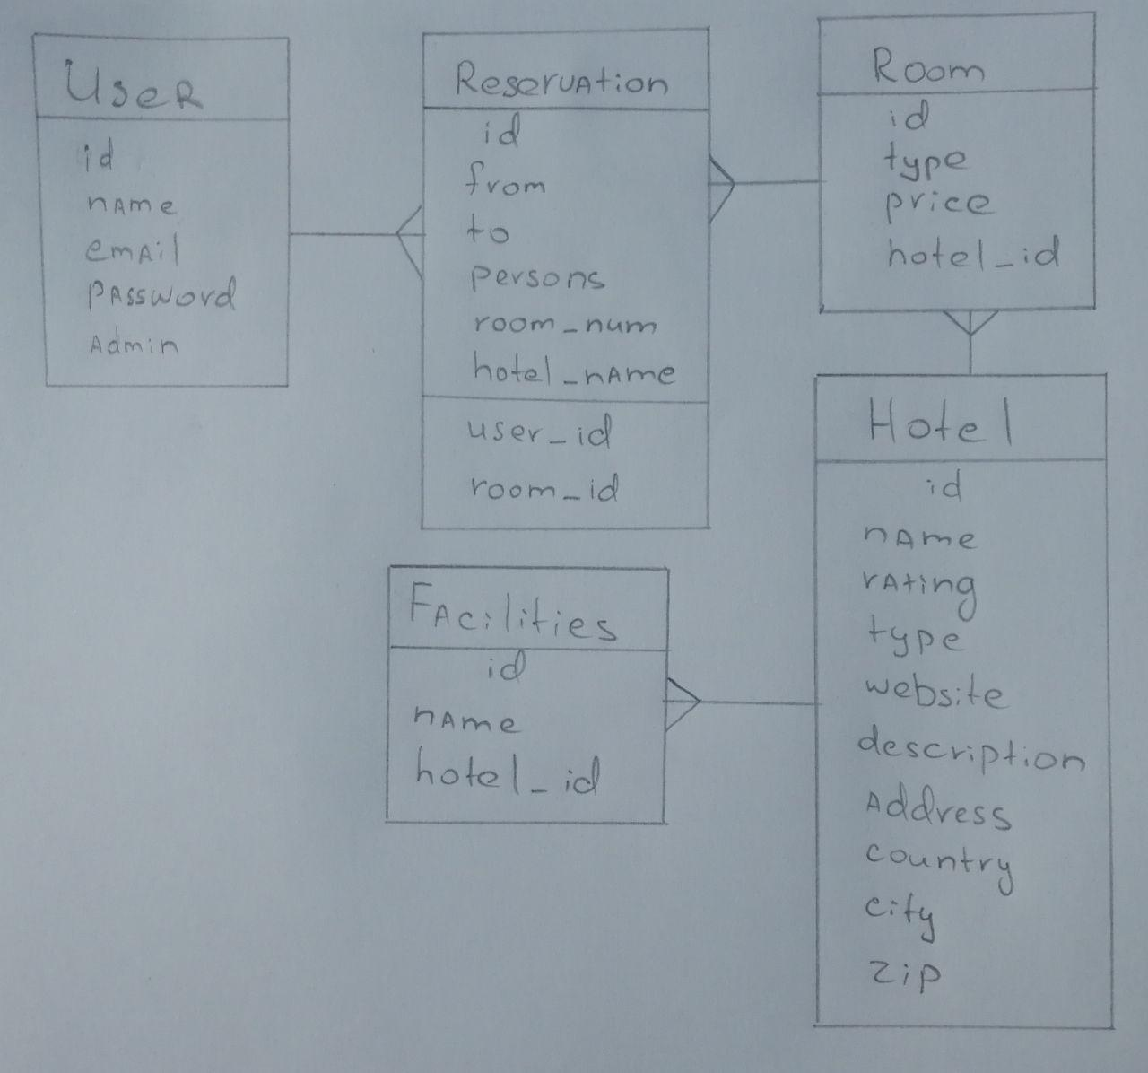

**Program features and screenshots**

Default page – here we can see login page and usual login form

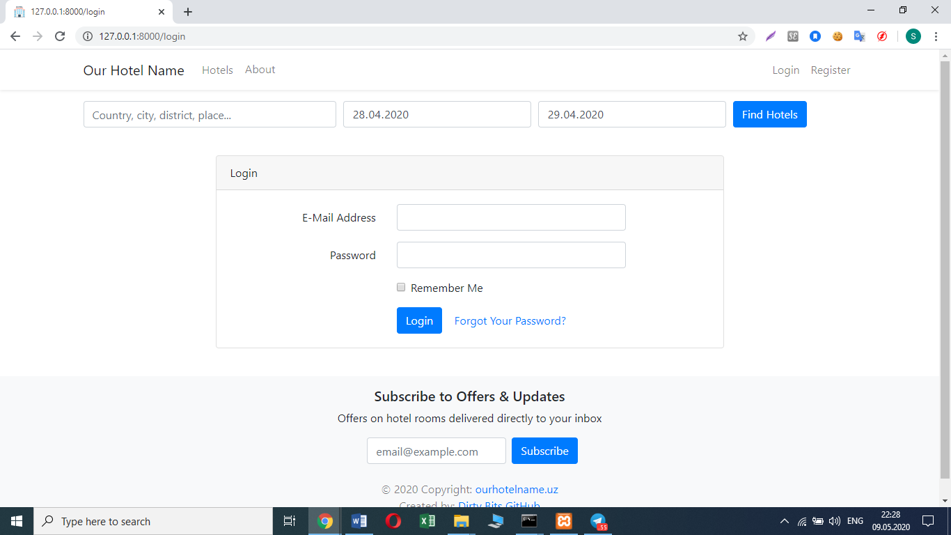

Hotels page is the main page of our site which contains all necessary info

about hotels that are listed in our system.

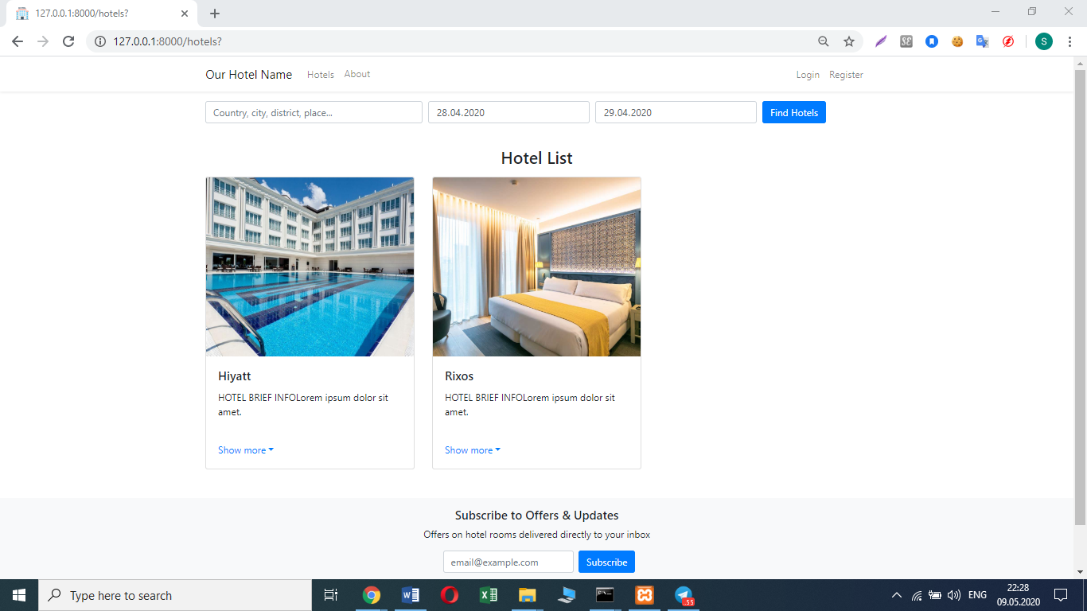

**Show more** button is implemented in order to display detailed info

about current hotel such as: hotel type, stars, site etc.

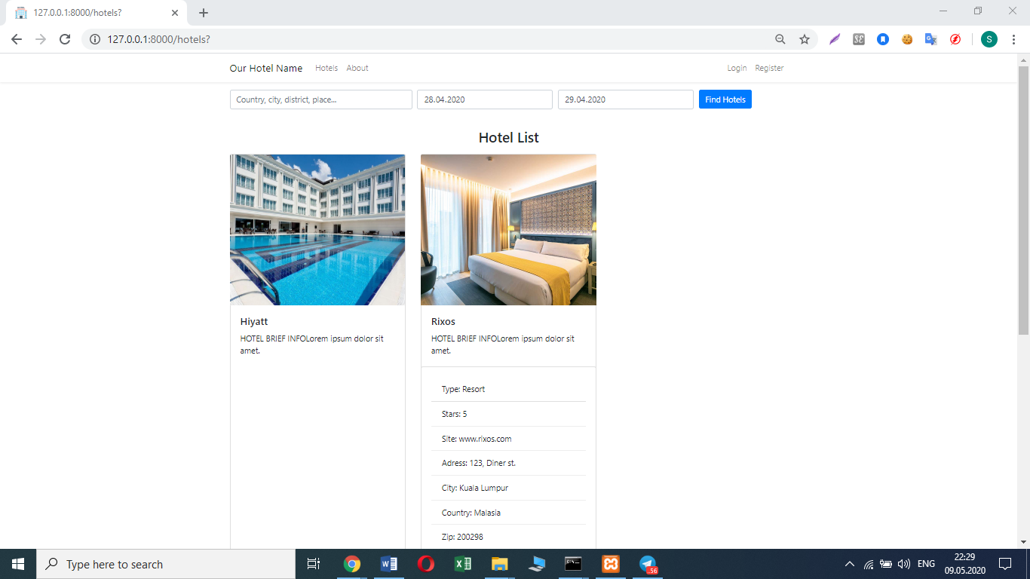

Searching engine is used to find all available hotels by keyword (key

word in the picture “Tashkent”)

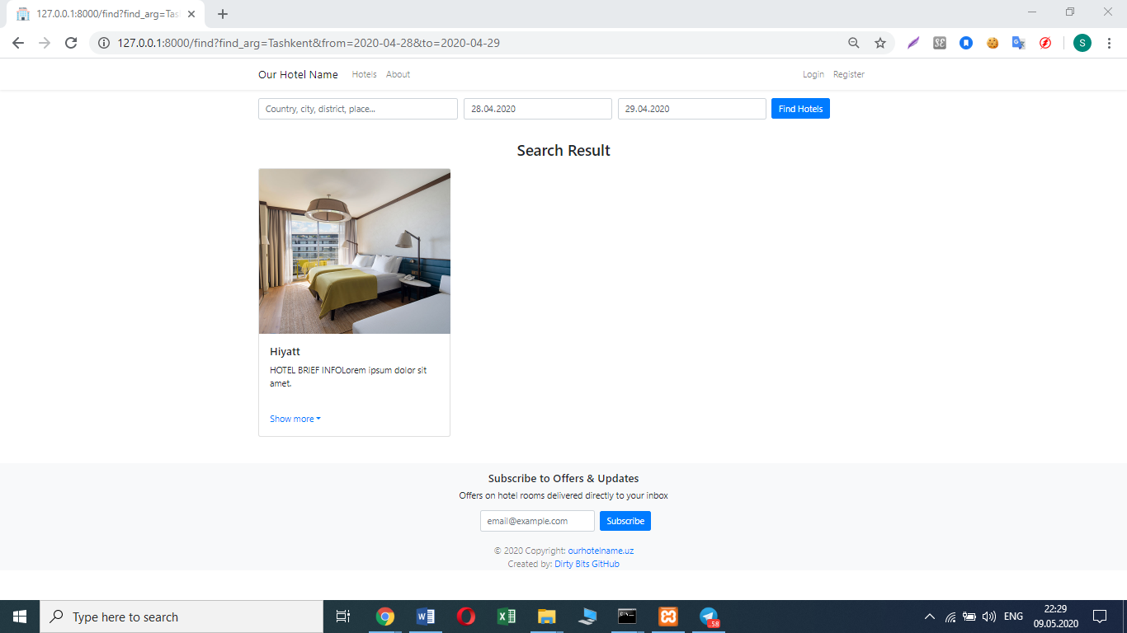

In **Registration Page** we used ordinary implementation of registration

Form

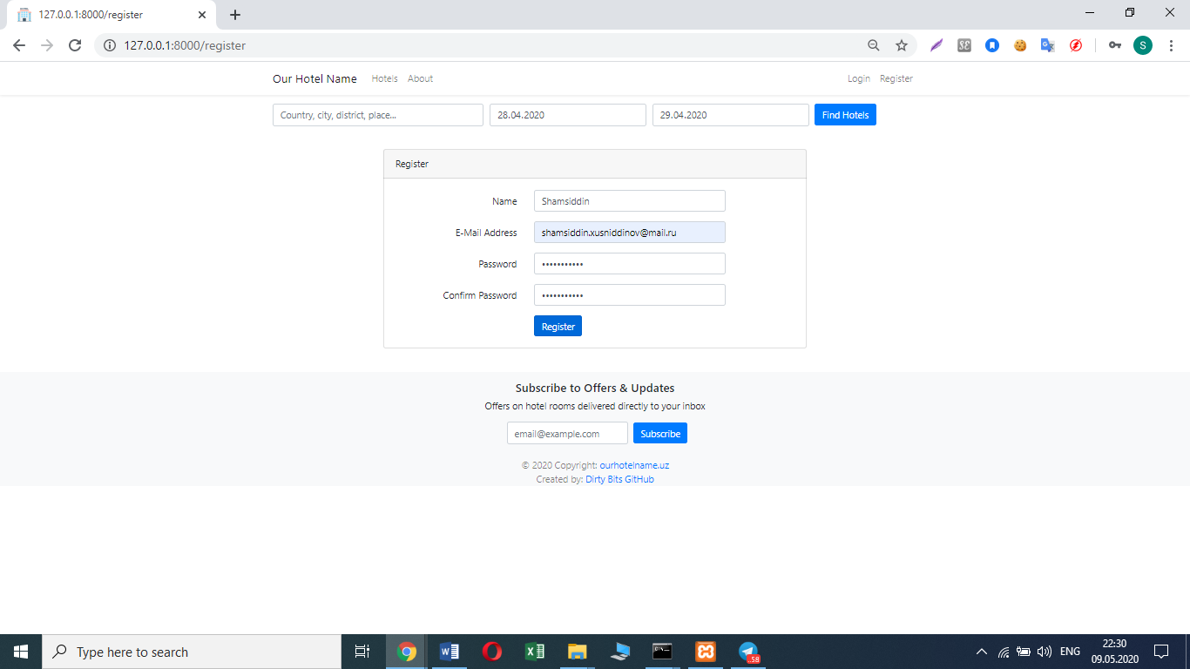

Picture below describes how the interface looks like to primary user

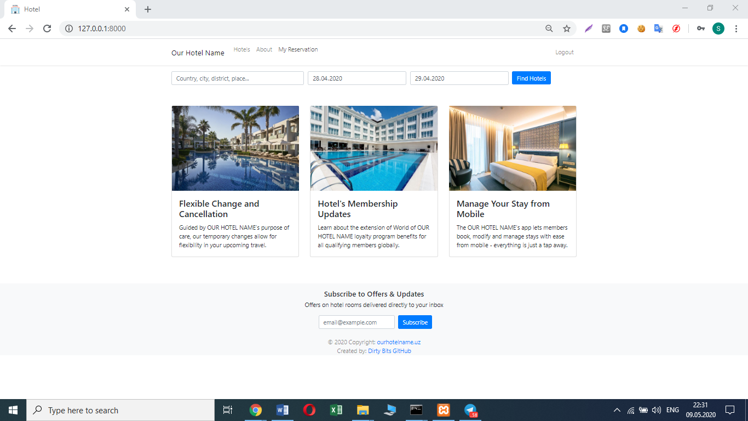

**Book now** button becomes available after used logged in.

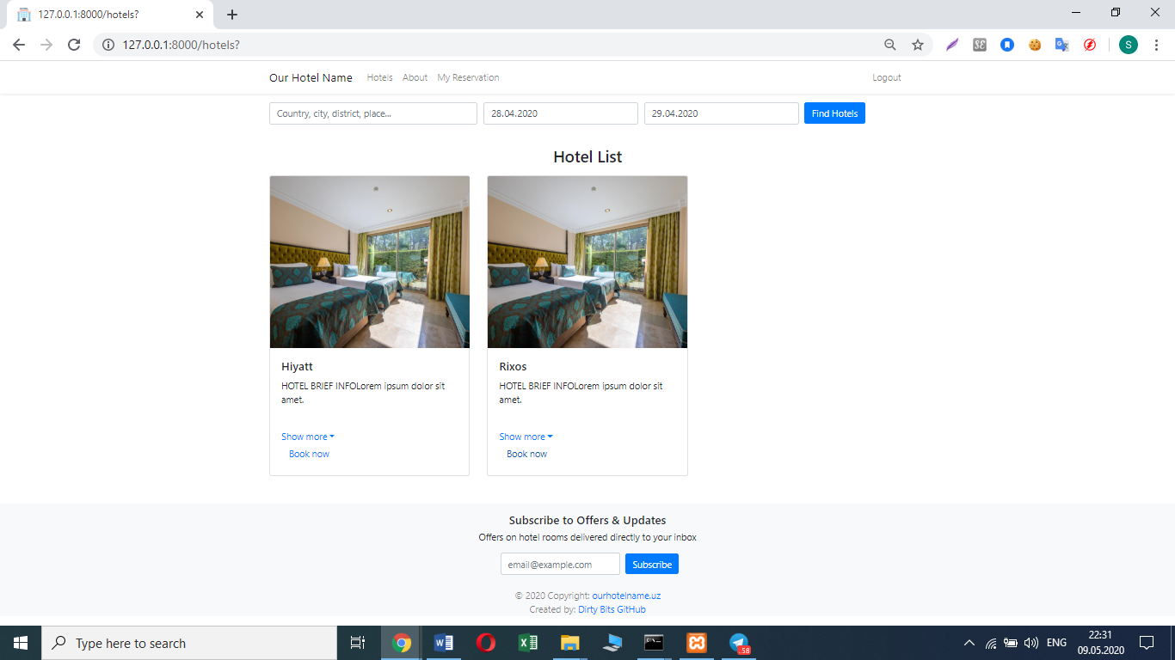

Booking process – **Reservation Details** page to book hotel that chosen in

the **Hotels** page.

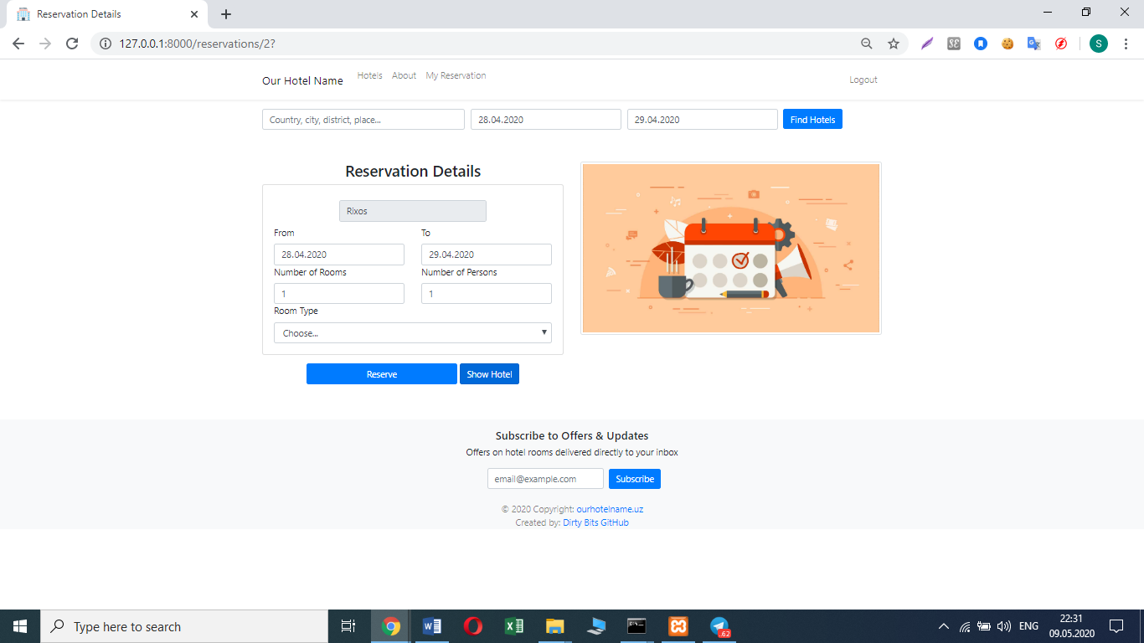

**Show more** button clicked

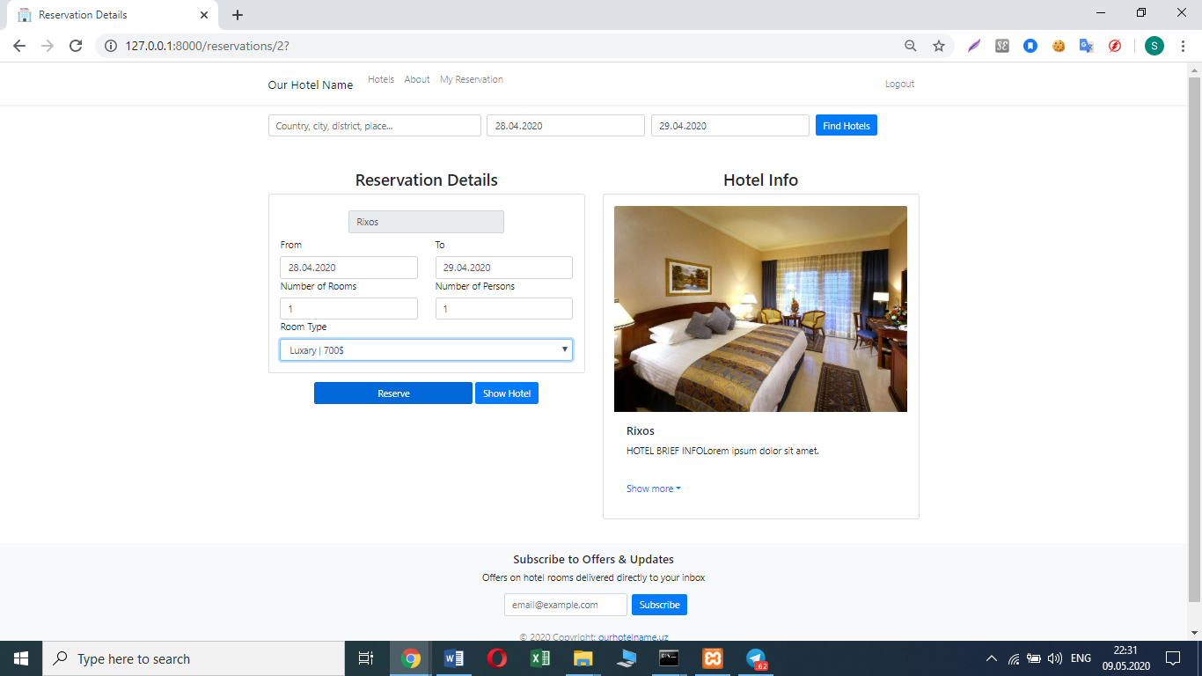

If booking process completed successfully, we can see **notification** about

this.

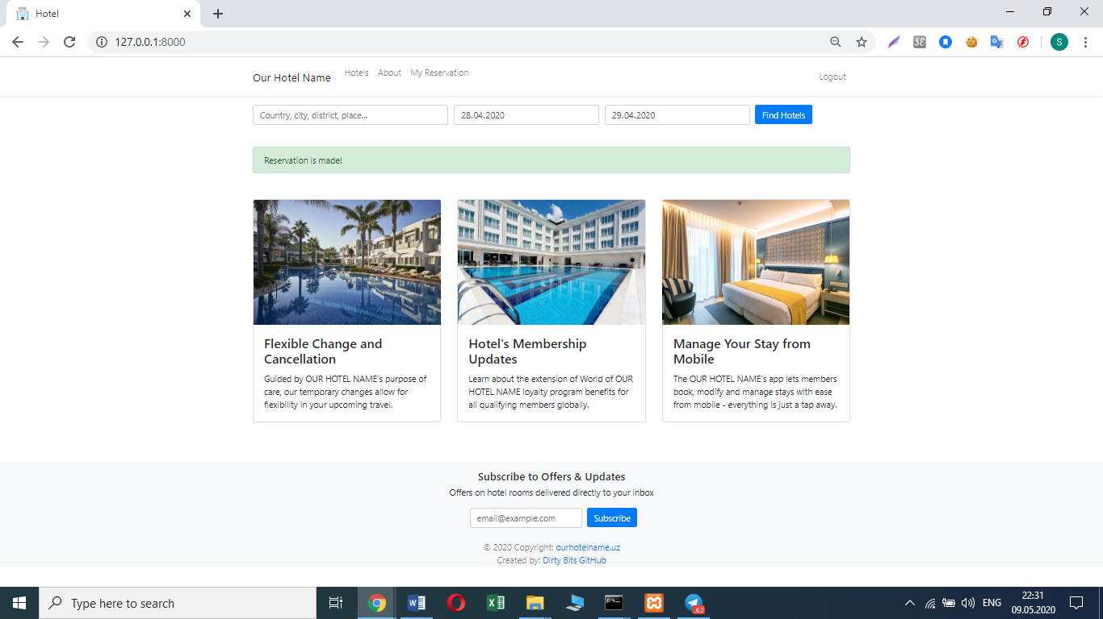

**My Reservations –** page for displaying user’s current reservations.

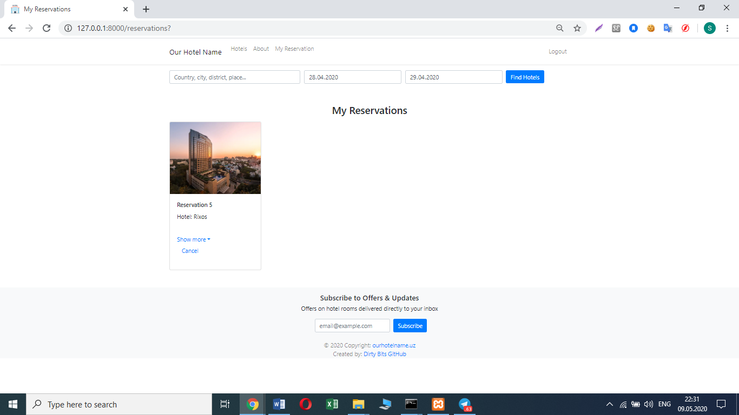

Admin’s interface differs from primary user’s interface.

New button **Create** appears for admins in navbar

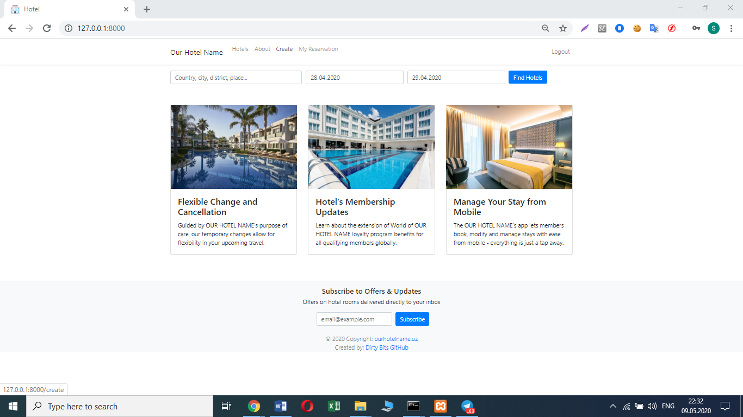

**Hotels** page as admin. New buttons: **Edit** and **Create** when **Show more**

button clicked.

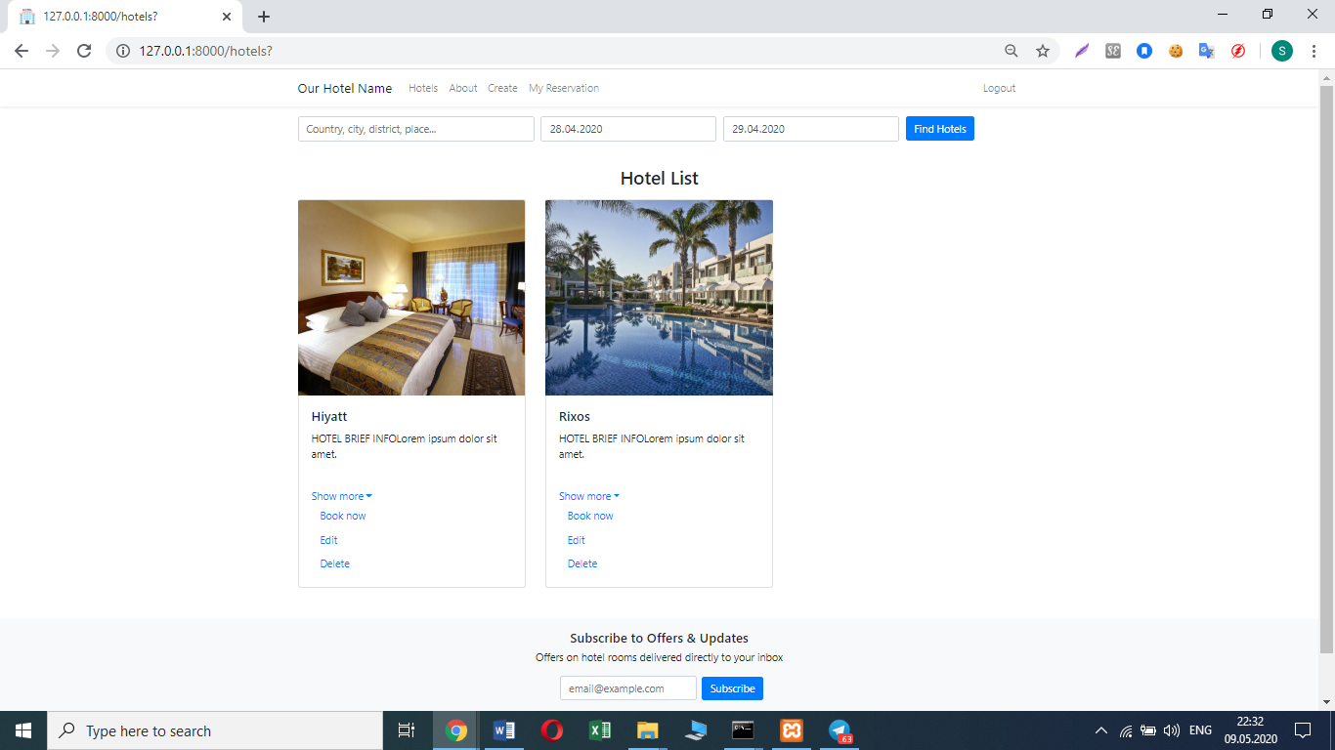

**Hotel Create** **Page** – here we should fill all necessary info about hotel

that we going to add to hotels list.

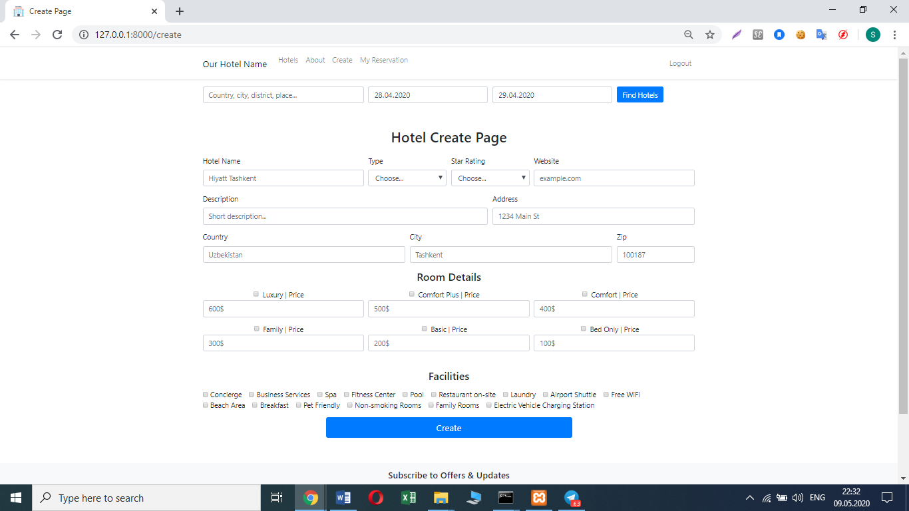

**Hotel Edit Page** to edit existing hotels in our list.

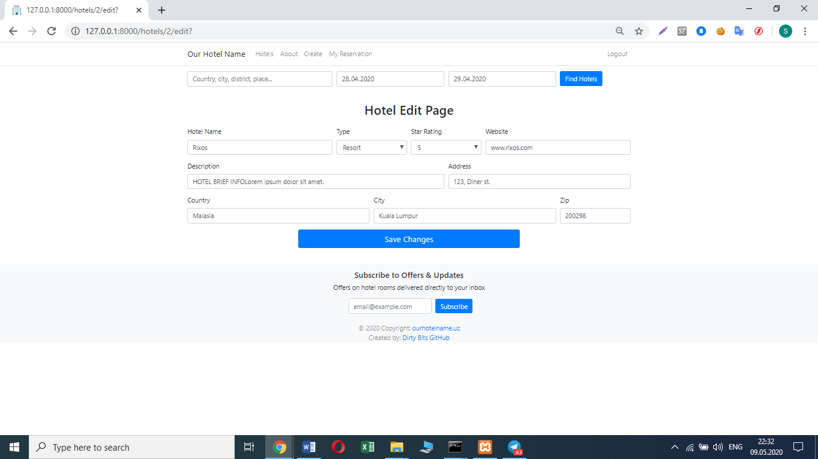

**About** page

