Lab 6 - MAC/ARP

Chibunze Uzo

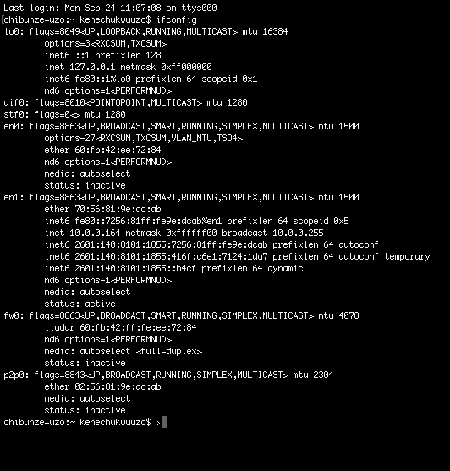

1. The MAC address from my computer is (70:56:81:9e:dc:ab)

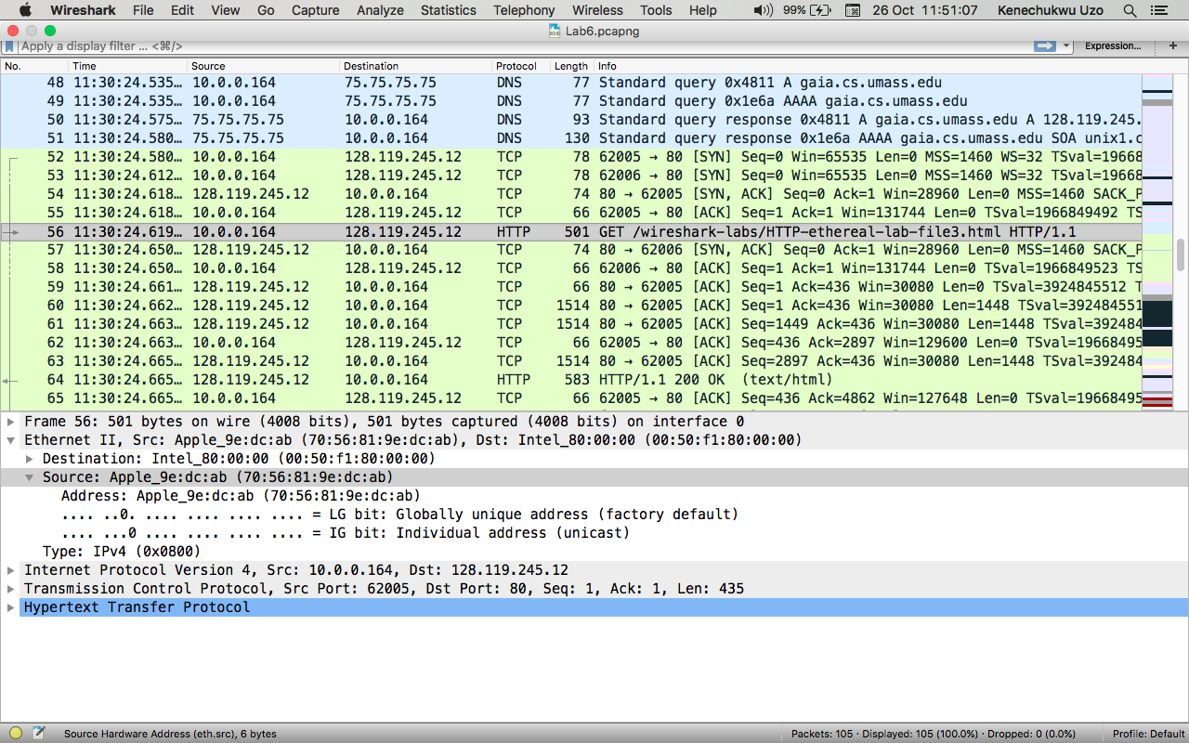

2. The destination MAC address is (00:50:f1:80:00:00)

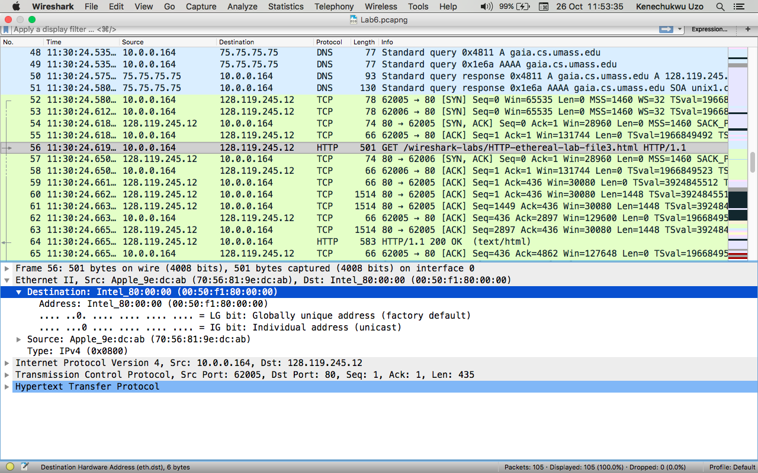

3. The device that has the MAC address shown in my destination is Intel



4. The destination MAC address only shows the MAC address of the router connected to the source which will later send the data to another router or the final destination. The destination IP address shows the address for the final destination rather than the middle routers.

5.

