- Are you more similar to your mother or your father?
I’m more similar to my mother because I share her patience and creativity. We both enjoy reading and have a similar sense of humor.
- b. How often do you go out with your family?
Not very often, but when we do, it’s usually for special occasions like birthdays, holidays, or family gatherings.
- c. What do you enjoy doing with your family?
I enjoy having meals together and talking. It feels nice to share stories and laugh over the dinner table.
eating together, sharing interesting/ funny stories and having a lot laughter.
- Do you prefer spending time with your family or your friends?
well, it depends. I prefer spending time with my family when I want to feel comfortable and supported. On the other hand, if I want explore new things, I enjoy being around my friends

Shallow =/ profound | nông =/ sâu
Passive voicemix well to form a dough
- It is mixed well to form a dough
Dùng It khi dung chủ từ giả và tránh lập từ
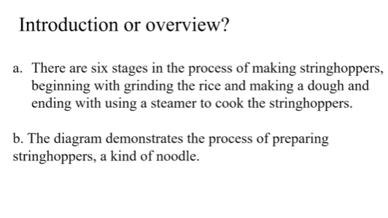
• a. "There are six stages in the process of making stringhoppers, beginning with grinding the rice and making a dough and ending with using a steamer to cook the stringhoppers."
→ This is an overview because it summarizes the main stages of the process.
• b. "The diagram demonstrates the process of preparing stringhoppers, a kind of noodle."
→ This is an introduction because it simply introduces what the diagram is about without giving details.
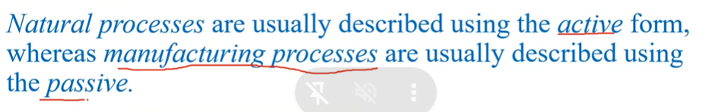
Produce = fabricate = make = manufacture

Remove = extract

a blast of air/noise =

form (v) - formation (n)
saturate = make something wet
The pictures show the process of making cherry jam. There are nine steps, starting with collecting cherries from the tree and finishing with putting labels on jars.

First, a sheet is put on the ground and the tree is shaken. The cherries fall down onto the sheet. Then the cherries are collected and moved to the factory. After that, the leaves and stems are removed. Next, the cherries are washed with water.

In the next stage, the stones are taken out from the cherries. After that, the cherries are cooked and extra things are added. Then the jam is checked for good quality. Later, the jam is put into jars. Finally, the jars are closed and a label is stuck on them.

In short, cherry jam production is a process that involves preparation, cleaning, cooking, quality control and packaging before the final product is ready for the consumer.

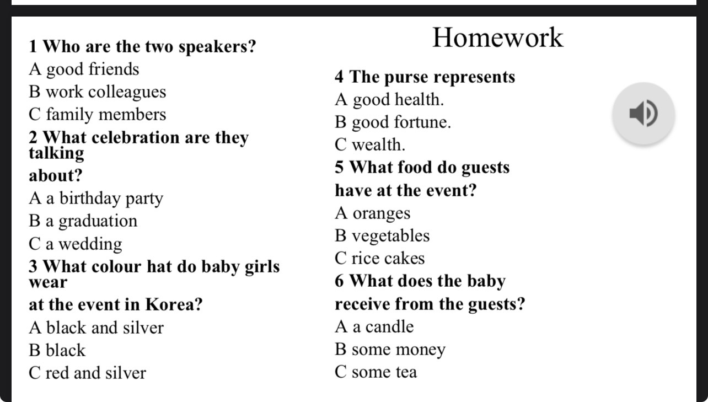

many, few: countable nouns => number of sth
much, little: uncountable nouns => amount of sth

a few: some few: not many
a little: some little: not much
colleagues: có li z

absolutely = yes
absolutely not = no

overcome difficulties

help+V/ to V
encourage sb to V
support sb to V
----------------
assist sb in Ving
aid sb in Ving

sometimes we go travelling to different places together
absolutely I like to spent time…

semi – một nữa , half

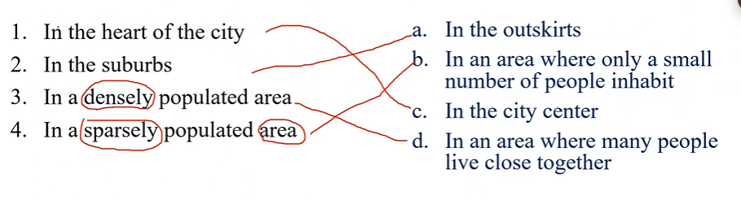

....sometimes we go travelling to different places together
I live in a detached house with a big garden in the back in a .....

I want to LIVE .. and SIGHTSEE

to be convenient for sb to do sth
It's convenient that S+V

Stuffy: ngột ngạt
Drafty: thông thoáng >< stuffy
deaf (adj): bị điếc
deafen(v): làm ai bị điếc
deafening(adj): ồn ào
I can immerse in the nature – đắm chiềm trong thiên nhiên
I like to live in a treehouse because firstly, it makes me feel cozy. Moreover, I enjoy living a high place so that it's drafty and I can be close to the nature

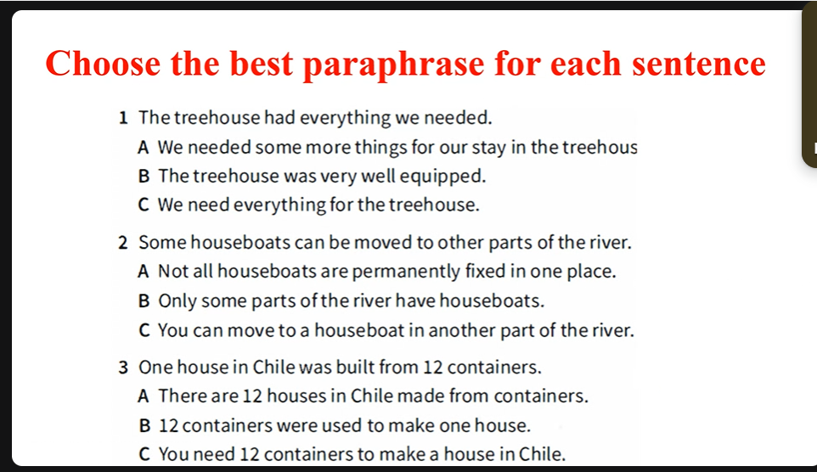
1️⃣ The treehouse had everything we needed.
✅ Answer: B. The treehouse was very well equipped.
👉 “Had everything we needed” = “was very well equipped.”
They both mean the treehouse already had all the necessary things.

2️⃣ Some houseboats can be moved to other parts of the river.
✅ Answer: A. Not all houseboats are permanently fixed in one place.
👉 If some can move, that means not all are fixed.
This keeps the same meaning logically.

3️⃣ One house in Chile was built from 12 containers.
✅ Answer: B. 12 containers were used to make one house.
👉 This is a direct rephrasing — “built from 12 containers” = “12 containers were used to make.”

equip sb/sth with sth
equip sb/sth for sth -> trang bị cho ai cái gì đó để làm gì đó

heart of QN – outskirt of QN

My house is very well equipped with a fridge and a washing machine.

I live in a detached house in the outskirt of QN. It is quite spacious with many rooms including 3 bedrooms, one for..,, one for my sister and the other is for me.
Moreover, there is a small garden in the front of the house where my mother grows flowers and vegetables.

Create, developed
Demolished
Increased in size
Relocated
Expanded
Separate

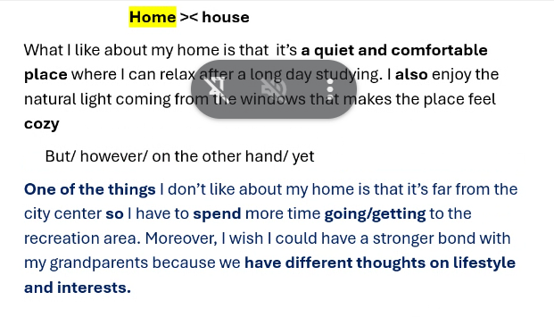
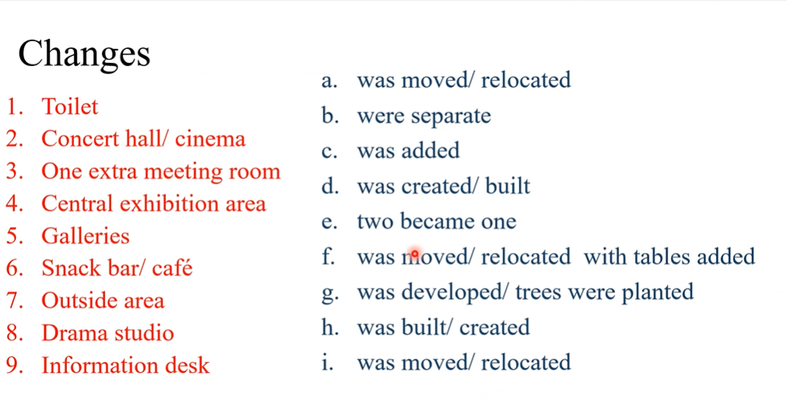

We can see that
It is clear that

- Happen – took place – Occurred
Intro: The two maps show the changes that occurred at the Co/wick Arts Centre between 2005 and the present day.
The two maps show how the Colwick Arts Centre has changed from 2005 to the present day.
Overview: We can see that the Colwick ..... was modernized with the addition of several new facilities and the expansions of the whole place.
Concluding: It is clear that the Cowick Arts Centre is now a much better and more modern place

I really like my home because it’s quiet and comfortable, which makes it easy for me to relax after a long day. The second thing I like about my home is natural light that comes in through the windows—it makes the place cozy and welcome
What I don’t like in my home is my house is far from the centre of QN city which take me many time to move to recreation area. Moreover, I hope that the generation gaps between my grandparents and me can be improved
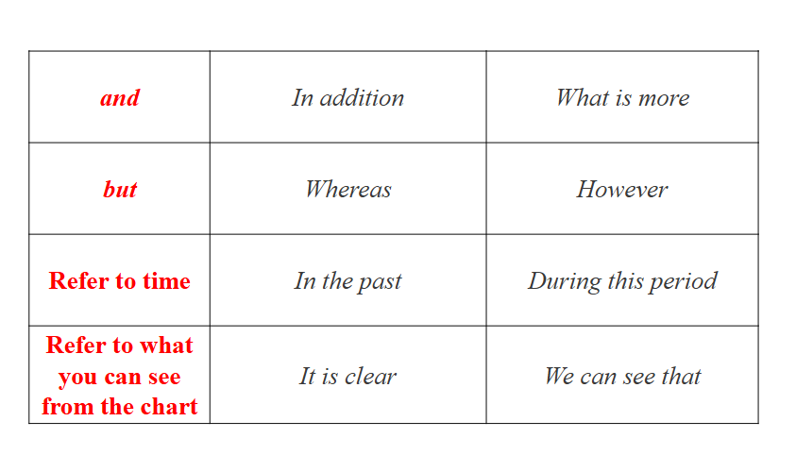
Knock – remove- destroy – demolish – pull down
Redevelop – modernize – rebuild - reconstruct - remodel
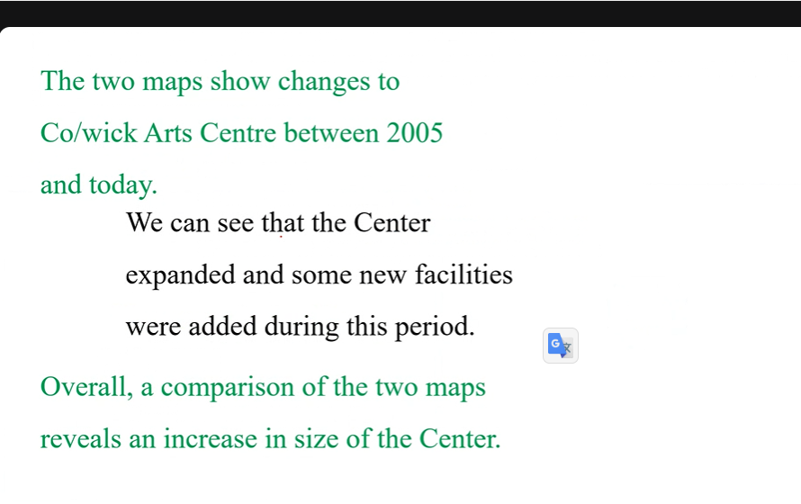
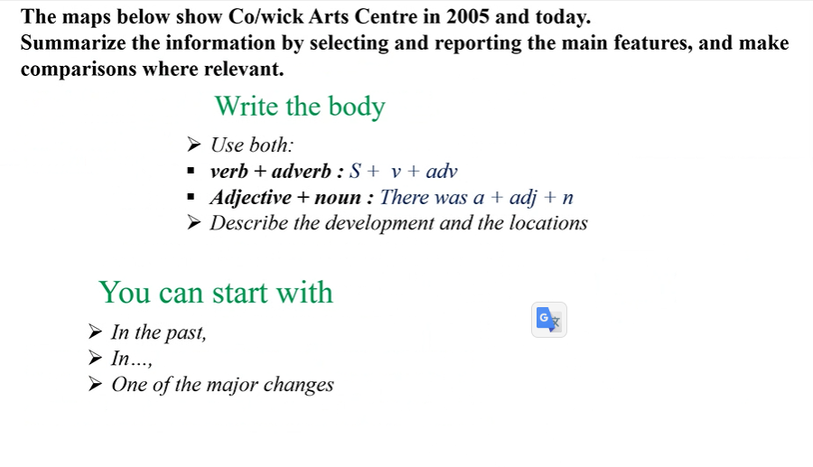
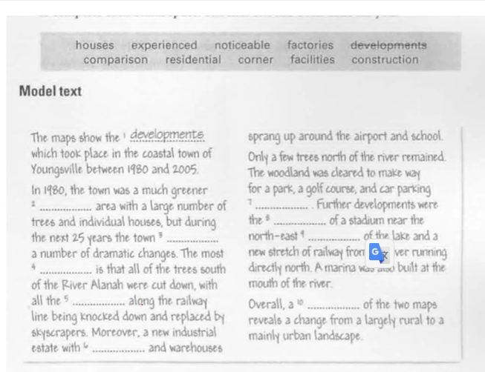

The two maps show the changes that occurred at the Co/wick Arts Centre between 2005 and the present day. Overall, We can see that the Co/wick Arts Centre was modernized with the addition of several new facilities and the expansions of the whole place.
In 2005, the building had a single area for the Concert Hall and Cinema. This space was split into two parts, the Cinema was moved to the top-right corner, and the Concert Hall was put on the bottom-right. Also, the two small Galleries were joined to become one large Gallery. What is more, a new large Central Exhibition Area was built near the middle of the building.
With these main changes, new facilities were added. A Drama Studio and a second Meeting Room were built next to the new Gallery space. In addition, some old facilities were moved. The Snack Bar was moved and changed into a Café with tables, and the Toilet also moved from the bottom-left to the bottom-right corner. The biggest change involved the Wasteland outside. This area was changed into an Outdoor Exhibition and Performance Area, which has a Stage and lots of trees planted to make it better.
So, It is clear that the Cowick Arts Centre is now a much better and more modern place.

Sigle story coachted - - ornate,cozy,tradiontial
Flat – glass contrcre steel – balcony – ultra modern, function, state-of-the-art (hiện đại) cramped (chật chội)
Two story house – brick – stairs case – conventional, typical, spacious, light, airy

Fabricated: chế tạo
Assembled: gộp lại
Confines: giới hạn

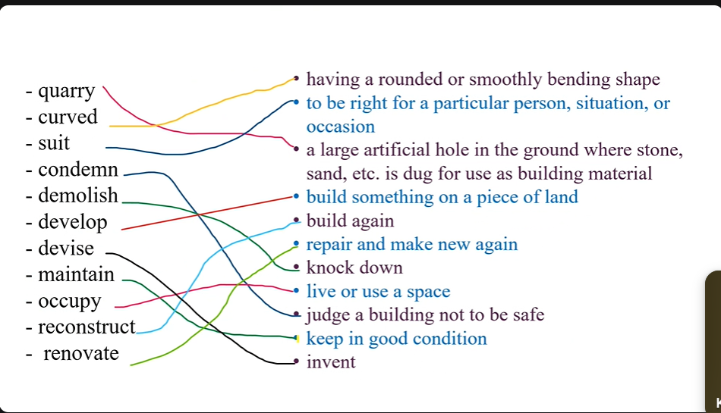

Yes, there’s a lot of exciting activities for young people to do, including fly a kite, hide and seek, … in beautiful parks, modern sports centers, and a huge skatepark.
In 5y ago my home town was much quieter and smaller. There were fewer buildings and not many entertainment options.

Yes, it has changed a lot. New shopping centers have opened, and many old buildings have been renovated and many convienient has been add including delivery food and

I come from a large, traditional city. You can see historic and ordinary buildings everywhere, where in summer quite hot and humid.
Because the city is so large, there's a lot of traffic and people on the streets, so it's quite busy and crowded. However, there's an incredible atmosphere in my town, especially in the tourist area, where it's very lively and exciting.

because it's easy for me to memorise things when other people are asleep
because it's easy for us to exchange our opinions, But if I have to work alone, I'd rather work with background music since I find it easy for me to concentrate
