**Your team Github URL**

**<https://github.com/jzhan862/615-project-Jinzhe>**

**The Github URL for the project you reviewed**

<https://github.com/Buoy-Project-Team-10/map_project>

**Does the code run?**

**Yes**

**How many maps are produced?**

**4**

**Comparison to Hurricane Exposure maps**

**10，10，10，10**

**Did your team include new code in your review?**

**No. But we found somewhere to improve.**

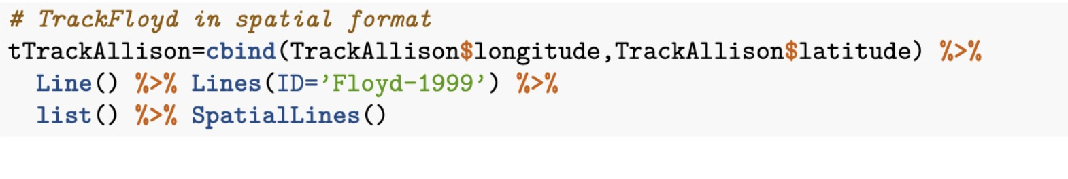

We think ID=Floyd-1999 should be replaced by ID=”Allison-2001”.