159.339 – Internet Programming

Semester 2 – 2018

Assignment 3

Benjamin Upton (16463710) & Zane Lamb(15160640)

# Report:

Specifications:

This project involved the creation of a back-end stock keeping system for a tool retailer. The following functionalities are included:

* Registration of users (using client-side validation to ensure no duplicate usernames and passwords meet a criteria). All user passwords are encrypted and stored as a hash string in the database.
* New users are sent a confirmation email that their account has been created.
* User sessions. A user must successfully log in to use the application. Any unauthorized attempt to access internal pages redirects to the login page.
* Search functionality. A user can query the application to find products that match their request. The search occurs in real time and will produce results for the user as they type their query.
* Browse functionality. A user can search the stock database based on categories and whether a product is in stock or not.

Design Choices:

The developers have proceeded with a clean, minimalistic approach to the application. The styling used is both functional, whilst being sophisticated and pleasing to the eye. An example of this can be found below. The project makes use of the concept of Model-View-Controller architecture to structure and separate the codebase based on both behaviour and data handling. The separation of concerns is consistent throughout the project, with use of the Document Object Model on the front end of development and MVC found in the back end.

Database:

This basic prototype for what could be a full application had a relatively simple database schema. There is only one relationship of note. The developers chose to separate the category of a tool from the tool specification itself. This prevents repetition in tool entries and if the project were to be extended, would help to ensure new products were always entered with a legitimate, pre-existing category. User accounts and products are both stored but have no other relationships to speak of.

Database Schema:

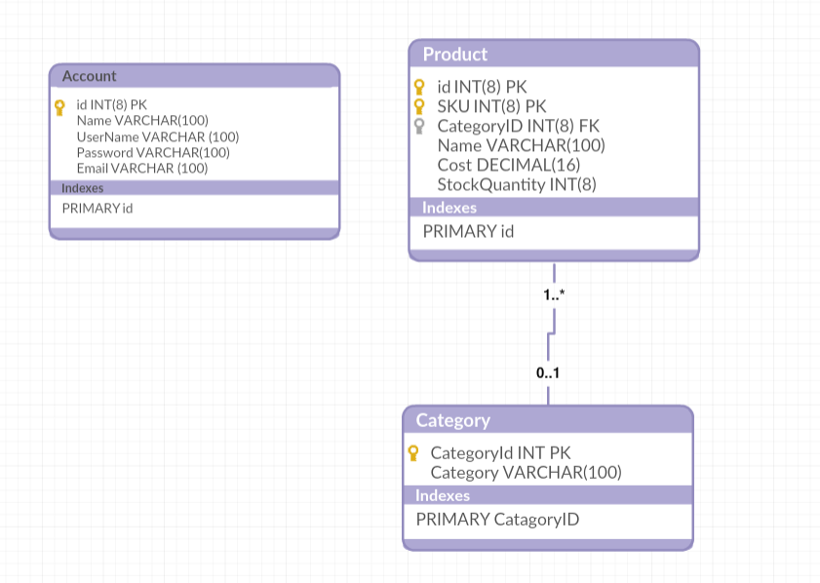

Example of styling:

