QA figure test

A
SoFi Stadium is the go-to destination in the heart of Los Angeles for sports fans. Its calendar is always packed with headline-grabbing events.
Upcoming Football Events
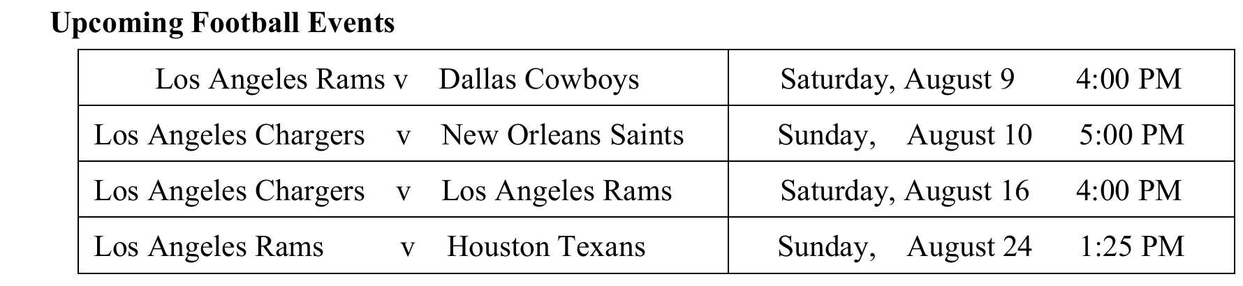
Nearby Hotels
When attending an event at SoFi Stadium, you’re just a short walk or ride from several comfortable and classy hotels. Right across the street, Sonder Lim Hotel offers spacious rooms and a rooftop pool. A mile away, the H Hotel Los Angeles, with its stylish design, is ideal for a nice stay between events. For those seeking both comfort and convenience, the Renaissance Los Angeles Airport Hotel is just a short drive away. If you’re willing to drive a little further, the Ritz-Carlton Los Angeles promises luxurious rooms and extensive leisure facilities- perfect for turning a game day into a great weekend escape.
Parking
SoFi Stadium requires you to park strictly in your assigned zone, and guests must enter through the exact gate indicated on their color-coded digital parking pass. If you enter through the wrong access point, you’ll be turned around and redirected-so plan ahead. Each parking zone consists of multiple lots, designed to efficiently manage traffic across the venue’s network. Make sure to download your parking pass to your smartphone before arrival. Upon entering the correct zone, parking staff will guide you directly to a space. For those wishing to park near friends, all vehicles must have passes for the same zone and arrive together--spaces cannot be saved.

1. Which team will play the most games at the stadium this month?
A. Washington Commanders.
B. Los Angeles Rams.
C. Los Angeles Chargers.
D. New Orleans Saints.
2. Which hotel is nearest to the stadium?
A. Sonder Lüm Hotel.
B. The Ritz-Carlton Los Angeles.
C. The H Hotel Los Angeles.
D. The Renaissance LA Airport Hotel.
3. What do you need to do if you want to park at the stadium?
A. Call the parking staff.
B. Prepay the parking fee.
C. Obtain a parking pass.
D. Choose a parking zone.

