Email Sentiment Analysis System
In this project as per your requirement we have designed web application which will accept either single email file as input and then detect sentiment from that email. User can upload folder with a sets of email and application can predict sentiment from all emails of a folder.
To implement this project we have designed following modules
- User Sign up: using this module user can sign up with the application
- User Login: after sign up can login to system
- Sentiment from Single Email: can upload a single file which contains email text and this text can have emoticons also and then application will read email and predict sentiment. This application can predict 5 different sentiments as ‘Positive, Negative, Neutral, Happy and extremely happy’.
- Sentiment from Email Folder: user can upload folder and then application can read all emails from folder and then predict sentiments
SCREEN SHOTS
To run project double click on run.bat file to get below screen
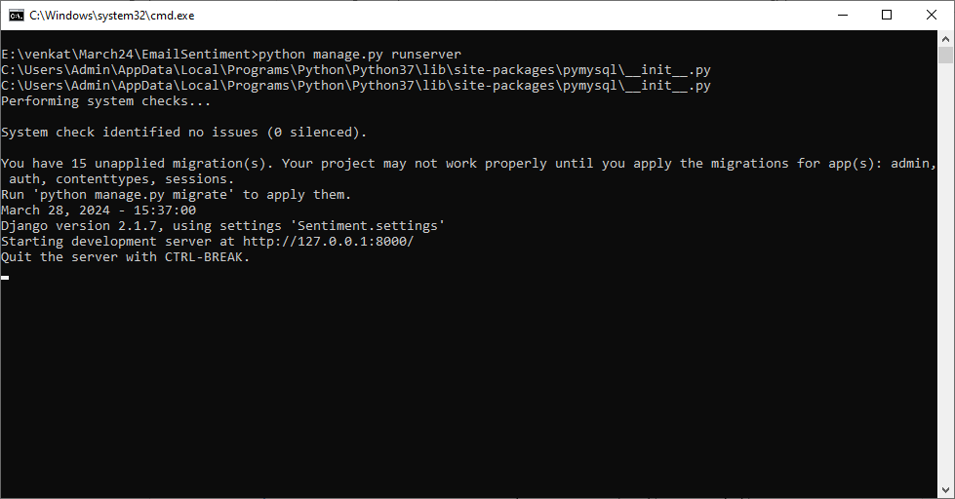
In above screen python server started and now open browser and enter URL as http://127.0.0.1:8000/index.html and press enter key to get below page
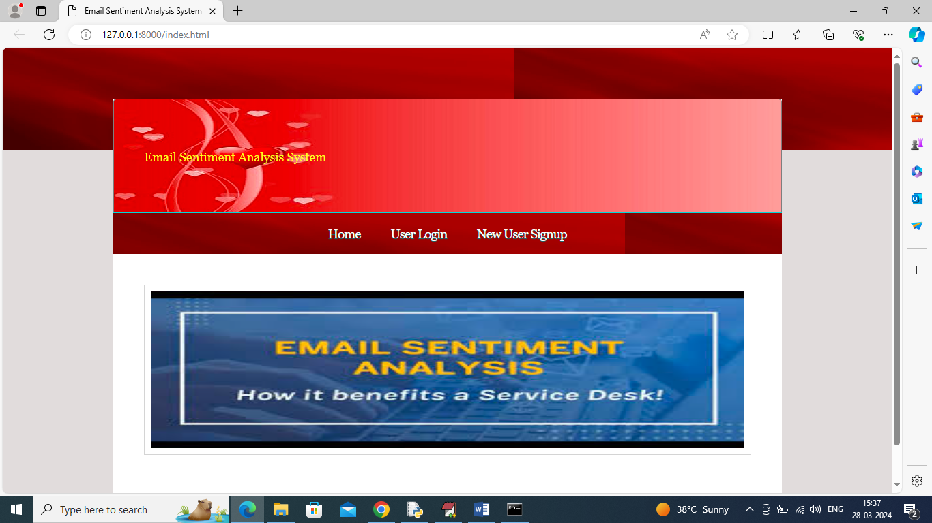
In above screen click on ‘New User sign up’ link to get below page
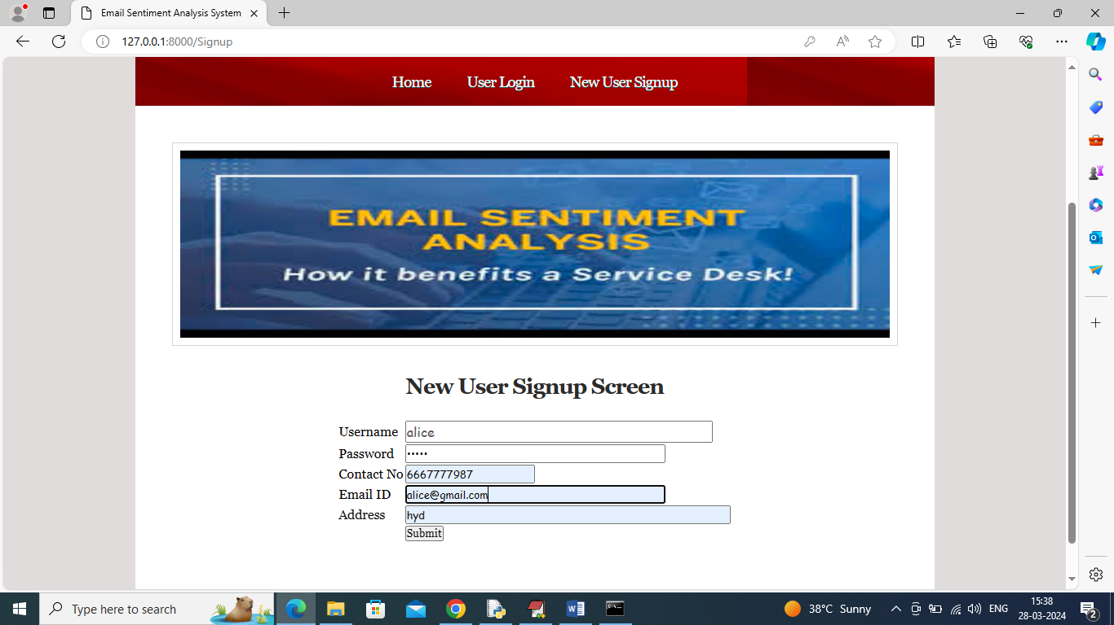
In above screen user is entering sign up details and then press button to get below page
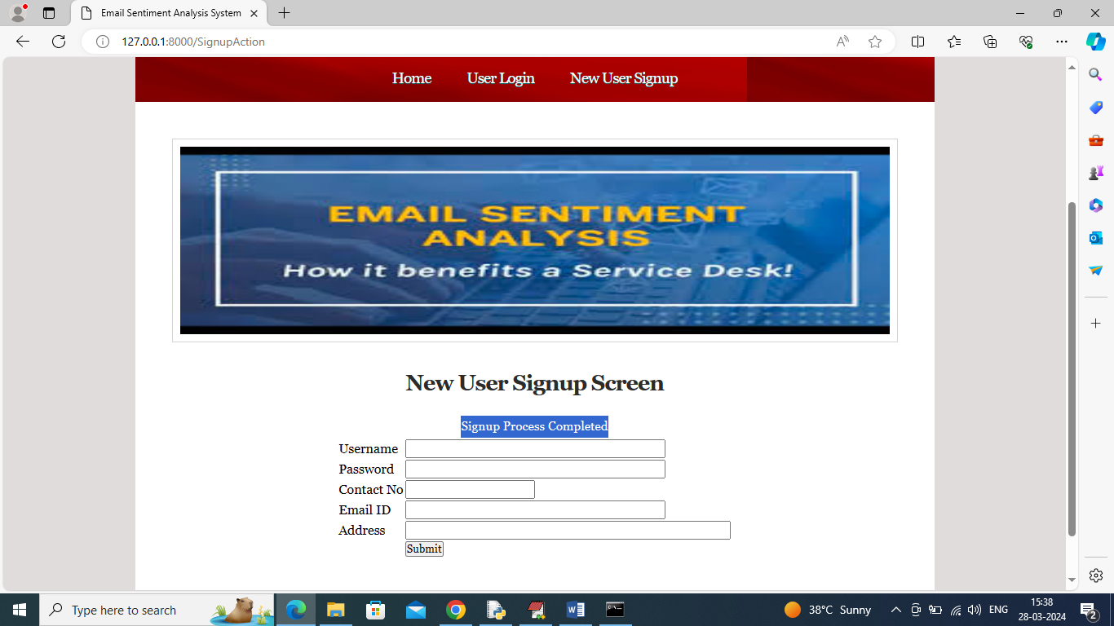
In above screen sign up completed and now click on ‘User Login’ link to get below page
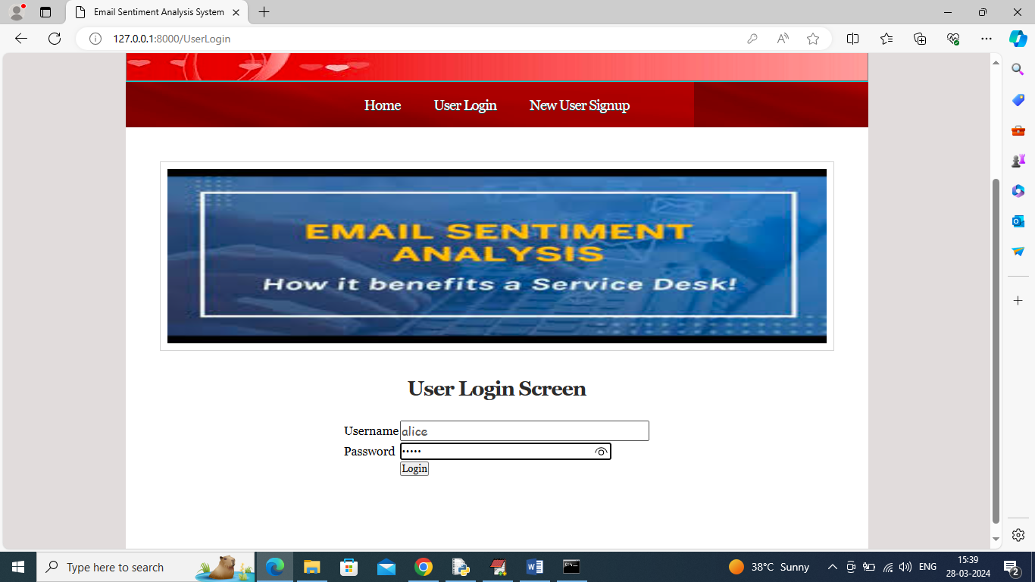
In above screen user is login and after login will get below page
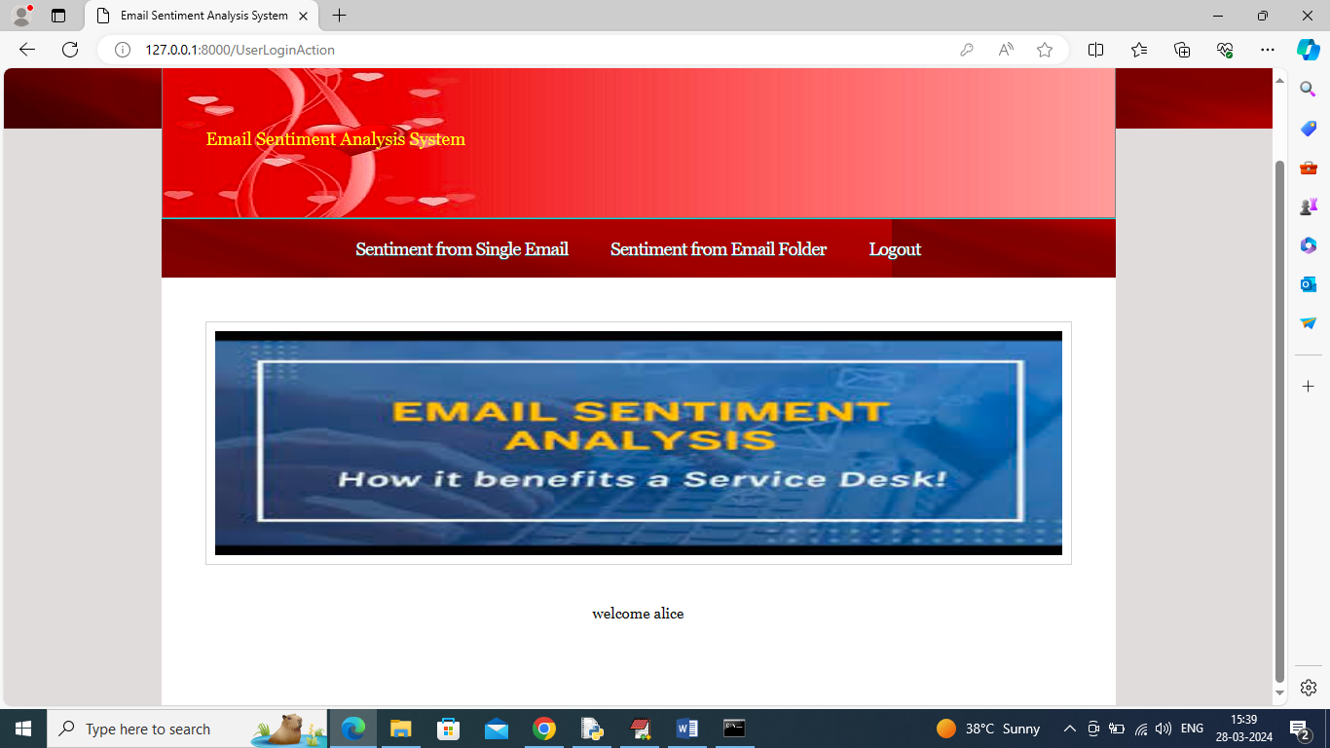
In above screen user can click on ‘Sentiment from single Email’ link to get below page
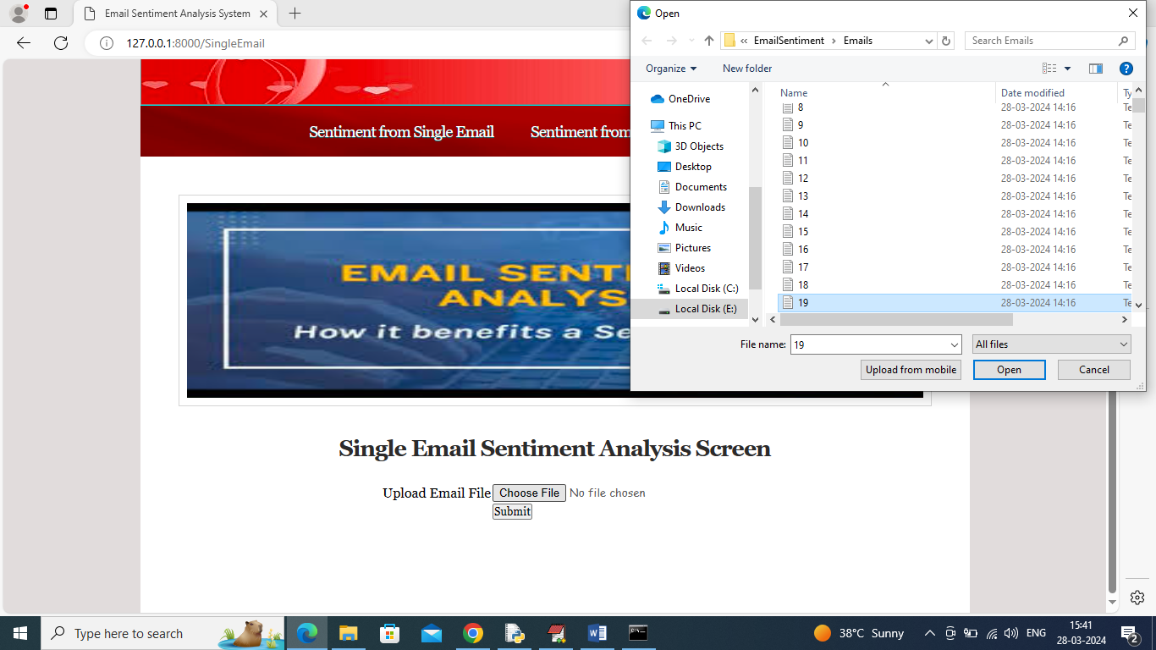
In above screen selecting and uploading 19.txt as single email file and then click on ‘Open’ and ‘Submit’ button to get below page
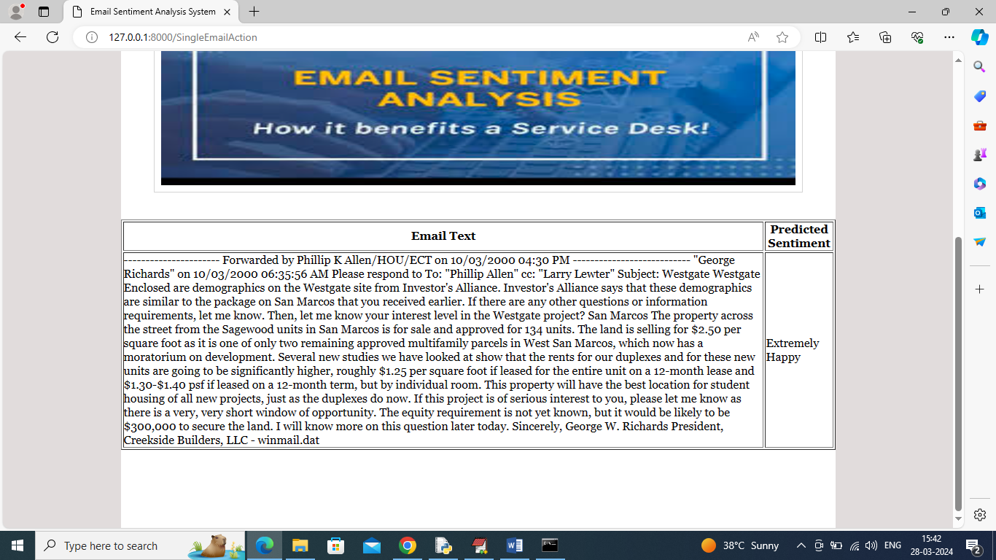
In above screen in first column can see email TEXT and in second column can see predicted sentiment as “extremely happy’ and similarly you can upload and test other emails and now click on ‘Sentiment Email from Folder’ link to get below page
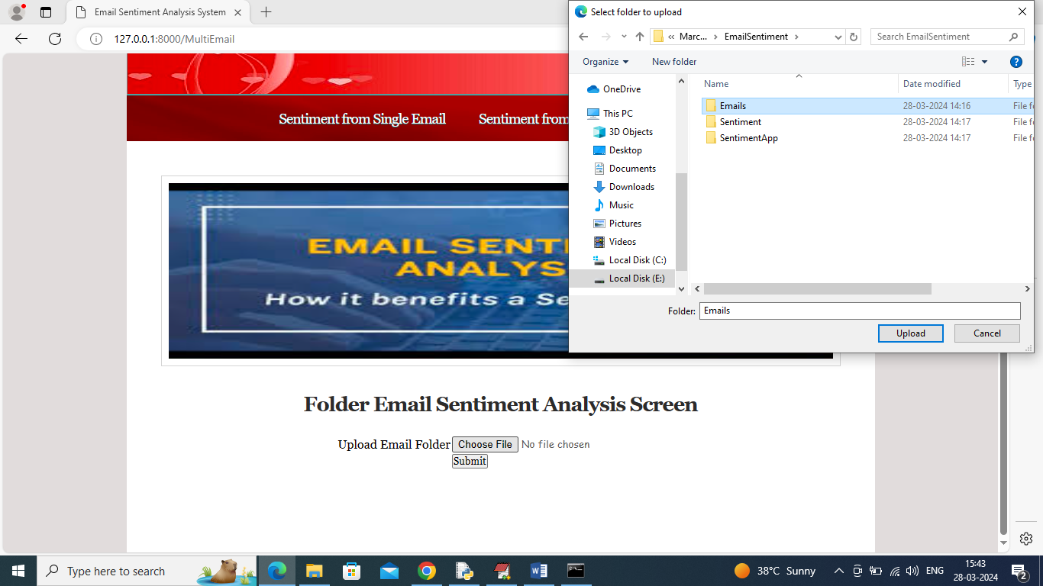
In above screen selecting and uploading entire ‘Emails’ folder which contains 1000 emails and then click on ‘Upload and Submit’ button to get below page
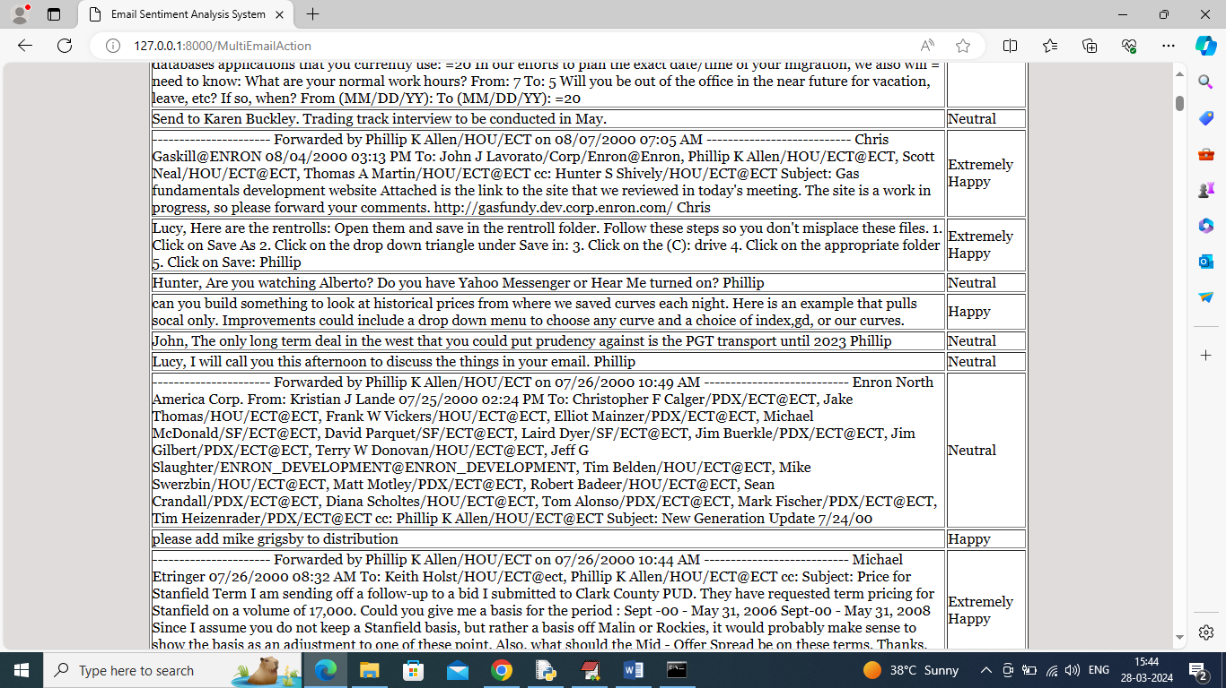
In above screen can see all emails in first column and in second column can see predicted sentiments.
Similarly upload single or multiple emails to predict sentiments by following above screens

