SUPPLEMENTARY A

TABLE I

Probabılıty of FEWER Mutatıons HAVING HIGHER Tm

|  |  |  |  |  |  |  |  |  |  |
| --- | --- | --- | --- | --- | --- | --- | --- | --- | --- |
| # of mutations    # of mutations | 2 | 3 | 4 | 5 | 6 | 7 | 8 | 9 | 10 |
| 1 | 0.127 | 0.037 | 0.012 | 0.005 | 0.002 |  |  |  |  |
| 2 |  | 0.182 | 0.063 | 0.023 | 0.011 | 0.006 |  |  |  |
| 3 |  |  | 0.22 | 0.086 | 0.038 | 0.018 | 0.01 |  |  |
| 4 |  |  |  | 0.251 | 0.114 | 0.053 | 0.026 | 0.016 |  |
| 5 |  |  |  |  | 0.28 | 0.142 | 0.073 | 0.038 | 0.023 |

TABLE II

Probabılıty of FEWER Mutatıons HAVING Tm WITHIN 5 °C

|  |  |  |  |  |  |  |  |  |  |
| --- | --- | --- | --- | --- | --- | --- | --- | --- | --- |
| # of mutations  # of mutations | 2 | 3 | 4 | 5 | 6 | 7 | 8 | 9 | 10 |
| 1 | 0.521 | 0.156 | 0.044 | 0.015 | 0.005 |  |  |  |  |
| 2 |  | 0.469 | 0.184 | 0.063 | 0.024 | 0.011 |  |  |  |
| 3 |  |  | 0.454 | 0.203 | 0.084 | 0.036 | 0.017 |  |  |
| 4 |  |  |  | 0.449 | 0.225 | 0.106 | 0.049 | 0.027 |  |
| 5 |  |  |  |  | 0.449 | 0.249 | 0.132 | 0.068 | 0.038 |

Here we randomly generated a random 25bp oligonucleotide and introduced different number random mutations and calculated Tm’s of interaction of original oligonucleotide with mutated oligonucleotides. For every mutation number pairs we generated 50000 oligonucleotides. Here we simulated variability in genomes; in general we would expect smaller number of mutations accumulated in a region in target genomes than in same region in background genomes, however in subtype differentiation studies of phylogenetically close highly variable genomes, this distinction beomes blurred.

In Table I, we report the probability when Tm of oligonuclotide with more mutations is higher. For example an oligonucleotide has 0.053 probability that its interaction with its complementary sequence with 7 mutations has higher Tm than its interaction with its complementary sequence with 4 mutations.

In Table II, we report the ratio when Tm of oligonuclotide with more mutations is within 5°C. For example an oligonucleotide has 0.106 probability that its interaction with its complementary sequence with 7 mutations has Tm that is within 5°C of its interaction with its complementary sequence with 4 mutations.

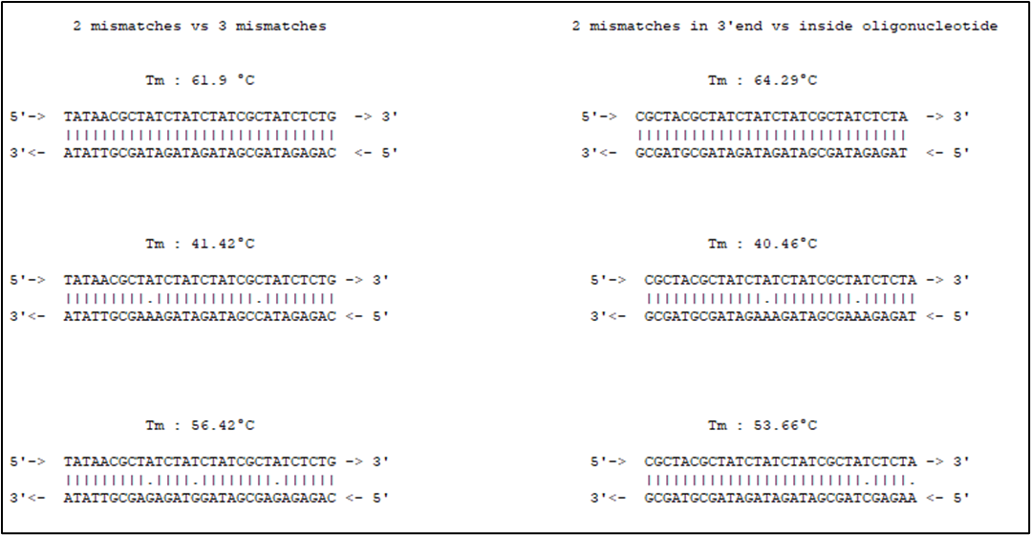

Fig. 1 Melting temperatures for different mismatch conditions