{{typeTest}}Test Report

Manufacturer | {{manufacturer}}  Gebze Org. San. Bölg. 1000.Cadde 13.Sokak No.:1004  41480 Gebze / Kocaeli / Türkiye |  |  |  | Client |  | {{client}}  Gebze Org. San. Bölg. 1000.Cadde 13.Sokak No.:1004  41480 Gebze / Kocaeli / Türkiye
Test object: | Metal-enclosed, air insulated AC, medium voltage switchgear  {{testobject}}
Serial No: | {{serialno}}
Designation: | {{paneltype}}
 | Rated voltage: | {{rV}} kV | Rated normal current: {{ra}} A |  |  |  |  | Rated frequency: {{rf}} Hz
 | Rated peak  Withstand current: | {{rp}} kA | Rated short-time  Withstand current: {{rc}} kA |  |  |  |  | Rated duration  of short-circut: {{rt}} s
Date of test
Applied test specifications:
IEC 62271-200: 2021-05,
clause 7.4 and 7.5
IEC 62271-1: 2017-07,
clause 7.4 and 7.5
IEC 61869-1: 2007-10,
clauses 6.4 and 7.2.2

Test performed:
Temperature rise test,
- Measurement of the resistance of the main circuit (before temperature rise test)
- Temperature rise test at current of {{tc}} A / 50 Hz
- Determination of the temperature rise of the secondary windings of current transformers
- Measurement of the resistance of the main circuit (after temperature rise test)

Test Results:
The above mentioned equipment under test has passed the tests performed in accordance with the applied test specifications

Kocaeli, {{reportdate}}

H. Coşkun ÖZTÜRK U. Barış KALKANCI
Test Engineer Test Engineer

Table of Contents

{{typeTest}}Test Report 1
Table of Contents 2
Technical Data of Test Object Switchgear 3
Technical Data of Test Object Switchgear (continued) 4
Identification of the Test Object ({{serialno}}) 5
Drawing No. 119-0366.2 Rev.01 Page.: 1- 6
Drawing No. 119-6081.4 Rev.00 Sh.No.: 01- 7
Material List of {{serialno}} : Page 1/10 8
Material List of {{serialno}} : Page 2/10 9
Material List of {{serialno}} : Page 3/10 10
Material List of {{serialno}} : Page 4/10 11
Material List of {{serialno}} : Page 5/10 12
Material List of {{serialno}} : Page 6/10 13
Material List of {{serialno}} : Page 7/10 14
Material List of {{serialno}} : Page 8/10 15
Material List of {{serialno}} : Page 9/10 16
Material List of {{serialno}} : Page 10/10 17
Test Arrangement and Measuring Points 18
Measuring Points 19
Temperature Rise Test 20
Temperature Rise Test (Continued) 21
Temperature Rise of Secondary Windings of the Cast-Resin Current Transformers 22
Measurement of the Resistance of the Main Circuit 23
Power Dissipated by Fuse Links 23
Test Results 23
Photos 24
Photos (Continued) 25

Technical Data of Test Object Switchgear

Test object: | {{testobject}}
Designation | {{paneltype}}
Manufacturer | {{manufacturer}}
Serial No: | {{serialno}}
Year of manufacture: | 2016
Drawing No: | See sheet 5,6,7,18,19
Ratings assigned by the manufacturer:
Rated voltage |  | {{rV}} | kV
Rated normal current |  | {{ra}} | A
Rated frequency |  | {{rf}} | Hz
Rated lightning impulse withstand voltage |  | {{rliv}} | kV
Rated power frequency withstand voltage |  | {{rpfv}} | kV
Rated peak withstand current |  | {{rp}} | kA
Rated short-time withstand current |  | {{rc}} | kA
Rated duration of short-circuit |  | {{rt}} | s
Insulating medium  IP Coding |  | Air  IP4X
Permissible values for internal arc faults:
Peak current |  | {{rp}} | kA
Short-circuit current |  | {{rc}} | kA
Duration of short-cirtcuit |  | {{rt}} | s
Further data:
Loss of service continuity category LSC |  | LSC 2B-PM
Internal arc qualification class  Essential characteristics and installed devices: |  | IAC A FLR {{iac}} kA {{iat}} s

- Current transformers

Type | Transformer ratio | Class of insulation | 1s1-1s2 coil parameters | Cl.: 5P10, 15VA
Type | Transformer ratio | Class of insulation | 2s1-2s2 coil parameters | Cl.: 1FS5, 15VA
Type | Transformer ratio | Class of insulation | Serial-No.
4MA72  PFK | 1250 / 1-1 A | {{ctins}} | L1 | L2 | L3
4MA72  PFK | 1250 / 1-1 A | {{ctins}} | 12/0388 | 12/0390 | 12/0389

- Circuit-breaker

Circuit-breaker type | 3AE5564-3
Serial-No | S 3AE5/00007563
Rated Voltage | 12 kV
Rated Current | 1600 A
Rated short-time withstand current | 25 kA
Rated duration of short circuit | 3s
Year of manufacture | 2016
Serial-No of vacuum tubes | L1: 146015875 L2: 146015883 L3: 146015867

Technical Data of Test Object Switchgear (continued)

- Voltage transformers

Type | Transformer ratio | Class of insulation | 1s1-1s2 coil parameters | Cl.:0.5,50VA Ith : 2A
Type | Transformer ratio | Class of insulation | 2s1-2s2 coil parameters | Cl.:3P,90VA Ith : 6A
Type | Transformer ratio | Class of insulation | Serial-No.
4MR12-PL  AYC | 6300/√3 / 100/√3-100/3 V | E | L1 | L2 | L3
4MR12-PL  AYC | 6300/√3 / 100/√3-100/3 V | E | 2015-1001620116 | 2015-1001620118 | 2015-1001620107

- Fuses
Manufacturer | Type designation | Rated Voltage | Rated Current
SIBA

- Busbar with copper bar {{busbar}} mm.
- Cable connection coppers for {{cable}} mm2 cable lugs per phase.

Identification of the Test Object ({{serialno}})

Drawing / Parts list  P=Parts list/D=Drawing |  | Rev. | P/D | Description | Remarks  (e.g. drawing date)
1 | <drawno1>Page.: 1- | <drawrev1> | D | NxAir VCB Panel 800mm Section View 12kV 25kA 1250A | İncluded in this test report
2 | <sinld>Page.: 1- | <sinldrev> | D | 12 kV 25kA 1250A NxAir Feeder Panel Outline Views& Single Line Diagram | İncluded in this test report
3 | <drawno2>Page: 1- | <drawrev2> | D | Arc Fault Bar | İncluded in this test report
4 | {{serialno}}: Page 1/2 | <matlistrev> | P | Material List of {{serialno}} | İncluded in this test report
5 | {{serialno}}: Page 2/2 | <matlistrev> | P | Material List of {{serialno}} | İncluded in this test report
*) P: parts list, D: drawing

The identification list of the test object was stamped by Siemens Testing Laboratory Gebze-Kocaeli and is archived in the test laboratory. The manufacturer confirmed whit his signature under the indentification list that the drawings and parts lists itemized in the identification list adequately describe the test object.
Remarks:

Test Arrangement and Measuring Points

¹⁾ Phases are short circuited (outside the panel on top of the rear box) in connection compartment with 2x60x10 copper conductors.
²⁾ Power is supplied to the test object via {{busbar}} extended busbars at point 1.
³⁾ Connection between the power supply and extended busbars are done by {{cable}} mm2 Cu-core cables per phase

Measuring Points

Temperature Rise Test

Date : <testdate>
Connection to Test Object : See sheet 10
Duration of Test : 19,7 Hours
Test Frequency : {{rf}} Hz
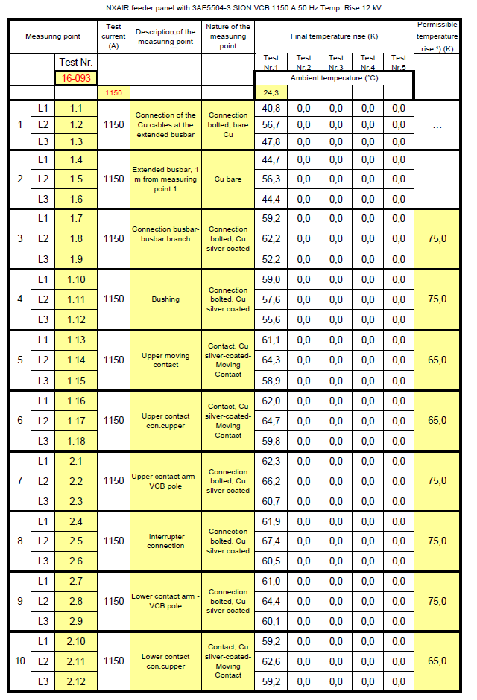

Temperature Rise Test (Continued)

Date : <testdate>
Connection to Test Object : See sheet 10
Duration of Test : 19,7 Hours
Test Frequency : {{rf}} Hz

Temperature Rise of Secondary Windings of the Cast-Resin Current Transformers

Date : <testdate>
Connection to Test Object : See sheet 10
Duration of Test : 19,7 Hours
Test Frequency : {{rf}} Hz

Temperature rise of secondary windings of the cast-resin current transformers

See: IEC 61869-1, 2007-10, clauses 6.4 and 7.2.2
The temperature rise of the windings is limited by the lowest class of insulation, either of the winding itself, or of the surrounding medium in which it is embedded.
Ratings assigned by the manufacturer:
- class of insulation of secondary winding: {{ctins}}, permissible temperature rise 75K at an ambient air temperature of 40 °C
- class of insulation of cast-resin bushing current transformers: {{ctins}}, permissible temperature rise 75K at an ambient air temperature of 40 °C.
The temperature rise of windings was calculated by following equation based of increase in resistance:

R_{ϑ} = R₂₀ [1+ α₂₀ x (ϑ - 20 °C)]

R_{ϑ} Resistance of winding Ω at a temperature ϑ (°C)
R₂₀ Resistance of winding Ω at an ambient air temperature of 20°C
α₂₀ Temperature coefficient of resistance for copper at an ambient air temperature of 20°C
(α₂₀ = 3,95 x 10⁻³ K⁻¹)
ϑ Temperature (°C) at measurement of resistance R_{ϑ} (Ω) (stagnation temperature for the test current of {{tc}} A / 50 Hz)
ϑ - 20°C Temperature rise of the winding (K)
t₂ Ambient temperature at the end of the test (°C)

Winding of the current transformer in the con. comp. | R₂₀ (Ω) | R_{ϑ} (Ω) | ϑ (°C) | ϑ - 20°C (K) | ϑ – t₂°C (K)
T1L2 / 1s1-1s2 | 5,576 | 6,974 | 83,5 | 63,5 | 59,2
T1L2 / 2s1-2s2 | 3,125 | 3,883 | 81,4 | 61,4 | 57,1

The permissible temperature rise of 75 K for the class of insulation {{ctins}} was not exceeded.

Measurement of the Resistance of the Main Circuit

Values before test
Date  29.06.2021 15:00 |  |  |  | Average Values
Ambient Air Temp.(˚C) | 24.6 | 24.7 | 24.9 | 24.7
 | Voltage Drop (mV)
L1 | 4.6 | 4.5 | 4.5 | 4.5
L2 | 4.2 | 4.5 | 4.5 | 4.4
L3 | 4.1 | 4.4 | 4.4 | 4.3

The resistance of the main circuit was measured with 100 A DC at ambient temperature on the test object between measuring point 2 and star point connection in the rear box by copper bars of {{cable}} mm.
(See sheet: 10 measuring points)

Power Dissipated by Fuse Links

Values of just before the end of the test period
Date
29.06.2021 15:00
 | L1 | L2 | L3
Voltage Drop (mV) | 50.5 | 50.5 | 50.5
Current (A) | 1249 | 1252 | 1254
Power (W) | 63,07

The voltage drop is measured between the fuse-link clamps (See sheet: 10 measuring points).

Test Results

The test object reached the final temperatures as shown in the survey on results. The permissible temperature rise according to IEC 62271-200:2021-05 was not exceeded.
The test has been passed.

Photos

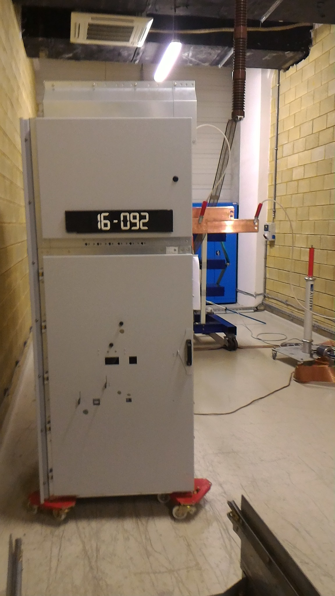
Photo No 1:Test object, front view

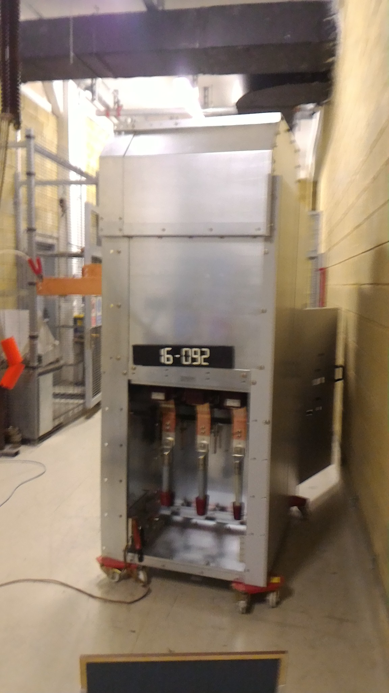
Photo No 2:Test object, rear view

Photos (Continued)

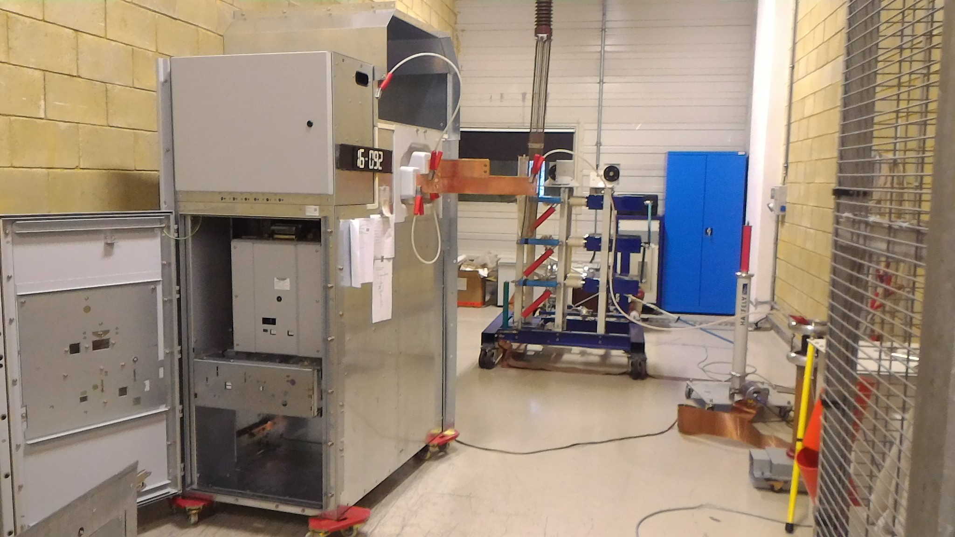
Photo No 3:Test object, lateral view

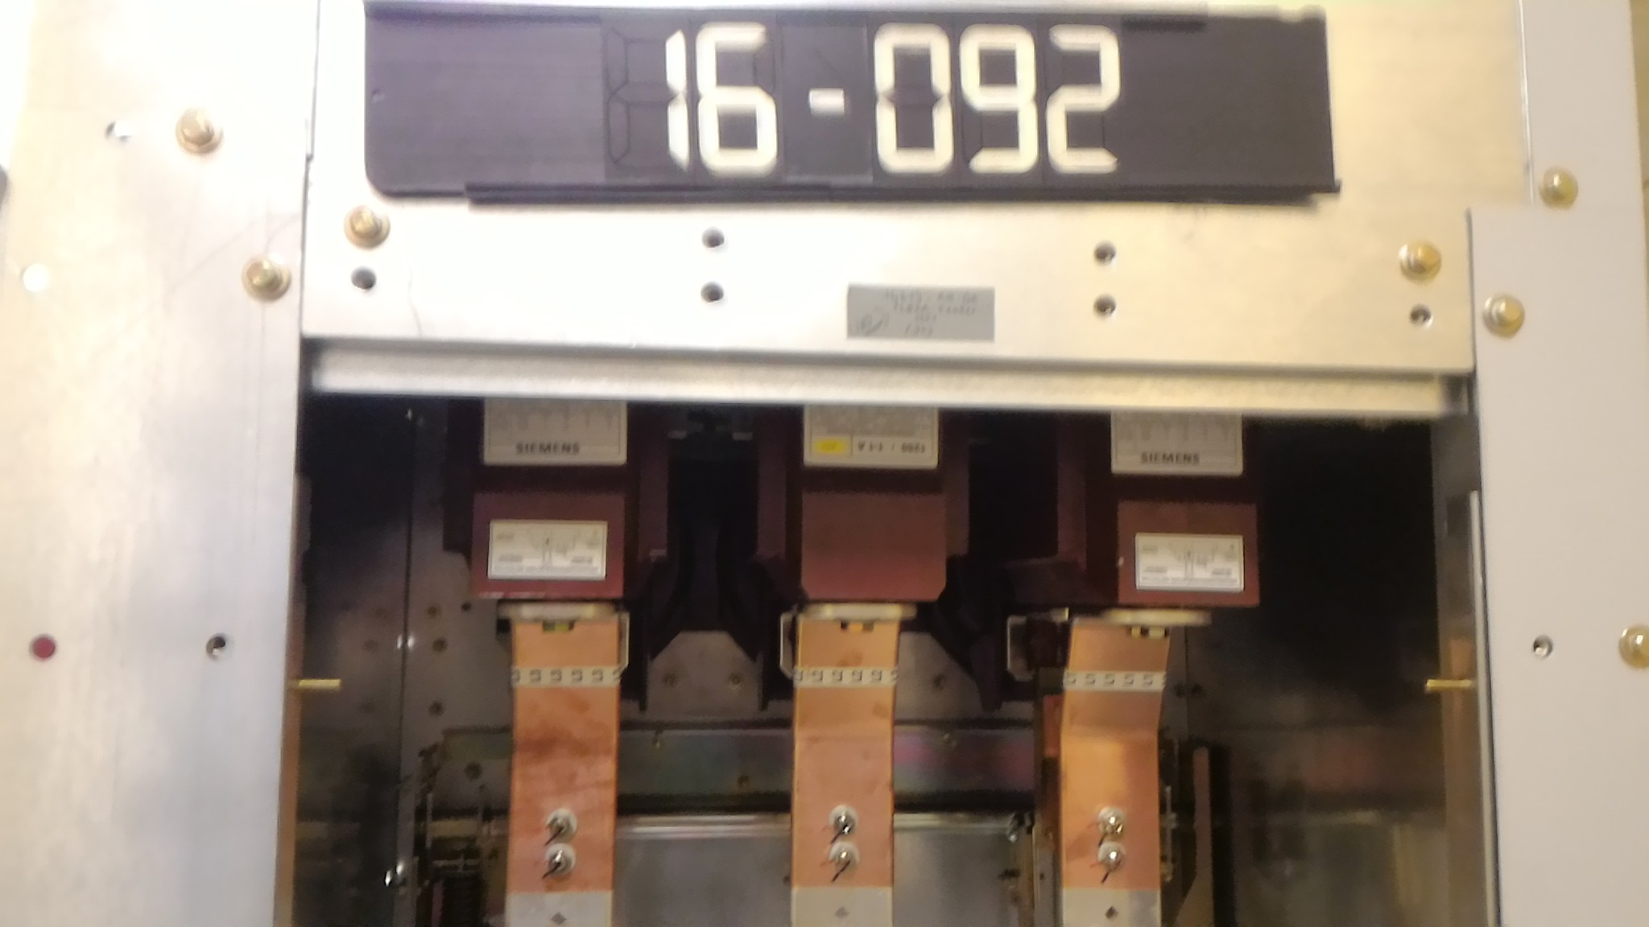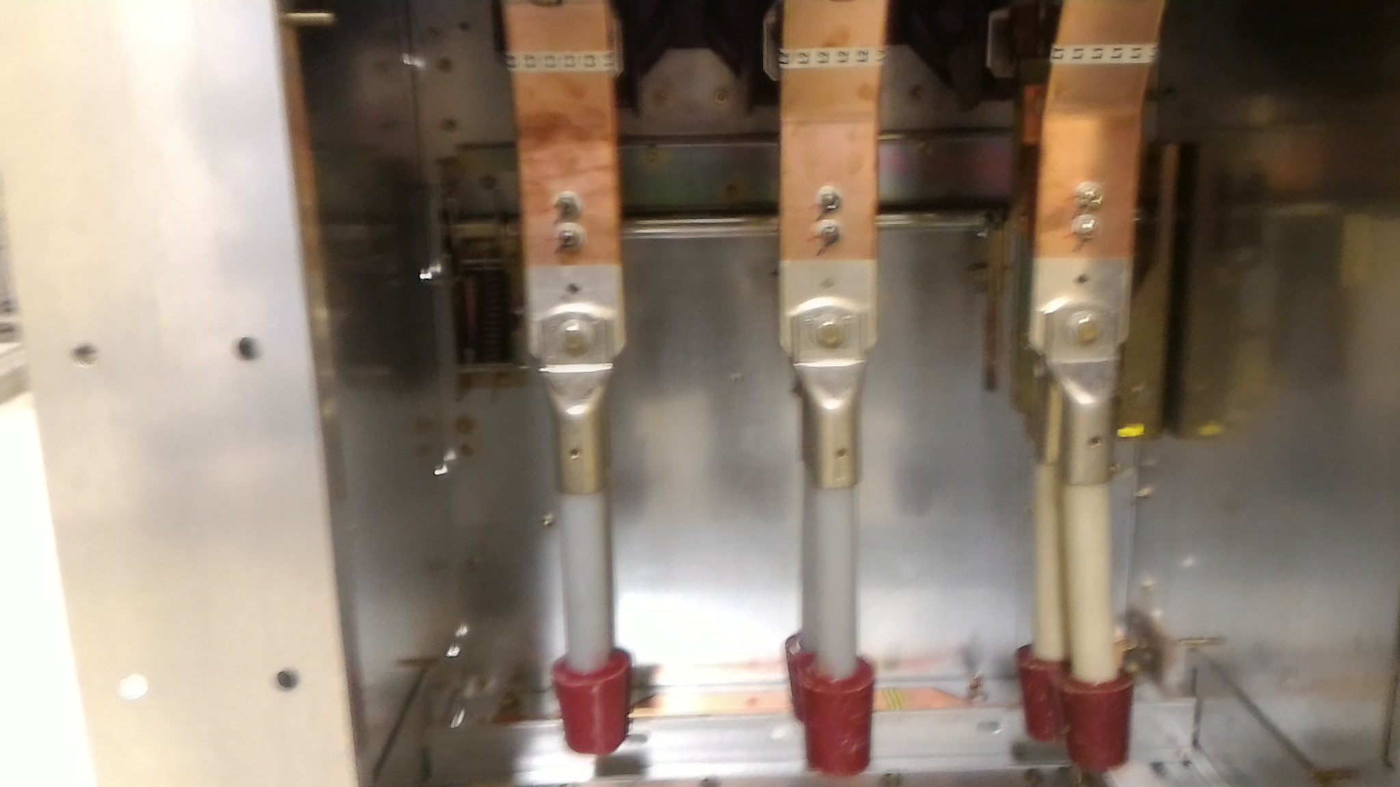
Photo No 4 & 5: Connection compartment of the test object

