2019 Spring CENG3528 Project Report

food order site with calories

# esra ay

# BURAK EKEN

# TABLE OF Contents

1. Project Introduction

2. Project Progress

2.1 Data Mining

2.2 Matching Data

2.3 Shiny UI

2.4 Shiny Server

3. Appearance

4.References

1.Project ıntroductıon

Nowadays, millions of people pay attention to the calories and nutritional values of the foods they eat. In this project we aimed to establish a food ordering site. The main feature of the site is that each meal data has a calorie value.

By filtering these calorie data, the user can display as many calories as desired on the application.

2.Project Progress

2.1 Data Mining

For create to our data, we used “RSelenium”, “XML”, “Httr” , “rvest”, “R.utils” and “stringr” library packages on R Studio. First we created a web server and opened it, then we navigate to “yemeksepeti.com” and load the data of all page with a loop. After, we scrapped the restaurant links for scrapping each page of restaurants.

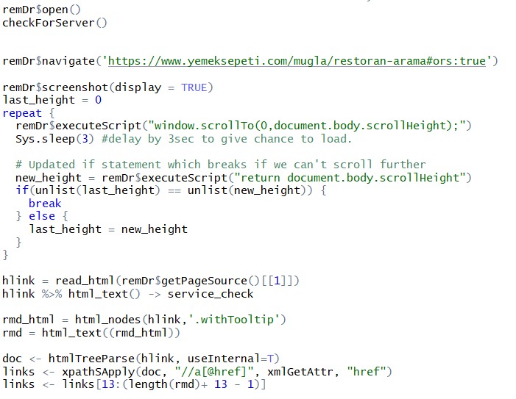

## 

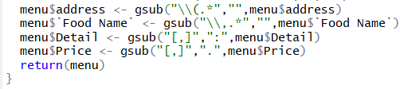

Next, we scrapped restaurant name, food name, detail, category, price and address from each restaurant then created a data.

After we scrapped the data from page of restaurants, we edited the data. First, we separated address column as district and neighborhood, changed comma with colon in detail column. Also, we changed comma with dot in price column. Then we removed the data of includes “menu” and “nylon bag”. Finally, we separated “drinks” from our data to work on easily.

2.2 Matching Data

**Adding Calories:**

For drinks table we found calories of drinks on internet and equaled with data.

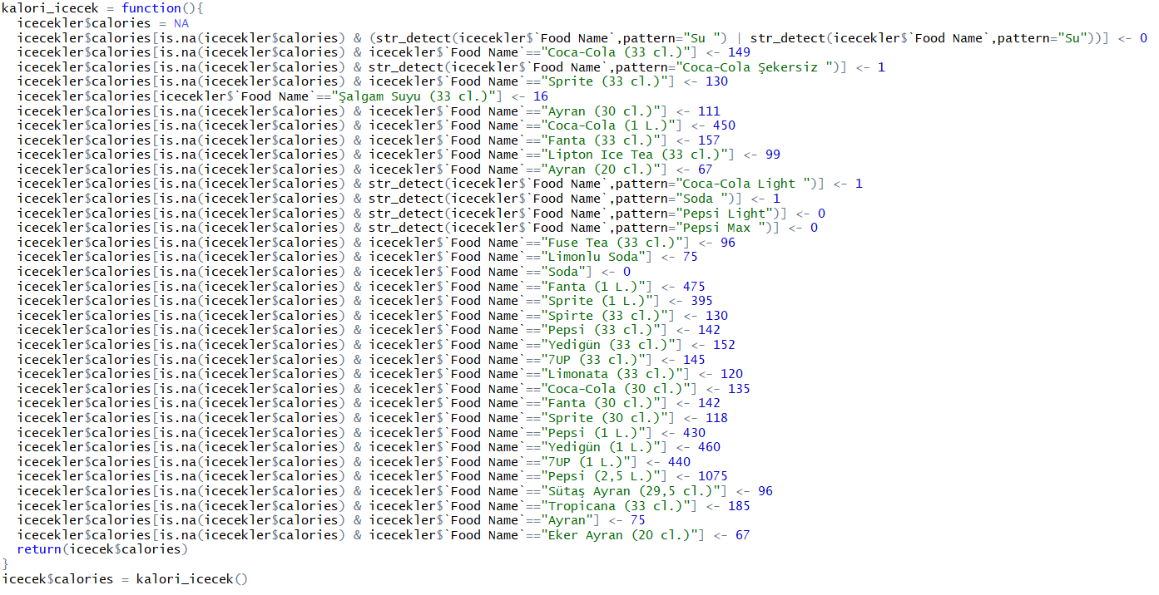

2.3 Shiny UI

We used the R Shiny app to present the data that we draw and add calories to the user. Our site has features such as ordinary food ordering sites, price range selection, city and county selection. Our own added calorie data can be displayed and filtered. There is also a map showing the locations of the restaurants.

metin, oturma içeren bir resim

Açıklama otomatik olarak oluşturulduekran görüntüsü içeren bir resim

Açıklama otomatik olarak oluşturuldu

We used “leaflet” library for map.

2.4 Shiny Server

In the server part, we prepared outputs for applying the filters we created for ui and creating the map. Every select or filter has a name and id.

User give input for these filters;duvar içeren bir resim

Açıklama otomatik olarak oluşturuldu

3.apPeARance

As final, we created a R Shiny app which contain some filters and map. iç mekan, bilgisayar içeren bir resim

Açıklama otomatik olarak oluşturuldu

harita içeren bir resim

Açıklama otomatik olarak oluşturuldu

4.references

[1]:https://callumgwtaylor.github.io/blog/2018/02/01/using-rselenium-and-docker-to-webscrape-in-r-using-the-who-snake-database/

[2]: <https://rstudio.github.io/leaflet/shiny.html>