Wykonanie: Grzegorz Denert, Michał Dorosz

**Zadanie 1.**

Zaimplementować perceptronową regułę uczenia. Algorytm powinien działać dla:

1. dowolnego wymiaru danych uczących

import numpy as np

def init_weights(n):

    return np.random.uniform(low = -10, high= 10, size=(n,))

def calculate_prediction(inputs,weights):

    sum = np.dot(inputs,weights)

    if sum >= 0:

        return 1

    else:

        return 0

def calculate_error(true_value, prediction):

    return true_value - prediction

def update_weights(inputs, true_value, weights):

    prediction = calculate_prediction(inputs,weights)

    error = calculate_error(true_value, prediction)

    weights[0:] += error * inputs

    return weights

def train(iterations, inputs, true_value, weights):

    i = 0

    while i < iterations:

        for x, y in zip(inputs, true_value):

            new_weights = update_weights(x,y,weights)

        i += 1

    return new_weights

Testowanie rozwiązania:

from sklearn.datasets import make_blobs

# generowanie zbioru danych

X, y = make_blobs(n_samples=1000,

                  n_features=2,

                  centers=2,

                  cluster_std=3,

                  random_state=23)

weights = init_weights(2)

new_weights = train(20,X,y, weights)

Generowanie wykresu

import matplotlib.pyplot as plt

def abline(ax, b, m, *args, **kwargs):

    "Add a line with slope m and intercept b to ax"

    xlim = ax.get_xlim()

    ylim = [m * xlim[0] + b, m * xlim[1] + b]

    ax.plot(xlim, ylim, *args, **kwargs)

fig, ax = plt.subplots()

ax.scatter(X[:, 0], X[:, 1], c=y, cmap='bwr', label='Data Points')

#slope and intercept

slope = -new_weights[0] / new_weights[1]

intercept = 0

#decision boundary line

abline(ax, intercept, slope, color='red', label=f'Line: y = {slope:.2f}x')

ax.set_xlabel('Feature 1')

ax.set_ylabel('Feature 2')

ax.legend()

ax.set_title('Scatter Plot with Decision Boundary')

plt.grid()

plt.ylim(-10, 10)

plt.xlim(-10, 10)

plt.show()

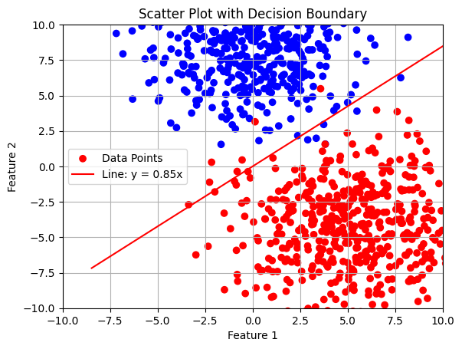Wykres prezentujący rozwiązanie:

1. dowolnej liczby neuronów w warstwie

import numpy as np

def init_neuron_weights(input_vector_size):

    return np.random.uniform(low = -10, high= 10, size=(input_vector_size,))

def init_layer_weights(layer_size, input_vector_size):

    layer_neurons_weights = []

    i = 0

    while i < layer_size:

        neuron_weights = init_neuron_weights(input_vector_size)

        layer_neurons_weights.append(neuron_weights)

        i += 1

    return layer_neurons_weights

def calculate_prediction(inputs,weights):

    sum = np.dot(inputs,weights)

    if sum >= 0:

        return 1

    else:

        return 0

def calculate_error(true_value, prediction):

    return true_value - prediction

def update_weights(inputs, true_value, weights):

    learning_coefficient = 0.1

    prediction = calculate_prediction(inputs,weights)

    error = calculate_error(true_value, prediction)

    inputs = np.array(inputs)

    weights[0:] += learning_coefficient*error * inputs

    return weights

def train(iterations, inputs, true_value, layer_weights):

    i = 0

    while i < iterations:

        for x, ys in zip(inputs, true_value):

            for weights,y  in zip(layer_weights,ys):

                new_weights = update_weights(x,y,weights)

        i += 1

    return layer_weights

Testowanie rozwiązania:

# linearly separable dataset with two classes

X, y = make_blobs(n_samples=1000,

                  n_features=2,

                  centers=3,

                  cluster_std=2,

                  random_state=23)

y_coded = []

for element in y:

    if element == 0:

        y_coded.append([0,0,0])

    elif element == 1:

        y_coded.append([0,0,1])

    elif element == 2:

        y_coded.append([0,1,0])

layer_weights = init_layer_weights(3,2)

new_layer_weights = train(10,X, y_coded, layer_weights)

Generowanie wykresu

def abline(ax, b, m, *args, **kwargs):

    "Add a line with slope m and intercept b to ax"

    xlim = ax.get_xlim()

    ylim = [m * xlim[0] + b, m * xlim[1] + b]

    ax.plot(xlim, ylim, *args, **kwargs)

fig, ax = plt.subplots()

colormap = np.array(['r', 'g', 'b'])

ax.scatter(X[:, 0], X[:, 1], c = colormap[y], label='Data Points')

for neuron_weights in new_layer_weights:

    slope = -neuron_weights[0] / neuron_weights[1]

    intercept = 0

    abline(ax, intercept, slope,

color='red',

label=f'Line: y = {slope:.2f}x')

ax.set_xlabel('Feature 1')

ax.set_ylabel('Feature 2')

ax.legend()

ax.set_title('Scatter Plot with Decision Boundary')

plt.grid()

plt.ylim(-10, 10)

plt.xlim(-10, 10)

plt.show()

Wykres prezentujący rozwiązanie:

**Zadanie 2**

Rozwiązać problem AND i OR (dla odpowiednich dwuwymiarowych danych wejściowych , 0 i 1,

neuron powinien zwracać na wyjściu odpowiadające im wartości funkcji AND i OR):

1. Samodzielnie (bez uczenia): zdefiniować neuron dyskretny wyznaczając jego wartości wag.

Narysować otrzymane rozwiązania.

**Bramka AND**

Obliczenia:

Kod:

|  |
| --- |
| import matplotlib.pyplot as plt  import numpy as np.  def calculate_neuron(inputs, weights, threshold):      return 1 if weights[0]*inputs[0]+weights[1]*inputs[1]-threshold>=0 else 0  inputs = [(0, 0), (0, 1), (1, 0), (1, 1)]  and_threshold = 1.5  and_weights = [1, 1]  sums = {}  for inp in inputs:      sums[inp] = calculate_neuron(inp, and_weights, and_threshold)  sums |
| {(0, 0): 0, (0, 1): 0, (1, 0): 0, (1, 1): 1} |

Wykres:

|  |
| --- |
| x = np.linspace(-1, 2, 100)  y = -1*x+1.5  plt.plot(x, y)  for point in inputs:          plt.scatter(point[0], point[1], color='red') |

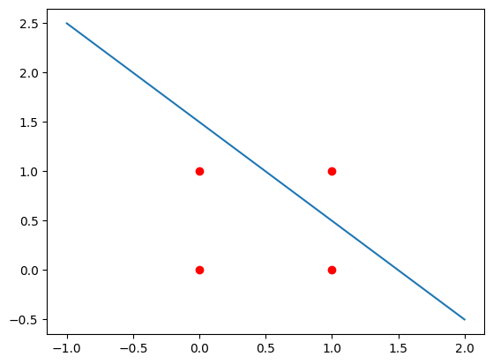

**Bramka OR**

Obliczenia:

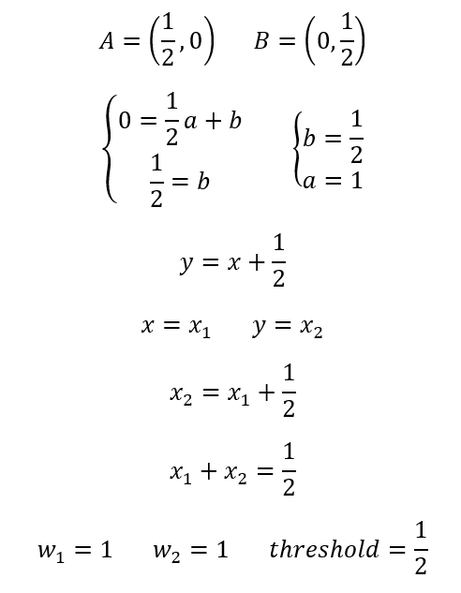

Kod:

|  |
| --- |
| or_threshold = 0.5  or_weights = [1, 1]  sums = {}  for inp in inputs:  sums[inp] = calculate_neuron(inp, or_weights, or_threshold)  sums |
| {(0, 0): 0, (0, 1): 1, (1, 0): 1, (1, 1): 1} |

Wykres:

|  |
| --- |
| x = np.linspace(-1, 2, 100)  y = -1*x+1.5  plt.plot(x, y)  for point in inputs:          plt.scatter(point[0], point[1], color='red') |

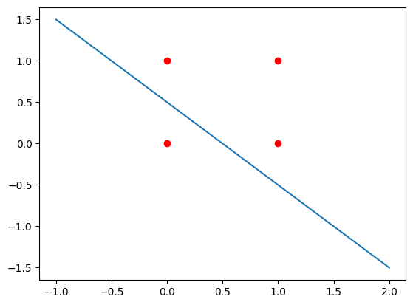

1. Wykorzystując regułę perceptronową: przeanalizować wstępne (losowe) wagi neuronów, a

następnie wagi po uczeniu. Ile iteracji wymagał proces uczenia? Narysować położenie

prostych reprezentujących neuron po inicjalizacji wag oraz otrzymane rozwiązania.

Perceptronowa reguła uczenia:

|  |
| --- |
| import numpy as np  def init_weights(n):      return np.random.uniform(low = -10, high= 10, size=(n,))  def calculate_prediction(inputs,weights):      sum = np.dot(inputs,weights)      if sum >= 0:          return 1      else:          return 0  def calculate_error(true_value, prediction):      return true_value - prediction  def update_weights(inputs, true_value, weights):      prediction = calculate_prediction(inputs,weights)      error = calculate_error(true_value, prediction)      weights[0:] += error * inputs      return weights  def train(iterations, weights, X_train, y_train):      i = 0      while i < iterations:          for x, y in zip(X_train, y_train):              new_weights = update_weights(x,y,weights)          i += 1      return new_weights |

**Bramka AND**

|  |
| --- |
| x_train = np.array([  [1, 0, 0], # bias, x1, x2  [1, 0, 1],  [1, 1, 0],  [1, 1, 1]  ])  y_train = np.array([0, 0, 0, 1]) |

Inicjalizacja wag, wstępne wagi neuronu:

|  |
| --- |
| weights = init_weights(x_train.shape[1])  weights |
| array([ 7.14467078, -8.00879785, -9.06272004]) |

Uczenie, wagi po nauczeniu, liczba iteracji:

|  |
| --- |
| def calculate_neuron(inputs, weights):      return 1 if weights[0]*inputs[0]+weights[1]*inputs[1]+weights[2]*inputs[2]>=0 else 0  counter = 0  while [calculate_neuron(x_train[i], weights) for i in range(len(y_train))] != y_train.tolist():      weights = train(1, weights, x_train, y_train)      counter+=1  weights = weights.tolist()  weights, counter |
| ([-3.0012682444802667, 2.0915894486629956, 1.3319104175388503], 13) |

Wykres:

|  |
| --- |
| # w0*1+w1*x1+w2*x2 = 0  ->  w2x2 = -w1x1-w0  ->  x2 = -w1x1-w0/w2  x1 = np.linspace(-1, 2, 100)  x2 = -1*(weights[1]*x1+weights[0])/weights[2]  plt.plot(x1, x2)  plt.xlabel('x1')  plt.ylabel('x2')  for point in inputs:      plt.scatter(point[0], point[1], color='red') |

**Bramka OR**

|  |
| --- |
| x_train = np.array([  [1, 0, 0], # bias, x1, x2  [1, 0, 1],  [1, 1, 0],  [1, 1, 1]  ])  y_train = np.array([0, 0, 0, 1]) |

Inicjalizacja wag, wstępne wagi neuronu:

|  |
| --- |
| weights = init_weights(x_train.shape[1])  weights |
| array([ 8.86592666, -6.97548513, -2.64845347]) |

Uczenie, wagi po nauczeniu, liczba iteracji:

|  |
| --- |
| counter = 0  while [calculate_neuron(x_train[i], weights) for i in range(len(y_train))] != y_train.tolist():      weights = train(1, weights, x_train, y_train)      counter+=1  weights = weights.tolist()  weights, counter |
| ([-0.13407333604199323, 1.0245148672552187, 0.35154653105984224], 18) |

Wykres:

|  |
| --- |
| x1 = np.linspace(-1, 2, 100)  x2 = -1*(weights[1]*x1+weights[0])/weights[2]  plt.plot(x, y)  plt.xlabel('x1')  plt.ylabel('x2')  for point in inputs:      plt.scatter(point[0], point[1], color='red') |

