DISCOVER ASSOCIATIONS BETWEEN PRODUCTS

Kevin Bergmeijer and Alejandro Rojo

11/12/2019

# Introduction

This report will show the *basket market analysis* to better understand the clientele that Electronidex – a start-up electronics online retailer- is currently serving. The final goal is advice and discuss if Electronidex would be an optimal acquisition based on the findings shown in this report.

#### Objectives

The objectives of this inform are the following:

* Find patterns or item relationships within transactions.
* Debate if should Blackwell acquire Electronidex.
* Make recommendations about this possible acquisition.

#### Materials

For the development of this exercise the data sets provided by Danielle Sherman via e-mail in .csv and pdf. formats will be used, consisting of the following documents:

* *ElectronidexTransactions2017.csv* – This csv file contains a record of one month (30 days) of 9835 online transactions and which items were purchased out of the 125 products that Electronidex sells.
* *ElectronidexItems2017.pdf* – This pdf file contains a list of the 125 products that Electronidex sells broken down into 17 product types.
* *existingprodutattributes2017.csv* – This csv file contains information about product features, reviews and historical sales information. This file has been rescued from the last task.

# Data Exploration

For the development of this analysis, initially the databases have been imported and worked on a sparse matrix that included 98355 observations (transactions) on 125 attributes (product types). It supposes 43104 products bought in one month by Electronidex.

#### Cleaning data

It has been removed to transactions because their respective rows (*8707*&*9506*) were empty (missing data).

#### Categorizing the dataset

In a first approximation, the product names have been changed by their product types, keeping the 17 original categories given by Electronidex. Also, the items have been listed by brand to explore the data. It was tried to make a *gaming* category, but in a later analysis was noticed that there were no relevant results.

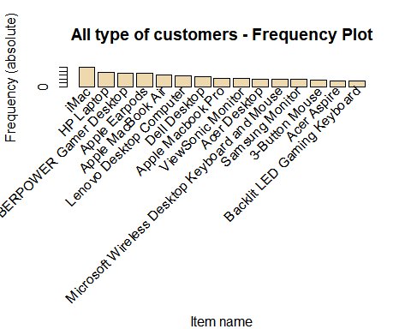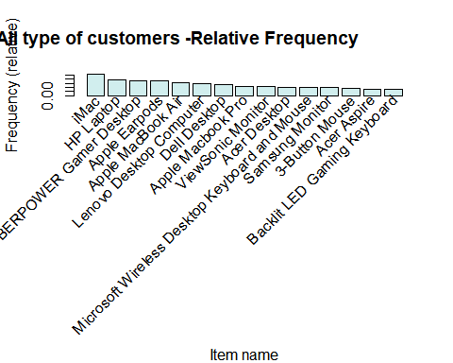

# Creating new groups: retailers and corporate

Before starting the search of rules, has been observed that clients are divided in two classes by the kind of buy that they make: retailers and corporate. For example, some customers bought 7 desktops or 3 printers. That is not a normal way to electronic products for a person, but it can be understood in a company context. So, for a better analysis, the sample has been split in that groups. For do it, four product types were categorized as ***Main items*** (*Laptops, Desktops, Tablet* and *Printer*). The rest of the products were categorized as ***Extra items***.

The following rules were established to catalogue transactions:

* If the transaction included more than one main item, it was listed as corporate (B2B).
* If the transaction included four extra items, it was also listed as corporate (B2B).
* All other transactions were catalogued as retailers (B2C).

Has been found that 5327 of the transactions were B2B (54,17%) and 4506 were B2C (45,83%). Talking about the number of total products sold, B2B suppose 34867 (80,89%) of the sold items and B2C the other 8237 (19,11%).

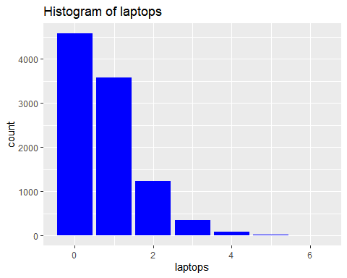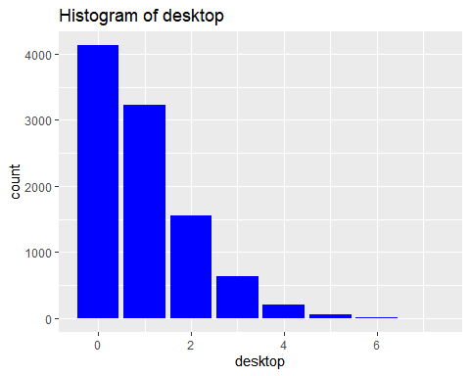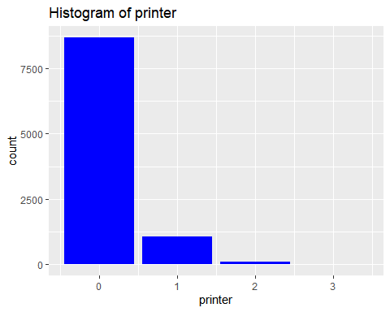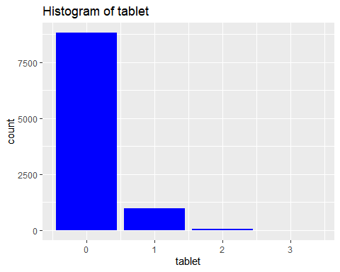

# Retail transactions

To create the rules, following parameters has been set:

* Support=0.02
* Confidence=0.02

The redundant rules were removed from the results. Here are shown the most relevant rules sort by lift, support and confidence. Any relevant rule about market basket associations has been noticed for the retail transactions.

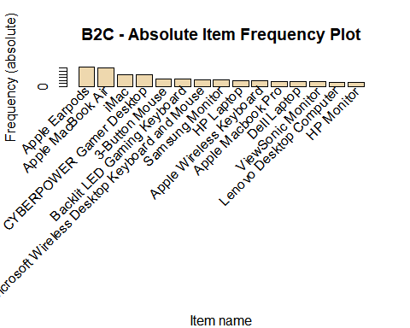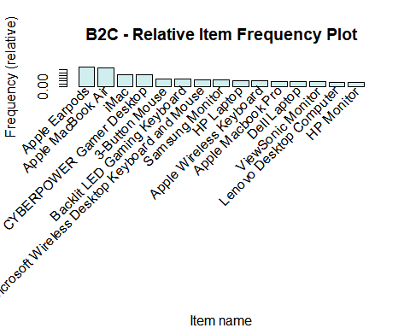

# Corporate transacions

To create the rules, following parameters has been set:

* Support=0.02
* Confidence=0.02

The redundant rules were removed from the results. Here are shown the most relevant rules sort by lift, support and confidence.

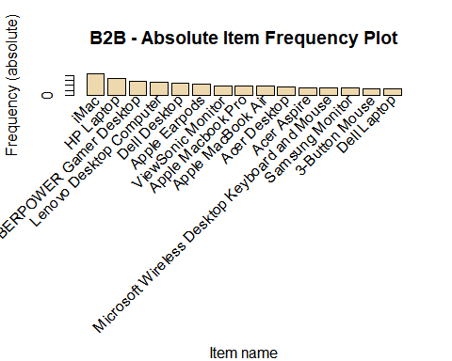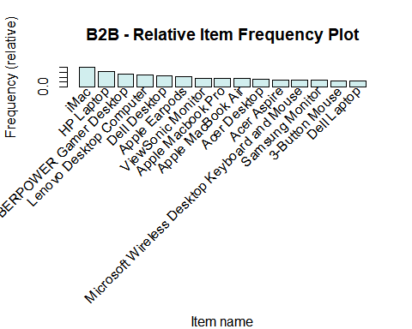

**Any relevant rule about market basket associations has been noticed for the corporate transactions.**

# Conclusions

* First of all, this dataset used is a sample of the transactions made in one month by Electronidex. The results are not considered as absolute because they can be biased. Therefore, these conclusions should be thought of as something indicative.
* Have been observed some rules as a result of the market basket associations. These were considered Irrelevant Rules because they were not helpful or were obvious. If the dataset will be expanded with a greater number of transactions and more qualitative / quantitative information about the transactions (price or location of the client, for example) it should be re-analysed to find relevant results.
* Electronidex is a company in which more than half of sales are corporate (B2B). Blackwell does not focus on this kind of customer (store sales weigh heavily, as seen in previous reports). It is considered interesting this way as a possibility to expand the business and diversify the type of customers. On the other hand, B2B sales have lower profit margins.
* It has been observed that in the Electronidex product portfolio there are a large number of items that are catalogued as for gamers. It is considered to be a booming market (e-Sports outperform other classic sports in viewers). The third best-selling product by Blackwell is a console, so it makes sense to sell other products focused on this audience such as specialized computers (desktop or laptop, mouse, keyboard, monitor, etc.).
* Electronidex also sells many of the products that were raised within a possible new portfolio for Blackwell (iMac is a clear example of this). In addition, these are among its best-selling products (as also was predicted in a previous report). We believe that this acquisition is aligned with the previous strategy set by Blackwell and that it would accelerate its implementation and minimize its risks.
* Electronidex sold 2109 Acer products in the month analysed. Previously it was also raised whether to sell Acer or Sony products. The fact that they already sell one of these brands could mean some kind of strategic partnership for Blackwell.
* For all the above, the acquisition of Electronidex by Blackwell is recommended.