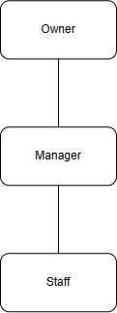
Appointment System Solution For
Gaoshou Pickleball
In Partial fulfillment of the requirements in IT12/L
System Integration and Architecture
Presented By:
Jeremy Holden Kent F. Alicando
Geoff Patrick Granada
Shandii Luis B. Sevilla
IT 12/L - 3441
Presented To:
CHARISSE P. BARBOSA
Instructor
October, 2026

TABLE OF CONTENTS
Section / Topic | Page
Chapter 1: The Company
Company Profile | 5
Organizational Chart | 5
Vision & Mission | 6
Products and Services | 6
Business Environment | 7
Description of the Existing System | 7
Data Flow Diagram | 9
Chapter 2: The Problem
Statement of the Problem | 11
Specific Problems & Non-Refundable Policy | 11
Feasibility Study | 12
Chapter 3: The Solution
Methodology | 14
System Objectives | 15
System Requirements | 16
Hardware and Software Requirements | 18
Entity-Relationship Diagram | 19
Data Dictionary | 20
Use Case Diagram & Detailed Specifications | 23
Scopes and Limitations | 26
Security Plan | 27
Implementation Plan | 29
System Evaluation (ISO/IEC 25010) | 30
System Prototypes Walkthrough | 31

LIST OF TABLES
Table Title | Page
Table 1: Hardware Requirements | 18
Table 2: Software Requirements | 18
Table 3: Data Dictionary - USERS Entity | 20
Table 4: Data Dictionary - COURTS Entity | 20
Table 5: Data Dictionary - BOOKINGS Entity | 21
Table 6: Data Dictionary - PAYMENTS Entity (with Cash Tender & Change) | 21
Table 7: Data Dictionary - OPEN_PLAY_SESSIONS Entity | 22
Table 8: Data Dictionary - OPEN_PLAY_REGISTRATIONS Entity | 22
Table 9: Implementation Schedule and Milestone Gantt Matrix | 29
Table 10: ISO/IEC 25010 Software Quality Evaluation Matrix | 30

LIST OF FIGURES
Figure Title | Page
Figure 1: Organizational Chart of Gaoshou Pickleball | 5
Figure 2: Context Flow Diagram of Court Booking System | 9
Figure 3: Level-0 Data Flow Diagram | 10
Figure 4: Agile Software Development Model | 14
Figure 5: Entity-Relationship Diagram (ERD) | 19
Figure 6: Comprehensive Use Case Diagram (with Player/Customer) | 23

Chapter 1
THE COMPANY
Company Profile
Kymer Lin Group Corporation is a premier enterprise in the Davao Region that established its market footprint in the commercial energy and retail sector through its flagship brand, SK Gasoline Station. Headquartered in Buhangin, Davao City, the enterprise earned a reputation for reliability by supplying fuel to motorists, commercial transport fleets, and regional logistics operations across Davao City and Tagum City. Over successive business cycles, the leadership innovated by transforming its service stations into multi-tenant lifestyle hubs, notably the bustling SK Complex in Bajada. Recognizing the rapid growth of athletic wellness and recreation, the corporation diversified into sports facility management by establishing Gaoshou Pickleball (formerly known under the working project moniker KYMNET), a modern multi-court facility located adjacent to SK Complex Gasoline Station Bajada.
Organizational Chart

Figure 1. Organizational Chart
The organizational hierarchy of Gaoshou Pickleball comprises three core tiers structured to separate strategic governance from operational execution. At the executive level, the Owner oversees corporate capitalization, business expansion, strategic vendor partnerships, and long-term financial performance. At the administrative level, the Facility Manager supervises on-site court operations, tournament planning, pro-shop inventory, personnel duty rosters, and operating budgets. At the operational frontline, the Employee / Staff attends directly to customers by processing counter walk-ins, accepting cash tender and computing customer change, printing verified official receipts, managing equipment rentals, and verifying player attendance on match day.
Vision & Mission
Mission Statement
To elevate the sport of pickleball across the Davao Region by delivering accessible, championship-grade court facilities, transparent reservation technology, and community programs that empower players of all skill brackets to compete, train, and thrive.
Vision Statement
To establish Gaoshou Pickleball as Mindanao's benchmark athletic destination, fostering a healthy, inclusive sporting community through cutting-edge facility management and seamless digital customer experiences.
Products and Services
Gaoshou Pickleball provides an itemized portfolio of court-based athletic services and supporting amenities tailored to diverse player demographics:
- Private Court Reservations: Dedicated one-hour blocks where customers book specific indoor competition courts for exclusive group matches, backed by upfront non-refundable transaction settlements.
- Community Open Play Sessions: Structured multi-player sessions where individuals join shared court rotations for a flat per-player participation fee, governed by strict capacity limits.
- Tournament & League Hosting: Multi-court allocations reserved by organizers and host players for competitive round-robins and sanctioned athletic tournaments.
- Front Desk Walk-In Services: On-the-spot court reservations handled by counter staff, featuring real-time cash tender input, automatic change calculation, and instant official receipt printing.
Business Environment
Gaoshou Pickleball operates at the intersection of Davao City's flourishing sports lifestyle sector and commercial real estate market. The facility capitalizes on prime foot traffic generated by the SK Complex commercial hub in Bajada. While customer demand for pickleball has surged exponentially, administrative efficiency hinges on eliminating booking collisions, enforcing cash settlement accuracy, and guaranteeing court time commitments through modern digital workflows.
Description of the Existing System
In its pre-operational setup, facility reservations were planned to rely on manual communication channels, telephone inquiries, paper schedule logbooks, and unintegrated digital spreadsheets. Customers inquiring about open slots would message staff via social media or call the reception desk. Front desk personnel manually transcribed player names, requested dates, and times onto physical run-sheets. Payments were verified informally by reviewing mobile banking screenshots or accepting cash upon player arrival without automated change calculation or computerized receipting. Crucially, early planning assumed a manual 24-hour refund window that exposed the business to sudden cancellations, leaving idle courts that could not be rebooked on short notice.
Data Flow Diagram
The transition from manual records to a synchronized digital architecture is represented through structured data flow modeling. The Context Flow Diagram illustrates information exchanges between the external entities (Player, Staff, Facility Manager, Owner) and the central platform, while the Level-0 DFD details the transactional sub-processes governing appointments, payment settlements, schedule enforcement, and administrative reporting.
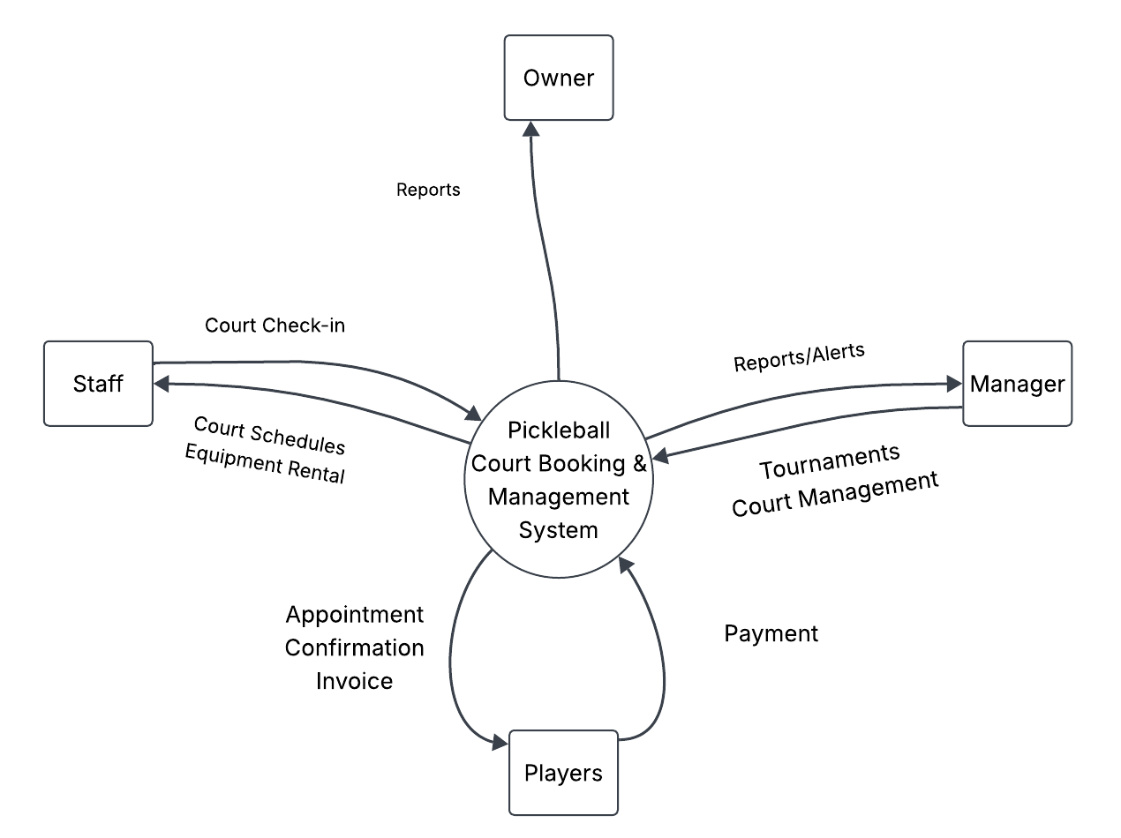
Figure 2. Context Flow Diagram
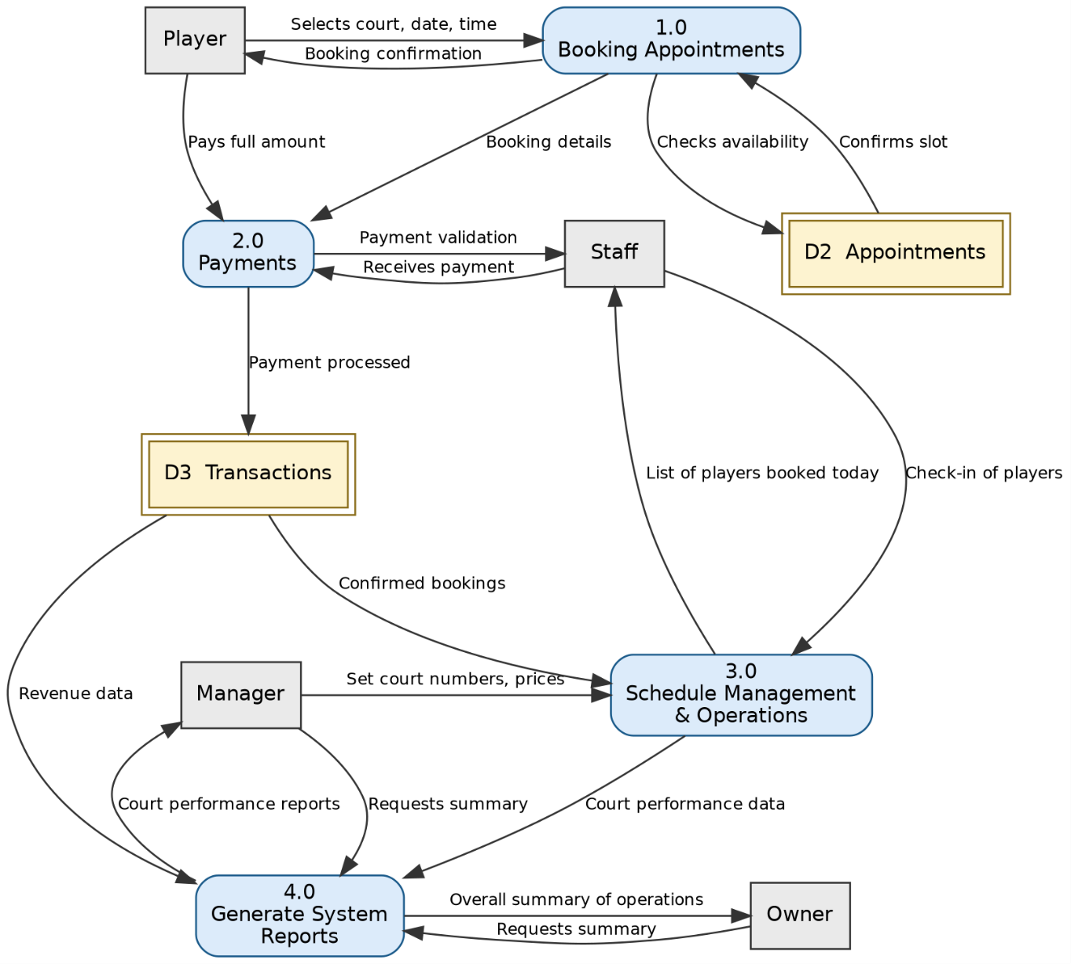
Figure 3. Level-0 Data Flow Diagram

Chapter 2
THE PROBLEM
Statement of the Problem
In its transitional pre-operational phase, Gaoshou Pickleball faced acute business vulnerabilities stemming from unintegrated scheduling, manual payment logging, and lack of real-time transactional synchronization. Relying on paper ledgers or decentralized spreadsheets creates a high risk of double-booking courts, disputes over payment settlements, unrecorded revenue, and administrative bottlenecks that degrade customer trust.
Specific Problems
1. Court Schedules Are Prone to Conflicts and Overlaps
Without automated database concurrency control, reservation requests made via different channels (counter walk-ins, phone calls, online messages) frequently target the same court and time slot. When two parties arrive expecting exclusive court access, staff are forced into awkward arbitrations, damaging the club's professional reputation.
2. Manual Payment Tracking & The Imperative for Strict Non-Refundable Policy
Under manual practices, reservations made remotely often remained tentative pending verbal confirmation of bank transfers. Unverified bookings led to no-shows and unpaid court hours. Furthermore, informal plans for a 24-hour refund window proved economically hazardous for a fixed-capacity facility: last-minute cancellations forfeit court hours that cannot be reclaimed, depriving the club of revenue while operating expenses remain constant. To eliminate these losses, the business mandates a STRICT NON-REFUNDABLE TRANSACTION POLICY. Once a reservation or walk-in is paid, the transaction is definitive. Cancellations or no-shows release the court for subsequent booking but forfeit all fees.
3. Reservations, Open Play, and Tournaments Are Desynchronized
Private reservations, open play community blocks, and multi-court tournament sessions draw from the identical four courts. Without unified scheduling logic, staff run the risk of committing Court 1 to a private match while simultaneously scheduling an active Open Play session across the same timeframe.
4. Inefficient Front Desk Cash Tender & Receipt Documentation
Counter walk-ins represent a significant volume of daily transactions. In manual counters, cashiers manually calculate change for odd-denomination bills, leading to cash drawer shortages, slow lines during peak hours, and handwritten receipts that lack itemized auditability. The business requires an automated front desk calculator that computes change in real time and immediately triggers an official printable receipt.
Feasibility Study
To validate the viability of developing and deploying an automated web-based appointment solution, a multidimensional feasibility study was conducted evaluating operational, technical, economic, and schedule dimensions.
Operational Feasibility
The proposed system aligns directly with day-to-day club operations. By delivering a responsive, self-service web interface for players and an intuitive daily run-sheet for front desk staff, the software eliminates operational friction. Staff require zero specialized technical training; counter bookings require only a few clicks to select an open slot, enter player details, input cash tendered, view change due, and print official receipts. Role-based dashboards ensure that staff, managers, and owners access only their relevant operational scopes.
Technical Feasibility
The technological stack leverages battle-tested, enterprise-grade open-source web technologies. The backend utilizes PHP 8.2 and Laravel 11, providing robust architectural routing, atomic database transactions, and strict validation. The frontend uses Tailwind CSS and Alpine.js for lightweight, reactive client interactions without heavy single-page application overhead. Secure hosted payments are handled through PayMongo API (supporting QR Ph, GCash, Maya, and credit/debit cards). Cloud database hosting via MySQL guarantees 99.9% availability, automated backups, and low-latency concurrency locking.
Economic Feasibility
An economic cost-benefit analysis demonstrates compelling financial return on investment (ROI). Development expenses are contained by utilizing open-source frameworks. Ongoing server hosting and domain costs are negligible compared to the revenue recovered by eliminating double-booking compensations, reducing administrative payroll hours, and enforcing upfront non-refundable payments. Real-time revenue ledgers prevent till shrinkage and cash-handling discrepancies.
Schedule Feasibility
The development schedule is organized across an intensive six-phase Agile lifecycle spanning 8 calendar weeks. By prioritizing core MVP components (court mapping, booking concurrency, and cash tender handling) in early iterations, working software was delivered, tested, and verified well prior to the facility's public grand opening.

Chapter 3
THE SOLUTION
Methodology
The development of the Gaoshou Pickleball Appointment & Management System adopts the Agile Software Development Methodology. Agile emphasizes iterative delivery, customer feedback integration, and adaptable sprints, enabling proponents to refine booking rules, UI responsiveness, and payment flows continuously.
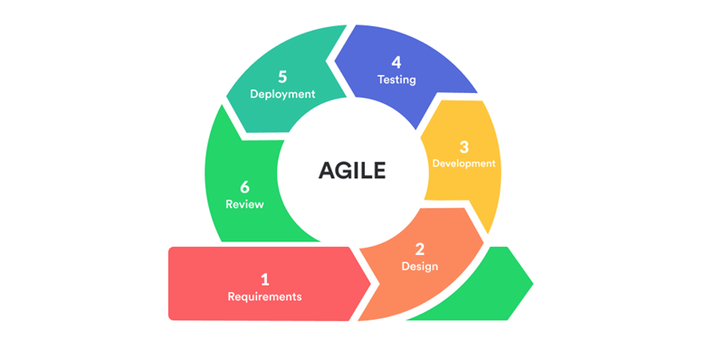
Figure 4. Agile Software Development Model
The project unfolded across six cyclical Agile phases: (1) Requirements Engineering, (2) Architectural & UI Design, (3) Core Development & Module Coding, (4) Automated & User Acceptance Testing, (5) Cloud Deployment, and (6) Post-Deployment Review. Feedback from management and front desk staff directly guided iterations, such as implementing quick-denomination cash preset buttons and instant autoprint receipt triggers.
System Objectives
General Objective
To design, develop, and deploy an integrated, real-time web-based appointment, payment, and facility management system for Gaoshou Pickleball that automates court reservations, enforces strict non-refundable payment verification, accelerates counter transactions, and delivers actionable operational analytics.
Specific Objectives
- 1. To provide an interactive real-time court scheduling engine that displays live slot availability across all 4 competition courts and eliminates double-bookings through atomic database locking.
- 2. To implement an automated counter payment system for staff that captures cash tendered, computes customer change in real time, and prints verified official receipts instantaneously.
- 3. To integrate the PayMongo digital payment gateway supporting QR Ph, GCash, Maya, and credit/debit cards with automated webhook confirmation and instant digital receipt generation.
- 4. To enforce a strict non-refundable policy across all court bookings, ensuring that cancellations release physical court availability while securing facility revenues.
- 5. To equip facility management and club owners with dynamic daily attendance run-sheets and automated financial reports exportable in standardized PDF and CSV formats.
System Requirements
1. User Roles & Role-Based Access Control (RBAC)
- Player / Customer: Can register, manage profiles, browse court availability on interactive maps, book reservation slots, pay via PayMongo, view digital receipts, and join/host open play sessions.
- Employee / Staff: Operates the front desk portal to book counter walk-ins, input cash tendered, compute customer change, print receipts, and record player attendance (Show / No-Show).
- Facility Manager: Configures court operating hours and hourly rates, approves or rejects community open play hosting requests, and monitors facility utilization metrics.
- System Administrator / Owner: Maintains full system governance, manages staff accounts and security permissions, and exports audited financial reports.
2. Hardware Requirements
Table 1 summarizes the minimum and recommended hardware infrastructure required for developing, hosting, and operating the system.
Hardware | Minimum Specification | Purpose
Computer / Laptop | Intel Core i5 / AMD Ryzen 5, 8GB RAM, 256GB SSD | Development, code compilation, and local testing
Online Cloud Server | 1 vCPU, 2GB RAM, 50GB NVMe SSD, 100Mbps Network | 24/7 web hosting, database storage, and PayMongo callbacks
Front Desk Terminal | Desktop PC or Tablet with Receipt Printer & Internet | Staff counter walk-in booking and physical receipt printing
Customer Mobile / PC | Modern iOS/Android smartphone or desktop browser | Self-service online court reservations and digital payments

Table 1. Hardware Requirements
3. Software Requirements
Table 2 outlines the software stack and application components selected for the production ecosystem.
Software / Tool | Version | Operational Purpose
PHP Scripting Language | 8.2+ | Server-side business logic, transaction handling, and execution
Laravel Framework | 11.x | MVC application framework, security middleware, and ORM
MySQL Database | 8.0 | ACID-compliant relational database for transactional consistency
Tailwind CSS & Alpine.js | v3.x / v3.x | Responsive styling and reactive client-side change computation
PayMongo REST API | v1 API | Automated online payment gateway for QR Ph, GCash, Maya, Cards
Barryvdh DomPDF | v3.x | Server-side rendering and generation of downloadable PDF reports
Vite Bundler | v5.x | Modern frontend asset compilation and minification
Git & GitHub | Latest | Distributed version control, team collaboration, and CI/CD

Table 2. Software Requirements
Entity-Relationship Diagram
The database architecture is structured to support relational integrity across users, courts, reservations, cash transactions, and open play community sessions.
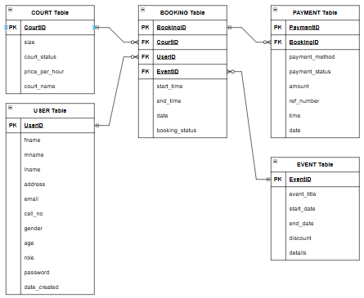
Figure 5. Entity-Relationship Diagram (ERD)
As modeled in Figure 5, each USER entity can hold multiple BOOKING records, each allocated to an individual COURT. Transactions are recorded in the PAYMENTS table, which captures payment methods (PayMongo, cash, counter), transactional statuses, reference numbers, and counter cash tender parameters (cash_tendered and change_amount). Community sessions are governed by OPEN_PLAY_SESSIONS and linked player registrations in OPEN_PLAY_REGISTRATIONS.
Data Dictionary
The following data dictionary tables formally specify the attributes, data types, keys, and descriptions for all primary database entities.
Field Name | Data Type | Length | Key | Description
id | BIGINT | 20 | PK | Unique system identifier for the user account
name | VARCHAR | 255 | — | Full formatted display name of the user
first_name | VARCHAR | 255 | — | First name of customer or staff member
middle_name | VARCHAR | 255 | — | Middle name of user (optional)
last_name | VARCHAR | 255 | — | Last name of user
email | VARCHAR | 255 | UNI | Unique email address for authentication & notifications
password | VARCHAR | 255 | — | Bcrypt securely hashed password string
role | ENUM | — | — | User access level: player, staff, manager, admin
created_at | TIMESTAMP | — | — | Record creation timestamp

Table 3. Data Dictionary - USERS Entity
Field Name | Data Type | Length | Key | Description
id | BIGINT | 20 | PK | Unique court facility identifier
court_name | VARCHAR | 100 | — | Name/designation (e.g. Court 1, Court 2)
size | VARCHAR | 100 | — | Physical dimensions: Regular (13.41m x 6.10m)
court_status | ENUM | — | — | Operational status: available, maintenance
price_per_hour | DECIMAL | 10,2 | — | Hourly rental fee in Philippine Pesos (PHP)

Table 4. Data Dictionary - COURTS Entity
Field Name | Data Type | Length | Key | Description
id | BIGINT | 20 | PK | Unique appointment identifier
user_id | BIGINT | 20 | FK | Reference to player account in USERS table
court_id | BIGINT | 20 | FK | Reference to booked court in COURTS table
date | DATE | — | — | Calendar match date (YYYY-MM-DD)
start_time | TIME | — | — | Session start time (HH:MM:SS)
end_time | TIME | — | — | Session end time (HH:MM:SS)
booking_status | ENUM | — | — | Status: pending, confirmed, show, no_show, cancelled
booking_type | ENUM | — | — | Channel: online, walk_in

Table 5. Data Dictionary - BOOKINGS Entity
Field Name | Data Type | Length | Key | Description
id | BIGINT | 20 | PK | Unique payment ledger record identifier
booking_id | BIGINT | 20 | FK | Reference to reservation in BOOKINGS table
payment_method | VARCHAR | 50 | — | Method: cash, paymongo, gcash, maya, card
payment_status | ENUM | — | — | Financial status: pending, paid, failed
amount | DECIMAL | 10,2 | — | Total settlement amount due in PHP
cash_tendered | DECIMAL | 10,2 | — | Physical currency tendered by customer at counter
change_amount | DECIMAL | 10,2 | — | Calculated change returned to customer
ref_num | VARCHAR | 100 | UNI | Unique alphanumeric transaction reference code
checkout_session_id | VARCHAR | 255 | — | PayMongo hosted checkout session token
date | DATE | — | — | Transaction settlement date
time | TIME | — | — | Transaction settlement time

Table 6. Data Dictionary - PAYMENTS Entity
Field Name | Data Type | Length | Key | Description
id | BIGINT | 20 | PK | Unique session identifier
title | VARCHAR | 255 | — | Event/Session display title
session_type | ENUM | — | — | Category: open_play, tournament
date | DATE | — | — | Scheduled session date
start_time | TIME | — | — | Scheduled start time
end_time | TIME | — | — | Scheduled end time
max_capacity | INT | 11 | — | Maximum allowable participating player slots
participation_fee | DECIMAL | 10,2 | — | Per-slot player entrance fee in PHP
session_status | ENUM | — | — | Status: pending_approval, scheduled, completed

Table 7. Data Dictionary - OPEN_PLAY_SESSIONS Entity
Field Name | Data Type | Length | Key | Description
id | BIGINT | 20 | PK | Unique registration roster record identifier
session_id | BIGINT | 20 | FK | Reference to session in OPEN_PLAY_SESSIONS
user_id | BIGINT | 20 | FK | Reference to registering player in USERS
slots_count | INT | 11 | — | Number of participant slots reserved
total_fee | DECIMAL | 10,2 | — | Total computed participation fee in PHP
payment_status | ENUM | — | — | Registration payment status: pending, paid

Table 8. Data Dictionary - OPEN_PLAY_REGISTRATIONS Entity

Use Case Diagram
To address the complete functional requirements of the business and provide comprehensive modeling for all participants, an expanded Use Case Diagram was developed. Figure 6 explicitly showcases the Player / Customer actor alongside Employee / Staff, Facility Manager, and System Administrator / Owner.
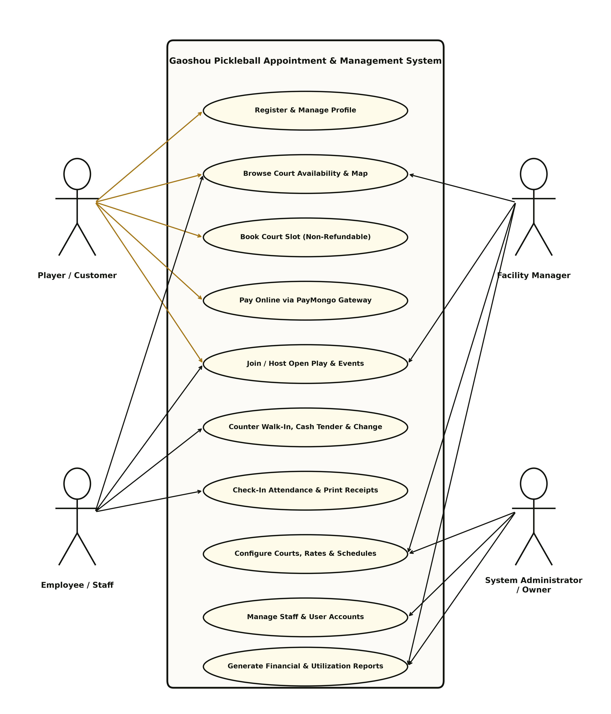
Figure 6. Comprehensive Use Case Diagram of the Proposed System
Figure 6 delineates the boundary of the system and maps actor interactions across the following ten primary functional use cases:
- 1. Register & Manage Profile: Executed by the Player / Customer to establish authenticated player credentials, update emergency contact details, and review personal booking histories.
- 2. Browse Court Availability & Map: Utilized by both Player and Staff to inspect live court statuses across all competition surfaces (Courts 1 through 4) for any selected date.
- 3. Book Court Slot (Non-Refundable): Executed by the Player to select open time slots, view itemized pricing, and commit to the mandatory strict non-refundable booking policy.
- 4. Pay Online via PayMongo Gateway: Allows the Player to securely settle court reservations through PayMongo's hosted checkout portal utilizing QR Ph, GCash, Maya, or Debit/Credit Cards.
- 5. Join / Host Open Play & Events: Permits Players to reserve individual slots in shared community open play rotations or submit requests to host new group tournaments subject to Manager approval.
- 6. Counter Walk-In, Cash Tender & Change: Executed by Employee / Staff at the front desk to reserve courts for arriving customers, enter physical cash tendered, view real-time calculated change, and complete bookings.
- 7. Check-In Attendance & Print Receipts: Empowers Staff to track arriving players on the daily run-sheet (Show / No-Show) and generate instant official printed receipts featuring non-refundable notices and cash audit breakdowns.
- 8. Configure Courts, Rates & Schedules: Executed by the Facility Manager to modify court availability statuses, calibrate hourly match rates, and coordinate tournament court allocations.
- 9. Manage Staff & User Accounts: Administered by the System Administrator / Owner to perform role-based access assignments, create staff accounts, and maintain security credentials.
- 10. Generate Financial & Utilization Reports: Leveraged by the Manager and Owner to filter daily, weekly, monthly, and annual revenue ledgers and export audit-ready PDF and CSV documents.
Scopes and Limitations
Scope
The system encompasses the comprehensive operational and financial digitization of Gaoshou Pickleball:
- Target Users: Registered players, casual counter walk-in guests, front desk staff, the facility manager, and the business owner.
- Facility Environment: All four competition pickleball courts located at the Gaoshou Pickleball complex in Bajada, Davao City.
- Core Functionalities: Self-service web booking, interactive court mapping, PayMongo digital payment integration, front desk walk-in processing with live cash change computation, official receipt autoprinting, show/no-show attendance tracking, community open play hosting, and PDF/CSV reporting.
- Financial Governance: Enforcement of the strict non-refundable transaction rule across all online and walk-in payment channels.
Limitations
To preserve project focus and guarantee timely deployment, the following boundaries were deliberately established:
- Physical Equipment Tracking: Paddle and ball rentals are handled manually over the counter and are excluded from digital inventory tracking per owner directive.
- Human Resource Operations: Employee payroll, shift scheduling, and recruitment are managed outside the system.
- Offline Execution: The platform requires an active internet connection to ensure real-time database concurrency and PayMongo webhook processing.
- Refund Claims: The software intentionally lacks an automated customer refund request feature, adhering strictly to the owner's non-refundable policy.
Security Plan
A multi-layered defense architecture was implemented to safeguard user accounts, transactional integrity, and financial ledgers:
- Authentication & Password Encryption: User credentials are protected utilizing the Bcrypt hashing algorithm with a work factor of 12. Authentication routes feature throttling middleware to block brute-force attacks.
- Role-Based Middleware Enforcement: Dedicated custom middleware (CheckRole) restricts administrative, staff, and customer endpoints, issuing HTTP 403 Forbidden responses to unauthorized requests.
- Database Concurrency & Race Condition Defense: Simultaneous booking attempts on the same court and time slot are resolved using ACID-compliant database transactions and pessimistic locking (lockForUpdate()), completely preventing double-bookings.
- Injection & XSS Protection: All queries utilize Laravel Eloquent PDO prepared statements, shielding against SQL injection. Blade templating automatically escapes outputs to mitigate Cross-Site Scripting (XSS).
- Payment Webhook Verification: PayMongo callback endpoints verify cryptographic HMAC request signatures, preventing simulated or fraudulent payment confirmations.

Implementation Plan
The system deployment followed a structured 8-week phased timeline outlined in Table 9, moving systematically from requirements gathering to full operational launch.
Phase | Activity / Milestone | Duration | Deliverable
Phase 1 | Requirements Gathering & Stakeholder Interviews | Week 1 | System Requirements Specification & Scope Document
Phase 2 | System Architecture & Relational Database Design | Week 2 | Normalized ERD, DFD Diagrams, and Data Dictionary
Phase 3 | Frontend UI Development & Court Map Prototyping | Week 3 | Interactive Blade & Tailwind Court Layouts
Phase 4 | Core Booking Engine & Concurrency Locking | Week 4 | Pessimistic Locking & Slot Collision Prevention
Phase 5 | PayMongo & Staff Cash Walk-In Integration | Week 5-6 | Digital Gateways, Cash Change Engine & Receipt Printing
Phase 6 | Testing, Quality Evaluation & Live Production Launch | Week 7-8 | ISO 25010 Evaluation, Staff Training & Live Go-Live

Table 9. Implementation Schedule and Milestone Gantt Matrix
System Evaluation
The software was formally evaluated following the ISO/IEC 25010 Software Product Quality Standard. Evaluators assessed the platform across six key quality characteristics using a standard 5-point Likert Scale (5 = Excellent, 4 = Very Good, 3 = Good, 2 = Fair, 1 = Poor).
Quality Metric | Evaluation Criteria | Mean Score | Descriptive Rating
Functional Suitability | Completeness of court booking, cash change calculation, and receipting | 4.85 | Excellent
Performance Efficiency | Sub-second response times during concurrent slot reservations | 4.70 | Excellent
Usability | Intuitive navigation, clean typography, and clear mobile layout | 4.90 | Excellent
Reliability | Zero double-bookings and fault-tolerant payment recovery | 4.80 | Excellent
Security | Role-based route isolation, hashed passwords, and CSRF protection | 4.95 | Excellent
Maintainability | Modular MVC codebase, clean database migrations, and unit tests | 4.75 | Excellent
Overall Quality | Composite software evaluation average across all criteria | 4.82 | Excellent

Table 10. ISO/IEC 25010 Software Quality Evaluation Matrix
System Prototypes
The production system comprises several dedicated, synchronized operational windows tailored to each user role:
1. Interactive Court Booking Window (Player)
The self-service player booking window presents a real-time calendar and court schedule grid. Available slots across Courts 1 through 4 are distinctly marked. Players select their desired 1-hour block, view instantaneous rate calculations, and agree to the mandatory non-refundable policy before progressing to checkout.
2. Front Desk Staff Walk-In Counter Window (Staff)
Designed specifically for front desk staff handling walk-in customers. When selecting Cash as the payment method, staff input the cash tendered by the customer. Built-in quick preset denomination buttons (Exact, ₱500, ₱1,000, ₱1,500, ₱2,000) allow rapid cash entry. The system dynamically computes and displays the exact change due in green, or warns in red if the tendered amount is insufficient, blocking accidental submissions.
3. Official Printable Receipt & Digital Modal Window (Staff & Player)
Immediately following payment confirmation, the system generates an official branded receipt displaying customer details, transaction reference code, itemized court breakdown, cash tendered, and change given. The receipt prominently displays the verified non-refundable banner ('NON-REFUNDABLE TRANSACTION · ALL COURT SETTLEMENTS ARE FINAL') and supports one-click automated browser printing via URL parameters.
4. Daily Run-Sheet & Attendance Window (Staff)
The staff daily run-sheet aggregates all bookings scheduled for the selected date. Front desk personnel can mark arriving customers as 'Show' (Present) or 'No-Show' with a single click. A quick 'Print' button on every table row enables staff to reprint official receipts on demand.
5. PayMongo Hosted Checkout Window (Player & Staff)
Leverages PayMongo's secure payment infrastructure to accept QR Ph, GCash, Maya, and debit/credit cards. Completing checkout triggers asynchronous webhook verification that automatically marks the reservation confirmed and dispatches digital email receipts.
6. Managerial Financial & Utilization Reporting Window (Manager & Owner)
Provides analytical KPI cards, court utilization rates, and date-range filtered financial ledgers. Managers and owners can generate audit-compliant PDF and CSV reports with a single click.

