Dimensonality_and_feature_selection

GRIFFIN BURET

2022-08-04

##RESEARCH QUESTION##

Carrefour Kenya and are currently undertaking a project that will inform the marketing department on the most relevant marketing strategies that will result in the highest no. of sales (total price including tax).This project is aimed at doing analysis on the dataset provided by carrefour and create insights on how to achieve highest sales.

##METRIC FOR SUCCESS##

Be able to detect and do away with anomalies in our dataset

##THE CONTEXT##

Carre Four is an International chain of retail supemarkets in the world, It was set up in Kenya in the year 2016 and has been performing well over the years.Carrefour ensures customer satisfaction and everyday convenience while offering unbeatable value for money with a vast array of more than 100,000 products, shoppers can purchase items for their every need, whether home electronics or fresh fruits from around the world, to locally produced items. This project is aimed at creating insights from existing and current trends to develop marketing strategies that will enable the marketing team achieve higher sales.

##EXPERIMENTAL DESIGN##

1. Loading libraries
2. Load data
3. Data cleaning
4. PCA 5.Feature selection
5. Conclusion
6. Recommendation # importing libraries

library(caret)

## Loading required package: ggplot2

## Loading required package: lattice

library(superml)

## Loading required package: R6

#install.packages("devtools", type = "win.binary")  
remotes::install_github('vqv/ggbiplot')

## Skipping install of 'ggbiplot' from a github remote, the SHA1 (7325e880) has not changed since last install.  
## Use `force = TRUE` to force installation

library(ggbiplot)

## Loading required package: plyr

## Loading required package: scales

## Loading required package: grid

#suppressWarnings(  
 #suppressMessages(if  
 #(!require(corrplot, quietly=TRUE))  
 #install.packages("corrplot")))  
library(corrplot)

## corrplot 0.92 loaded

# Loading dataset

#reading the data set  
sales<- read.csv("C:/Users/Admin/Downloads/Supermarket_Dataset_1 - Sales Data.csv")

**Previewing the data**

#previewing the head  
head(sales)

## Invoice.ID Branch Customer.type Gender Product.line Unit.price  
## 1 750-67-8428 A Member Female Health and beauty 74.69  
## 2 226-31-3081 C Normal Female Electronic accessories 15.28  
## 3 631-41-3108 A Normal Male Home and lifestyle 46.33  
## 4 123-19-1176 A Member Male Health and beauty 58.22  
## 5 373-73-7910 A Normal Male Sports and travel 86.31  
## 6 699-14-3026 C Normal Male Electronic accessories 85.39  
## Quantity Tax Date Time Payment cogs gross.margin.percentage  
## 1 7 26.1415 1/5/2019 13:08 Ewallet 522.83 4.761905  
## 2 5 3.8200 3/8/2019 10:29 Cash 76.40 4.761905  
## 3 7 16.2155 3/3/2019 13:23 Credit card 324.31 4.761905  
## 4 8 23.2880 1/27/2019 20:33 Ewallet 465.76 4.761905  
## 5 7 30.2085 2/8/2019 10:37 Ewallet 604.17 4.761905  
## 6 7 29.8865 3/25/2019 18:30 Ewallet 597.73 4.761905  
## gross.income Rating Total  
## 1 26.1415 9.1 548.9715  
## 2 3.8200 9.6 80.2200  
## 3 16.2155 7.4 340.5255  
## 4 23.2880 8.4 489.0480  
## 5 30.2085 5.3 634.3785  
## 6 29.8865 4.1 627.6165

#previewing the tail  
tail(sales)

## Invoice.ID Branch Customer.type Gender Product.line Unit.price  
## 995 652-49-6720 C Member Female Electronic accessories 60.95  
## 996 233-67-5758 C Normal Male Health and beauty 40.35  
## 997 303-96-2227 B Normal Female Home and lifestyle 97.38  
## 998 727-02-1313 A Member Male Food and beverages 31.84  
## 999 347-56-2442 A Normal Male Home and lifestyle 65.82  
## 1000 849-09-3807 A Member Female Fashion accessories 88.34  
## Quantity Tax Date Time Payment cogs gross.margin.percentage  
## 995 1 3.0475 2/18/2019 11:40 Ewallet 60.95 4.761905  
## 996 1 2.0175 1/29/2019 13:46 Ewallet 40.35 4.761905  
## 997 10 48.6900 3/2/2019 17:16 Ewallet 973.80 4.761905  
## 998 1 1.5920 2/9/2019 13:22 Cash 31.84 4.761905  
## 999 1 3.2910 2/22/2019 15:33 Cash 65.82 4.761905  
## 1000 7 30.9190 2/18/2019 13:28 Cash 618.38 4.761905  
## gross.income Rating Total  
## 995 3.0475 5.9 63.9975  
## 996 2.0175 6.2 42.3675  
## 997 48.6900 4.4 1022.4900  
## 998 1.5920 7.7 33.4320  
## 999 3.2910 4.1 69.1110  
## 1000 30.9190 6.6 649.2990

#checking the data structure  
str(sales)

## 'data.frame': 1000 obs. of 16 variables:  
## $ Invoice.ID : chr "750-67-8428" "226-31-3081" "631-41-3108" "123-19-1176" ...  
## $ Branch : chr "A" "C" "A" "A" ...  
## $ Customer.type : chr "Member" "Normal" "Normal" "Member" ...  
## $ Gender : chr "Female" "Female" "Male" "Male" ...  
## $ Product.line : chr "Health and beauty" "Electronic accessories" "Home and lifestyle" "Health and beauty" ...  
## $ Unit.price : num 74.7 15.3 46.3 58.2 86.3 ...  
## $ Quantity : int 7 5 7 8 7 7 6 10 2 3 ...  
## $ Tax : num 26.14 3.82 16.22 23.29 30.21 ...  
## $ Date : chr "1/5/2019" "3/8/2019" "3/3/2019" "1/27/2019" ...  
## $ Time : chr "13:08" "10:29" "13:23" "20:33" ...  
## $ Payment : chr "Ewallet" "Cash" "Credit card" "Ewallet" ...  
## $ cogs : num 522.8 76.4 324.3 465.8 604.2 ...  
## $ gross.margin.percentage: num 4.76 4.76 4.76 4.76 4.76 ...  
## $ gross.income : num 26.14 3.82 16.22 23.29 30.21 ...  
## $ Rating : num 9.1 9.6 7.4 8.4 5.3 4.1 5.8 8 7.2 5.9 ...  
## $ Total : num 549 80.2 340.5 489 634.4 ...

#checking the unique values in the rows  
#sapply(sales,n_distinct)

our data has 1000 observations and 16 columns. there are 8 character variables and 8 numeric variables # Data cleaning **Checking missing values**

#checking missing values  
colSums((is.na(sales)))

## Invoice.ID Branch Customer.type   
## 0 0 0   
## Gender Product.line Unit.price   
## 0 0 0   
## Quantity Tax Date   
## 0 0 0   
## Time Payment cogs   
## 0 0 0   
## gross.margin.percentage gross.income Rating   
## 0 0 0   
## Total   
## 0

our dataset has no missing values **checking duplicates**

duplicates <- sales[duplicated(sales)]  
duplicates

## data frame with 0 columns and 1000 rows

our data has no duplicates

#dropping columns we wont nedd  
#we drop the id column , date column,time and gross.margin column since we wont need  
sales_df<- sales[,-c(1,9,10,13)]  
head(sales_df)

## Branch Customer.type Gender Product.line Unit.price Quantity  
## 1 A Member Female Health and beauty 74.69 7  
## 2 C Normal Female Electronic accessories 15.28 5  
## 3 A Normal Male Home and lifestyle 46.33 7  
## 4 A Member Male Health and beauty 58.22 8  
## 5 A Normal Male Sports and travel 86.31 7  
## 6 C Normal Male Electronic accessories 85.39 7  
## Tax Payment cogs gross.income Rating Total  
## 1 26.1415 Ewallet 522.83 26.1415 9.1 548.9715  
## 2 3.8200 Cash 76.40 3.8200 9.6 80.2200  
## 3 16.2155 Credit card 324.31 16.2155 7.4 340.5255  
## 4 23.2880 Ewallet 465.76 23.2880 8.4 489.0480  
## 5 30.2085 Ewallet 604.17 30.2085 5.3 634.3785  
## 6 29.8865 Ewallet 597.73 29.8865 4.1 627.6165

# Data Processing

**converting categorical data to numeric**

#label encoding our data set  
label <- LabelEncoder$new()  
print(label$fit(sales_df$Customer.type))

## [1] TRUE

print(label$fit(sales_df$Gender))

## [1] TRUE

print(label$fit(sales_df$Product.line))

## [1] TRUE

print(label$fit(sales_df$Payment))

## [1] TRUE

sales_df$Branch <- label$fit_transform(sales_df$Branch)  
sales_df$Customer.type <- label$fit_transform(sales_df$Customer.type)  
sales_df$Gender <- label$fit_transform(sales_df$Gender)  
sales_df$Product.line <- label$fit_transform(sales_df$Product.line)  
sales_df$Payment <- label$fit_transform(sales_df$Payment)  
head(sales_df)

## Branch Customer.type Gender Product.line Unit.price Quantity Tax Payment  
## 1 0 0 0 0 74.69 7 26.1415 0  
## 2 1 1 0 1 15.28 5 3.8200 1  
## 3 0 1 1 2 46.33 7 16.2155 2  
## 4 0 0 1 0 58.22 8 23.2880 0  
## 5 0 1 1 3 86.31 7 30.2085 0  
## 6 1 1 1 1 85.39 7 29.8865 0  
## cogs gross.income Rating Total  
## 1 522.83 26.1415 9.1 548.9715  
## 2 76.40 3.8200 9.6 80.2200  
## 3 324.31 16.2155 7.4 340.5255  
## 4 465.76 23.2880 8.4 489.0480  
## 5 604.17 30.2085 5.3 634.3785  
## 6 597.73 29.8865 4.1 627.6165

**scaling data**

#we encoded our data because PCA only works with numeric data and since it is sensitive to scale of measurement we need to scale our data  
sales_num<- sales_df[,c(5,7:12)]  
head(sales_num)

## Unit.price Tax Payment cogs gross.income Rating Total  
## 1 74.69 26.1415 0 522.83 26.1415 9.1 548.9715  
## 2 15.28 3.8200 1 76.40 3.8200 9.6 80.2200  
## 3 46.33 16.2155 2 324.31 16.2155 7.4 340.5255  
## 4 58.22 23.2880 0 465.76 23.2880 8.4 489.0480  
## 5 86.31 30.2085 0 604.17 30.2085 5.3 634.3785  
## 6 85.39 29.8865 0 597.73 29.8865 4.1 627.6165

#checking the stats of our numerical data to check if they have same mean and variance  
stats<- data.frame(  
 sd=apply(sales_num,2,sd),  
 mean = apply(sales_num,2,mean)  
   
)  
stats

## sd mean  
## Unit.price 26.4946283 55.67213  
## Tax 11.7088255 15.37937  
## Payment 0.8096292 0.96600  
## cogs 234.1765096 307.58738  
## gross.income 11.7088255 15.37937  
## Rating 1.7185803 6.97270  
## Total 245.8853351 322.96675

#the numerical dataset has different means and variance thus the need to scale  
sales_scale<- scale(sales_num)  
head(sales_scale)

## Unit.price Tax Payment cogs gross.income Rating  
## [1,] 0.71780097 0.91914693 -1.19313873 0.91914693 0.91914693 1.2378240  
## [2,] -1.52454035 -0.98723557 0.04199453 -0.98723557 -0.98723557 1.5287619  
## [3,] -0.35260468 0.07141032 1.27712779 0.07141032 0.07141032 0.2486355  
## [4,] 0.09616553 0.67544187 -1.19313873 0.67544187 0.67544187 0.8305111  
## [5,] 1.15638044 1.26649176 -1.19313873 1.26649176 1.26649176 -0.9733034  
## [6,] 1.12165642 1.23899114 -1.19313873 1.23899114 1.23899114 -1.6715541  
## Total  
## [1,] 0.91914693  
## [2,] -0.98723557  
## [3,] 0.07141032  
## [4,] 0.67544187  
## [5,] 1.26649176  
## [6,] 1.23899114

#combining the numerical data with the categorical  
sales_new<- cbind(sales_df,sales_scale)  
sales_data<- sales_new[,-c(5,7:12)]  
head(sales_data)

## Branch Customer.type Gender Product.line Quantity Unit.price Tax  
## 1 0 0 0 0 7 0.71780097 0.91914693  
## 2 1 1 0 1 5 -1.52454035 -0.98723557  
## 3 0 1 1 2 7 -0.35260468 0.07141032  
## 4 0 0 1 0 8 0.09616553 0.67544187  
## 5 0 1 1 3 7 1.15638044 1.26649176  
## 6 1 1 1 1 7 1.12165642 1.23899114  
## Payment cogs gross.income Rating Total  
## 1 -1.19313873 0.91914693 0.91914693 1.2378240 0.91914693  
## 2 0.04199453 -0.98723557 -0.98723557 1.5287619 -0.98723557  
## 3 1.27712779 0.07141032 0.07141032 0.2486355 0.07141032  
## 4 -1.19313873 0.67544187 0.67544187 0.8305111 0.67544187  
## 5 -1.19313873 1.26649176 1.26649176 -0.9733034 1.26649176  
## 6 -1.19313873 1.23899114 1.23899114 -1.6715541 1.23899114

# implementing the solution

**Dimensionality Reduction usinng PCA**

#fitting the model  
sales_pca <- prcomp(sales_data,scale=FALSE,center=TRUE)  
summary(sales_pca)

## Importance of components:  
## PC1 PC2 PC3 PC4 PC5 PC6 PC7  
## Standard deviation 3.3229 1.7146 1.5308 1.00619 0.99747 0.81592 0.50549  
## Proportion of Variance 0.5623 0.1497 0.1193 0.05156 0.05067 0.03391 0.01301  
## Cumulative Proportion 0.5623 0.7121 0.8314 0.88297 0.93364 0.96754 0.98056  
## PC8 PC9 PC10 PC11 PC12  
## Standard deviation 0.4895 0.37696 2.049e-16 1.363e-16 1.166e-16  
## Proportion of Variance 0.0122 0.00724 0.000e+00 0.000e+00 0.000e+00  
## Cumulative Proportion 0.9928 1.00000 1.000e+00 1.000e+00 1.000e+00

our data has 12 PCs and the the first,second and the third explain 56%,14% and 12% variance respectively

#getting the structure of the PCA output to see the sdev ,rotation and other output  
str(sales_pca)

## List of 5  
## $ sdev : num [1:12] 3.323 1.715 1.531 1.006 0.997 ...  
## $ rotation: num [1:12, 1:12] 0.00151 -0.00289 -0.01073 -0.03623 0.85469 ...  
## ..- attr(*, "dimnames")=List of 2  
## .. ..$ : chr [1:12] "Branch" "Customer.type" "Gender" "Product.line" ...  
## .. ..$ : chr [1:12] "PC1" "PC2" "PC3" "PC4" ...  
## $ center : Named num [1:12] 0.992 0.499 0.499 2.574 5.51 ...  
## ..- attr(*, "names")= chr [1:12] "Branch" "Customer.type" "Gender" "Product.line" ...  
## $ scale : logi FALSE  
## $ x : num [1:1000, 1:12] 2.35 -1.5 1.34 2.91 2.63 ...  
## ..- attr(*, "dimnames")=List of 2  
## .. ..$ : NULL  
## .. ..$ : chr [1:12] "PC1" "PC2" "PC3" "PC4" ...  
## - attr(*, "class")= chr "prcomp"

#ploting a scree plot to see the variation of each PC  
#getting the variance  
pr<- sales_pca$sdev^2  
#getting propotion  
pve<- pr/sum(pr)  
#ploting scree plot  
plot(pve, xlab = "Principal Component",  
 ylab = "Proportion of Variance Explained",  
 ylim = c(0, 1), type = "b")

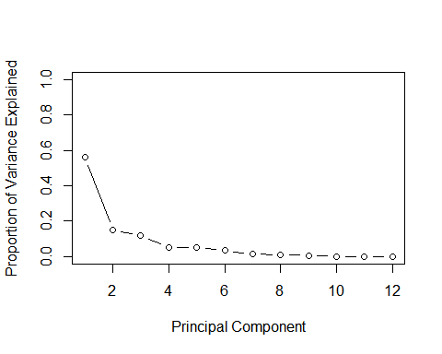

# Plot cumulative proportion of variance explained  
plot(cumsum(pve), xlab = "Principal Component",  
 ylab = "Cumulative Proportion of Variance Explained",  
 ylim = c(0, 1), type = "b")

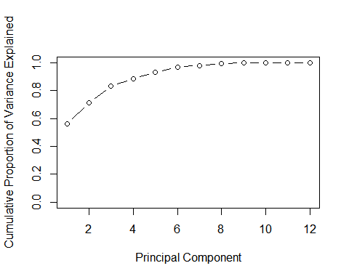

#ploting biplot using the first 2 PCs  
ggbiplot(sales_pca)

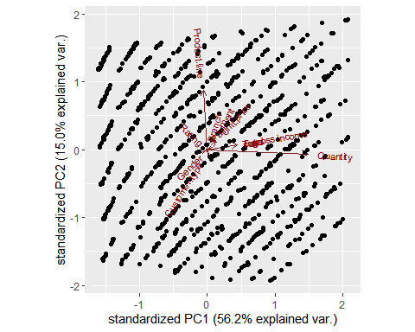 from the biplot we can see that the quantity and the product line has the longest vectors thus they contribute the most variability the quantity contributes more to PC1 and the product line contribute more to PC2 the gross income and the quantity are closely corelated as the angle between the vectors are small

#ploting biplot using the third and fourth PCs  
ggbiplot(sales_pca,choices = c(3,4))

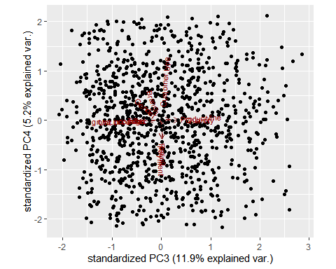 the length of the vectors are short since most variability have been accounted by the first two components **feature selection**

# calculate correlation matrix  
correlationMatrix <- cor(sales_data)  
# summarize the correlation matrix  
print(correlationMatrix)

## Branch Customer.type Gender Product.line Quantity  
## Branch 1.000000000 -0.004899261 -0.012218875 0.01257525 0.002120920  
## Customer.type -0.004899261 1.000000000 0.039996160 -0.02510945 -0.016762706  
## Gender -0.012218875 0.039996160 1.000000000 -0.06612647 -0.074258307  
## Product.line 0.012575246 -0.025109450 -0.066126475 1.00000000 -0.062514713  
## Quantity 0.002120920 -0.016762706 -0.074258307 -0.06251471 1.000000000  
## Unit.price 0.013763477 -0.020237875 0.015444630 0.03842765 0.010777564  
## Tax 0.012811933 -0.019670283 -0.049450989 -0.01854396 0.705510186  
## Payment 0.026725563 -0.069286242 -0.049514182 0.01051098 0.007333388  
## cogs 0.012811933 -0.019670283 -0.049450989 -0.01854396 0.705510186  
## gross.income 0.012811933 -0.019670283 -0.049450989 -0.01854396 0.705510186  
## Rating -0.049585348 0.018888672 0.004800208 0.02339096 -0.015814905  
## Total 0.012811933 -0.019670283 -0.049450989 -0.01854396 0.705510186  
## Unit.price Tax Payment cogs gross.income  
## Branch 0.013763477 0.012811933 0.026725563 0.012811933 0.012811933  
## Customer.type -0.020237875 -0.019670283 -0.069286242 -0.019670283 -0.019670283  
## Gender 0.015444630 -0.049450989 -0.049514182 -0.049450989 -0.049450989  
## Product.line 0.038427649 -0.018543956 0.010510982 -0.018543956 -0.018543956  
## Quantity 0.010777564 0.705510186 0.007333388 0.705510186 0.705510186  
## Unit.price 1.000000000 0.633962089 -0.019637884 0.633962089 0.633962089  
## Tax 0.633962089 1.000000000 0.008823723 1.000000000 1.000000000  
## Payment -0.019637884 0.008823723 1.000000000 0.008823723 0.008823723  
## cogs 0.633962089 1.000000000 0.008823723 1.000000000 1.000000000  
## gross.income 0.633962089 1.000000000 0.008823723 1.000000000 1.000000000  
## Rating -0.008777507 -0.036441705 0.013001094 -0.036441705 -0.036441705  
## Total 0.633962089 1.000000000 0.008823723 1.000000000 1.000000000  
## Rating Total  
## Branch -0.049585348 0.012811933  
## Customer.type 0.018888672 -0.019670283  
## Gender 0.004800208 -0.049450989  
## Product.line 0.023390962 -0.018543956  
## Quantity -0.015814905 0.705510186  
## Unit.price -0.008777507 0.633962089  
## Tax -0.036441705 1.000000000  
## Payment 0.013001094 0.008823723  
## cogs -0.036441705 1.000000000  
## gross.income -0.036441705 1.000000000  
## Rating 1.000000000 -0.036441705  
## Total -0.036441705 1.000000000

# find attributes that are highly corrected (ideally >0.75)  
highlyCorrelated <- findCorrelation(correlationMatrix, cutoff=0.75)  
# print indexes of highly correlated attributes  
print(highlyCorrelated)

## [1] 7 9 10

we see that the highly correlated attributes are tax,cogs,gross.income and thus we remove them

#we now remove the highly correlleted variables  
sales_data1<- sales_data[-(highlyCorrelated)]  
head(sales_data1)

## Branch Customer.type Gender Product.line Quantity Unit.price Payment  
## 1 0 0 0 0 7 0.71780097 -1.19313873  
## 2 1 1 0 1 5 -1.52454035 0.04199453  
## 3 0 1 1 2 7 -0.35260468 1.27712779  
## 4 0 0 1 0 8 0.09616553 -1.19313873  
## 5 0 1 1 3 7 1.15638044 -1.19313873  
## 6 1 1 1 1 7 1.12165642 -1.19313873  
## Rating Total  
## 1 1.2378240 0.91914693  
## 2 1.5287619 -0.98723557  
## 3 0.2486355 0.07141032  
## 4 0.8305111 0.67544187  
## 5 -0.9733034 1.26649176  
## 6 -1.6715541 1.23899114

#making graphical presantation before and after removing the highly correlated features  
par(mfrow = c(1, 2))  
corrplot(correlationMatrix, order = "hclust")  
corrplot(cor(sales_data1), order = "hclust")

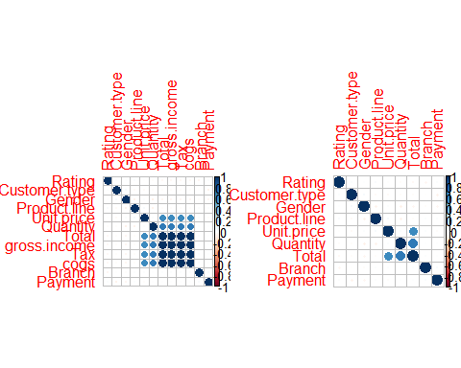 # Recomendations the are some variables that are redundant thus need to do dimensonality reduction and feature selection to identify the important features # Conclusion dimesionality reduction and feature selection helps speed up the training of the model as they remove reduntant features