Download the installable file ( WordPress eXtended RSS file also call WXR file ) from following location

<https://github.com/BurgahJasper/LSDManagement/tree/main/installable>

You need to have access to WordPress.

**Approach 1 is to have wordpress running in your EC2 instance and then install this application.**

**Approach 1 needed to have wordpress installed with all packages in ec2 instance and guide is available in this link.** [**https://github.com/BurgahJasper/LSDManagement/blob/main/EC2_WordpressInstalation_Readme.txt**](https://github.com/BurgahJasper/LSDManagement/blob/main/EC2_WordpressInstalation_Readme.txt)

**Approach 2 is create user in worddpress.com and install the application there (paid domain is needed to run dynamic application).**

**Approach 1**

**(Installing the application in EC2 instance running wordpress and maria DB )**

**Step 1:** Go to WordPress admin home page.

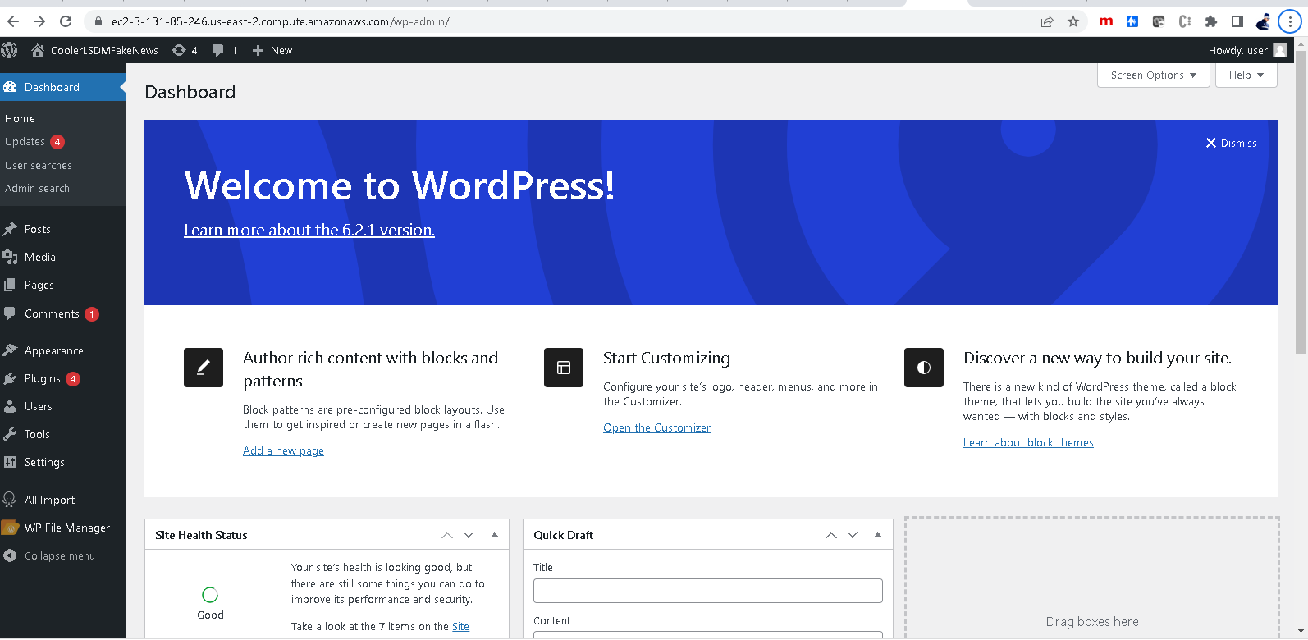

Step2: Have the **installable extract (WordPress eXtended RSS or WXR)** file **coolerlsdmfakenews.2023-04-30.xml** handy.

**Step3:** Click Tools 🡪 Import

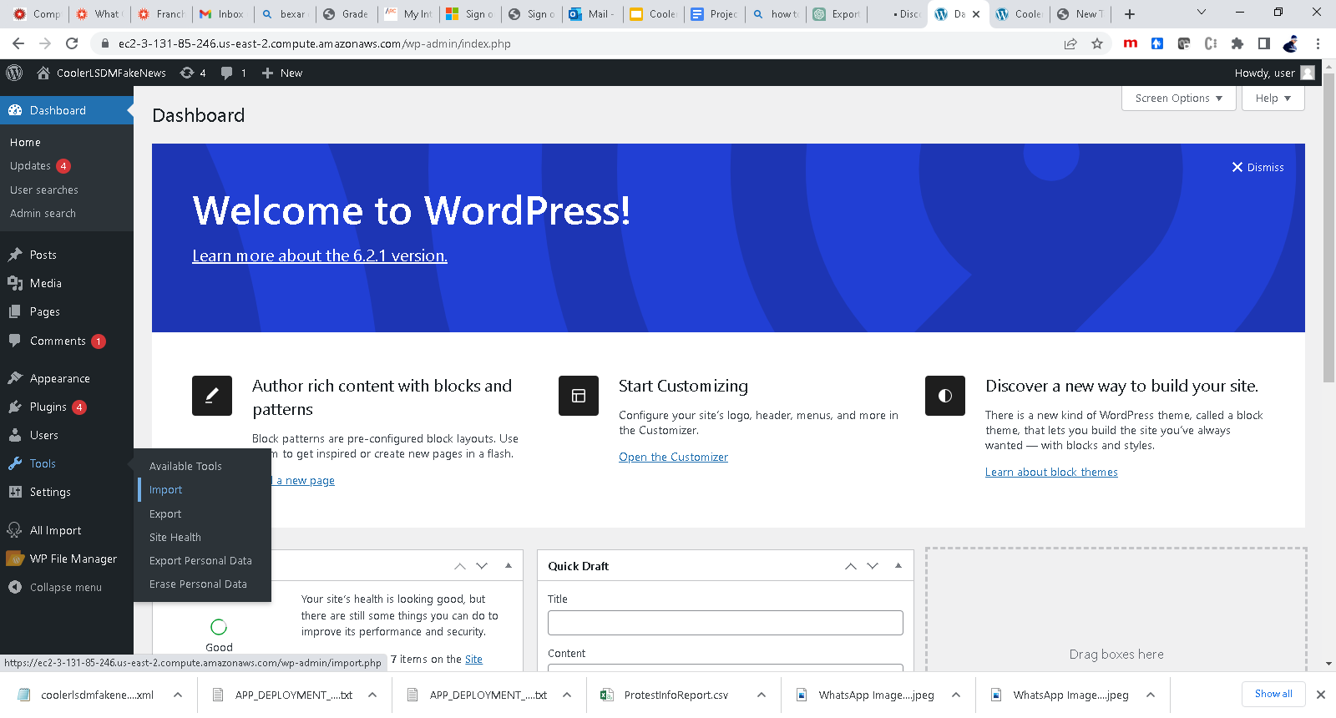

**Step4:** Click Install Now click near WordPress option.

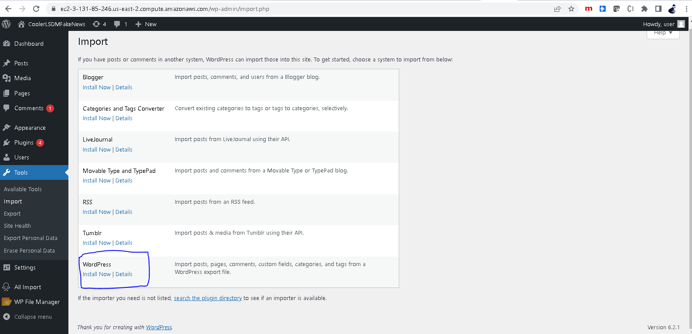

**Step5:** You will get “Importer Installed Successfully”

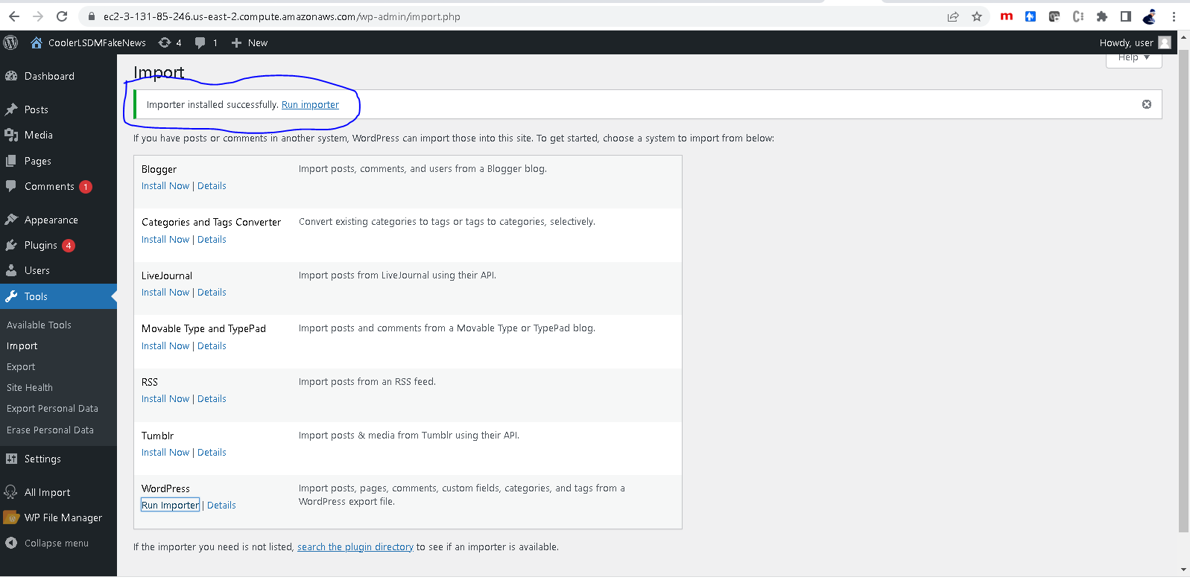

**Step7:** Click on **Run Importer**

**Step8:** You will get option to import WXR file ( .xml format)

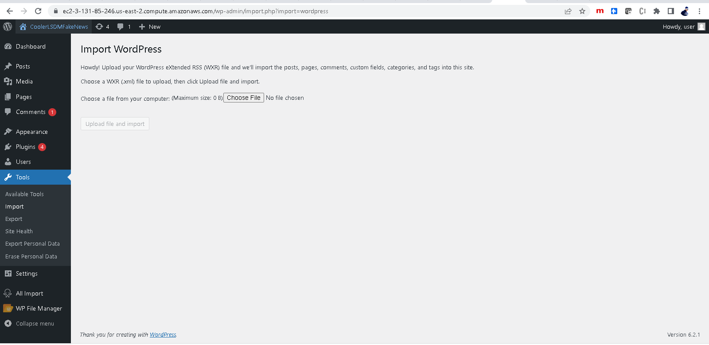

**Step9:** Click Choose File and once dialog box opens, select the provided WXR file **coolerlsdmfakenews.2023-04-30.xml**

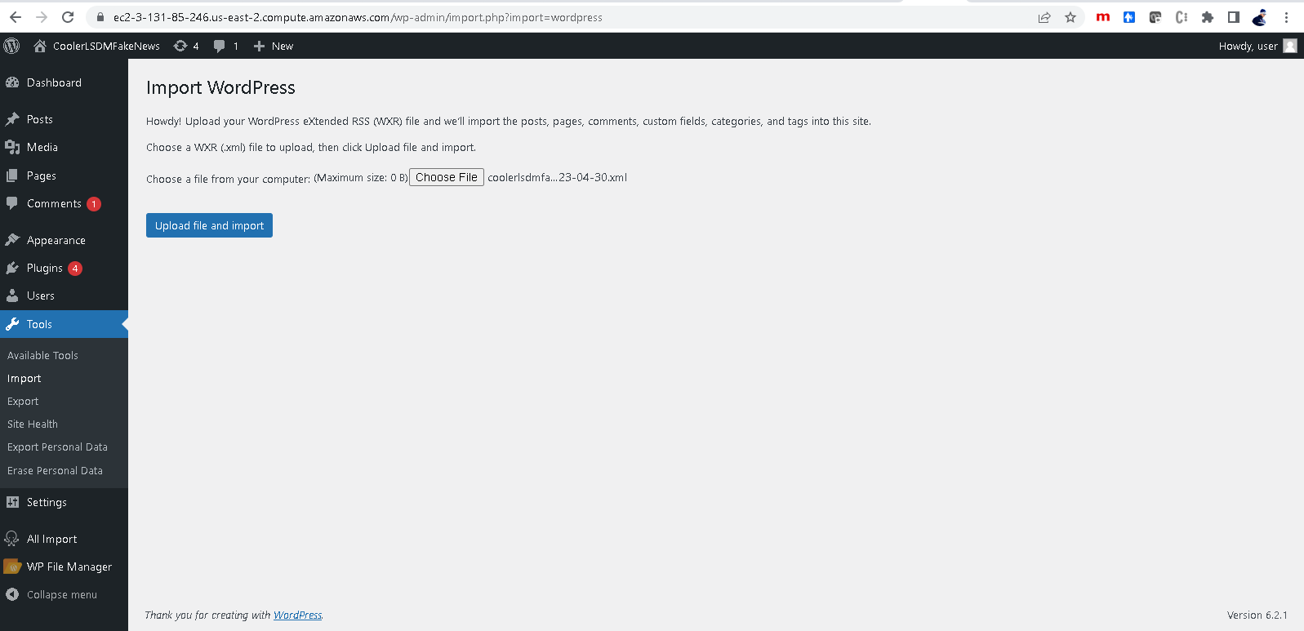

**Step10:** Click “Upload file and Import”

**Step11:** Select existing User or create a new and check the check box Download and import attachments, and click submit. It will deploy the application

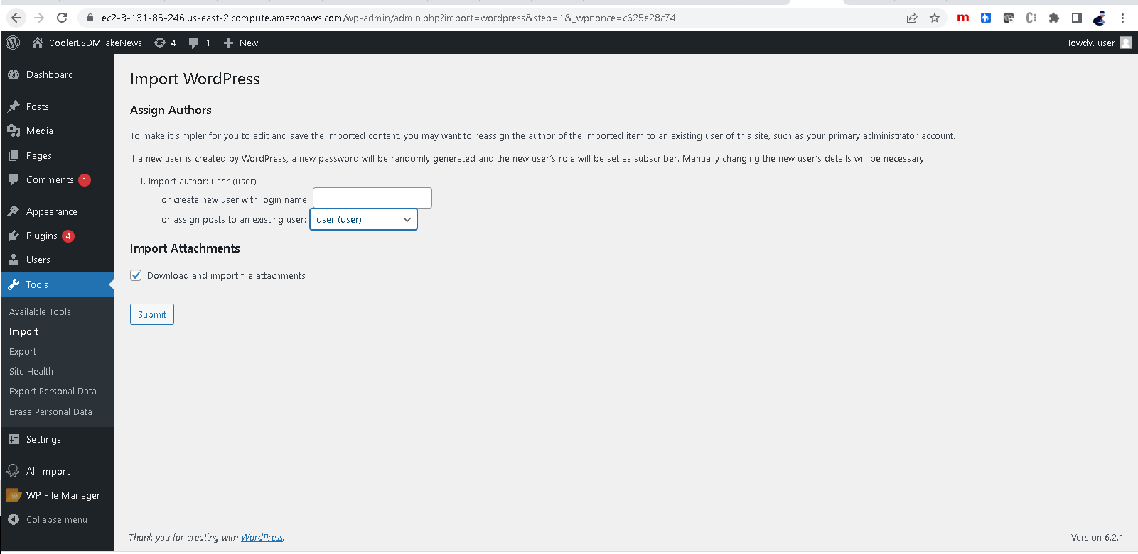

---------------------------------------------------

**Approach 2: Install/Deploy the application in wordpress.com.**

**Step1: Login to your wordpress account in wordpress dotcom and go to dashboard home page.**

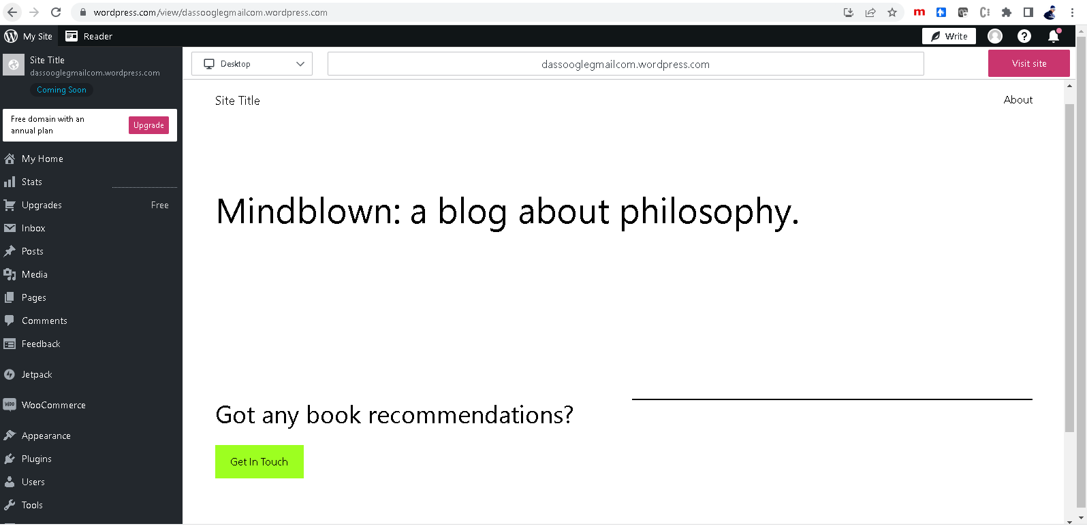

**Step2 : Go to Tools 🡪 Import and click**

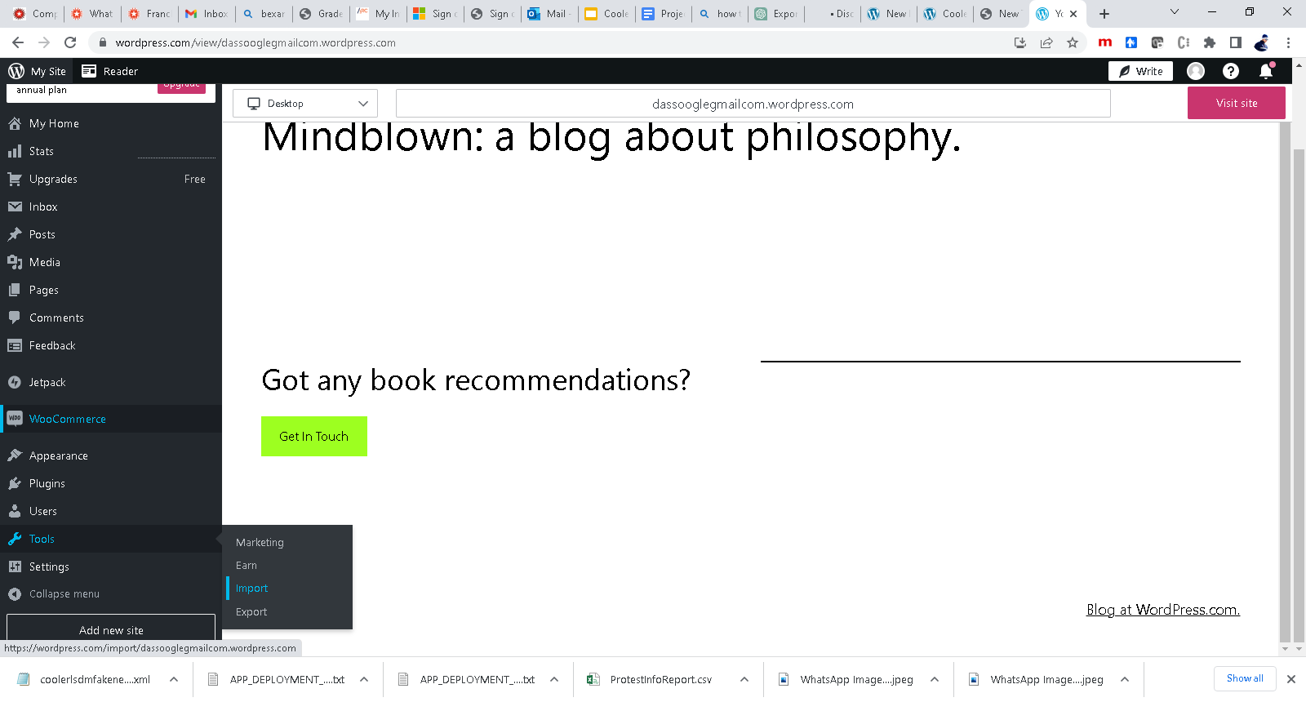

**Step3: Select WordPress option, Drag and drop** the **WXR file (coolerlsdmfakenews.2023-04-30.xml) and** Click on **Start Import once provided that option.**

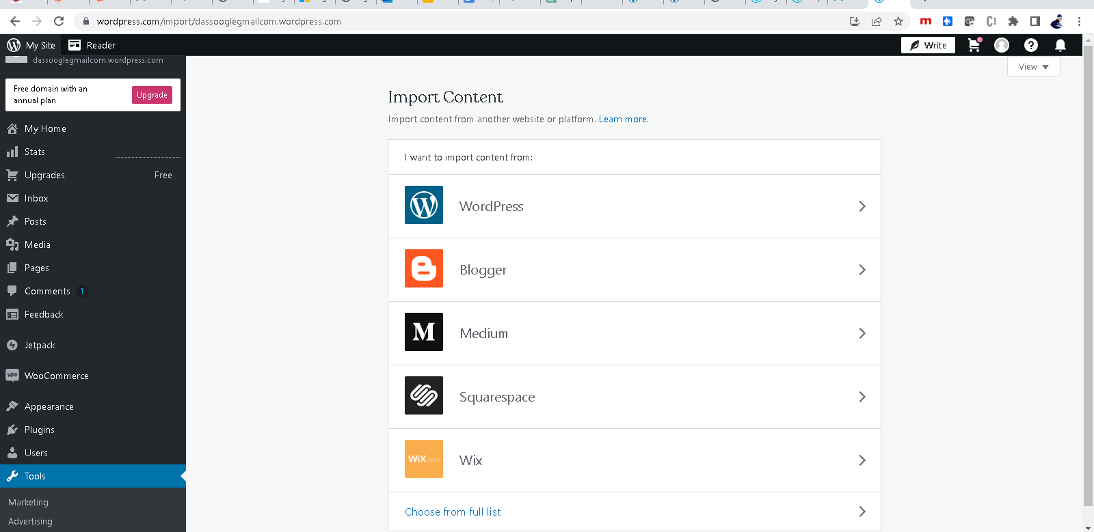

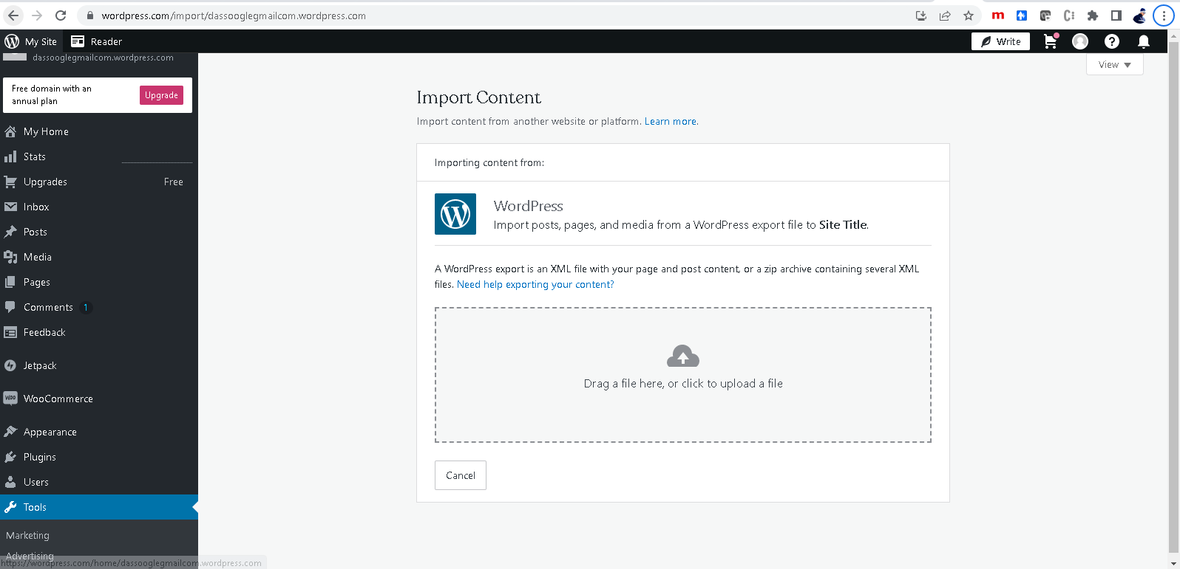

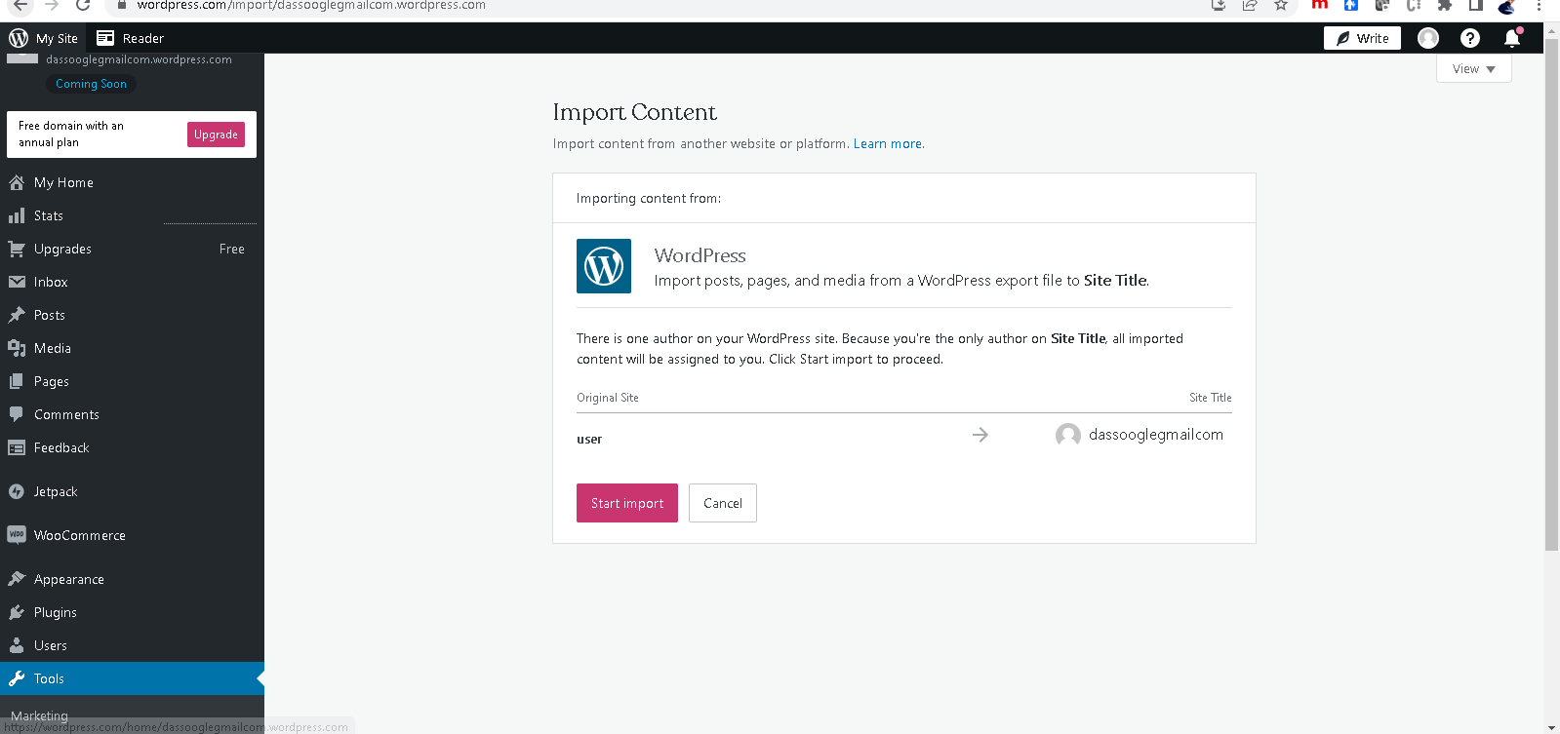

Step4: Click on **Start Import**

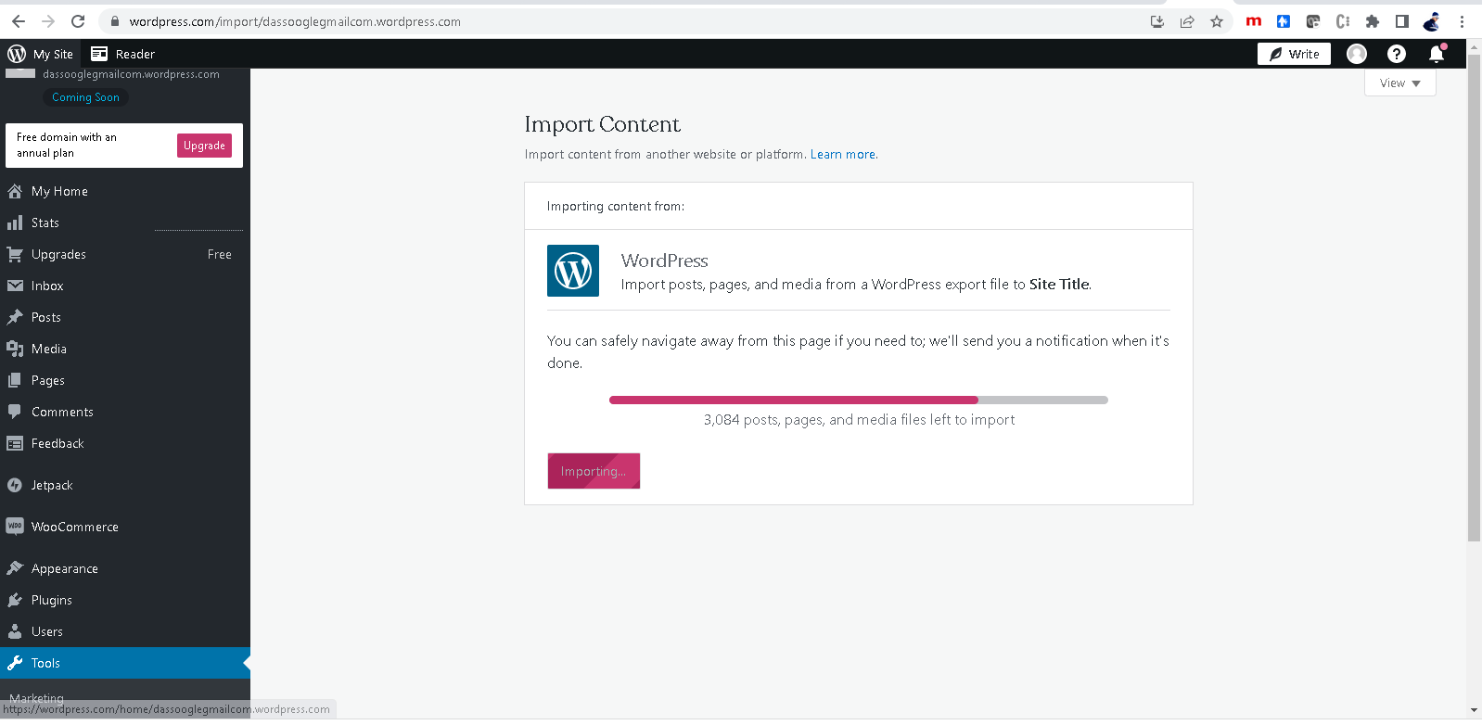

Step 5: Once imported (Deployed) Successfully, View Site option will be provided.

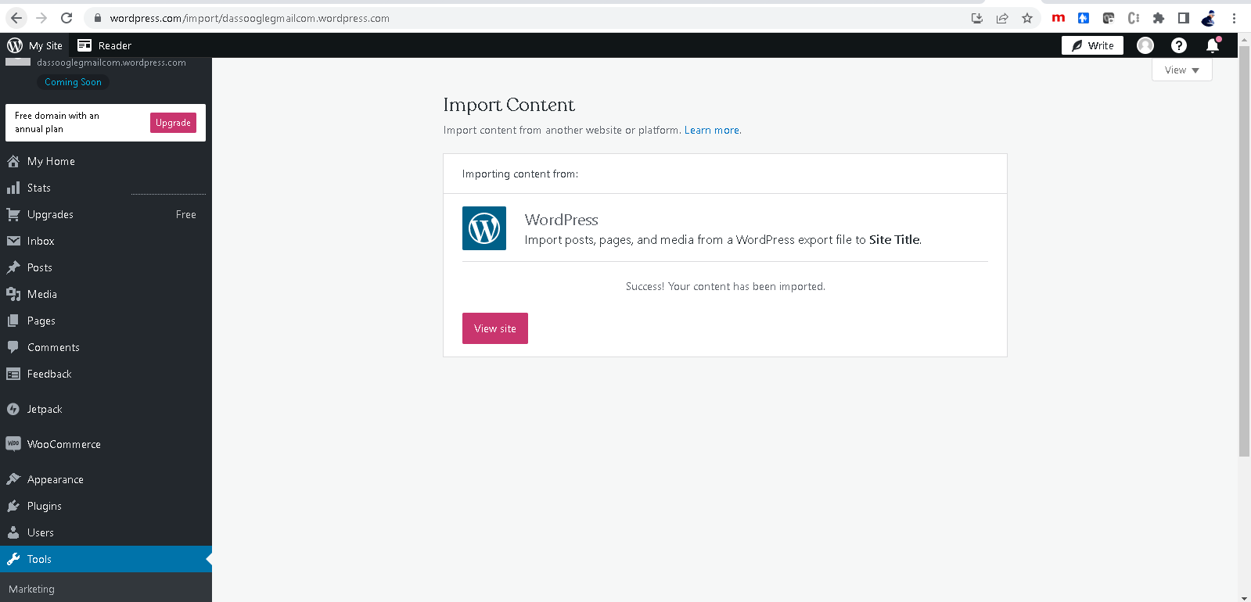

Step6: Click on view site to get **Visit Site** option at top right corner.

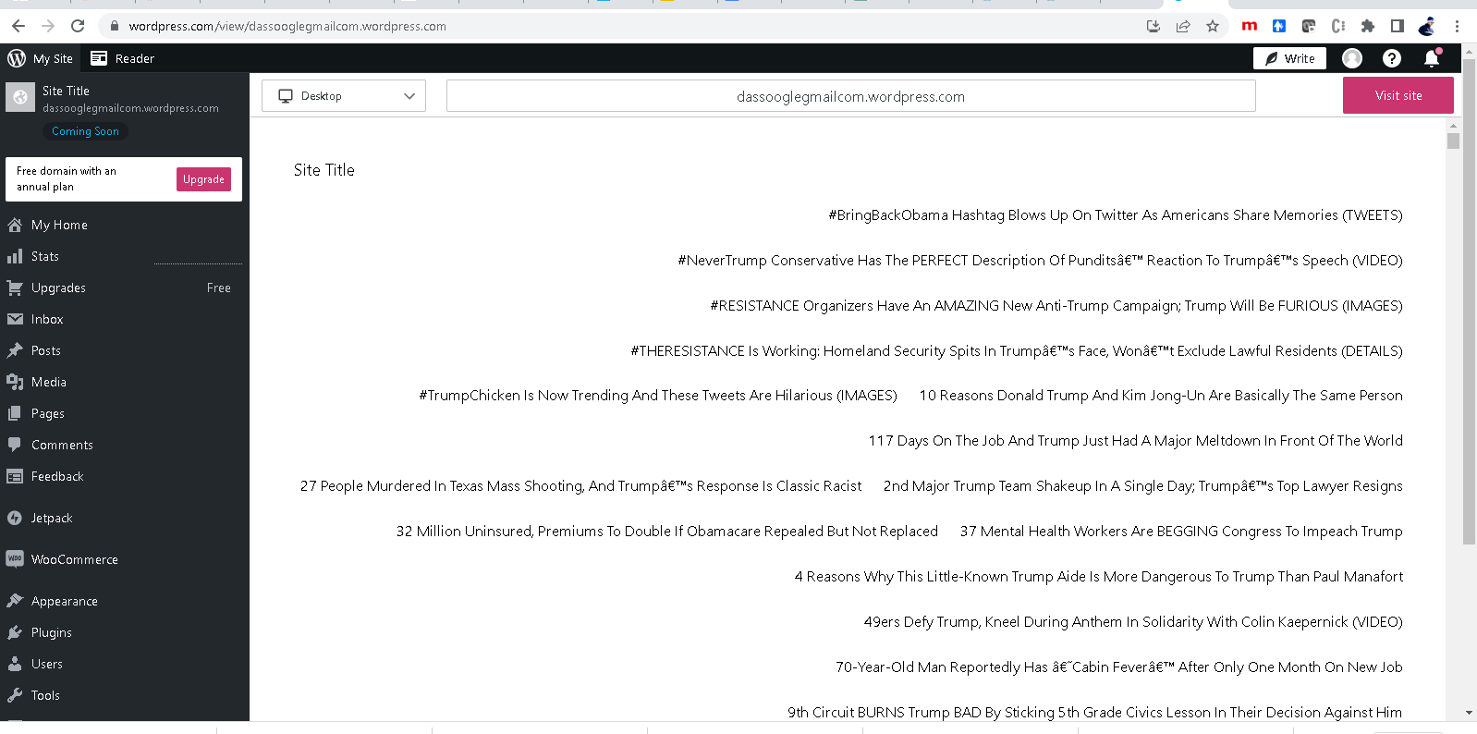

Step7: Click on it to get **Launch Site** option

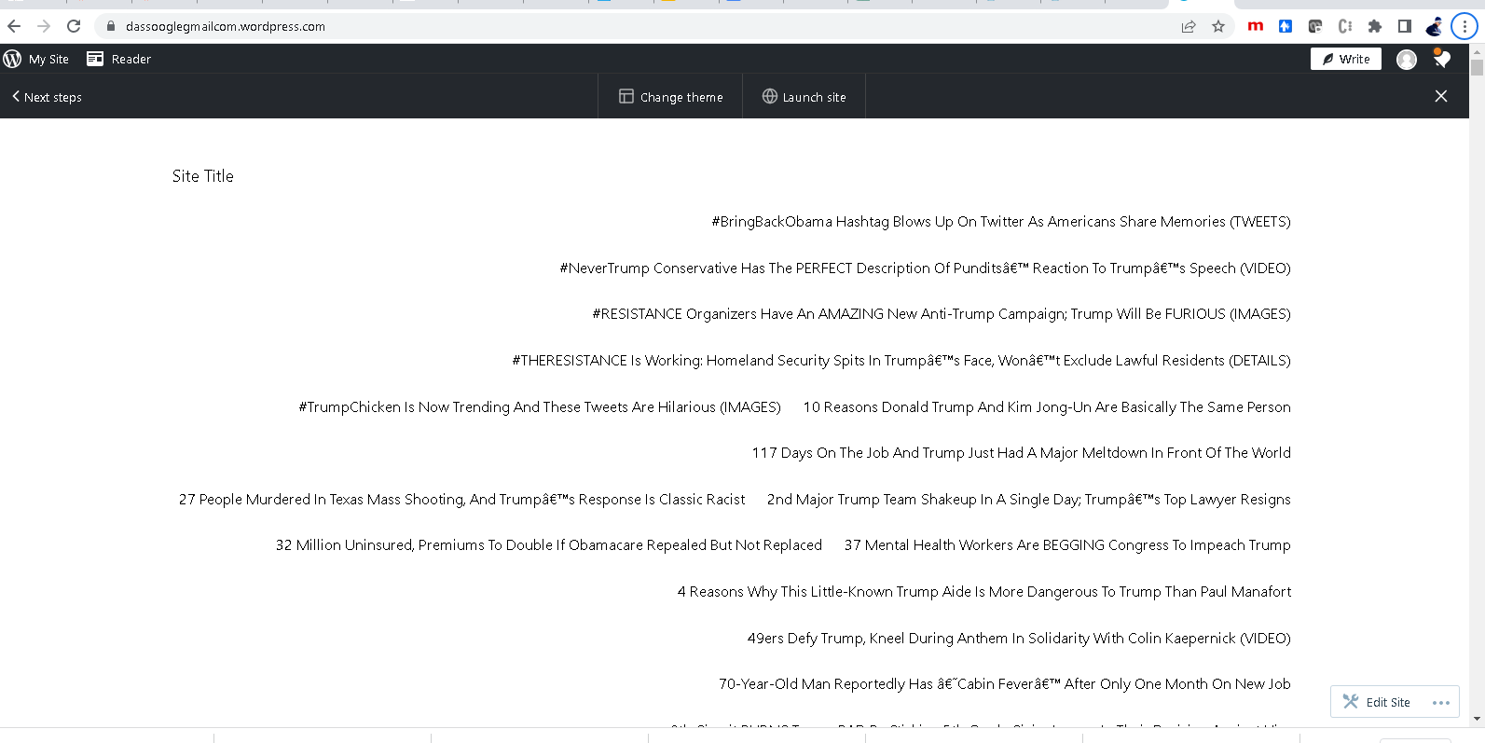

**Step7:** Select the paid domain to get the site up and running in proper form as it is a dynamic site.

