 | National University  of Computer and Emerging Sciences  Chiniot-Faisalabad Campus  Department of Artificial Intelligence and Data Science | 
Course Code | CL2001
Course Title | Data Structures - Lab
Lab Task | 3
Due Date | 08 September 2026
Instructions:
- Rename this Word file as LT3_25F0007
- If found plagiarism, straight zero will be marked against task.
- Submit task on Due Date. No Late Submission will be Tolerated.

Objective
Practice dynamic arrays in C++ using new[], delete[], and basic ADT operations.
Part 1: Search and Count
Task
- Take the number of students n.
- Dynamically allocate an integer array of size n.
- Input the marks.
- Ask for a mark to search.
- Create a function that searches the array and counts its occurrences.
- Display the result.
- Release the dynamically allocated memory.

Code
#include<iostream>
using namespace std;
void search(int arr[],int size);
int main()
{
int n;
cout << "Enter the size of an array" << endl;
cin >> n;
int *arr = new int[n];
cout << "Enter marks" << endl;
for (int i = 0; i < n; i++)
{
cin >> arr[i];
}
search(arr,n);
delete[] arr;

system("pause");
return 0;

}
void search(int arr[],int size)
{
int s,count=0;
cout << "Enter whatt youy want to search" << endl;
cin >> s;
for (int i = 0; i < size; i++)
{
if (arr[i] == s)
{
count++;
}

}

cout << "Total accourence of" << s << ":" << count << endl;

}
Screenshot
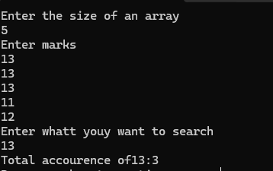

Part 2: Insert into a Sorted Dynamic Array
A game leaderboard stores player scores in descending order. A new player's score must be inserted while keeping the leaderboard sorted.
Task
- Take the number of players n.
- Dynamically allocate an array of size n.
- Input scores in descending order.
- Take a new score.
- Create a function that:
  - Allocates a new array of size n + 1.
  - Inserts the new score at its correct position.
  - Copies the remaining scores.
  - Releases the old array.
- Display the updated leaderboard.

Code
#include<iostream>
using namespace std;
void update(int arr[], int size, int score);
int main()
{
int n;
int new_score;
cout << "Enter no of players" << endl;
cin >> n;
int*arr = new int[n];
cout << "Enter scores in decendind order" << endl;
cin >> arr[0];
for (int i =1 ; i < n; i++)
{
cin >> arr[i];
while (arr[i] > arr[i - 1])
{
cout << "Enter correct input" << endl;
cin >> arr[i];
}

}
cout << "Enter new score:";
cin >> new_score;
update( arr, n, new_score);
delete[] arr;
system("pause");
return 0;

}
void update(int arr[], int size, int score)
{
int* n_arr = new int[size + 1];

for (int i = 0; i < size; i++)
{
if (arr[i] > score)
{
n_arr[i] = arr[i];
}
else if (arr[i] < score)
{
n_arr[i] = score;

for (int j = i; j < size; j++)
{
n_arr[j + 1] = arr[j];
}

break;
}
else
{
n_arr[i] = score;

for (int j = i; j < size; j++)
{
n_arr[j + 1] = arr[j];
}

break;
}
}

if (score < arr[size - 1])
{
n_arr[size] = score;
}

for (int i = 0; i < size + 1; i++)
{
cout << n_arr[i] << " ";
}

delete[] n_arr;
}

Screenshot
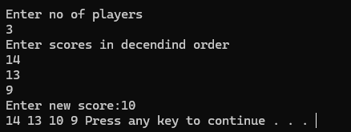

Part 3: Remove Duplicate Product IDs
A shopkeeper has entered product IDs into a dynamic array. Some IDs appear more than once. Create a cleaned array containing each ID only once, while keeping the first occurrence.
Task
- Take the number of products n.
- Dynamically allocate an array of size n.
- Input product IDs.
- Create a function that:
  - Creates a temporary dynamic array.
  - Copies an ID only if it has not appeared before.
  - Keeps track of the number of unique IDs.
  - Creates a new dynamic array containing only the unique IDs.
  - Releases unnecessary arrays.
- Display the cleaned product list.
Code
#include<iostream>
using namespace std;
void remove(int arr[],int n);
int main()
{
int n;
cout << "Enter no of products" << endl;
cin >> n;
int *arr = new int[n];
cout << "Enter IDS" << endl;
for (int i = 0; i < n; i++)
{
cin >> arr[i];
}
remove(arr, n);

delete[] arr;

system("pause");
return 0;

}
void remove(int arr[], int n)
{
int* temp = new int[n];
int k = 0;

for (int i = 0; i < n; i++)
{
int count = 0;

for (int j = 0; j < i; j++)
{
if (arr[i] == arr[j])
{
count++;
break;
}
}

if (count == 0)
{
temp[k] = arr[i];
k++;
}
}

cout << "Cleaned IDs: ";

for (int i = 0; i < k; i++)
{
cout << temp[i] << " ";
}

delete[] temp;
}

Screenshot


