 | National University  of Computer and Emerging Sciences  Chiniot-Faisalabad Campus  Department of Artificial Intelligence and Data Science | 
Course Code | CL2001
Course Title | Data Structures - Lab
Lab Task | 4
Instructions:
- Rename this Word file as LT4_25F0007
- If found plagiarism, straight zero will be marked against task.
- Submit task on Due Date. No Late Submission will be Tolerated.

Objective
Practice implementing and manipulating Singly Linked Lists through insertion, deletion, searching, traversal, and reversal.
Task 1 Train Bogie Management
A railway logistics terminal manages train assembly using a singly linked list. Each node represents a unique bogie ID.

Start with the following train:
101 → 102 → 103 → 104 → NULL

Part A: Insert at Position

Insert a VIP bogie with ID 999 at the 2nd position.
Expected list:
101 → 999 → 102 → 103 → 104 → NULL

Part B: Insert at End

Add a luggage bogie with ID 555 at the end.
Expected list:
101 → 999 → 102 → 103 → 104 → 555 → NULL

Part C: Delete by Position

A defective bogie at the 3rd position must be removed.
Expected list:
101 → 999 → 103 → 104 → 555 → NULL

Part D: Delete by Value

Search for bogie ID 104 and delete that node.
Expected list:
101 → 999 → 103 → 555 → NULL

Part E: Display
Display the train composition after every update.

Hint: To insert or delete at a position, traverse the list until the node immediately before the required position.
Code
#include <iostream>
using namespace std;

class node
{
public:
int data;
node* next;

node(int data)
{
this->data = data;
this->next = nullptr;
}
};

class linklist
{
private:
node* head;

public:
linklist()
{
head = nullptr;
}

// Insert at a specific position
void insert(int data, int position)
{
node* new_node = new node(data);

if (position == 1)
{
new_node->next = head;
head = new_node;
return;
}

node* temp = head;

for (int i = 1; i < position - 1 && temp != nullptr; i++)
{
temp = temp->next;
}

if (temp == nullptr)
{
cout << "Invalid position" << endl;
delete new_node;
return;
}

new_node->next = temp->next;
temp->next = new_node;
}

// Insert at end
void insertend(int data)
{
node* new_node = new node(data);

if (head == nullptr)
{
head = new_node;
return;
}

node* temp = head;

while (temp->next != nullptr)
{
temp = temp->next;
}

temp->next = new_node;
}

// Delete by position
void deleteposition(int position)
{
if (head == nullptr)
{
return;
}

if (position == 1)
{
node* temp = head;
head = head->next;
delete temp;
return;
}

node* temp = head;

for (int i = 1; i < position - 1 && temp != nullptr; i++)
{
temp = temp->next;
}

if (temp == nullptr || temp->next == nullptr)
{
cout << "Invalid position" << endl;
return;
}

node* delete_node = temp->next;

temp->next = delete_node->next;

delete delete_node;
}

// Delete by value
void deletevalue(int value)
{
if (head == nullptr)
{
return;
}

if (head->data == value)
{
node* temp = head;
head = head->next;
delete temp;
return;
}

node* temp = head;

while (temp->next != nullptr)
{
if (temp->next->data == value)
{
node* delete_node = temp->next;

temp->next = delete_node->next;

delete delete_node;

return;
}

temp = temp->next;
}
}

// Display
void display()
{
node* temp = head;

while (temp != nullptr)
{
cout << temp->data << " -> ";
temp = temp->next;
}

cout << "NULL" << endl;
}
};

int main()
{
linklist list;

list.insertend(101);
list.insertend(102);
list.insertend(103);
list.insertend(104);

cout << "By Burhan" << endl;
cout << "Starting list: ";
list.display();

list.insert(999, 2);

cout << "By Burhan" << endl;
cout << "After inserting 999 at position 2: ";
list.display();

list.insertend(555);

cout << "By Burhan" << endl;
cout << "After inserting 555 at end: ";
list.display();

list.deleteposition(3);

cout << "By Burhan" << endl;
cout << "After deleting node at position 3: ";
list.display();

list.deletevalue(104);

cout << "By Burhan" << endl;
cout << "After deleting value 104: ";
list.display();

return 0;
}
Screenshot
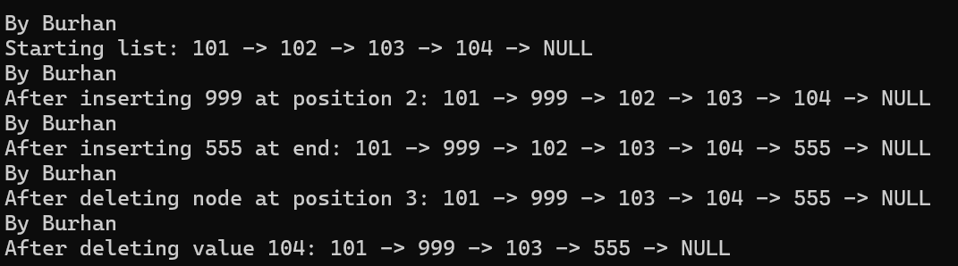

Task 2: Warehouse Stock Tracker
An automated warehouse uses a singly linked list to maintain product stock. Each node contains: Item Code and Quantity
Start with:
(101, 50) → (102, 20) → (103, 75) → NULL

Part A: Insert at Beginning

A new shipment arrives:
Item Code = 100, Quantity = 30
Insert it at the beginning.
Expected list:
(100,30) → (101,50) → (102,20) → (103,75) → NULL

Part B: Search and Update

Search for item code 102 and update its quantity from 20 to 45.
Expected list:
(100,30) → (101,50) → (102,45) → (103,75) → NULL

Part C: Delete by Condition
Assume an item's quantity becomes 0.
Modify your program so that a node whose quantity is 0 is removed from the list.

Part D: Display

Traverse the complete list and display the current inventory.

Hint: Search the list using the item code, then modify the data members of the matching node directly.
Code
#include <iostream>
using namespace std;

class node
{
public:
int itemCode;
int quantity;
node* next;

node(int itemCode, int quantity)
{
this->itemCode = itemCode;
this->quantity = quantity;
this->next = nullptr;
}
};

class linklist
{
private:
node* head;

public:
linklist()
{
head = nullptr;
}

void insertAtBeginning(int itemCode, int quantity)
{
node* new_node = new node(itemCode, quantity);

new_node->next = head;
head = new_node;
}

void insertAtEnd(int itemCode, int quantity)
{
node* new_node = new node(itemCode, quantity);

if (head == nullptr)
{
head = new_node;
return;
}

node* temp = head;

while (temp->next != nullptr)
{
temp = temp->next;
}

temp->next = new_node;
}

// Search and update quantity
void updateQuantity(int itemCode, int newQuantity)
{
node* temp = head;

while (temp != nullptr)
{
if (temp->itemCode == itemCode)
{
temp->quantity = newQuantity;
return;
}

temp = temp->next;
}

cout << "Item not found" << endl;
}

void deleteZeroQuantity()
{
// Delete from beginning
while (head != nullptr && head->quantity == 0)
{
node* temp = head;
head = head->next;
delete temp;
}

node* temp = head;

while (temp != nullptr && temp->next != nullptr)
{
if (temp->next->quantity == 0)
{
node* delete_node = temp->next;

temp->next = delete_node->next;

delete delete_node;
}
else
{
temp = temp->next;
}
}
}

void display()
{
node* temp = head;

while (temp != nullptr)
{
cout << "(" << temp->itemCode << ", " << temp->quantity << ") -> ";

temp = temp->next;
}

cout << "NULL" << endl;
}
};

int main()
{
linklist list;

list.insertAtEnd(101, 50);
list.insertAtEnd(102, 20);
list.insertAtEnd(103, 75);

cout << "By Burhan" << endl;
cout << "Starting inventory: ";
list.display();

list.insertAtBeginning(100, 30);

cout << "By Burhan" << endl;
cout << "After inserting (100,30): ";
list.display();

list.updateQuantity(102, 45);

cout << "By Burhan" << endl;
cout << "After updating item 102: ";
list.display();

list.updateQuantity(103, 0);

cout << "By Burhan" << endl;
cout << "After making item 103 quantity 0: ";
list.display();

list.deleteZeroQuantity();

cout << "By Burhan" << endl;
cout << "After deleting zero-quantity item: ";
list.display();

return 0;
}
Screenshot
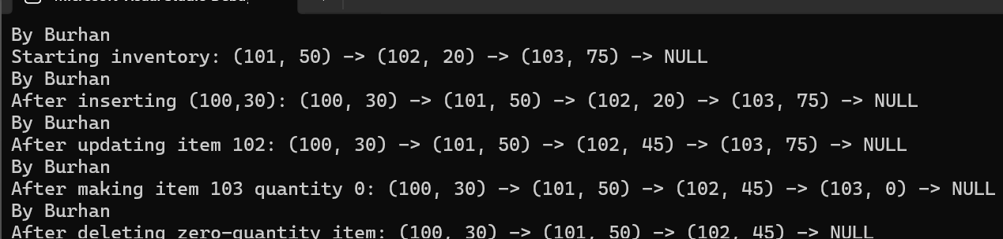

Task 3: Academic Roll Call Reversal
An academic administration system stores student roll numbers in a singly linked list:
10 → 20 → 30 → 40 → 50 → NULL

Part A: Count Students

Traverse the list and calculate the total number of students.
Expected output:
Total Students: 5

Part B: Reverse the List

Reverse the linked list in-place without creating another list.
Expected output:
50 → 40 → 30 → 20 → 10 → NULL

Part C: Display

Display the list before and after reversal.

Part D: Verify

After reversal, traverse the list again and verify that the number of students remains unchanged.

Hint: Use three pointers, prev, current, and next, to change the direction of each node's next pointer.
Code
#include <iostream>
using namespace std;

class node
{
public:
int rollNo;
node* next;

node(int rollNo)
{
this->rollNo = rollNo;
next = nullptr;
}
};

class linklist
{
private:
node* head;

public:
linklist()
{
head = nullptr;
}

void addStudent(int rollNo)
{
node* newNode = new node(rollNo);

if (head == nullptr)
{
head = newNode;
return;
}

node* current = head;

while (current->next != nullptr)
{
current = current->next;
}

current->next = newNode;
}

int getCount()
{
int total = 0;
node* current = head;

while (current != nullptr)
{
total++;
current = current->next;
}

return total;
}

void reverseList()
{
node* previous = nullptr;
node* current = head;
node* nextNode;

while (current != nullptr)
{
nextNode = current->next;
current->next = previous;

previous = current;
current = nextNode;
}

head = previous;
}

void showList()
{
node* current = head;

while (current != nullptr)
{
cout << current->rollNo << " -> ";
current = current->next;
}

cout << "NULL" << endl;
}
};

int main()
{
linklist students;

students.addStudent(10);
students.addStudent(20);
students.addStudent(30);
students.addStudent(40);
students.addStudent(50);

cout << "Before reversal: ";
students.showList();

cout << "Total Students: " << students.getCount() << endl;

students.reverseList();

cout << "After reversal: ";
students.showList();

cout << "Total Students after reversal: "
<< students.getCount() << endl;

return 0;
}

Screenshot


