National University
of Computer and Emerging Sciences
Chiniot-Faisalabad Campus


Department of Artificial Intelligence and Data Science
Course Code | CL2001
Course Title | Data Structures - Lab
Lab Task | 8
Instructions:
- Rename this Word file as LT8_25F0008
- If found plagiarism, straight zero will be marked against task.
- Submit task on Due Date. No Late Submission will be Tolerated.
Objective
Implement queue operations using a linked list and apply queue-based reasoning to sort elements using only two queues.
Task 1: Queue Operations Using Linked List
Implement a Queue using a singly linked list. Your queue must support the following operations:
Part A) Enqueue: Insert an element at the rear of the queue.
Part B) Dequeue: Remove and display the element at the front.
Part C) IsEmpty: Return whether the queue contains any elements.
Part D) GetFront: Return the front element without removing it.
Part E) Size: Return the total number of elements currently in the queue.
Part F) Test All Operations: Perform the following sequence and display the queue after relevant operations.
- Enqueue 100, 200, 300, 400, 500.
- Display the front element and queue size.
- Dequeue two elements.
- Enqueue 600, 700.
- Display the updated queue, front element, and size.
- Dequeue all remaining elements and verify that the queue is empty.
Hint: Maintain pointers to both the front and rear nodes to perform enqueue and dequeue efficiently.

Code
#include <iostream>
using namespace std;

class Node {
public:
int data;
Node* next;

Node(int data)
{
this->data = data;
this->next = nullptr;
}
};

class Queue
{
private:
Node* front, * rear;
int count;

public:
Queue()
{
front = nullptr;
rear = nullptr;
count = 0;
}

void enqueue(int x)
{
Node* t = new Node(x);

if (!front)
{
front = rear = t;
}
else
{
rear->next = t;
rear = t;
}

count++;
}

int dequeue()
{
int x = -1;

if (!front)
{
cout << "Queue is Empty" << endl;
}
else
{
Node* t = front;
x = front->data;
front = front->next;

if (!front)
{
rear = nullptr;
}

delete t;
count--;
}

return x;
}

bool isEmpty()
{
return front == nullptr;
}

int getFront()
{
if (!front)
{
return -1;
}

return front->data;
}

int size()
{
return count;
}

void display()
{
Node* p = front;

while (p)
{
cout << p->data << " ";
p = p->next;
}

cout << endl;
}
};

int main()
{
Queue q;

q.enqueue(100);
q.enqueue(200);
q.enqueue(300);
q.enqueue(400);
q.enqueue(500);

cout << "Queue: ";
q.display();

cout << "Front: " << q.getFront() << endl;
cout << "Size: " << q.size() << endl;

cout << endl;

cout << "Dequeue: " << q.dequeue() << endl;
cout << "Dequeue: " << q.dequeue() << endl;

q.enqueue(600);
q.enqueue(700);

cout << endl;

cout << "Updated Queue: ";
q.display();

cout << "Front: " << q.getFront() << endl;
cout << "Size: " << q.size() << endl;

cout << endl;

cout << "Remaining: ";

while (!q.isEmpty())
{
cout << q.dequeue() << " ";
}

cout << endl;

cout << "Is Empty: " << q.isEmpty() << endl;

return 0;
}

Screenshot
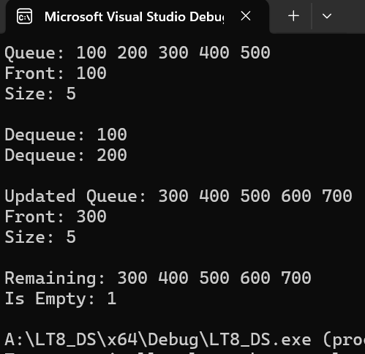
Task 2: Sort a Queue Using Only Two Queues
Implement a function that sorts all elements of a queue in ascending order, using only the original queue and one helper queue. Your solution must handle positive numbers, negative numbers, and duplicate values.
Part A: Implement the Sorting Function
Create a function similar to: void sortQueue(Queue &q);
The function should sort the queue in place, using a single helper queue.
You may use repeated passes through the queue. Think about how elements can be compared and transferred between the two queues to gradually build the required order.
Hint: Consider how you could identify an appropriate element to place next in sorted order, while transferring the remaining elements between the original queue and the helper queue. You must preserve elements that have equal values.
Part B: Test Your Implementation
Test your function using all three examples.
Example Input Queue Expected Output
- 9, 3, 7, 1, 8 1, 3, 7, 8, 9
- 12, 5, 12, 3, 8 3, 5, 8, 12, 12
- 4, -2, 7, 0, -2 -2, -2, 0, 4, 7

Part C: Verify Correctness
After sorting each queue:
- Display the original queue after sorting.
- Verify that the elements are in ascending order.
- Confirm that the number of elements has not changed.
- Confirm that duplicate values have been preserved.
Challenge:
Your algorithm must also work for an already sorted queue, a reverse-sorted queue, and a queue containing only duplicate values.
Summary of Requirements:
- Only two queue objects may exist during sorting: the original queue and one helper queue.
- Use only enqueue and dequeue operations to manipulate queue elements.
- Scalar temporary variables and counters are allowed.
- Do not use arrays, stacks, vectors, lists, recursion, priority queues, or built-in sorting functions.
- After sorting, the original queue must contain all elements in ascending order.
- Preserve all duplicate values.
Code
#include <iostream>
using namespace std;

class Node {
public:
int data;
Node* next;

Node(int data)
{
this->data = data;
this->next = nullptr;
}
};

class Queue
{
private:
Node* front, * rear;
int count;

public:
Queue()
{
front = nullptr;
rear = nullptr;
count = 0;
}

void enqueue(int x)
{
Node* t = new Node(x);

if (!front)
{
front = rear = t;
}
else
{
rear->next = t;
rear = t;
}

count++;
}

int dequeue()
{
if (!front)
{
return -1;
}

Node* t = front;
int x = front->data;

front = front->next;

if (!front)
{
rear = nullptr;
}

delete t;
count--;

return x;
}

bool isEmpty()
{
return front == nullptr;
}

int size()
{
return count;
}

void display()
{
Node* p = front;

while (p)
{
cout << p->data << " ";
p = p->next;
}

cout << endl;
}
};

void sortQueue(Queue& q)
{
Queue temp;
int n = q.size();

for (int i = 0; i < n; i++)
{
int min = q.dequeue();

for (int j = 1; j < n - i; j++)
{
int x = q.dequeue();

if (x < min)
{
temp.enqueue(min);
min = x;
}
else
{
temp.enqueue(x);
}
}

q.enqueue(min);

while (!temp.isEmpty())
{
q.enqueue(temp.dequeue());
}
}

for (int i = 0; i < n; i++)
{
temp.enqueue(q.dequeue());
}

while (!temp.isEmpty())
{
q.enqueue(temp.dequeue());
}
}

int main()
{
Queue q;

q.enqueue(9);
q.enqueue(3);
q.enqueue(7);
q.enqueue(1);
q.enqueue(8);

cout << "Original Queue: ";
q.display();

int oldSize = q.size();

sortQueue(q);

cout << "Sorted Queue: ";
q.display();

cout << "Size: " << q.size() << endl;
cout << "Size Same: " << (oldSize == q.size()) << endl;

return 0;
}

Screenshot


