 | National University  of Computer and Emerging Sciences  Chiniot-Faisalabad Campus  Department of Artificial Intelligence and Data Science | 
Course Code | CL2001
Course Title | Data Structures - Lab
Lab Task | 1
Due Date | 25 August 2026
Instructions:
- Rename this Word file as LT1_25F0007
- If found plagiarism, straight zero will be marked against task.
- Submit task on Due Date. No Late Submission will be Tolerated.

Objective
Practice pointer declaration, dereferencing, passing pointers to functions, pointer scope, and returning pointers from functions.
Part 1: Pointer Basics
1. Declare an integer variable and take its value from the user.
2. Create a pointer to the variable.
3. Display the value, address of the variable, address stored in the pointer, and value using dereferencing.

Sample Input
Enter value: 25

Sample Output
Value: 25
Address of variable: 0x...
Address stored in pointer: 0x...
Value using pointer: 25
Code
#include<iostream>
using namespace std;
int main()
{
int num;
int*ptr=&num;

cout << "Enter value:";
cin >> num;
cout << "Adress of variable:" << &num << endl;
cout << "Adress stored in pointer :" << ptr << endl;
*ptr = 30;
cout << "Value using pointer:" << *ptr<<endl;
system("pause");
}
Screenshot
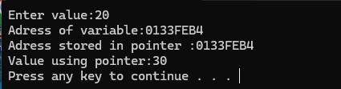

Part 2: Passing Pointer to a Function
4. Create void doubleValue(int *ptr).
5. Pass the pointer from Part 1 and double the original variable.

Sample Output
Before function call: 25
After function call: 50
Code
cout << "Value using pointer:" << *ptr<<endl;
cout << "Before function call:" << *ptr << endl;
doubleValue(ptr);
cout << "After function call:" << *ptr << endl;
system("pause");
}
void doubleValue(int*ptr)
{
*ptr *= 2;
}
Screenshot
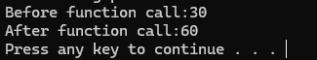

Part 3: Pointer with Function Scope
6. Create void outerFunction().
7. Inside outerFunction(), declare an integer variable and a pointer to it.
8. Pass the pointer to doubleValue() and display the value before and after the call.
9. The pointer must be local to outerFunction() and must not be directly accessible from main().
Code
outerFunction();
system("pause");
}
void doubleValue(int*ptr)
{
*ptr *= 2;

}
void outerFunction()
{
int v1=25;
int*ptr=&v1;
cout << "Before function call:" << *ptr << endl;
doubleValue(ptr);
cout << "After function call:" << *ptr << endl;

}
Screenshot
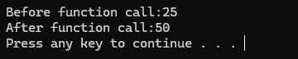

Part 4: Function Returning a Pointer
10. Create int* findLarger(int *a, int *b).
11. Return a pointer to the larger of the two values.

Sample Input
First value: 35
Second value: 20
Sample Output
Larger value: 35
Code
int v1 = 10;
int v2 = 20;
cout << "First value:" << v1<<endl;
cout << "second value:" << v2<<endl;
cout << "Larger Value :" << *findlarge(&v1, &v2) << endl;
system("pause");
}
int*findlarge(int*a, int*b)
{
if (*a > *b)
{
return a;
}
else
{
return b;
}
}
Screenshot
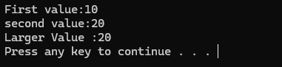

Part 5: Swap Using Pointers
12. Create void swapValues(int *a, int *b).
13. Swap two integers using pointers.

Sample Input
First value: 10
Second value: 25
Sample Output
Before Swap:
First: 10
Second: 25
After Swap:
First: 25
Second: 10
Code
int n1 = 10;
int n2 = 50;
cout << "Before swap " << endl << "First value:" << n1 << " Second Value: " << n2 << endl;
swapValues(&n1,&n2);
system("pause");
}

void swapValues(int*a, int*b)
{
int c;
c = *b;
*b = *a;
*a = c;
cout << "After swap " << endl << "First value:" << *a << " Second Value: " << *b << endl;

}
Screenshot


