National University
of Computer and Emerging Sciences
Chiniot-Faisalabad Campus


Department of Artificial Intelligence and Data Science
Course Code | CL2001
Course Title | Data Structures - Lab
Lab Task | 2
Instructions:
- Rename this Word file as LT2_25F0007
- If found plagiarism, straight zero will be marked against task.
- Submit task on Due Date. No Late Submission will be Tolerated.
Objective
Use pointers with structures, pointer arithmetic, functions, and returned pointers.
Part 1: Input and Display
- Define a Student structure containing int id, float quiz, float assignment, and float finalExam.
- Create records for 5 students using a fixed-size array.
- Use a Student* pointer to input and display all records.
- Traverse the array using pointer arithmetic rather than array indexing.
Sample Input
- 70 80 75
- 60 65 70
- 90 85 95
- 55 60 50
- 80 75 85
Sample Output
ID Quiz Assignment Final
- 70 80 75
- 60 65 70
- 90 85 95
- 55 60 50
- 80 75 85
Code

#include <iostream>
using namespace std;

struct Student
{
int id;
float quiz;
float assignment;
float finalExam;
};

void input(Student* ptr)
{
for (int i = 0; i < 5; i++)
{
cin >> ptr->id;
cin >> ptr->quiz;
cin >> ptr->assignment;
cin >> ptr->finalExam;

ptr++;
}
}

void display(Student* ptr)
{
cout << "ID\tQuiz\tAssignment\tFinal" << endl;

for (int i = 0; i < 5; i++)
{
cout << ptr->id << "\t"
<< ptr->quiz << "\t "
<< ptr->assignment << "\t "
<< ptr->finalExam << endl;

ptr++;
}
}

int main()
{
Student students[5];
Student* ptr = students;
input(ptr);
ptr = students;
display(ptr);
return 0;
}
Screenshot
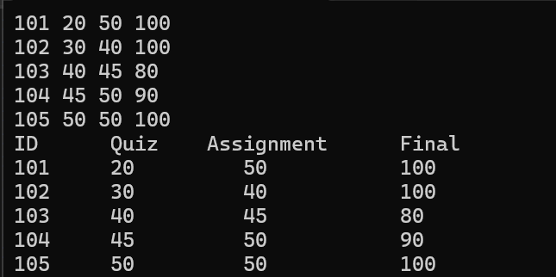
Part 2: Search Student
- Create Student* findStudent(Student *start, int size, int id).
- Search using pointer arithmetic.
- Return a pointer to the matching student, or nullptr if the ID does not exist.
Sample Input
Enter Student ID: 103
Sample Output
Student Found
ID: 103
Quiz: 90
Assignment: 85
Final Exam: 95
Code
Student* findStudent(Student* start, int size, int id)
{
for (int i = 0; i < size; i++)
{
if (start->id == id)
{
return start;
}

start++;
}

return nullptr;
}
int main()
{
Student students[5];
Student* ptr = students;
input(ptr);
ptr = students;
display(ptr);

int id;
cout << "Enter Student ID: ";
cin >> id;
Student* result = findStudent(students, 5, id);
if (result != nullptr)
{
cout << "Student Found" << endl;
cout << "ID: " << result->id << endl;
cout << "Quiz: " << result->quiz << endl;
cout << "Assignment: " << result->assignment << endl;
cout << "Final Exam: " << result->finalExam << endl;
}
else
{
cout << "Student Not Found" << endl;
}
return 0;
}
Screenshot
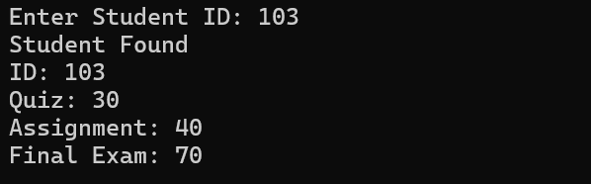
Part 3: Calculate Student Result
8. Create a function that receives a Student* and calculates the weighted score.
- Quiz = 20%
- Assignment = 30%
- Final Exam = 50%
9. A student is PASS if the weighted score is at least 50.
Sample Output
Student ID: 103
Weighted Score: 91
Status: PASS
Code
float calculateScore(Student* student)
{
float score;

score = student->quiz * 0.20
+ student->assignment * 0.30
+ student->finalExam * 0.50;

return score;
}

int main()
{
Student students[5];
Student* ptr = students;
input(ptr);
ptr = students;
display(ptr);

int id;
cout << "Enter Student ID: ";
cin >> id;
Student* result = findStudent(students, 5, id);
if (result != nullptr)
{
cout << "Student Found" << endl;
cout << "ID: " << result->id << endl;
cout << "Quiz: " << result->quiz << endl;
cout << "Assignment: " << result->assignment << endl;
cout << "Final Exam: " << result->finalExam << endl;
}
else
{
cout << "Student Not Found" << endl;
}

if (result != nullptr)
{
float score = calculateScore(result);

cout << "Student ID: " << result->id << endl;
cout << "Weighted Score: " << score << endl;

if (score >= 50)
{
cout << "Status: PASS" << endl;
}
else
{
cout << "Status: FAIL" << endl;
}
}
else
{
cout << "Student Not Found" << endl;
}
return 0;
}
Screenshot
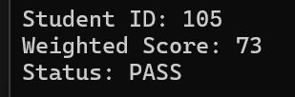
Part 4: Update Student Record
- Ask the user for a Student ID.
- Use findStudent() to obtain the student's pointer.
- Update the student's Final Exam marks.
- Reject marks outside 0–100.
Sample Input
Student ID: 102
New Final Exam Marks: 82
Sample Output
Record updated successfully.
ID: 102
Quiz: 60
Assignment: 65
Final Exam: 82
Code
if (result != nullptr)
{
float marks;

cout << "New Final Exam Marks: ";
cin >> marks;

if (marks >= 0 && marks <= 100)
{
result->finalExam = marks;

cout << "Record updated successfully." << endl;
cout << "ID: " << result->id << endl;
cout << "Quiz: " << result->quiz << endl;
cout << "Assignment: " << result->assignment << endl;
cout << "Final Exam: " << result->finalExam << endl;
}
else
{
cout << "Invalid marks." << endl;
}
}
else
{
cout << "Student Not Found" << endl;
}

Screenshot
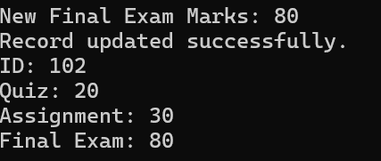
Part 5: Menu Integration
Combine the previous parts into a menu-driven program.
- Display All Students
- Search Student
- Update Final Exam Marks
- Display Student Result
- Exit
Handle invalid menu choices and non-existing Student IDs. Sample Menu
===== Student Record System =====
1. Display All Students

- Search Student
- Update Final Exam Marks
- Display Student Result
- Exit
Enter choice:
Code
int choice;

do
{
cout << "\n Student Record System " << endl;
cout << "1. Display All Students" << endl;
cout << "2. Search Student" << endl;
cout << "3. Update Final Exam Marks" << endl;
cout << "4. Display Student Result" << endl;
cout << "5. Exit" << endl;
cout << "Enter choice: ";
cin >> choice;

if (choice == 1)
{
ptr = students;
display(ptr);
}

else if (choice == 2)
{
cout << "Enter Student ID: ";
cin >> id;

Student* result = findStudent(students, 5, id);

if (result != nullptr)
{
cout << "Student Found" << endl;
cout << "ID: " << result->id << endl;
cout << "Quiz: " << result->quiz << endl;
cout << "Assignment: " << result->assignment << endl;
cout << "Final Exam: " << result->finalExam << endl;
}
else
{
cout << "Student Not Found" << endl;
}
}

else if (choice == 3)
{
cout << "Student ID: ";
cin >> id;

Student* result = findStudent(students, 5, id);

if (result != nullptr)
{
float marks;

cout << "New Final Exam Marks: ";
cin >> marks;

if (marks >= 0 && marks <= 100)
{
result->finalExam = marks;

cout << "Record updated successfully." << endl;
}
else
{
cout << "Invalid marks." << endl;
}
}
else
{
cout << "Student Not Found" << endl;
}
}

else if (choice == 4)
{
cout << "Enter Student ID: ";
cin >> id;

Student* result = findStudent(students, 5, id);

if (result != nullptr)
{
float score = calculateScore(result);

cout << "Student ID: " << result->id << endl;
cout << "Weighted Score: " << score << endl;

if (score >= 50)
{
cout << "Status: PASS" << endl;
}
else
{
cout << "Status: FAIL" << endl;
}
}
else
{
cout << "Student Not Found" << endl;
}
}

else if (choice == 5)
{
cout << "Program ended." << endl;
}

else
{
cout << "Invalid choice." << endl;
}

} while (choice != 5);

return 0;
}
Screenshot


