**Maker/Manufacturer Responsibilities**

**Product Labeling Instructions**

A sample label is provided for your use. You must complete the sections marked in red. Once complete, you may change the font color to black.

* Body Contacting Materials include the materials you selected for mask and head ties. Other materials include those used for the nose piece reinforcement.
* Name, Address, Phone/Email must be included.

**Your Responsibilities as a Maker/Manufacturer**

**To comply with the Federal Drug Administration’s (FDA) Emergency Use Authorization (EUA) re-issued April 24, 2020, a manufacturer or distributor has the following responsibilities and conditions for compliance:**  
  
A. Manufacturers and Distributors will make face masks available with labeling that includes a description of the product as a face mask, including a list of the body contacting materials (none of which include drugs or biologics).   
  
B. Manufacturers and Distributors of authorized products should not label the product: 1) as a surgical mask, to provide liquid barrier protection; 2) for use in a clinical setting where the infection risk level through inhalation exposure is high; 3) for antimicrobial or antiviral protection or related uses or uses for infection prevention or reduction or related uses; 4) as a respiratory protective device; or 5) for high risk aerosol generating procedures.   
  
C**.** Manufacturers must make the required labeling available to each end user or end user facility (e.g. each hospital) in hard copy or in an alternative format (e.g., electronic labeling on the manufacturer’s website). Instructions on how to access the labeling if provided in an alternative format must be available to each end user or end user facility.   
  
D. Manufacturers and Distributors will include instructions for recommended cleaning and/or disinfection materials and processes, if applicable, for their authorized product(s). Manufacturers must provide these instructions, if applicable, to each end user or end user facility (e.g., each hospital) in hard copy or in an alternative format (e.g., electronic instructions). Instructions on how to access the labeling if provided in an alternative format must be available to each end user or end user facility.   
  
E. Manufacturers will **have a process in place** for reporting adverse events of which they become aware to FDA under 21 CFR Part 803. Adverse events of which the manufacturer becomes aware will be reported to FDA.   
  
F. Manufacturers and distributors will **ensure that any records associated with this EUA are maintained** until otherwise notified by FDA. Such records will be made available to FDA for inspection upon request.   
  
G. Through a process of inventory control, manufacturers and distributors will **maintain records of the entities to which they distribute the face masks and the numbers of each such product they distribute**.  
  
H. Manufacturers and distributors are authorized to make available additional information relating to the emergency use of the product that is consistent with, and does not exceed, the terms of the EUA.

**Advertising and Promotion.** All advertising and promotional descriptive printed matter relating to the use of the product should be consistent with labeling elements and clearly and conspicuously state that**:** “**The product has not been FDA cleared or approved**. The product has been authorized by FDA under an EUA for use as sourcecontrol by the general public as well as by HCP in healthcare settings as to help prevent the spread of infection or illness during the COVID-19pandemic. This product is authorized only for the duration of the declaration that circumstances exist justifying the authorization of the emergency use of medical devices, including alternative products used as medical devices, during the COVID-19 outbreak, under section 564(b)(1) of the Act, 21 U.S.C. § 360bbb-3(b)(1) unless the authorization is terminated or revoked sooner.”

**Disclaimer.** These instructions contain information believed to be accurate at the time of issuance but are not guaranteed to be complete or accurate. Compliance with all applicable laws and regulations is the sole responsibility of the product manufacturer. Refer to the full April 24, 2020 Emergency Use Authorization here: <https://www.fda.gov/media/137121/download>

**Example Manufacturer’s Label: MakerMask: Surge**

**Intended Use**

The **MakerMask: Surge** (this product) is a **nonwoven polypropylene** face mask intended for use by members of the general public as well as HCPs in healthcare settings to cover their noses and mouths as source control to help contain the wearer’s respiratory secretions. It may be worn and safely discarded after single use or laundered and/or disinfected for multiple uses by a single individual following the instructions provided by the manufacturer or according to your facility’s infection control policies.

|  |  |
| --- | --- |
| **Body Contacting Materials\*** | **Other Materials** |
| * Non-woven Polypropylene (NWPP) * Cotton * Other (specified) __________________________________________________________________ | * Steel Wire * Copper Wire * Other (specified) __________________________________________________________________ |

* This product **must not be used** if the maker has not specified the body contacting materials used in construction.

|  |  |
| --- | --- |
| **WARNINGS**   * **DO NOT** **USE** in a clinical setting where the infection risk level through inhalation exposure is high. * **DO NOT USE** in the presence of high intensity heat sources or flammable gas. * This product is **NOT a surgical mask** * This product is **NOT Personal Protective Equipment (PPE)** and should not be used to meet a professional healthcare facility’s obligations to protect workers against infectious disease hazards. | |
| **This product has not been FDA cleared or approved.****This product has been authorized by FDA under an EUA for use as source control by the general public as well as by HCP in healthcare settings to help prevent the spread of infection or illness during the COVID-19 pandemic.** | **This product is authorized only for the duration of the declaration that circumstances exist justifying the authorization of the emergency use of medical devices, including alternative products used as medical devices, during the COVID-19 outbreak, under section 564(b)(1) of the Act, 21 U.S.C. § 360bbb-3(b)(1) unless the authorization is terminated or revoked sooner.** |

**Procedures for cleaning, disinfecting, and sterilizing this product have not been validated and FDA approved.** The CDC suggests, “A washing machine should suffice in properly washing a face covering.”

* **Recommended cleaning instructions (as needed):** Discard heavily soiled products. Wash lightly soiled products as needed.Machine wash warm (50°C) in laundry bag. No fabric softener. Tumble dry low. Do Not Bleach. Do Not Iron. For best results (longer mask life), hand wash warm and hang dry.
* **Recommended disinfection instructions (prior to first use; after each use)**: For home use, submerge this product in boiling water for 10 minutes. Hang dry. For healthcare settings**,** follow facility infection control policies and autoclave (moist heat) at 15 psi, 121°C for 15 minutes.

Prior to each use, masks should be inspected for defects. Discard if defects are detected or if concerns arise.

This product was made by:   
Name or Company

Address  
City, State Zip  
Email - Phone

Date of Manufacture: _________

**Instructions for use:** Inspect the Face Mask before each use to ensure that it is in good operating condition. Examine all the parts of the Face Mask for signs of damage including the head straps, nosepiece, and mask materials. Ensure there are no holes in the breathing zone of the mask, no signs of particle shedding, and no other damage. The Face Mask should be disposed of immediately upon observation of damage or if concerns arise.If dizziness, irritation, or other distress occurs, the Face Mask should be removed as soon as it is safe to do so.Face Masks may be used until damaged, breathing becomes difficult, or soiling/contamination occurs. Follow national, state, local and facility infection control guidance and policies. When it is not practical to wear a single Face Mask for the full duration of an activity or work shift, particularly if it becomes wet, soiled, or otherwise visibly contaminated, a clean Face Mask (or disposable facemask option) should be used and changed out as needed.

Visually inspect reusable Face Masks before each use and discard if defects or concerns arise. Face Masks should be kept free from food residues and other soiling matter. Face Masks should be washed or laundered between uses if they become wet, sticky, visibly soiled, and/or difficult to breath through. If heavily soiled, Face Masks should be discarded.

**Face Masks should:**

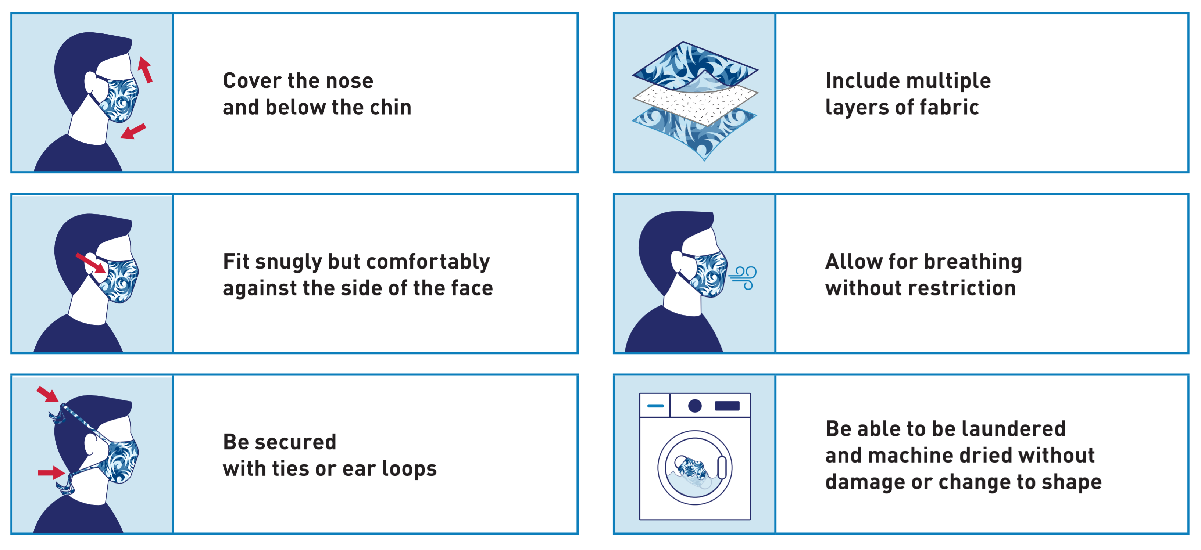

Figure 1. From the FDAs: "[Use of Respirators, Facemasks, and Cloth Face Coverings in the Food and Agriculture Sector During Coronavirus Disease (COVID-19) Pandemic](https://www.fda.gov/food/food-safety-during-emergencies/use-respirators-facemasks-and-cloth-face-coverings-food-and-agriculture-sector-during-coronavirus)"

**IMPORTANT:** Hand hygiene is an important infection prevention and control measure. Wash your hands with soap and water for at least 20 seconds after putting on, touching, or removing Face Masks. The use of Face Masks in the work environment should be used in addition to other control measures, including engineering controls such as physical partitions or barriers; and administrative controls such as implementing social distance practices and frequent cleaning and disinfection protocols. If you have symptoms and feel sick, stay home. For more information see the CDC’s: [*Use of Cloth Face Coverings to Help Slow the Spread of COVID-19*](https://www.cdc.gov/coronavirus/2019-ncov/prevent-getting-sick/diy-cloth-face-coverings.html).

**Limitations:** This Face Mask was not designed to be used by children. Individuals with chronic respiratory, cardiac or other conditions which increase the work of breathing may experience difficulty breathing through Face Masks. Face Masks should never be shared. When not in use, Face Masks must be stored to protect them from damage, contamination, dust, sunlight, extreme temperatures, excessive moisture, and damaging chemicals; if applicable, they should be stored according to the facility’s infection control policy and procedure and OSHA regulations. If contact transmission is of concern, dispose of immediately after each use.

**Additional Information:** To learn more about the regulation applicable to Face Masks, see: [Enforcement Policy for Face Masks and RespiratorsDuring the Coronavirus Disease (COVID-19) Public Health Emergency (Revised) Guidance for Industry and FDA Staff April 2020.](https://www.fda.gov/regulatory-information/search-fda-guidance-documents/enforcement-policy-face-masks-and-respirators-during-coronavirus-disease-covid-19-public-health)