

ALLIANCE UNIVERSITY
Alliance School of Advanced Computing

Student Name:
Burhan Cyclegar
Register Number:
PROV/ASAC/MCA/7/26/078
Project Name:
Amazon Product Data Analysis and Interactive Dashboard
ACADEMIC YEAR: 2026-2028

Department of Computer Applications

Program - Master of Computer Applications
Semester 1

ACKNOWLEDGEMENT
I would like to express my sincere gratitude to everyone who supported and guided me throughout the successful completion of this project.
I am thankful to my Project Guide for providing valuable guidance, suggestions, encouragement, and continuous support throughout the development of this project. I also express my gratitude to the faculty members and my institution for providing the necessary resources and a supportive learning environment.
I would also like to thank my friends and classmates for their cooperation and support during the completion of this project. Finally, I am deeply grateful to my family for their constant encouragement, motivation, and support.
I sincerely thank everyone who contributed directly or indirectly to the successful completion of this project.
Student Name:
Burhan Cyclegar
Register Number:
PROV/ASAC/MCA/7/26/078
Project Title:
Amazon Product Data Analysis and Interactive Dashboard
Signature of Student

Signature of Faculty & Project Guide

Project Faculty & Project Guide Name: Oleti Durga Bravish

Abstract
This project presents an interactive Amazon Grocery Sales Analysis dashboard developed in Microsoft Power BI. The purpose of the project is to convert a large transactional grocery dataset into clear business information that can be understood quickly by a manager, analyst, or student. The cleaned dataset contains 8,523 records and 14 fields covering products, item categories, outlet characteristics, visibility, weight, ratings, sales, and outlet age.
After data validation and cleaning, the project uses Power BI to calculate and visualize important measures such as total sales, average sales, median sales, maximum sales, and average customer rating. The final dataset produces total sales of 1,201,681.49, an average sales value of 140.99, a median sales value of 143.01, a maximum sales value of 266.8884, and an average rating of 3.97.
The dashboard is designed around practical questions: Which product categories contribute most to sales? How does outlet size affect total sales? Which outlet formats are important? How are sales distributed across fat-content groups and outlet location tiers? The project emphasizes data quality because a visually attractive dashboard is only reliable when its underlying data has been checked carefully.
The final outcome is a user-friendly Power BI reporting system that reduces the effort required to inspect thousands of rows manually. Instead of reading spreadsheets line by line, a user can use slicers, KPI cards, charts, and category views to explore the business from different angles.

Keywords
- Amazon Grocery Sales Analysis
- Retail Sales Analytics
- Power BI, Business Intelligence
- Data Visualization
- Data Cleaning
- Exploratory Data Analysis (EDA)
- Sales Performance Analysis
- Item Type Analysis
- Item Fat Content Analysis
- Item Weight Analysis
- Item Visibility Analysis
- Customer Rating Analysis
- Outlet Performance Analysis
- Outlet Type Analysis
- Outlet Size Analysis
- Outlet Location Analysis
- Outlet Establishment Year
- Sales Aggregation
- Key Performance Indicators (KPI)

INTRODUCTION
Modern retail businesses generate a large amount of data from products, stores, customers, and sales transactions. The challenge is no longer simply storing this information; the real challenge is understanding what the information is saying. A spreadsheet may contain thousands of records, but a decision-maker generally needs a small set of trustworthy indicators and comparisons.
This project uses an Amazon grocery-style sales dataset to demonstrate a complete analytics workflow. The work begins with data inspection and quality validation, continues through cleaning and transformation, and ends with an interactive Power BI dashboard. The dashboard acts as the communication layer between raw data and business decisions.

Project Objectives
Understand the structure and meaning of the grocery sales dataset.
Check missing values, duplicate records, inconsistent categories, data types, and suspicious observations.

Prepare a reliable dataset for business intelligence reporting.

Create meaningful KPIs for sales and customer rating.
Compare sales by item type, fat content, outlet size, outlet type, outlet location, and outlet age.
Design an interactive Power BI dashboard with filters and visual summaries.
Translate numerical results into simple business observations and recommendations.

Scope
The scope of this project is descriptive and diagnostic business analysis. It focuses on understanding historical sales patterns in the supplied dataset. It does not claim to predict future sales or measure real-time Amazon performance. The findings should therefore be interpreted as insights from the provided dataset rather than as statements about Amazon's current commercial operations.

PROBLEM STATEMENT
A common problem in sales analysis is that important information is spread across many columns and thousands of records. If the data is examined manually, it becomes difficult to compare product groups, outlets, locations, and performance indicators consistently. Manual reporting also makes it easy to overlook missing values, duplicates, inconsistent labels, or unusual observations. The specific problem addressed by this project is to create a reliable and interactive analytical system that converts grocery sales records into useful business insights. The system should allow a user to move from an overall sales view to a more detailed category or outlet-level view without repeatedly preparing separate reports.

Key Questions
How much total sales are represented in the dataset?
Which item types contribute the highest sales?
How do Low Fat and Regular products compare?
Which outlet sizes and outlet types contribute most to total sales?
How are sales distributed across Tier 1, Tier 2, and Tier 3 locations?
Are there missing values, duplicates, or unusual values that could affect the dashboard?
Can the final results be presented through an interactive Power BI interface?

Expected Outcome
The expected outcome is a clean analytical dataset and a dashboard that allows a user to answer the above questions quickly. The project is successful when the dashboard is both technically correct and easy to understand.
- To prepare a structured and well-organized dataset for accurate analysis.
- To identify and handle missing values, duplicate records, and inconsistent data.
- To improve data quality through systematic validation and preprocessing.
- To analyze overall sales performance using appropriate statistical measures.
- To calculate key performance indicators such as total sales, average sales, median sales, and maximum sales.
- To evaluate the contribution of different product categories to total sales.
- To compare sales performance between Low Fat and Regular products.
- To analyze sales distribution across different outlet sizes.
- To compare the performance of different outlet types.
- To understand sales variations across Tier 1, Tier 2, and Tier 3 locations.To examine customer ratings and understand their distribution within the dataset.
- To identify statistically unusual observations using the Interquartile Range (IQR) method.
- To retain valid observations and avoid unnecessary data removal during cleaning.
- To create interactive charts, KPI cards, and visual summaries using Microsoft Power BI.
- To enable users to explore sales information through filters and slicers.
- To reduce the effort required to analyze large amounts of data manually.
- To present complex sales information in a simple and understandable visual format.
- To identify high-performing product categories and outlet segments for further investigation.
- To support data-driven decision-making through meaningful business insights.
- To establish a reusable analytical framework that can be enhanced with additional data in the future.
The project will be considered successful when the final dataset is properly validated, the dashboard displays consistent results, and users can understand the major sales patterns efficiently. The analysis will focus on the supplied dataset and will not be treated as a real-time representation of Amazon's actual business performance.

EXISTING SYSTEM
Before the proposed dashboard, the same type of analysis would normally be performed using raw Excel sheets, manually created pivot tables, static charts, or separate reports. Such an approach can work for a small dataset, but it becomes less convenient when the number of records and analytical questions increase.

Limitations of a Manual / Traditional Approach
- Large spreadsheets require repeated scrolling and manual filtering.
- Different analysts may prepare different formulas or definitions for the same KPI.
- Static charts do not provide the same level of interactive exploration.
- Data-quality problems may remain hidden if validation is not performed systematically.
- Updating a manually prepared report can take additional time.
- Relationships between sales, products, and outlet characteristics are harder to explore at a glance.

Why an Improved System is Needed
The main requirement is not simply to create more charts. It is to create a consistent analytical workflow where cleaning, calculation, visualization, and interpretation are connected. Power BI is suitable for this purpose because it can connect to structured data, transform fields, create measures, and provide interactive visual exploration in one environment.

Existing vs. Proposed
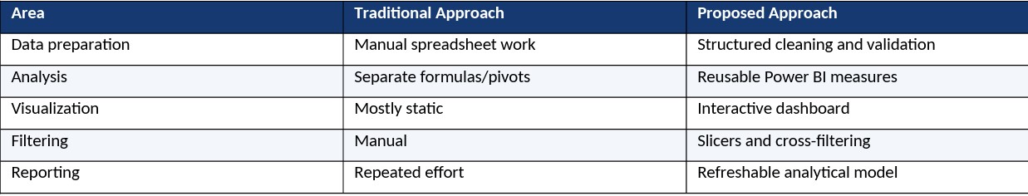

PROPOSED SYSTEM
The proposed system is a Power BI-based business intelligence solution for Amazon grocery sales analysis. The design follows a simple flow: input data is validated, cleaned and transformed, loaded into the analytical model, summarized through measures, and finally displayed through interactive dashboard pages.

Main Components
- Data Source: the supplied Excel workbook containing 8,523 grocery sales records.
- Data Quality Layer: checks for missing values, duplicates, data types, category consistency, and unusual numerical observations.
- Transformation Layer: prepares fields for analysis and uses the Outlet_Age field to make outlet-age analysis easier.
- Data Model: organizes dimensions such as item type, fat content, outlet, size, location, and outlet type around salesrelated measures.
- Visualization Layer: KPI cards, bar charts, donut charts, funnel-style/category views, line charts, treemaps, and slicers.
- Insight Layer: converts dashboard observations into understandable business conclusions.
Why Power BI?
Power BI was selected because it combines data preparation, calculations, visualization, filtering, and report sharing in a single workflow. It also makes it possible to create dashboard interactions where selecting a product type or outlet category changes other visuals automatically.

User Interaction
A user can start with the overall KPIs and then filter the dashboard by item type, item fat content, outlet type, outlet size, location tier, or other available dimensions. This turns the report from a static presentation into an exploratory analytical tool.

ABOUT DATASET
The supplied workbook contains 8,523 rows and 14 columns. Each row represents an item/outlet observation used for sales analysis. The dataset combines product attributes with outlet characteristics and performance measures.

Dataset Fields
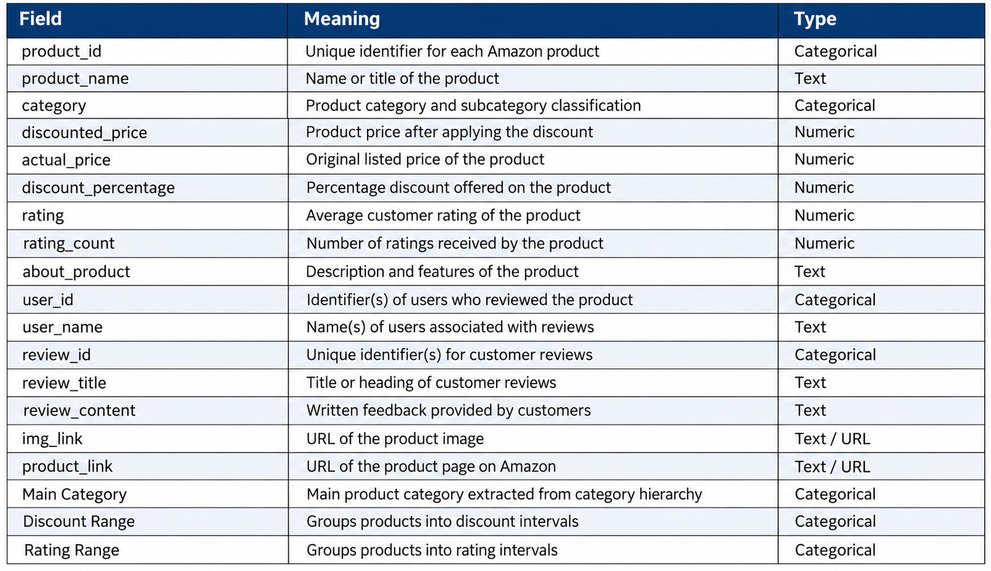

The dataset contains 1,559 distinct item identifiers, 16 item types, 10 outlet identifiers, 3 outlet location tiers, 3 outlet sizes, and 4 outlet types. These dimensions provide enough variety for meaningful comparative analysis.

6.1 DATA CLEANING & DATA QUALITY
Data cleaning is one of the most important parts of this project. The dashboard should not be trusted simply because the charts look correct. Before visualization, the dataset was checked systematically so that the final report would be based on consistent and usable records.

Missing Values
The supplied cleaned workbook contains 0 missing cells across the 14 fields. In other words, every field used in the final dashboard is populated. Because there are no missing values in the supplied cleaned file, no artificial imputation was required at the final stage. This is important because replacing values unnecessarily can change the meaning of the original data.

Duplicate Records
A full-row duplicate check identified 0 exact duplicate rows. Therefore, no duplicate rows were removed from the final dataset. The absence of duplicates reduces the risk of accidentally counting the same observation more than once.

Data Types and Consistency
- Categorical columns were treated as categories/text fields so that Power BI could group them correctly.
- Numeric fields such as Sales, Rating, Item Weight and Item Visibility were validated as numeric values.
- Outlet Establishment Year and Outlet_Age were validated as integer-style fields. Category labels were reviewed to ensure that values such as Low Fat, Regular, Tier 1, Tier 2, Tier 3 and outlet-size labels remained consistent.
- The final workbook was kept in a clean tabular structure so it could be loaded into Power BI without unnecessary restructuring.

Cleaning Principle
The goal was not to delete unusual values just because they were unusual. A good cleaning process separates genuine data errors from legitimate variation. This principle is especially important when dealing with ratings and sales values.

6.2 OUTLIER ANALYSIS
Outlier analysis was performed using the Interquartile Range (IQR) rule. Under this method, values below Q1 − 1.5×IQR or above Q3 + 1.5×IQR are flagged as statistical outliers. An outlier flag is not automatically an error; it simply identifies observations that deserve inspection.
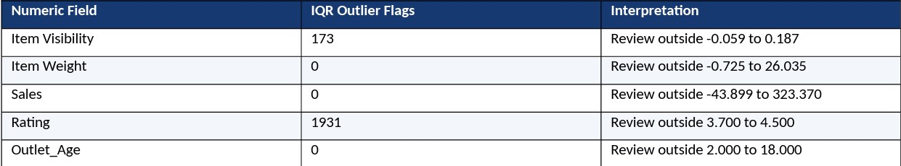

Important Interpretation
0 Review outside 2.000 to 18.000 Item Visibility has 173 IQR-flagged observations. These values are not automatically invalid because visibility can naturally vary between products.
The dashboard therefore retains them rather than deleting them without business justification. Rating produces 1,931 IQR flags because the distribution is concentrated toward higher ratings and the IQR threshold is relatively narrow.
Ratings below the statistical lower fence are not necessarily data errors; they can represent genuinely less highly rated products.
Removing them would distort the customer-rating story. Sales has no IQR-flagged observations under the 1.5×IQR rule. This supports using the supplied Sales values directly for the dashboard KPIs. Item Weight and Outlet_Age also have no IQR flags under this rule.

Outlier Handling Decision
The final approach is conservative: retain statistically unusual but plausible business observations, and avoid arbitrary deletion. This preserves the real variation in the dataset while still documenting where statistical flags occur.

TECHNOLOGIES USED
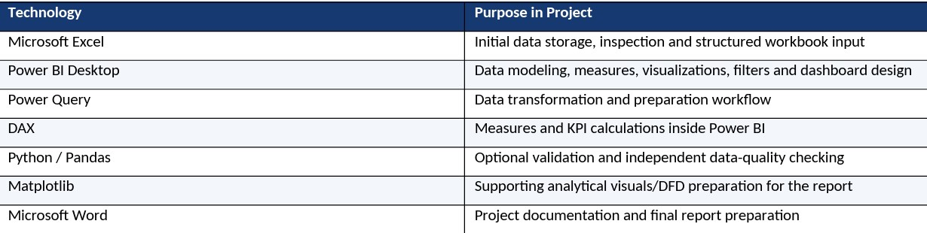

Power BI Measures Used / Represented
- Total Sales = SUM(Sales)
- Average Sales = AVERAGE(Sales)
- Median Sales = MEDIAN(Sales)
- Maximum Sales = MAX(Sales)
- Count of Sales Records = COUNT(Sales)
- Project documentation and final report preparation Average Rating = AVERAGE(Rating)
Using measures rather than manually typing totals makes the report more reliable because the KPI values respond to filters and selections. For example, when a user filters a particular item type, the sales measures can recalculate for that selected subset.

Analytical Approach
The technical workflow is deliberately practical: inspect → clean → validate → model → calculate → visualize → interpret. This makes the project suitable as a demonstration of an end-to-end business analytics process rather than only a dash board design exercise.

DATA FLOW DIAGRAM — LEVEL 2
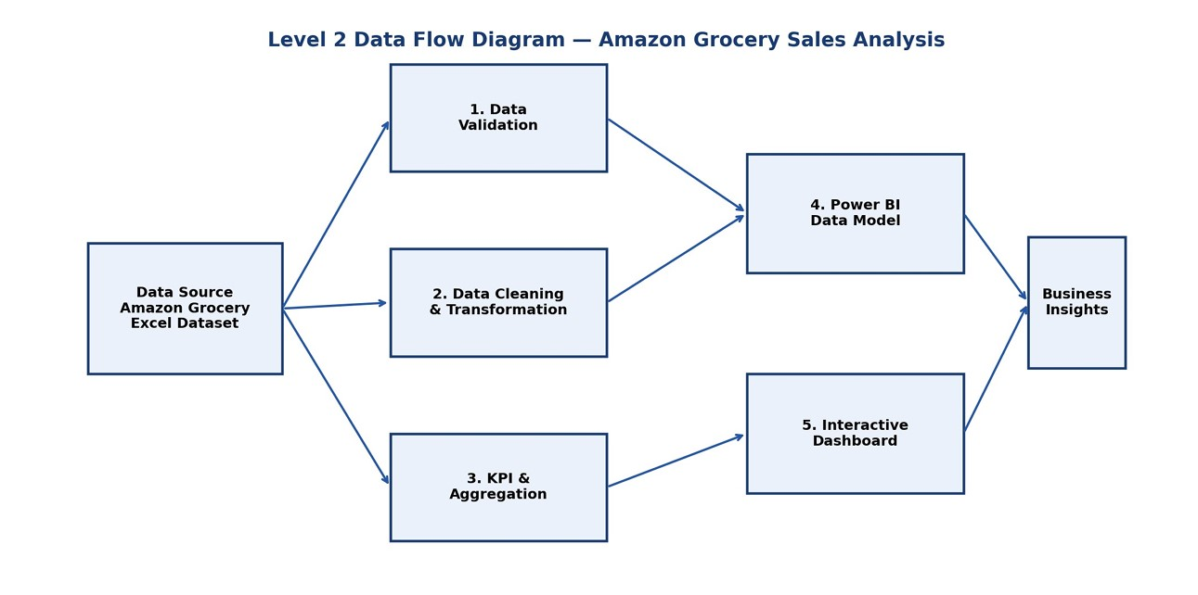

The Level 2 DFD shows how the raw Excel dataset moves through validation, cleaning and transformation before becoming an analytical Power BI model. The final dashboard then communicates the results to the end user.

DFD Explanation
The Data Flow Diagram (DFD) illustrates the flow of data through the Amazon Grocery Sales Analysis project, from the initial dataset input to the final presentation of business insights. It explains how the dataset is validated, cleaned, transformed, analyzed, and visualized using Python, SQL, and Power BI. Each process performs a specific task to ensure that the data is suitable for analysis and reporting.
Process 1: Dataset Input and Validation
The first process receives the Amazon Grocery dataset in Excel format and verifies its basic structure. It checks the availability of required columns, field names, data types, and overall dataset consistency. This step helps identify structural issues before further processing. Proper validation ensures that the dataset can be processed reliably in the subsequent stages.
Process 2: Data Cleaning and Quality Checks
The second process focuses on improving data quality by checking for missing values, duplicate records, inconsistent entries, and incorrect data types. Python can be used to perform data inspection and cleaning, while SQL can support structured queries and data verification. Relevant fields are standardized to maintain consistency across the dataset. Potential outliers are also examined to determine whether they represent unusual but valid observations or possible data-quality issues.
Process 3: Data Transformation and Aggregation
After cleaning, the dataset is prepared for analysis through appropriate transformations and calculations. This process organizes the relevant fields and calculates business measures such as total sales, average sales, median sales, maximum sales, and average ratings. Sales are also grouped by item type, fat content, outlet type, outlet size, and location tier. These calculations help reveal differences in sales performance across various product and outlet categories.
Process 4: Data Modelling in Power BI
The fourth process represents the organization of data within Power BI. Relevant columns, measures, and analytical categories are arranged to support reporting. Calculated measures and appropriate aggregations are used to display sales and rating information consistently. This stage creates the analytical foundation required for interactive reports and dashboard development.
Process 5: Interactive Dashboard and Reporting
The fifth process presents the processed information through interactive Power BI dashboard pages. Charts, cards, tables, and other visual elements help users understand sales performance and compare different product categories and outlet characteristics. Where configured, filters and slicers allow users to explore specific categories, outlet types, sizes, and location tiers. The dashboard converts numerical results into a clear visual format that is easier to interpret.
OUTPUT — DASHBOARD OVERVIEW

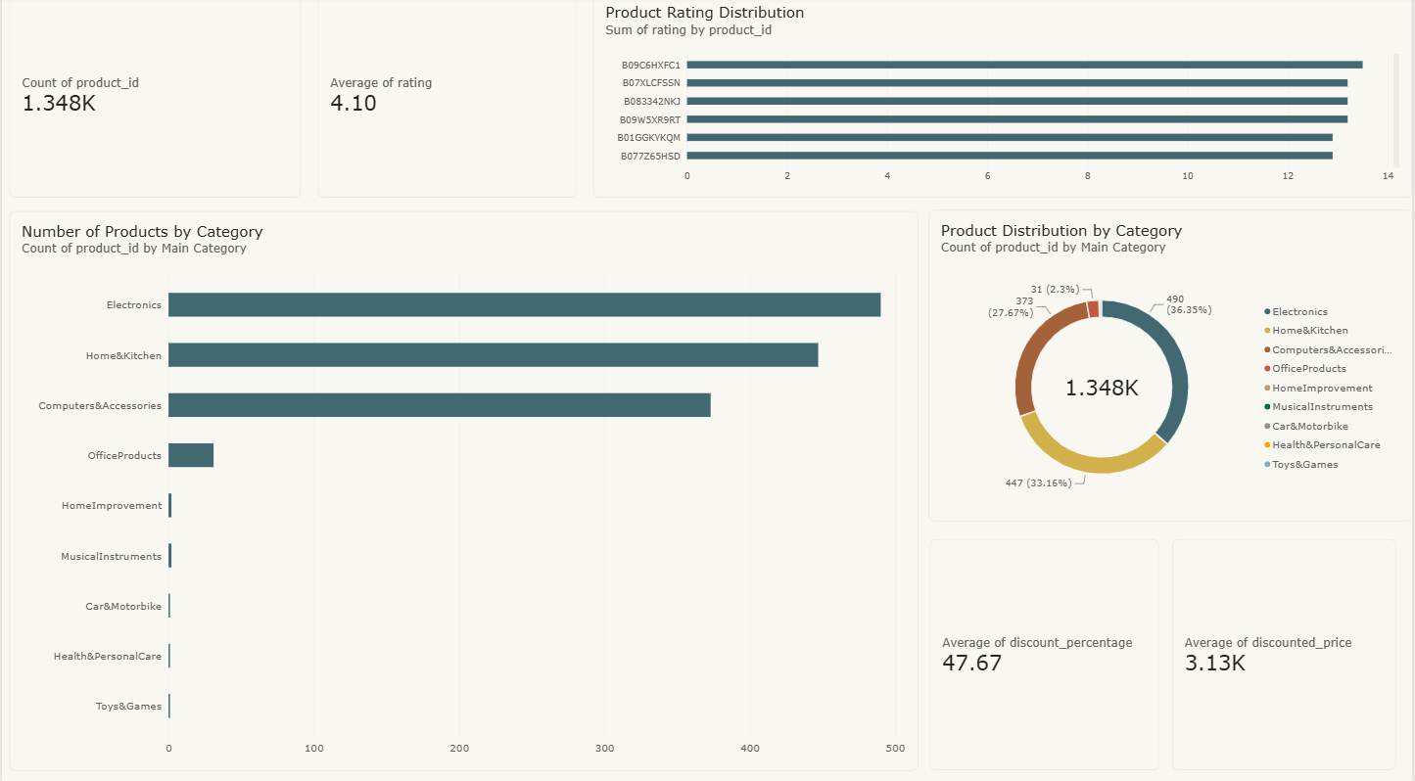

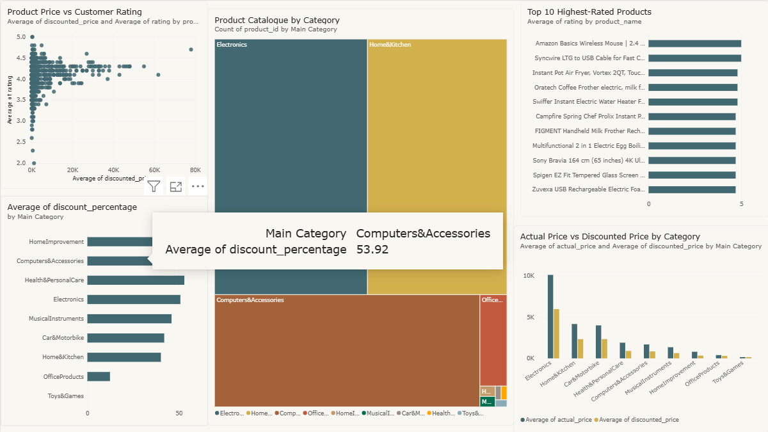

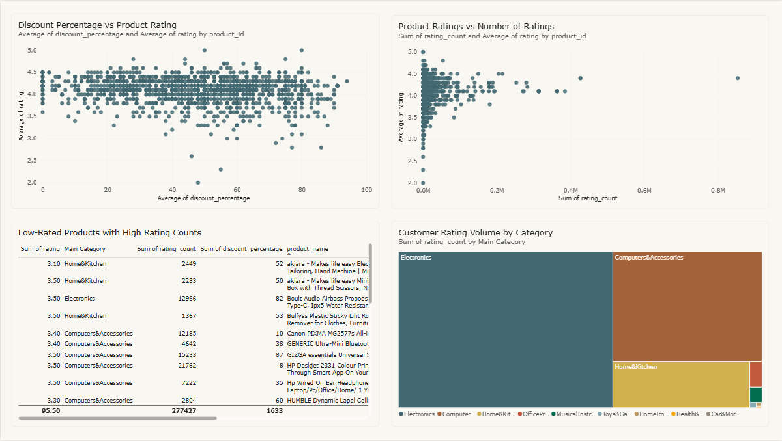
The dashboard presents a quick overview of the dataset. The KPI cards show median sales of approximately 143.01, a salesrecord count of 8.523K, and an average rating of 3.97. The visuals below break the overall result into fat-content, item-type, and outlet-related views.

What the User Can See Immediately
Overall sales performance without manually calculating totals. Relative contribution of different fatcontent groups. Item-category contribution using horizontal comparison visuals. Outlet-size and outletrelated distribution. Interactive filtering through outlet type or other report dimensions.

9.1 OUTPUT — CATEGORY & OUTLET ANALYSIS
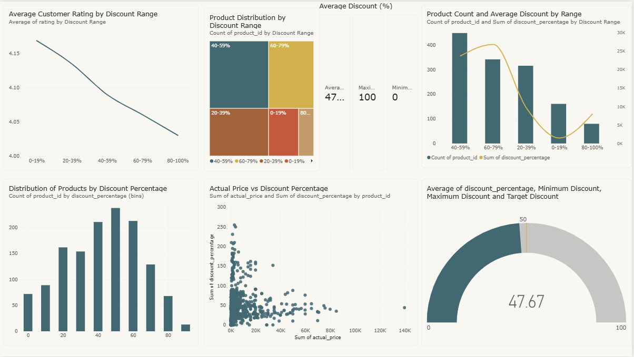

Key Findings
Fruits and Vegetables is the highest-sales item type with total sales of 178,124.08, followed by Snack Foods with 175,433.92.
At the other end, Seafood contributes the smallest total among the listed item types, at 9,077.87. Low Fat products contribute 776,319.69 in total sales compared with 425,361.80 for Regular products.
This difference is strongly influenced by the larger number of Low Fat observations in the dataset.
Medium outlets contribute the highest total sales at 507,895.74, followed by Small outlets at 444,794.17. High-size outlets contribute 248,991.59.

9.2 OUTPUT — KPI & TREND-STYLE ANALYSIS
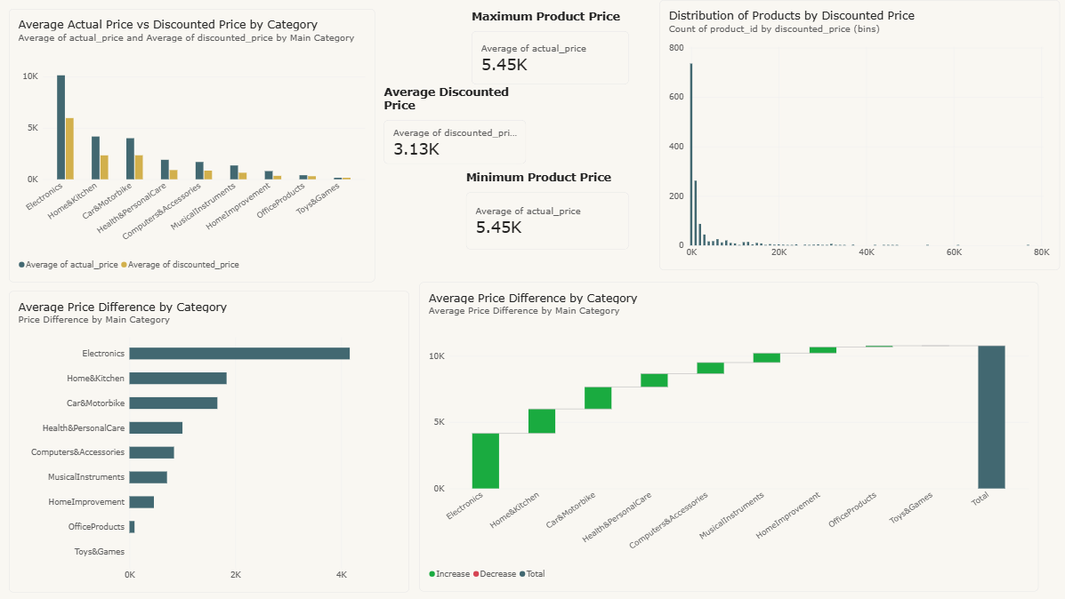
Figure 3: Dashboard view with average sales, maximum sales, total sales and category comparisons.

Headline KPI Interpretation KPI
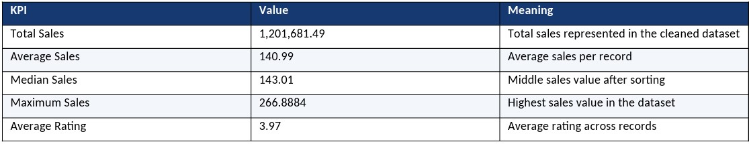
The difference between the mean sales value and the median is small, which indicates that the central sales values are relatively close. The maximum value is higher than the average, as expected, but the IQR analysis did not identify Sales as an outlier field.

Outlet-Type Observation
Supermarket Type1 contributes the largest total sales at 787,549.89. Grocery Store, Supermarket Type2 and Supermarket Type3 contribute 151,939.15, 131,477.78, and 130,714.67, respectively.

9.3 OUTPUT — DETAILED BUSINESS INSIGHTS
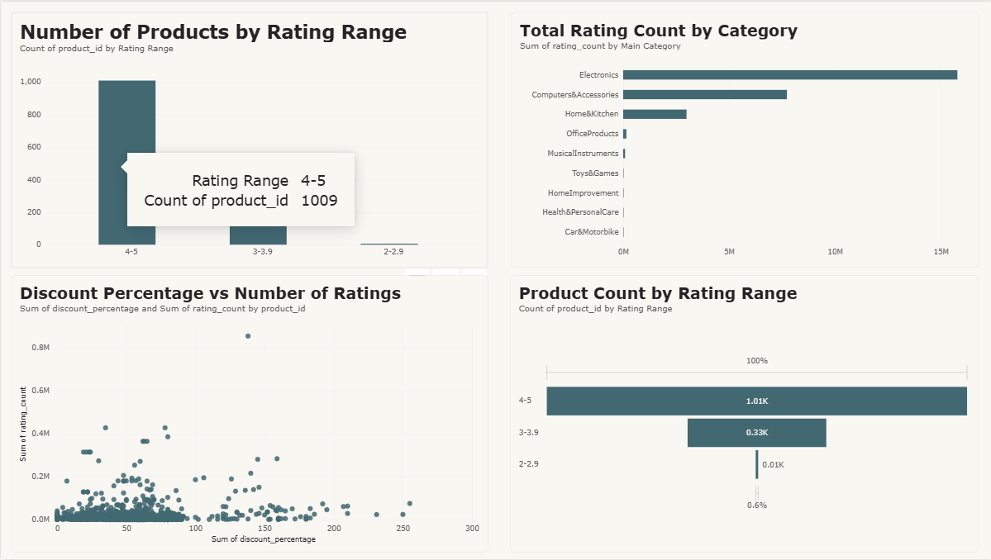

Insight 1: Product Mix
Fruits and Vegetables and Snack Foods are the two largest contributors by item type. This suggests that these categories deserve particular attention when evaluating assortment, shelf availability, promotions, and outlet-level performance.

Insight 2: Outlet Location
Tier 3 outlets contribute 472,133.03, Tier 2 contributes 393,150.65, and Tier 1 contributes 336,397.81. Because the number of records is also different by tier, total sales should be interpreted together with record count rather than treated as a pure productivity measure.
Insight 3:
Outlet Size Medium outlets lead total sales, while High outlets have a slightly higher average sales value per record than Medium outlets. This is a useful reminder that total contribution and per-record performance answer different business questions.
Insight 4:
Rating The average rating is approximately 3.97. The distribution contains enough lower ratings to trigger IQR flags, but those observations were retained because a lower rating can be a legitimate customer signal rather than a data error.

9.4 OUTPUT — LIMITATIONS & RECOMMENDATIONS
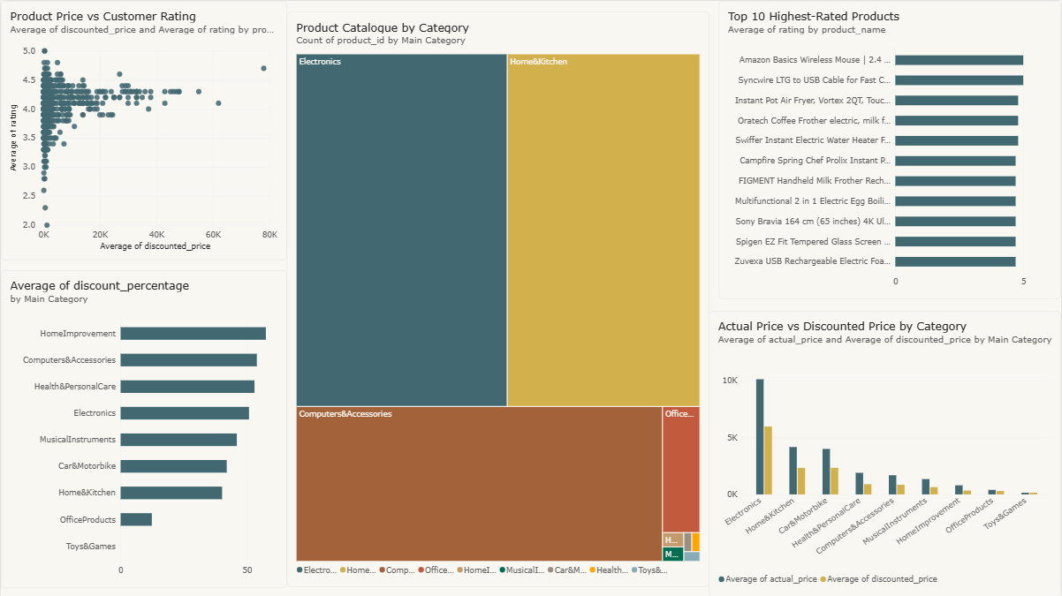

Recommendations
- Use the dashboard to prioritize deeper analysis of Fruits and Vegetables and Snack Foods because they have the highest total sales contribution.
- Compare total sales with record counts before judging outlet productivity.
- Use lower-rated observations as an opportunity for investigation rather than deleting them as outliers.
- Monitor Item Visibility separately because 173 observations were statistically flagged by the IQR rule.
- Refresh the dashboard when new transactional data becomes available so that the KPIs remain current.
- Add profit margin, discount, inventory, stock-out, promotion, and timeseries fields in a future version for stronger business decisions.

Limitations
- The dataset is a supplied analytical dataset and should not be interpreted as real-time Amazon corporate data.
- The project is mainly descriptive and does not establish causal relationships between different variables.
- Sales alone do not measure profitability because cost, profit margin, discount, and logistics information are not included.
- Outlet-level conclusions should be interpreted alongside the number of observations in each group.

• | Statistical outliers were reviewed conceptually and retained when they appeared plausible.
• | The analysis depends on the accuracy, completeness, and reliability of the supplied dataset.
• | The dataset does not provide sufficient information to determine the actual purchasing behavior of individual customers.
• | The project does not include detailed customer demographics, preferences, or purchase histories.
• | The absence of transaction dates limits the ability to analyze seasonal patterns and changes in sales over time.
• | The project does not implement predictive models for forecasting future sales.
• | The analysis cannot independently determine whether higher sales result from better product quality, stronger demand, promotions, or other factors.
• | The dataset does not contain detailed inventory information, so stock availability and stock-out situations cannot be evaluated directly.
• | The relationship between customer ratings and sales cannot be interpreted as proof that ratings cause changes in sales.
• | Differences in total sales across product categories may be influenced by differences in the number of records in each category.
• | The dashboard's usefulness depends on the correct configuration of data relationships, measures, filters, and visualizations.
• | Incorrect field definitions or data types may affect calculations and the interpretation of results.
• | The Interquartile Range (IQR) method identifies statistically unusual values but cannot determine automatically whether they are genuine errors.
• | The project does not include a real-time automated data collection system from Amazon.
• | The findings are limited to the variables available in the supplied workbook and cannot explain business factors that are not recorded.
• | The dashboard supports analytical exploration, but final business decisions still require domain knowledge and additional verification.
• | The project does not compare sales with competitors or external market trends.
• | The results may not remain representative if future datasets contain different products, outlets, or sales patterns.
• | The current analysis does not evaluate the financial impact of marketing campaigns or promotional activities.

• The project focuses on Power BI-based reporting and does not provide a complete enterprise-level business intelligence infrastructure.
Despite these limitations, the project provides a useful foundation for understanding grocery sales patterns, evaluating outlet performance, and presenting business information through interactive visualizations. These limitations also identify opportunities for future improvements through additional data collection, advanced statistical techniques, predictive analytics, and automated data refresh mechanisms.

CONCLUSION
The Amazon Grocery Sales Analysis project demonstrates how raw retail-style data can be converted into a practical business intelligence solution. The most important lesson from the project is that dashboard development begins with data quality, not chart selection. By validating the dataset first, the final Power BI visuals become more trustworthy and easier to explain. The final dataset contains 8,523 records with no missing cells and no exact duplicate rows. The analysis also documented statistical outlier flags rather than silently deleting unusual observations. This is especially important for Rating and Item Visibility, where unusual values may represent genuine business variation. From the analytical results, total sales are 1,201,681.49, average sales are 140.99, median sales are 143.01, maximum sales are 266.8884, and average rating is 3.97. Fruits and Vegetables and Snack Foods are leading item types by total sales, Low Fat products account for the larger share of total sales, and Supermarket Type1 is the strongest outlet type by total sales. Overall, the proposed Power BI system achieves the project's main objective: it turns a large spreadsheet into an interactive, human-readable analytical report. With future additions such as profit, discounts, inventory, promotions, customer segments, and time-based sales data, the same framework could be extended into a more advanced retail decision-support system.
Final Statement
This project combines data cleaning, statistical checking, business analysis, visualization, and communication into one complete workflow. It demonstrates that good analytics is not only about finding numbers; it is about making those numbers understandable, defensible, and useful for the person who needs to make a decision.

