Assignment 1 (Odoo Setup and Installation)

**Software Construction and Development (SE-3001)**

Course Instructor:

**Mam. Laiba Imran**

Submitted by:

**Syed Burhan Haider (22I-2730)**

Section:

**BS-SE (A)**

Date:

**19th September, 2025**

Fall 2025



**Department of Software Engineering**

FAST – National University of Computer & Emerging Sciences

Islamabad Campus

Table of Contents

Part 1: Installation of Odoo 1

Installation guide: 1

Step 1: Research Hardware & Software Requirements 1

Step 2: Prepare Ubuntu Server 2

Step 3: Install PostgreSQL 2

Step 4: Install Odoo from Source 3

Step 5: Configure Odoo 3

Step 6: Creating a systemd service file for Odoo 4

Step 6: Start Odoo 5

Browser view: 6

Problems and Troubleshooting: 7

(i). VirtualBox Issues 7

(ii). Odoo Issues 7

Part 2: Initial Configuration of Odoo 9

2.1 Logging in and changing default user: 9

2.2 Creating a new user with administrative privileges: 10

2.3 Exploring the Odoo dashboard: 10

2.4 Configuring basic settings (company information, currency, language, and timezone): 10

2.5 Install additional modules or apps: 12

Installing Restaurant module (Extension of Point of Sale): 12

3. Advanced Configuration and Customization: 13

3.1 Exploring the configuration options: 13

Opening the Cash Control: 13

Adding demo data to the session: 13

Payment method: 14

Payment Successful: 14

Table Management: 15

Order Management: 15

3.2,3.3 Customizing the module and Documentation and Integration: 15

Adding custom fields: 15

Modifying workflow: 17

Creating reports: 19

Restarting after all steps: 23

3.4 Testing the configured module: 23

Custom field while creating a new product: 23

Application of discount on the set amount: 24

Generating a report: 24

Challenges and Solutions: 25

Challenge 1: "Technical" Menu Not Visible in Settings 25

Challenge 2: QWeb Report Error - "Opening and ending tag mismatch" 25

Challenge 3: Workflow Automation Not Available 25

# Part 1: Installation of Odoo

## Installation guide:

### ****Step 1: Research Hardware & Software Requirements****

Before installing Odoo, document the following requirements:

#### ****Hardware Requirements****

* **CPU:** Minimum 2-core processor (4-core recommended)
* **RAM:** 2GB minimum (4GB+ recommended)
* **Storage:** At least 20GB of free disk space
* **Network:** Internet connection for downloading dependencies

#### ****Software Requirements****

* **Operating System:** Ubuntu Server 20.04 or later
* **Dependencies:** Python 3, PostgreSQL, Node.js, wkhtmltopdf, and other required libraries.

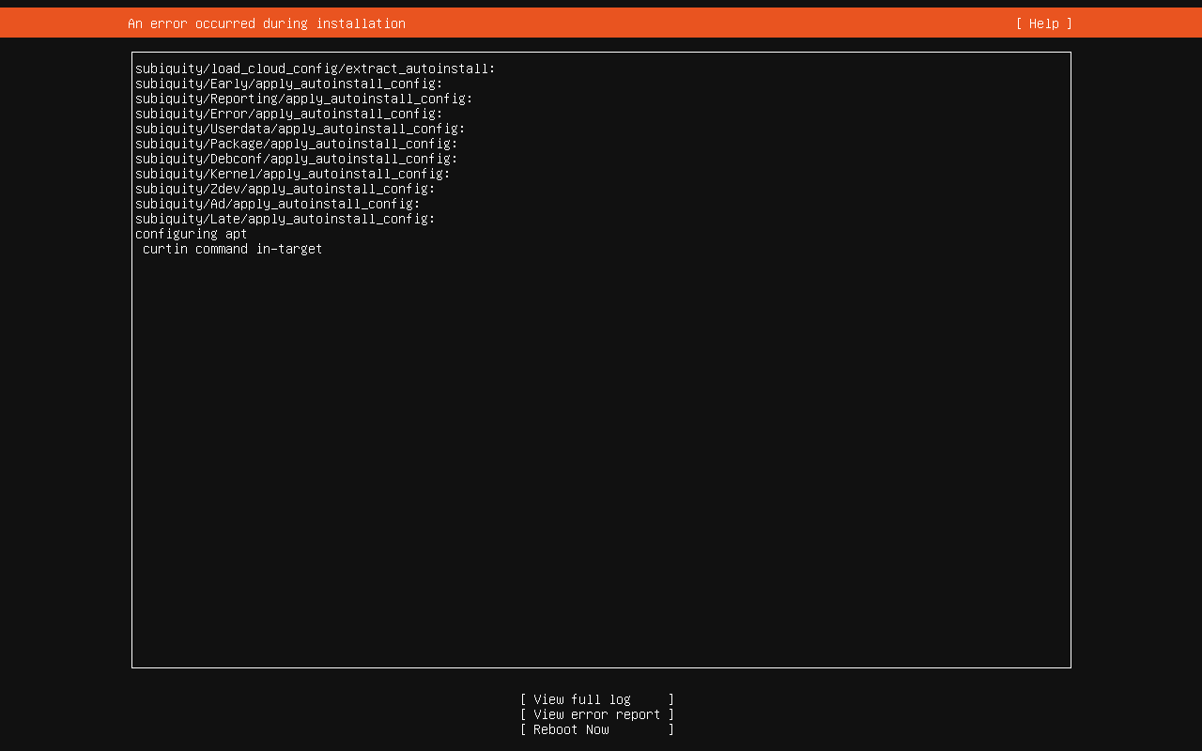

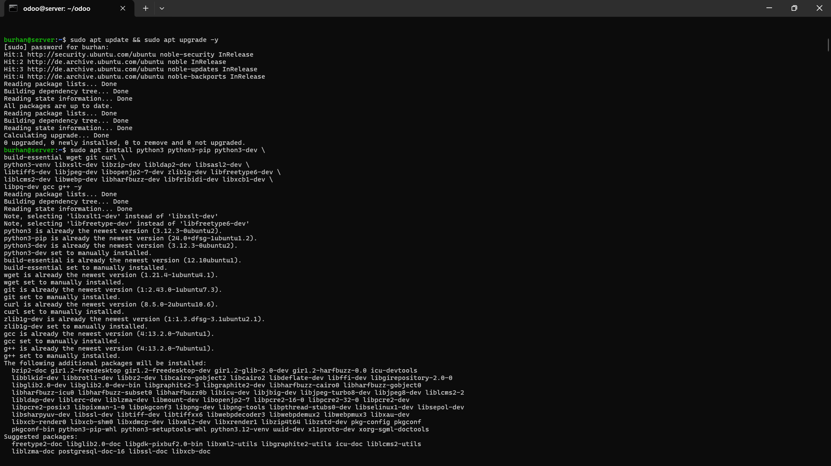

### ****Step 2: Prepare Ubuntu Server****

**Update the system packages:**

sudo apt update && sudo apt upgrade -y

**Install essential dependencies:**

sudo apt install git python3 python3-pip python3-venv libpq-dev libxml2-dev libxslt1-dev zlib1g-dev

libsasl2-dev libldap2-dev build-essential libssl-dev libffi-dev libjpeg-dev libpng-dev xfonts-75dpi

xfonts-base -y

### ****Step 3: Install PostgreSQL****

Odoo requires PostgreSQL as the database.

Install PostgreSQL:

sudo apt install postgresql -y

Start and enable PostgreSQL:

sudo systemctl enable postgresql

sudo systemctl start postgresql

Create a PostgreSQL user for Odoo:

createuser --createdb --username postgres --no-createrole --superuser --pwprompt odoo18

### ****Step 4: Install Odoo from Source****

**Create a new Odoo user:**

sudo useradd -m -d /opt/odoo -U -r -s /bin/bash odoo

**Switch to the Odoo user:**

sudo su – odoo

**Clone the Odoo source code (version 17.0):**

sudo apt-get install –y git (if not installed already)

git clone <https://www.github.com/odoo/odoo> --depth 1 --branch 17.0 --single-branch .

**Create and activate a virtual environment:**

python3 -m venv odoo-venv

source odoo-venv/bin/activate

**Install Python dependencies:**

pip install -r requirements.txt

**Exit the Odoo user:**

deactivate

exit

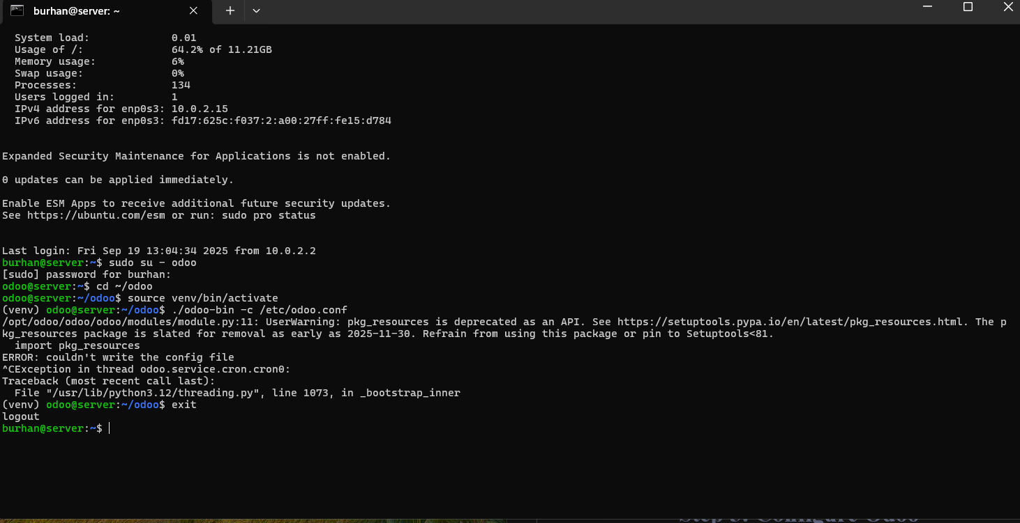

### ****Step 5: Configure Odoo****

1. Create the configuration file:
2. sudo nano /etc/odoo.conf

Add the following:

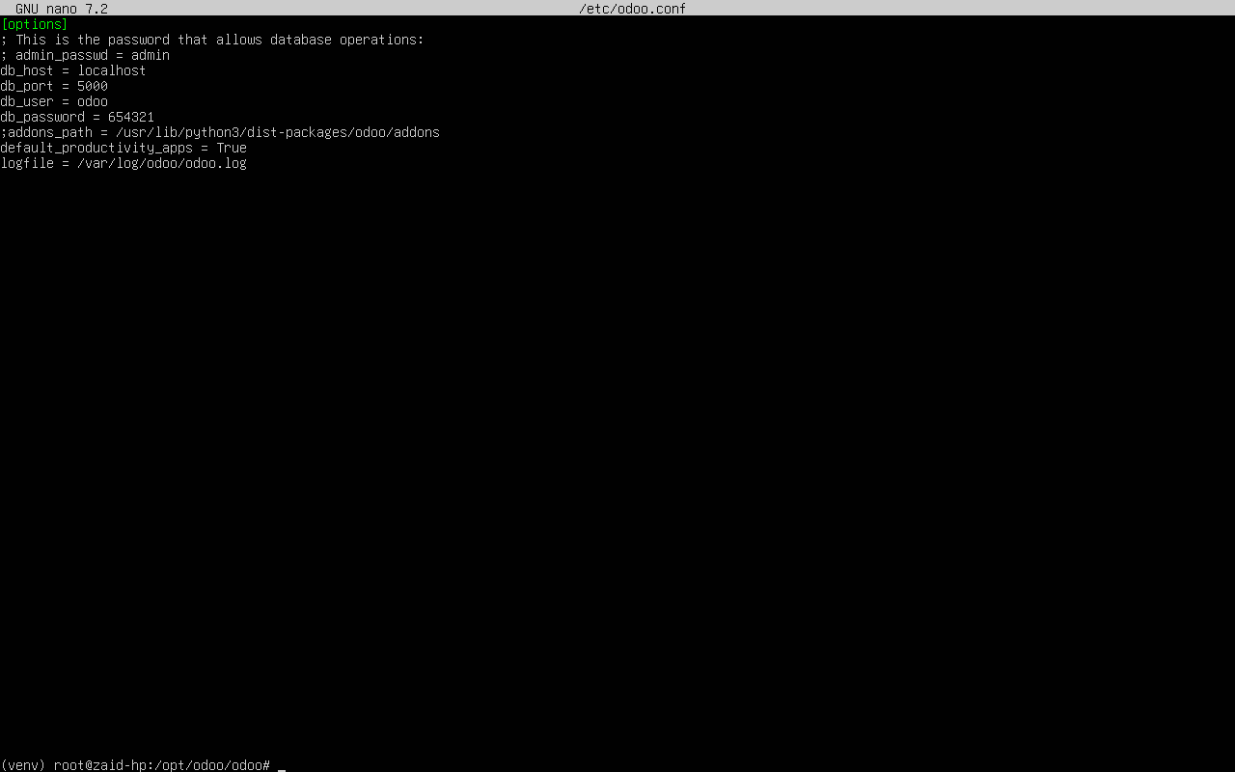og

1. **Create log directory and set permissions:**
2. sudo mkdir /var/log/odoo
3. sudo chown odoo:odoo /var/log/odoo

### Step 6: Creating a systemd service file for Odoo

sudo nano /etc/systemd/system/odoo18.service

Write the following:

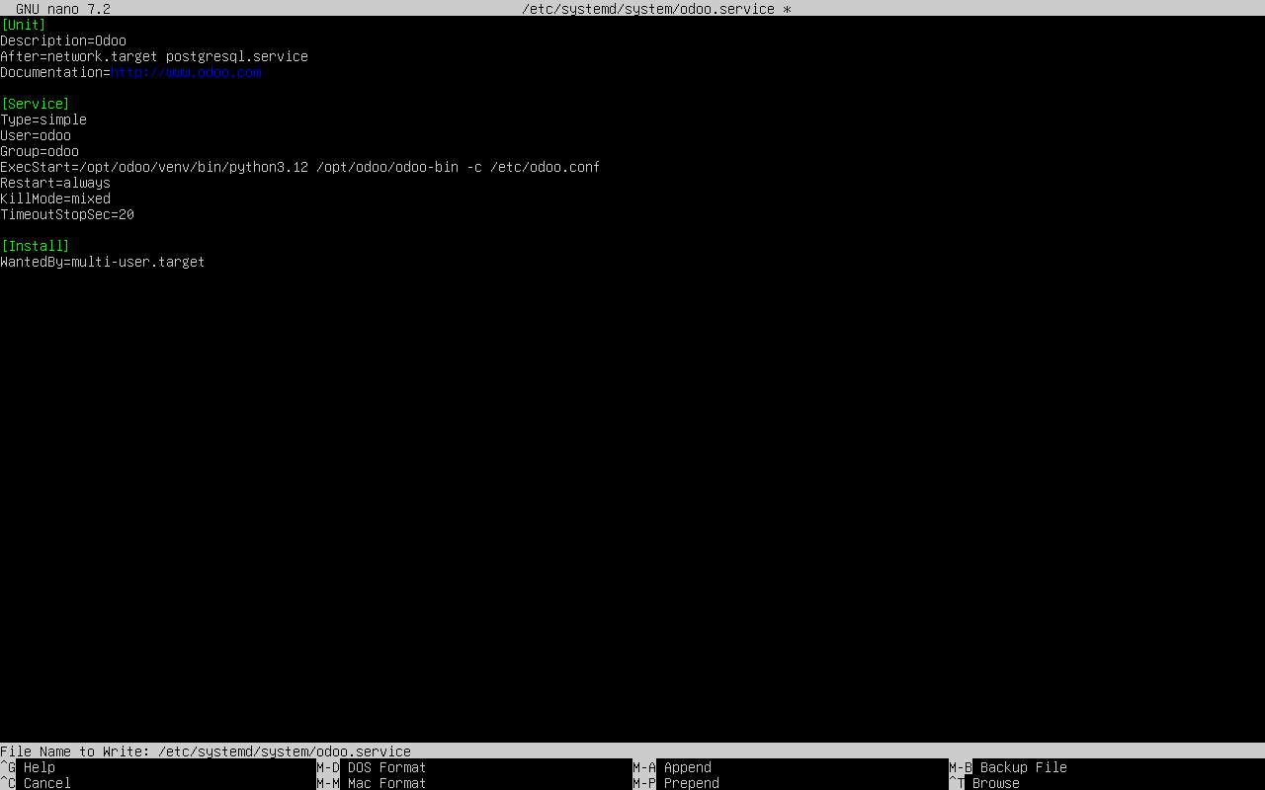

### ****Step 6: Start Odoo****

1. Start Odoo manually:
2. sudo -u odoo /opt/odoo/odoo-bin -c /etc/odoo.conf
3. Open a web browser and go to:
4. http://localhost:8069

If Odoo opens, the installation is successful.

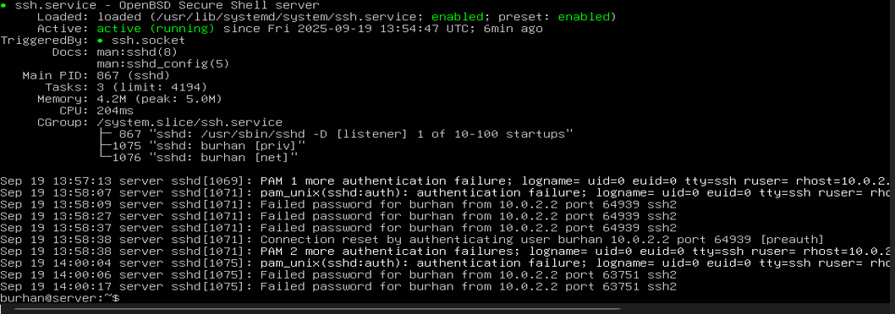

## Browser view:

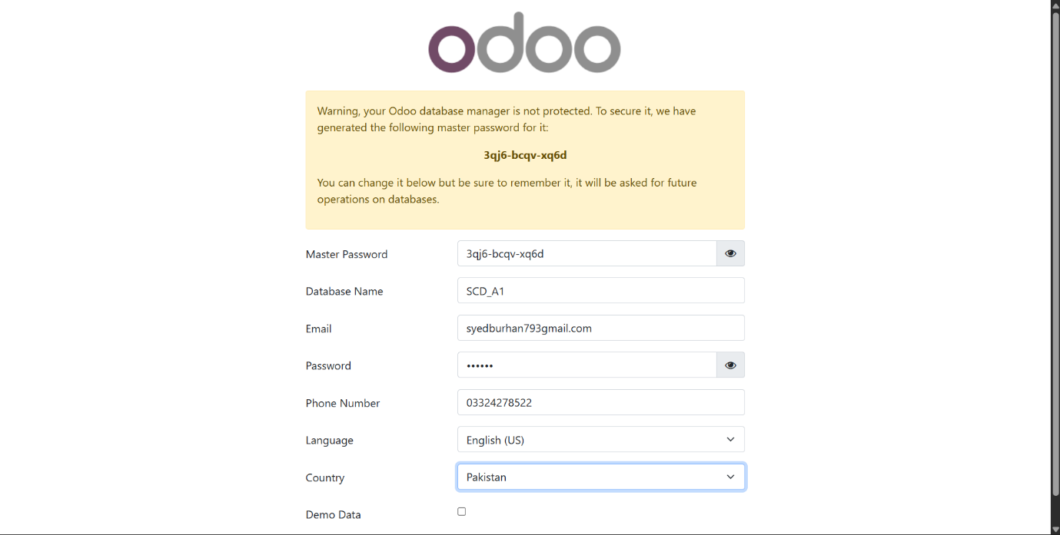

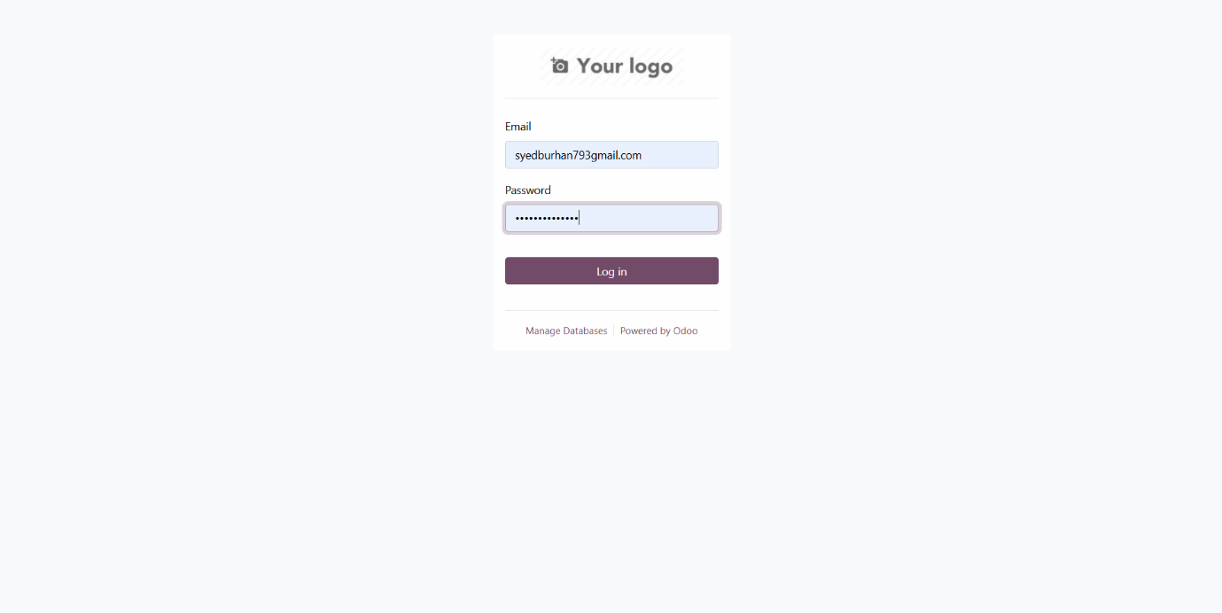

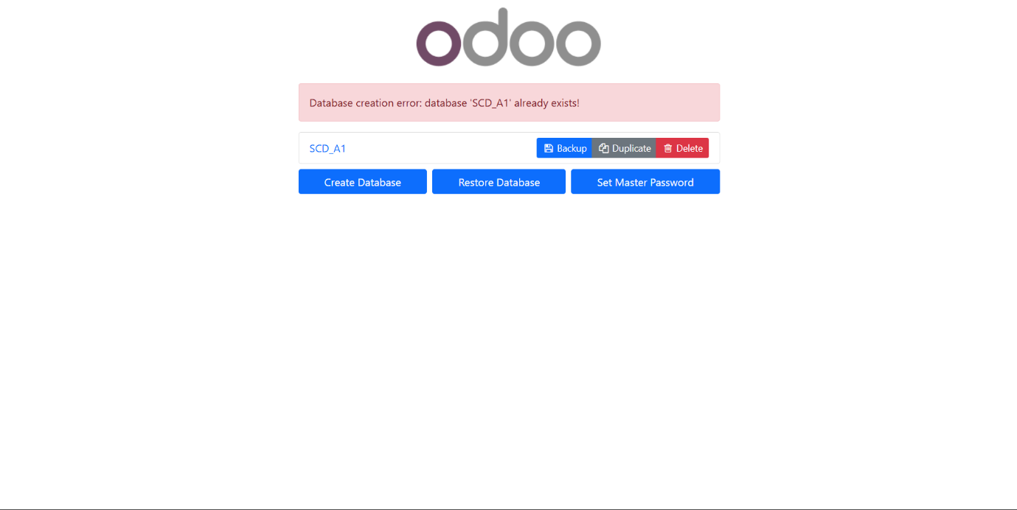

## Problems and Troubleshooting:

## (i). VirtualBox Issues

* Black screen during Ubuntu installation
  + Restart the VM and try disabling 3D acceleration in the VM settings
  + Try with or without EFI boot enabled
* Installation failure of Ubuntu
  + Changing the mirror to include “in” instead of “pk”
* Network connectivity issues
  + Ensure your host has internet connectivity
  + Try switching between NAT and Bridged adapter in network settings
* "This kernel requires an x86-64 CPU" error
  + Ensure you've selected the 64-bit version of Ubuntu
  + Verify that hardware virtualization is enabled in your BIOS/UEFI
* Slow performance
  + Allocate more RAM and CPU cores to the VM if available
  + Ensure you're not running too many applications on the host simultaneously
* VirtualBox Guest Additions installation fails
  + Ensure you have the required packages: `sudo apt install -y build-essential dkms linux-headers-$(uname -r)`
  + Try rebooting before installation

## (ii). Odoo Issues

* Service Won't Start
  + Check the Odoo log file:
  + sudo tail -f /var/log/odoo18/odoo18.log
* Database Connection Issues
  + Verify PostgreSQL is running:
  + sudo systemctl status postgresql
  + Ensure the odoo18 database user exists:
  + sudo -u postgres psql -c "\du"
* Permission Issues
  + Check ownership of directories:
  + ls -la /opt/odoo18/
  + ls -la /var/log/odoo18/
* Fix permissions if needed:
  + sudo chown -R odoo18:odoo18 /opt/odoo18/
  + sudo chown -R odoo18:odoo18 /var/log/odoo18/

## Part 2: Initial Configuration of Odoo

## 2.1 Logging in and changing default user:



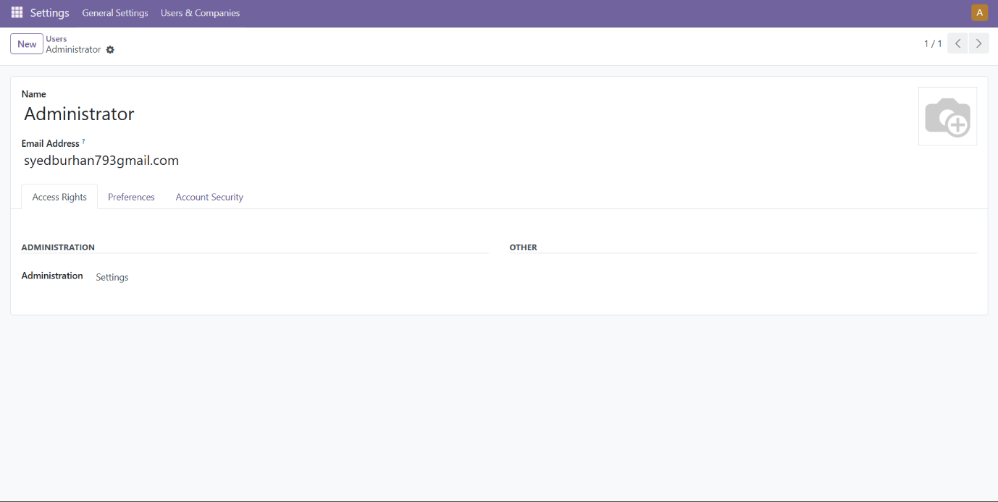

## 2.2 Creating a new user with administrative privileges:



## 2.3 Exploring the Odoo dashboard:

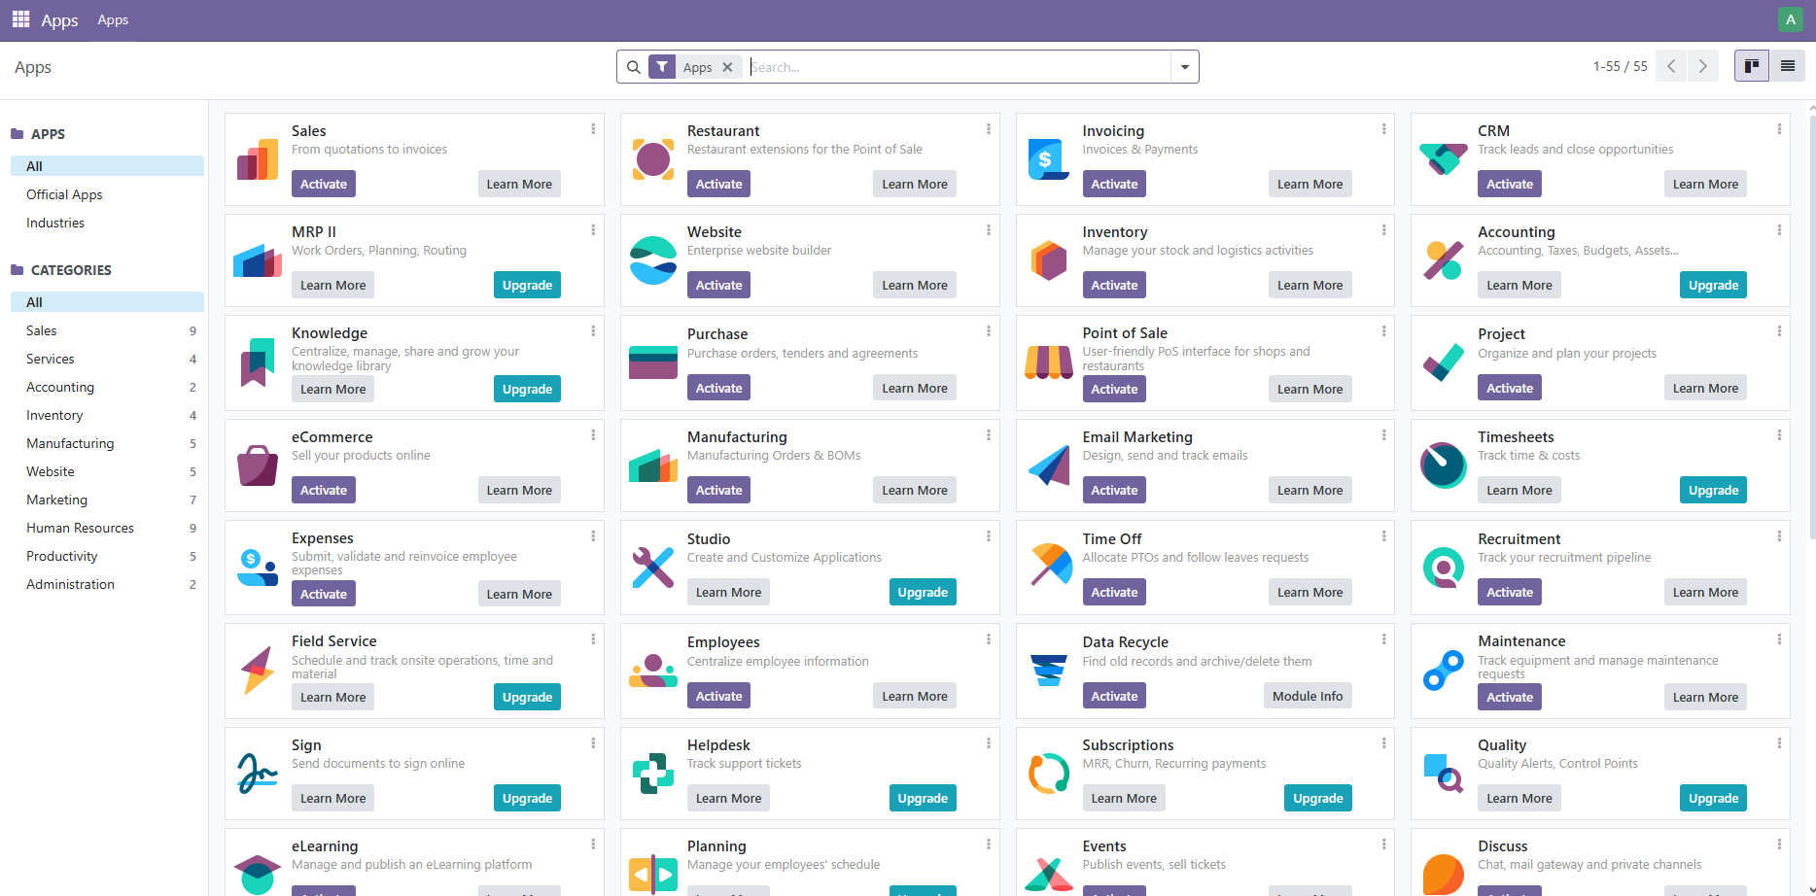

## 2.4 Configuring basic settings (company information, currency, language, and timezone):

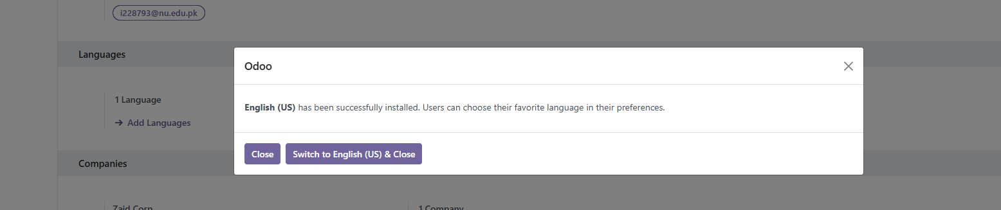

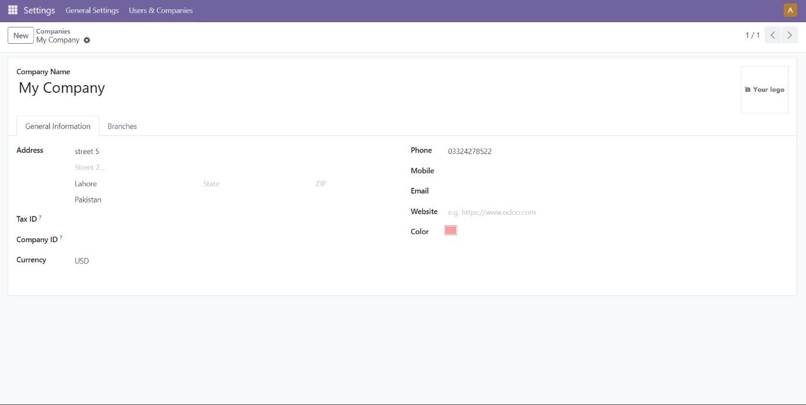

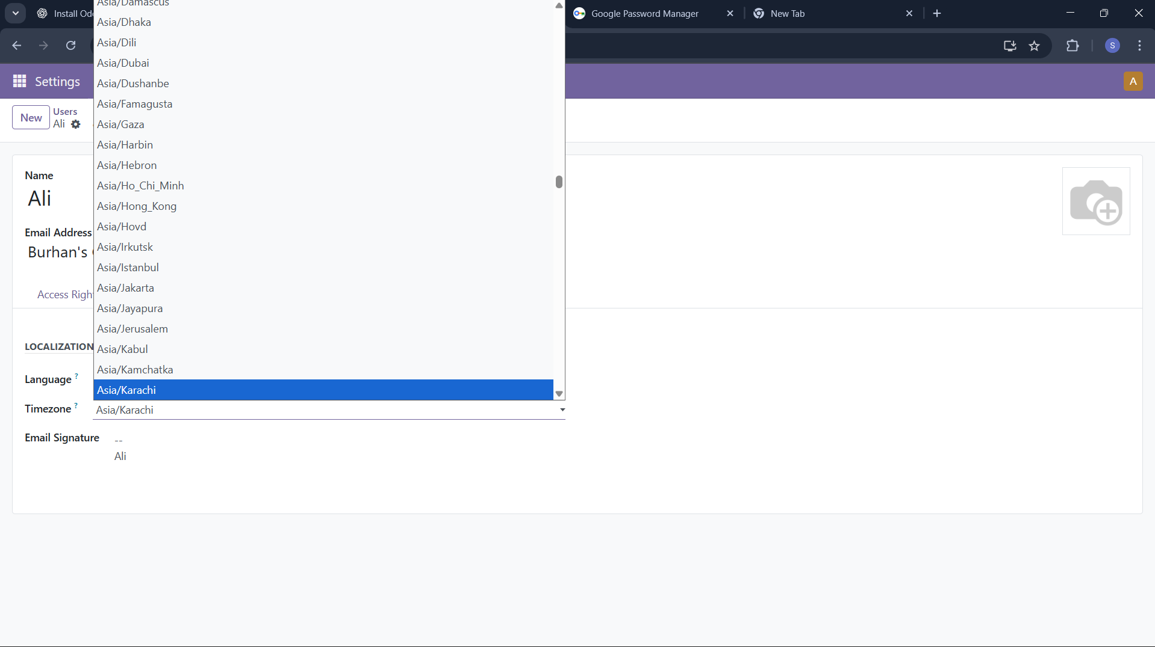

## 2.5 Install additional modules or apps:

### Installing Restaurant module (Extension of Point of Sale):

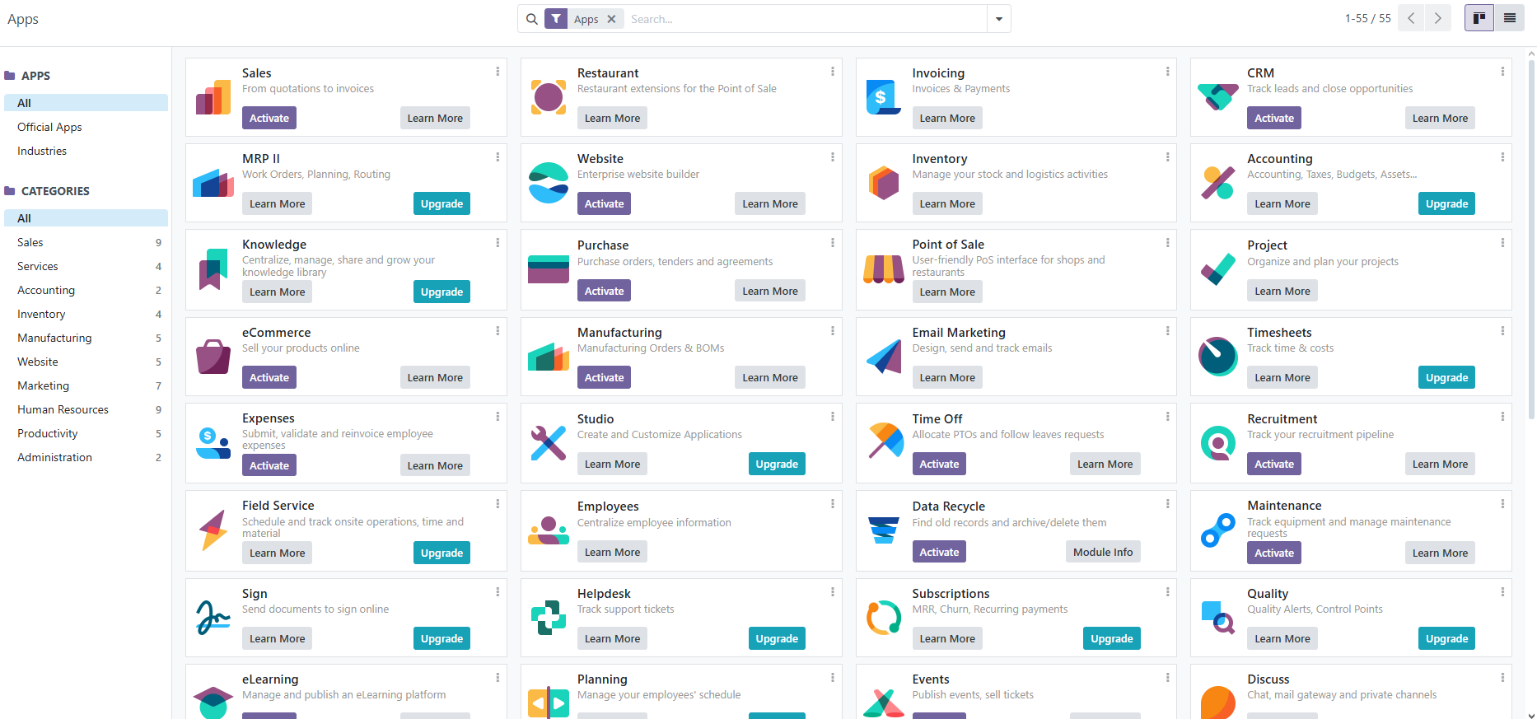

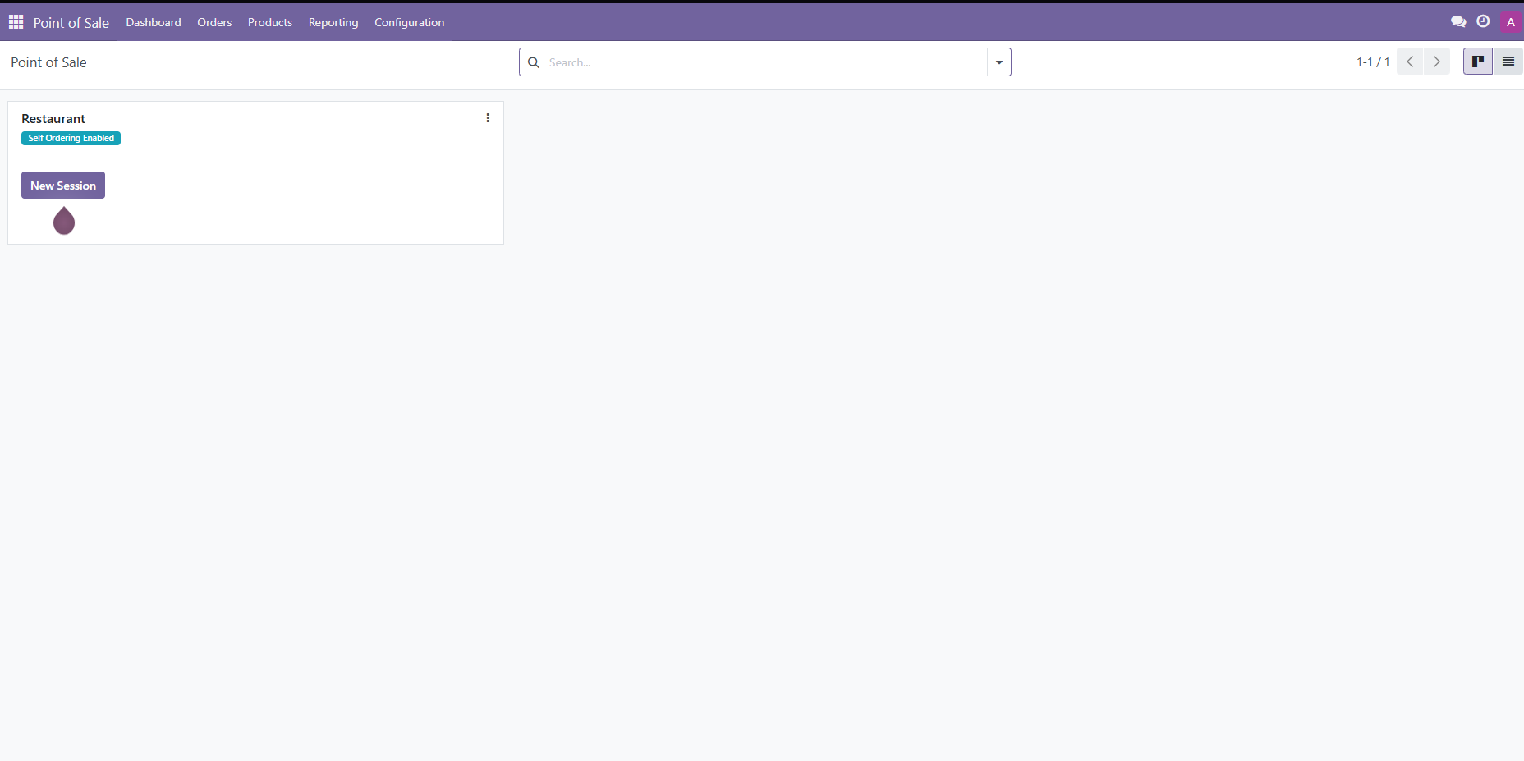

# 3. Advanced Configuration and Customization:

## 3.1 Exploring the configuration options:

### Opening the Cash Control:

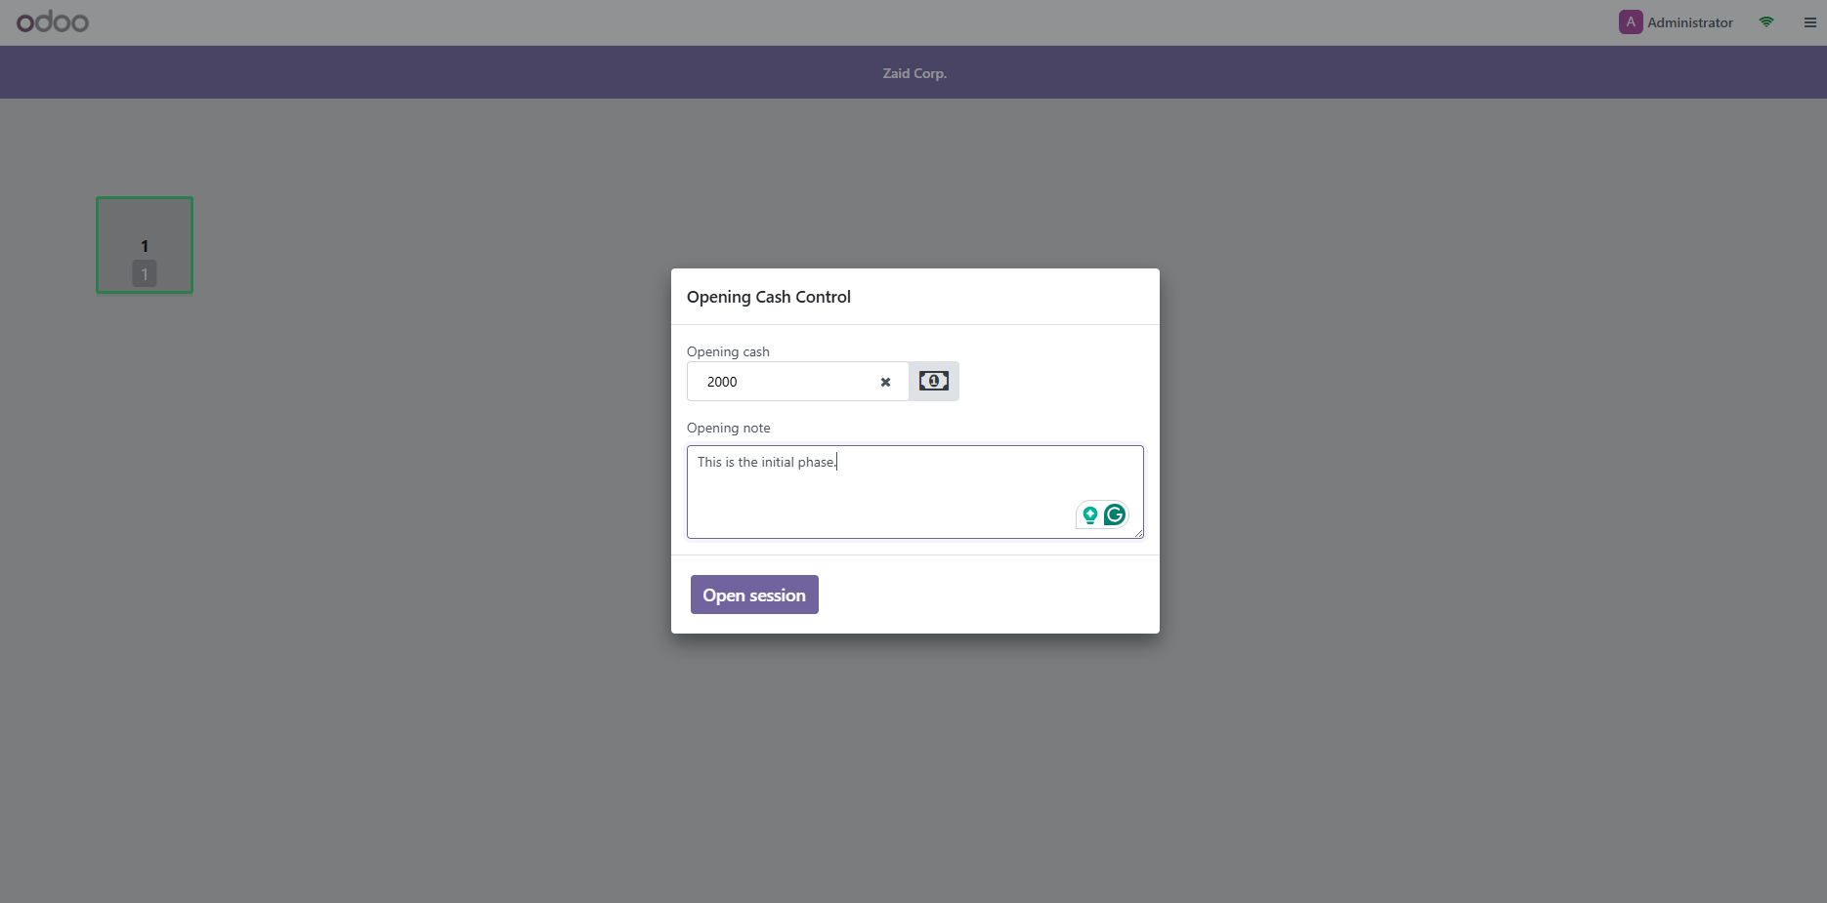

### Adding demo data to the session:

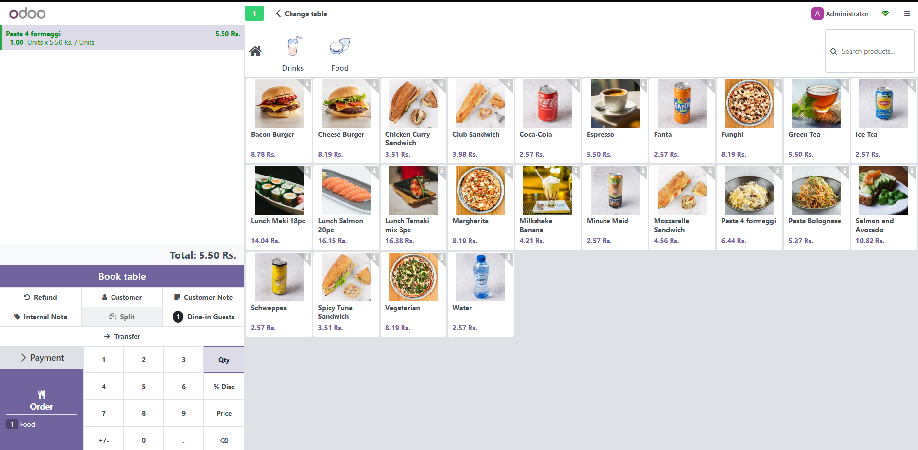

### Payment method:

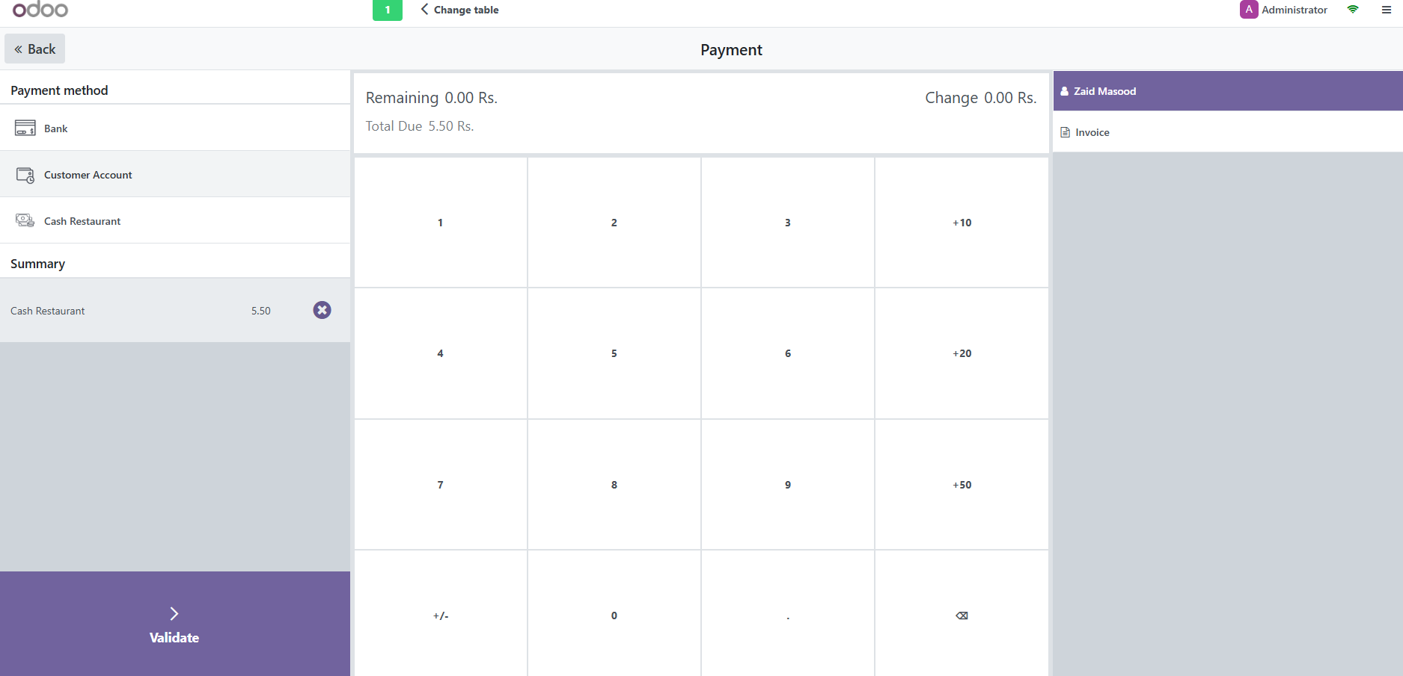

### Payment Successful:

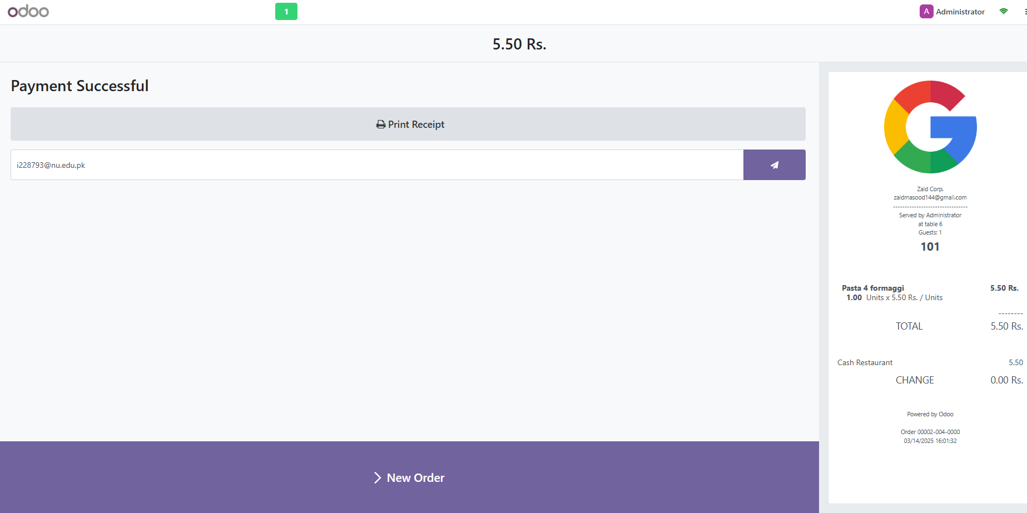

### Table Management:

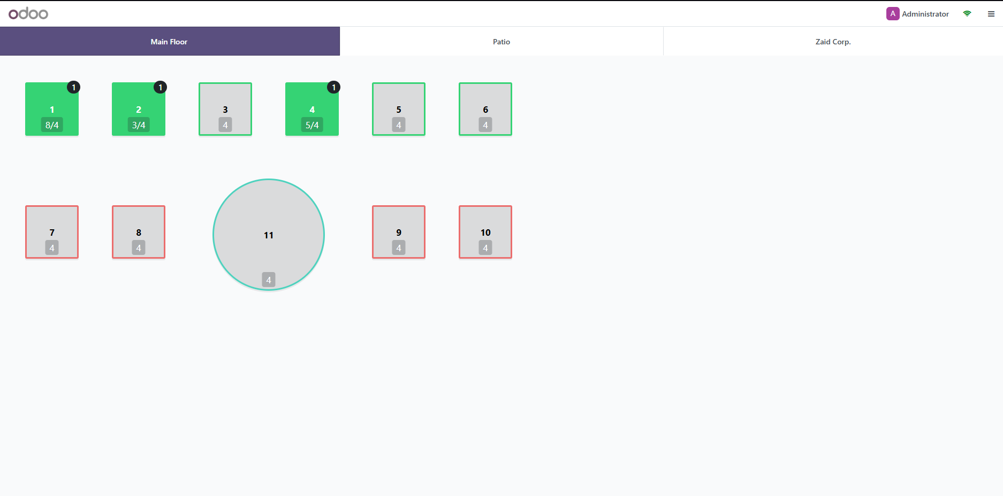

### Order Management:

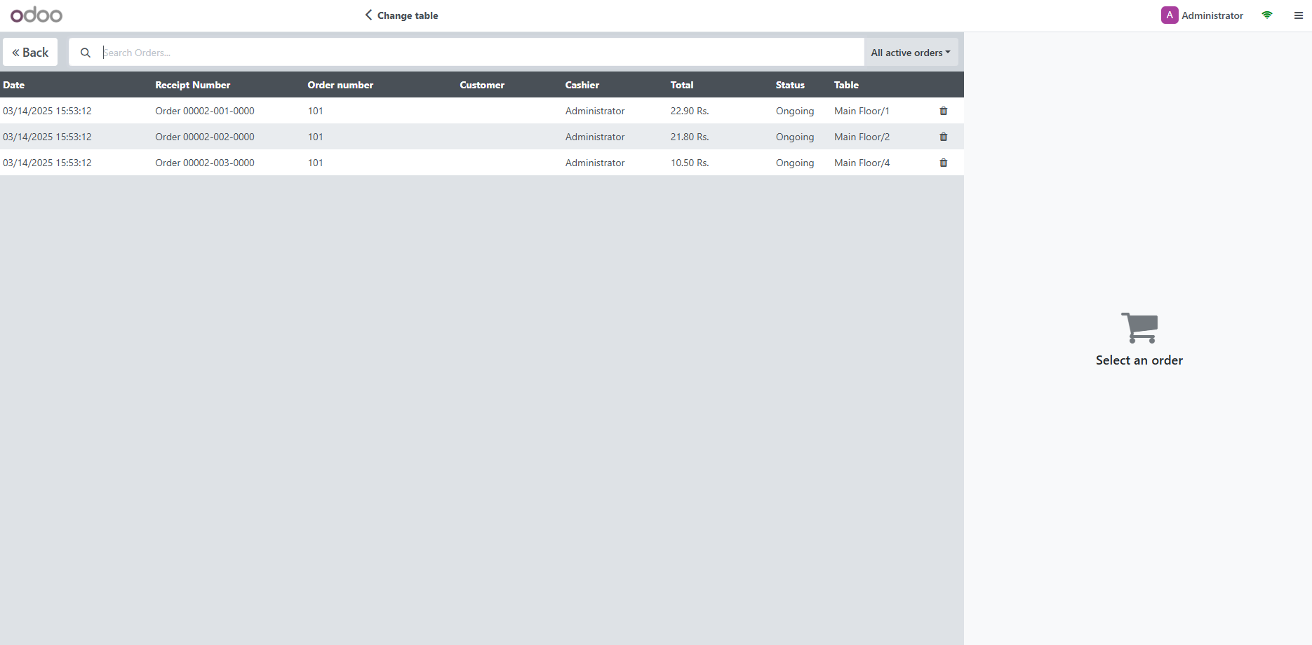

## 3.2,3.3 Customizing the module and Documentation and Integration:

### Adding custom fields:

choose “activate developer mode” for this step:

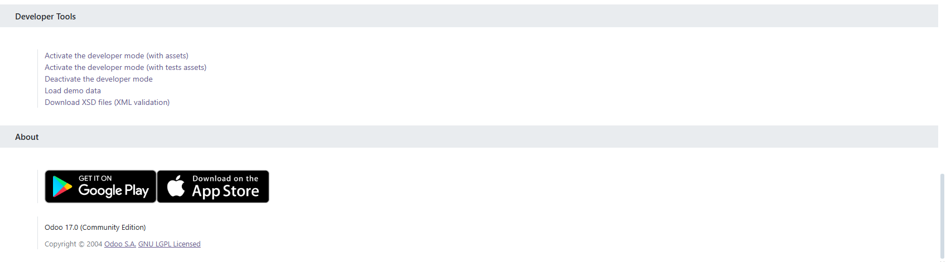

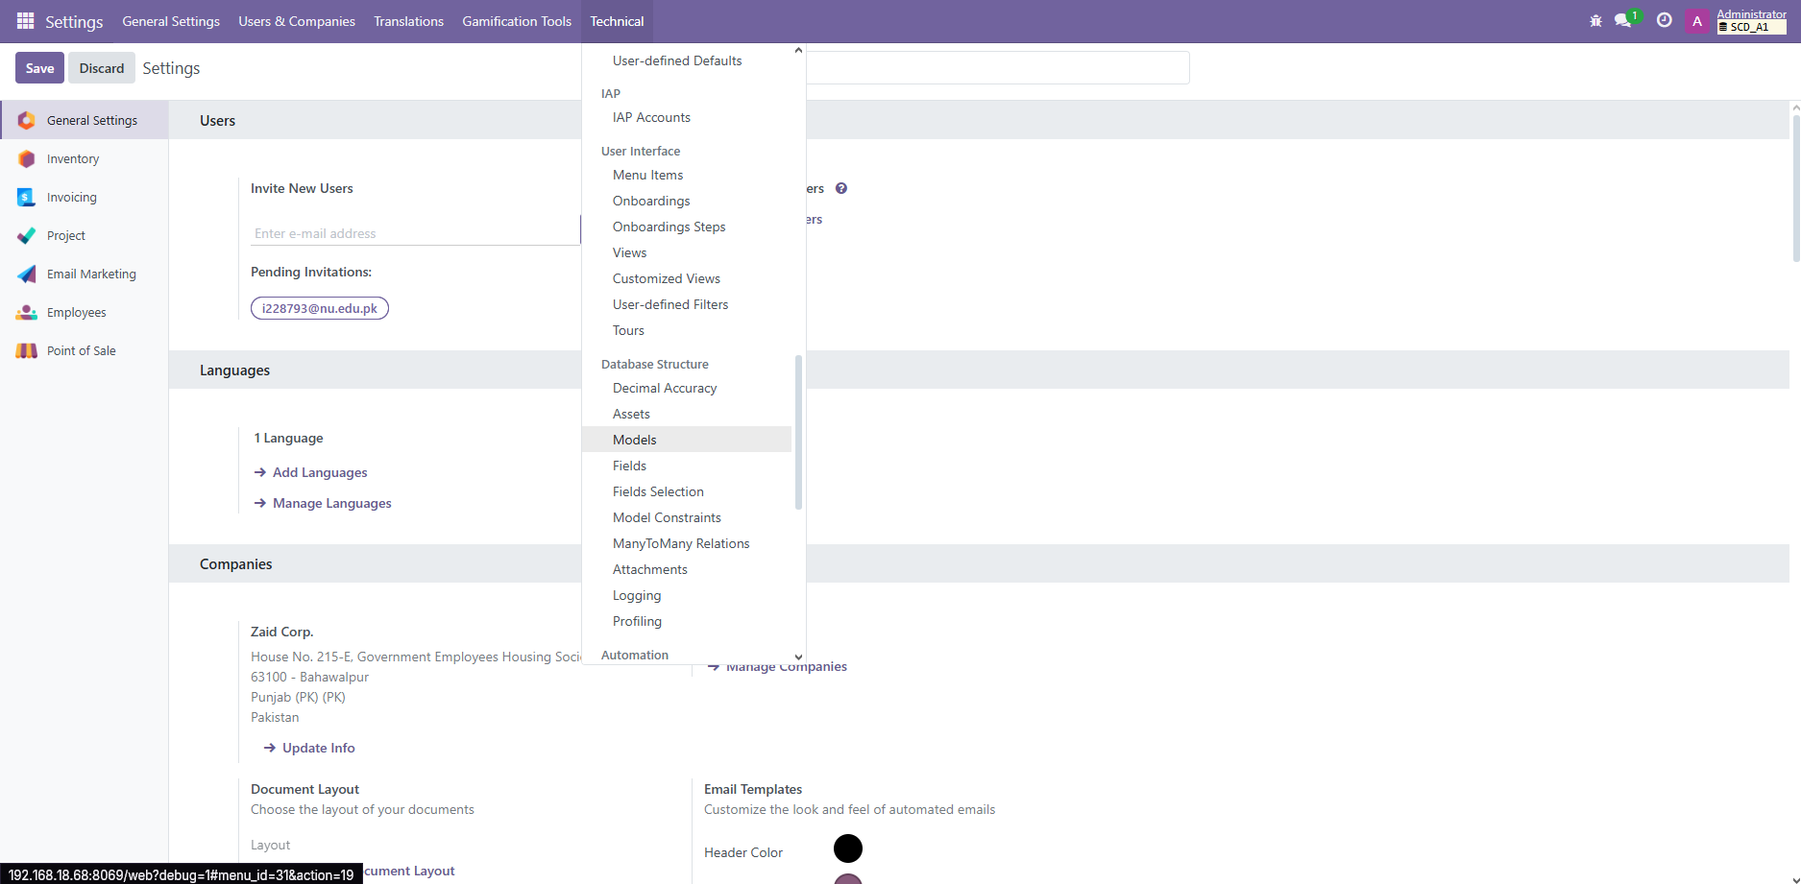

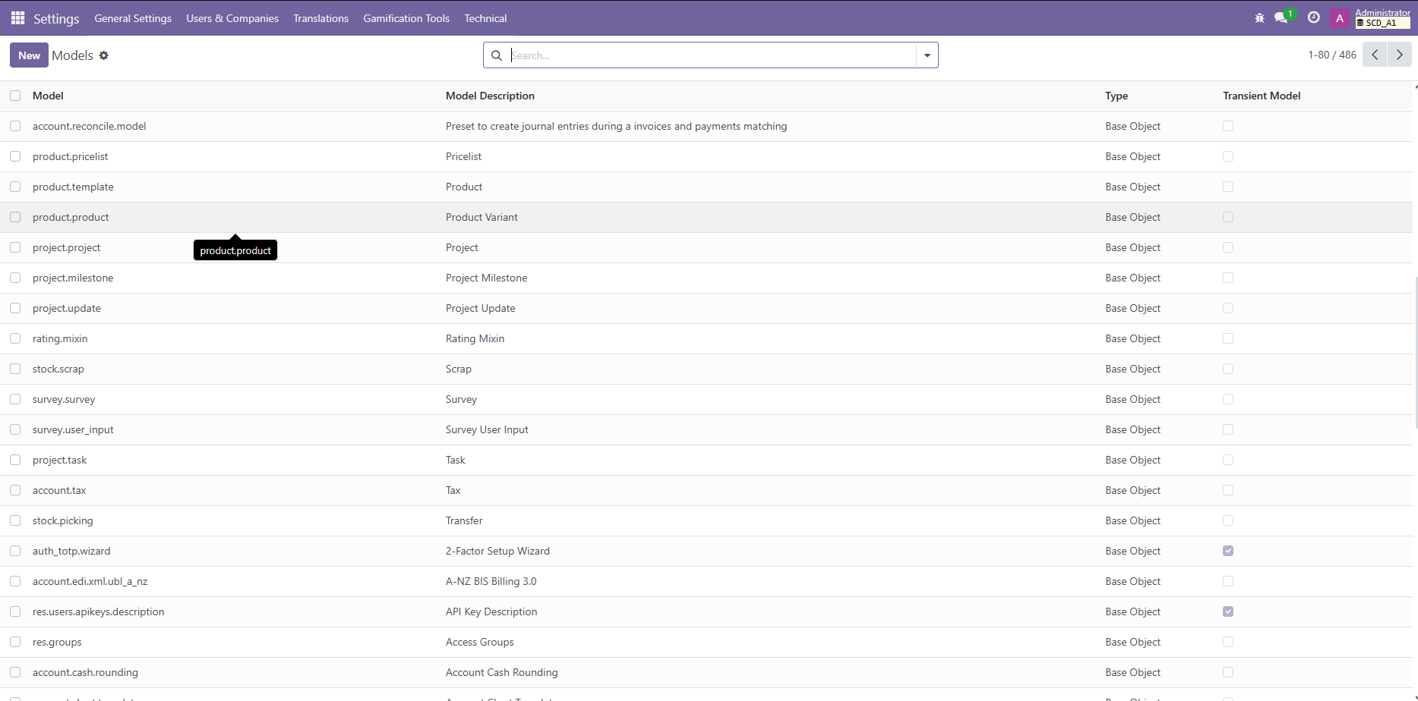

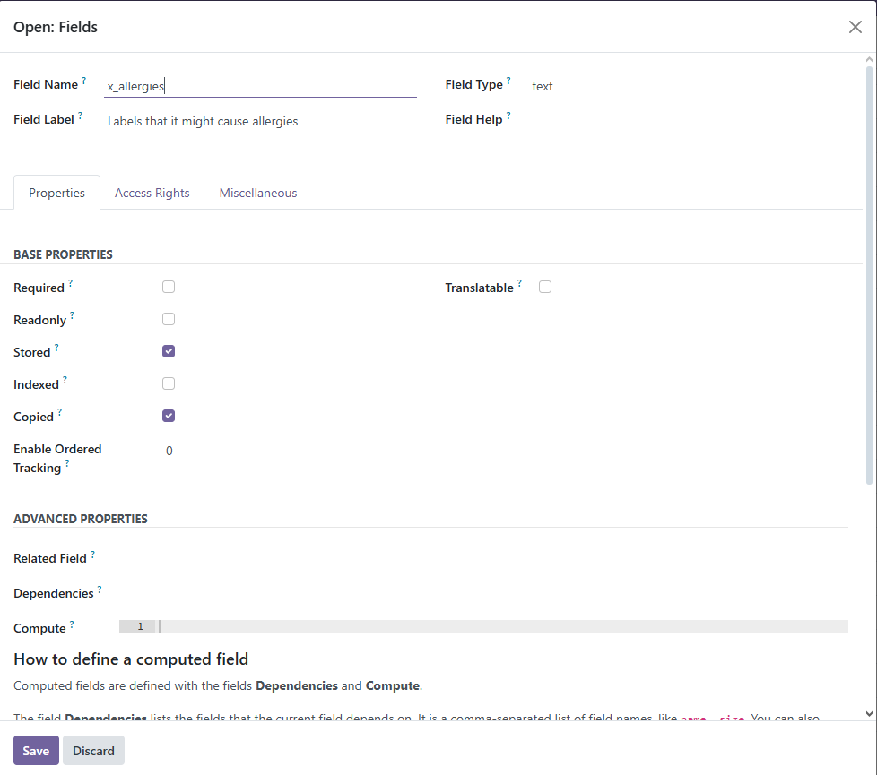

### Modifying workflow:

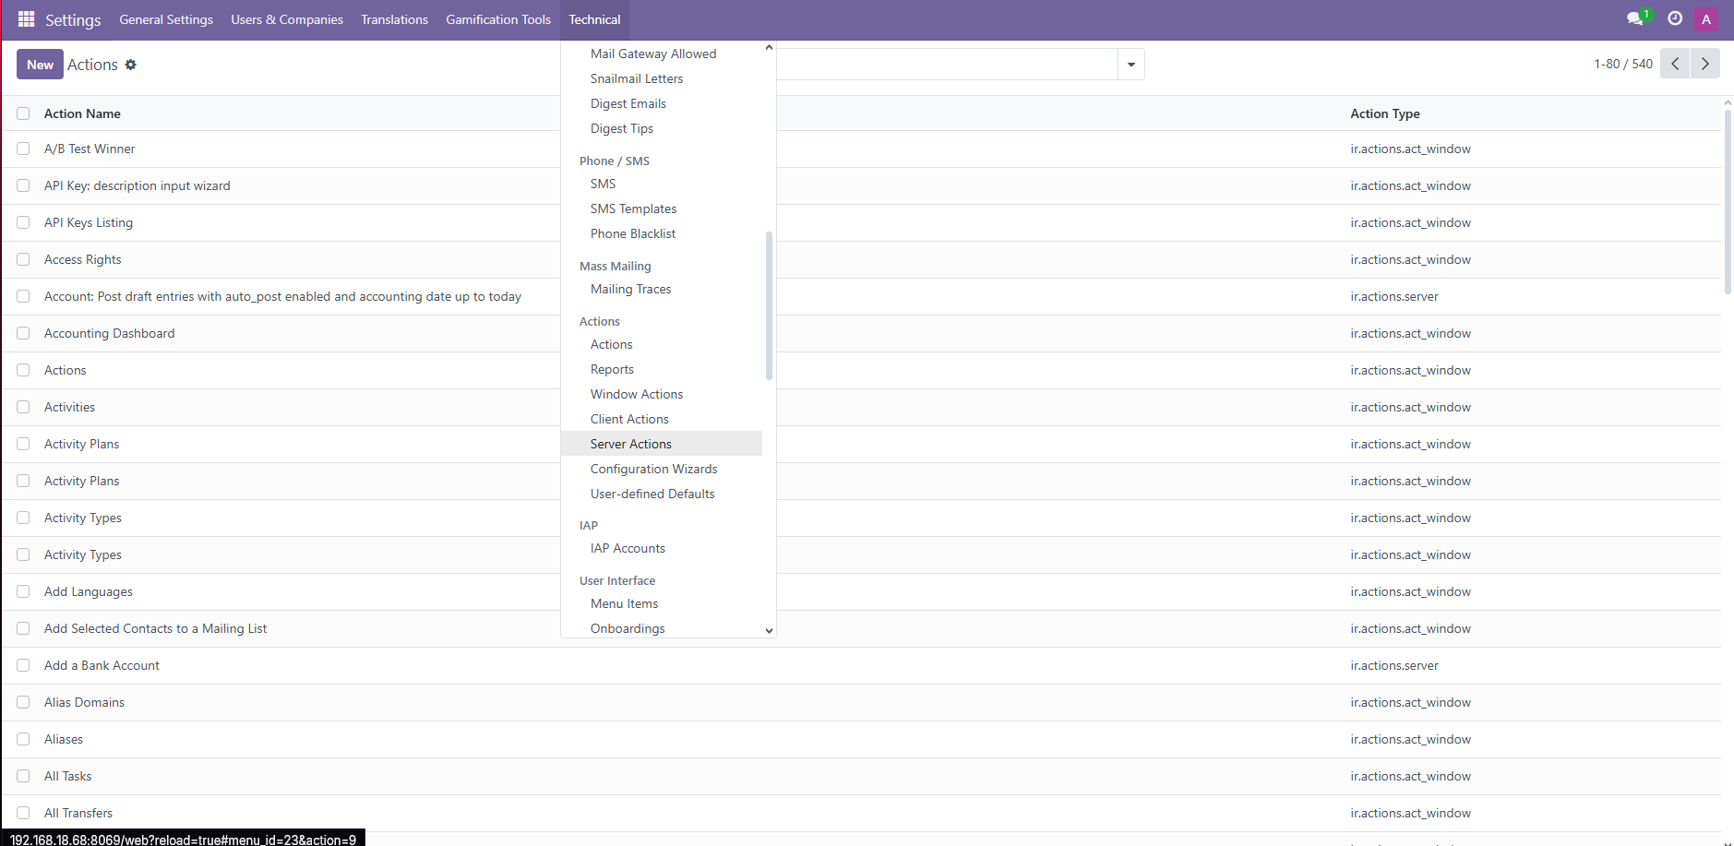

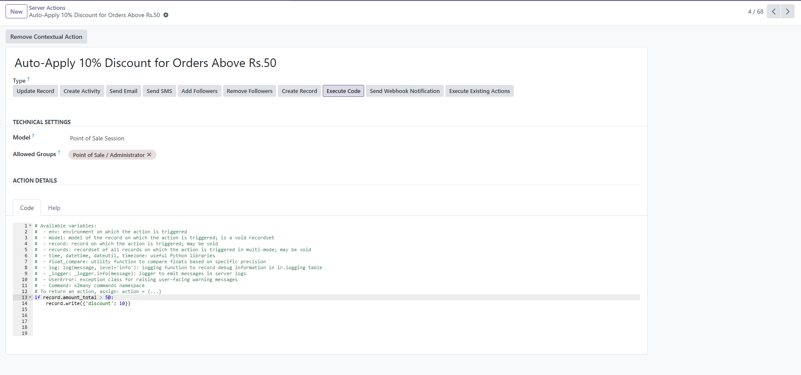

Code:

if record.amount_total > 50:

record.write({'discount': 10})

### Creating reports:

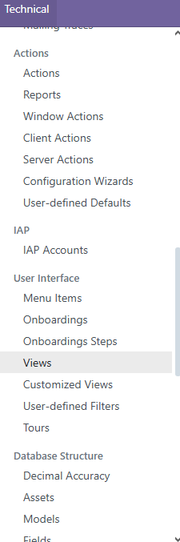

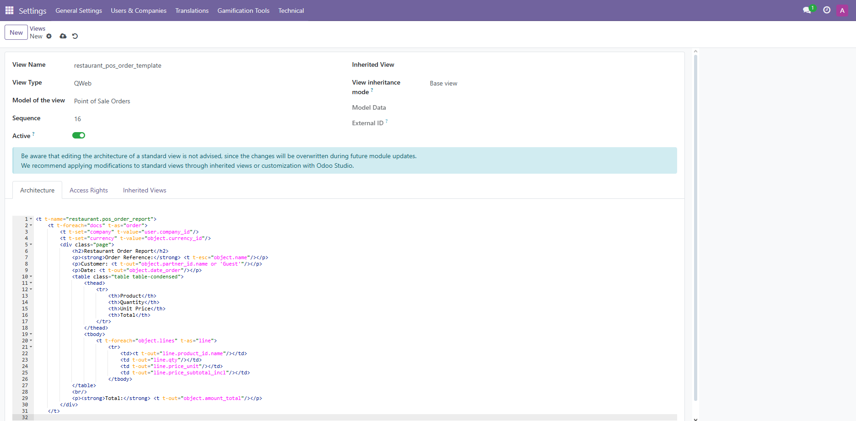

Code:

<t t-name="restaurant.pos_order_report">

<t t-foreach="docs" t-as="order">

<t t-set="company" t-value="order.company_id"/>

<t t-set="order_lines" t-value="order.lines"/>

<div class="page">

<h2>Restaurant Order Report</h2>

<p><strong>Order Reference:</strong> <t t-esc="order.name"/></p>

<p><strong>Customer:</strong> <t t-esc="order.partner_id.name or 'Walk-in Customer'"/></p>

<p><strong>Order Date:</strong> <t t-esc="order.date_order"/></p>

<table class="table table-condensed">

<thead>

<tr>

<th>Product</th>

<th>Quantity</th>

<th>Unit Price</th>

<th>Total</th>

</tr>

</thead>

<tbody>

<t t-foreach="order_lines" t-as="line">

<tr>

<td><t t-esc="line.product_id.name"/></td>

<td><t t-esc="line.qty"/></td>

<td><t t-esc="line.price_unit"/></td>

<td><t t-esc="line.price_subtotal_incl"/></td>

</tr>

</t>

</tbody>

</table>

<p><strong>Total Amount:</strong> <t t-esc="order.amount_total"/></p>

</div>

</t>

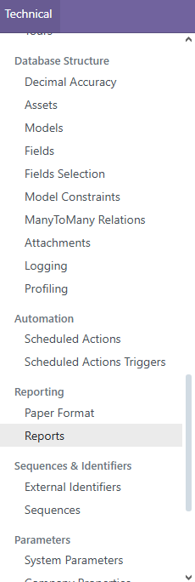

### Restarting after all steps:

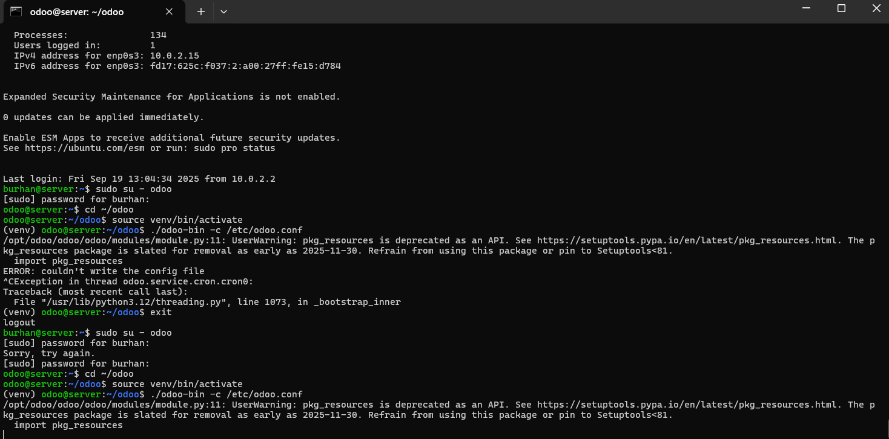

## 3.4 Testing the configured module:

### Custom field while creating a new product:

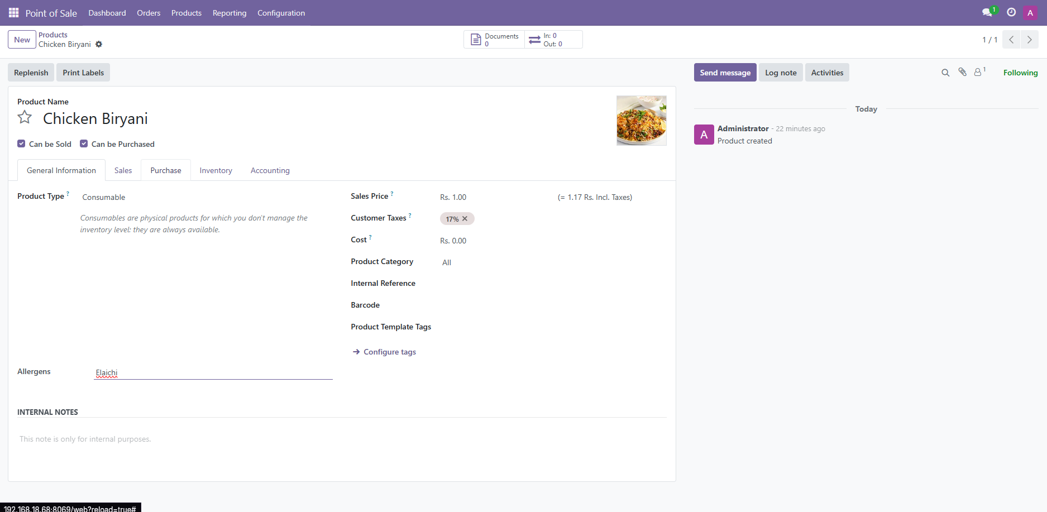

### Application of discount on the set amount:

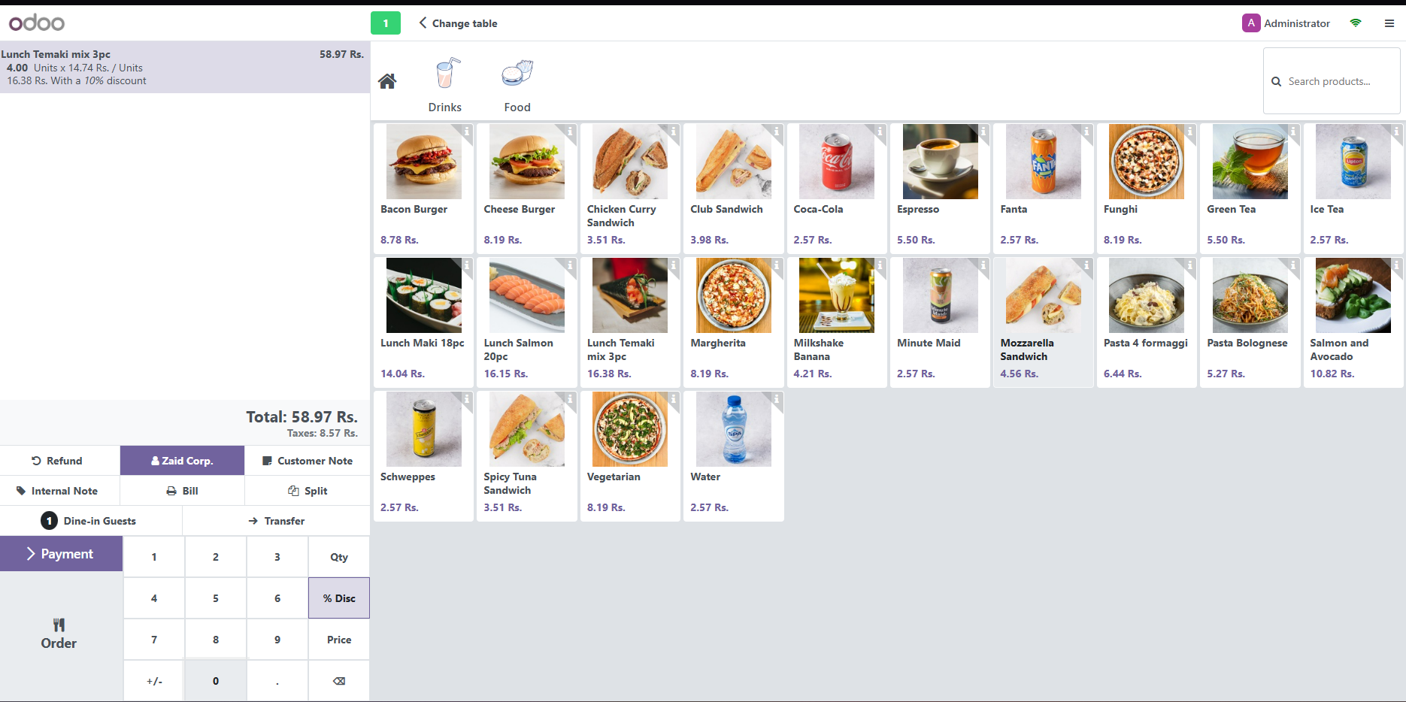

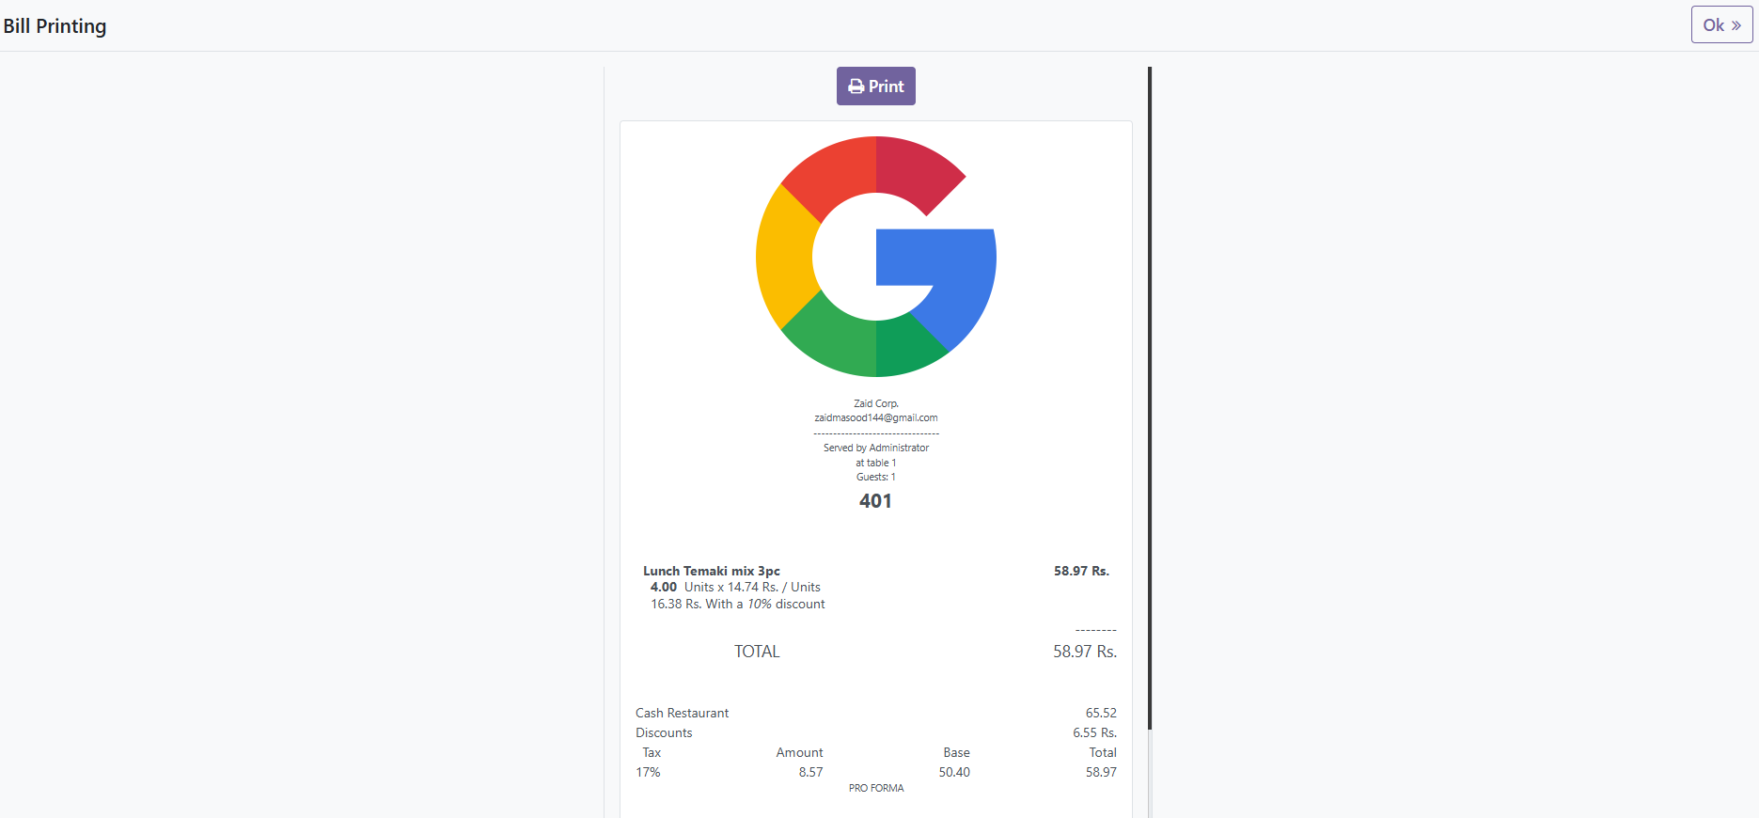

### Generating a report:

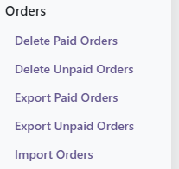

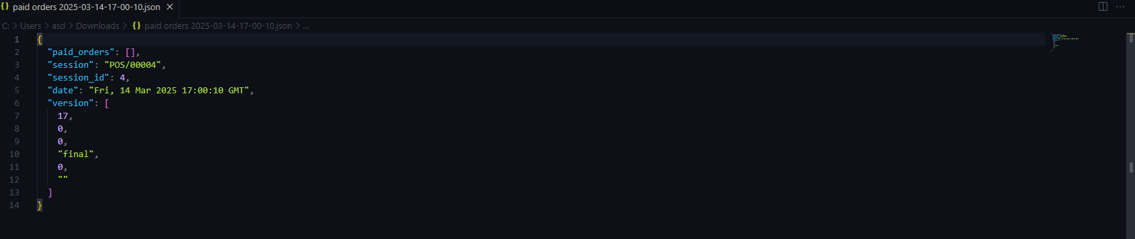

## Challenges and Solutions:

### ****Challenge 1: "Technical" Menu Not Visible in Settings****

**Issue:** The "Technical" menu was missing, preventing access to model configurations.

**Solution:**

* **Enable Developer Mode** using:
  + **Settings → Activate Developer Mode**, OR
  + Adding ?debug=1 to the URL.

### ****Challenge 2: QWeb Report Error - "Opening and ending tag mismatch"****

**Issue:** The <tr> and <td> tags were incorrectly structured, causing XML errors.

**Solution:**

* Fixed the **loop structure** in QWeb template to ensure proper nesting.
* Verified closing tags for <tr> and <td>.

### ****Challenge 3: Workflow Automation Not Available****

**Issue:** **"Workflows"** were deprecated in Odoo 17, requiring a new way to automate actions.

**Solution:**

* Used **Automated Actions** instead:
  1. **Go to** Settings > Technical > Automation > Automated Actions.
  2. **Create New Action**:
     + **Model:** pos.order
     + **Trigger:** On Creation
     + **Condition:** Apply **10% discount** if order > Rs.50.
     + **Action:** Execute Python Code:
     + if record.amount_total > 50:
     + record.write({'discount': 10})
  3. **Save & Test** the automation.