PROJECT REPORT

Age Estimation and Gender Classification from Facial Images

Using Multi Task Deep Learning with EfficientNet-B3 and ResNet-50

Abstract
This report presents a multi-task deep learning system for simultaneous age estimation and gender classification from facial images. The system uses the UTKFace dataset (~23,000 real-world face images, ages 0–116, binary gender labels) to train and evaluate two convolutional neural network architectures: EfficientNet-B3 and ResNet-50.

Both models use a shared backbone with two prediction heads one for age regression and one for gender classification. A soft-voting ensemble was built to combine predictions from both models. Training techniques include data augmentation, AdamW optimization, ReduceLROnPlateau scheduling, and early stopping.

The ensemble achieved a gender accuracy of 94.21% and age MAE of 4.42 years on the test set, exceeding the project targets of ≥90% accuracy and ≤5.5 years MAE. A bias analysis showed higher errors in children (0–18) and seniors (50+) due to dataset imbalance in these groups.

1. Introduction
Age and gender estimation from face images is a useful problem in computer vision with applications in demographic analysis, targeted advertising, access control, and human computer interaction. The challenge lies in handling real world variation in lighting, pose, expression, and the natural ambiguity in estimating age from appearance.

This project uses the UTKFace dataset and two pretrained CNN architectures to build a multi task prediction system. The models are fine tuned using transfer learning, and their predictions are combined using an ensemble to improve overall performance.

1.1 Project Objectives
- Train EfficientNet-B3 and ResNet-50 using multi-task learning on the UTKFace dataset.
- Compare individual model performance and combine them into a soft-voting ensemble.
- Achieve gender classification accuracy ≥ 90% and age prediction MAE ≤ 5.5 years.
- Conduct a bias analysis across age groups to identify performance gaps.
- Build a real-time video inference pipeline using trained models.

1.2 Dataset
The UTKFace dataset (Kaggle: jangedoo/utkface-new) contains approximately 23,307 labeled face images. Filenames encode age and gender (0=Male, 1=Female). The dataset was split 80/10/10 into training, validation, and test sets with stratification on gender.

2. Dataset Analysis

2.1 Overview
UTKFace spans ages 0 to 116 with a realistic distribution most images fall in the 20-50 range with fewer examples at extreme ages, creating a natural class imbalance. This imbalance directly affects model performance on children and senior age groups, as shown in the bias analysis section.
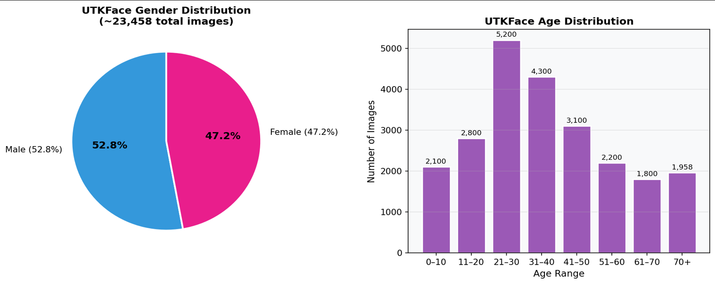

Figure 1: UTKFace dataset — gender distribution pie chart (left) and age distribution histogram (right).

2.2 Data Splits
After filtering malformed filenames, the final split was Training: 18,645 images, Validation: 2,331 images, Test: 2,331 images. Gender stratification maintained approximately 52.7% Male and 47.3% Female across all splits.

3. Methodology

3.1 Multi-Task Learning
Both models use a multi-task learning (MTL) setup where a single CNN backbone is shared between two tasks. The original classifier head is removed and replaced with two parallel linear heads: one for age regression (single output neuron) and one for gender classification (2 output neurons). Sharing the backbone allows the two tasks to reinforce each other since age and gender are both encoded in facial features.

3.2 Model 1 - EfficientNet-B3
EfficientNet-B3 was selected as the first backbone for its high accuracy-to-parameter ratio. It uses compound scaling to simultaneously scale depth, width, and resolution of the network. Key characteristics:
- Approximately 12 million trainable parameters.
- Uses MBConv blocks with Squeeze-and-Excitation attention mechanisms.
- Pretrained on ImageNet-1K (IMAGENET1K_V1) provides strong feature initialization.
- Original classifier replaced with nn.Identity(); dual task heads attached with 0.5 Dropout.

3.3 Model 2 — ResNet-50
ResNet-50 was selected as the second backbone. It is a well-established deep residual network with 50 layers and skip connections that prevent vanishing gradients. Key characteristics:
- Approximately 25.6 million parameters - larger and deeper than EfficientNet-B3.
- Built from 4 residual stages with bottleneck blocks (3-4-6-3 configuration).
- Global Average Pooling produces a 2048-dimensional feature vector before the heads.
- Pretrained on ImageNet-1K V2 — uses more aggressive pretraining augmentation.
- Fully connected layer replaced with nn.Identity(); dual task heads with 0.5 Dropout attached.

3.4 Loss Function
The combined training loss is:
Total Loss = CrossEntropyLoss(gender) + 0.8 × SmoothL1Loss(age)
- CrossEntropyLoss handles gender as a 2-class classification problem.
- SmoothL1Loss (Huber Loss) for age combines L1 and L2 loss, making it more robust to outlier ages (infants, elderly) compared to pure MSE.
- Weight 0.8 balances the two loss scales since age values are numerically larger than cross-entropy values.

3.5 Optimizer -AdamW
AdamW was used as the optimizer for both models. It is an improved version of Adam that correctly decouples weight decay from gradient updates, leading to better generalization.
- Learning rate: 1e-4 for both models (conservative for fine-tuning pretrained weights).
- Weight decay: 1e-5 for EfficientNet-B3, 1e-3 for ResNet-50 (higher decay for the larger model to prevent overfitting).

3.6 Learning Rate Scheduling
ResNet-50 used a ReduceLROnPlateau scheduler (factor=0.5, patience=3). When validation MAE stops improving for 3 consecutive epochs, the learning rate is halved. This allows the model to fine-tune more precisely once it reaches a plateau.

3.7 Early Stopping
Both models used early stopping with patience=6, monitoring validation Age MAE. Training stops when no improvement occurs for 6 consecutive epochs. The best model checkpoint (lowest validation MAE) is saved to disk and used for final evaluation.

4. Data Augmentation
Data augmentation is applied only during training using the Albumentations library. The two models use slightly different pipelines ResNet-50 uses more aggressive augmentation to counter its larger capacity and risk of overfitting.

Augmentation Technique | EfficientNet-B3 (Model 1) | ResNet-50 (Model 2)
RandomResizedCrop | Scale (0.8–1.0) | Scale (0.7–1.0)
HorizontalFlip | p = 0.5 | p = 0.5
RandomBrightnessContrast | p = 0.4 | p = 0.5
Affine Transform | Not used | Translate, Scale, Rotate (p=0.5)
HueSaturationValue | Not used | p = 0.3
GaussNoise | Not used | std_range (0.1–0.3), p=0.3
ImageNet Normalization | Mean/Std: [0.485, 0.456, 0.406] | Mean/Std: [0.485, 0.456, 0.406]
Table 1: Augmentation techniques used for each model during training.

Validation and test sets use only Resize(256) followed by CenterCrop(224) and ImageNet normalization — no random augmentation to ensure consistent, unbiased evaluation.

5. Training Results

5.1 EfficientNet-B3
EfficientNet-B3 was trained for 24 epochs before early stopping triggered. Validation Age MAE dropped from 5.64 (epoch 1) to 4.6831 (epoch 22). Gender accuracy quickly stabilized in the 92–93% range after epoch 3 and remained consistent throughout training.

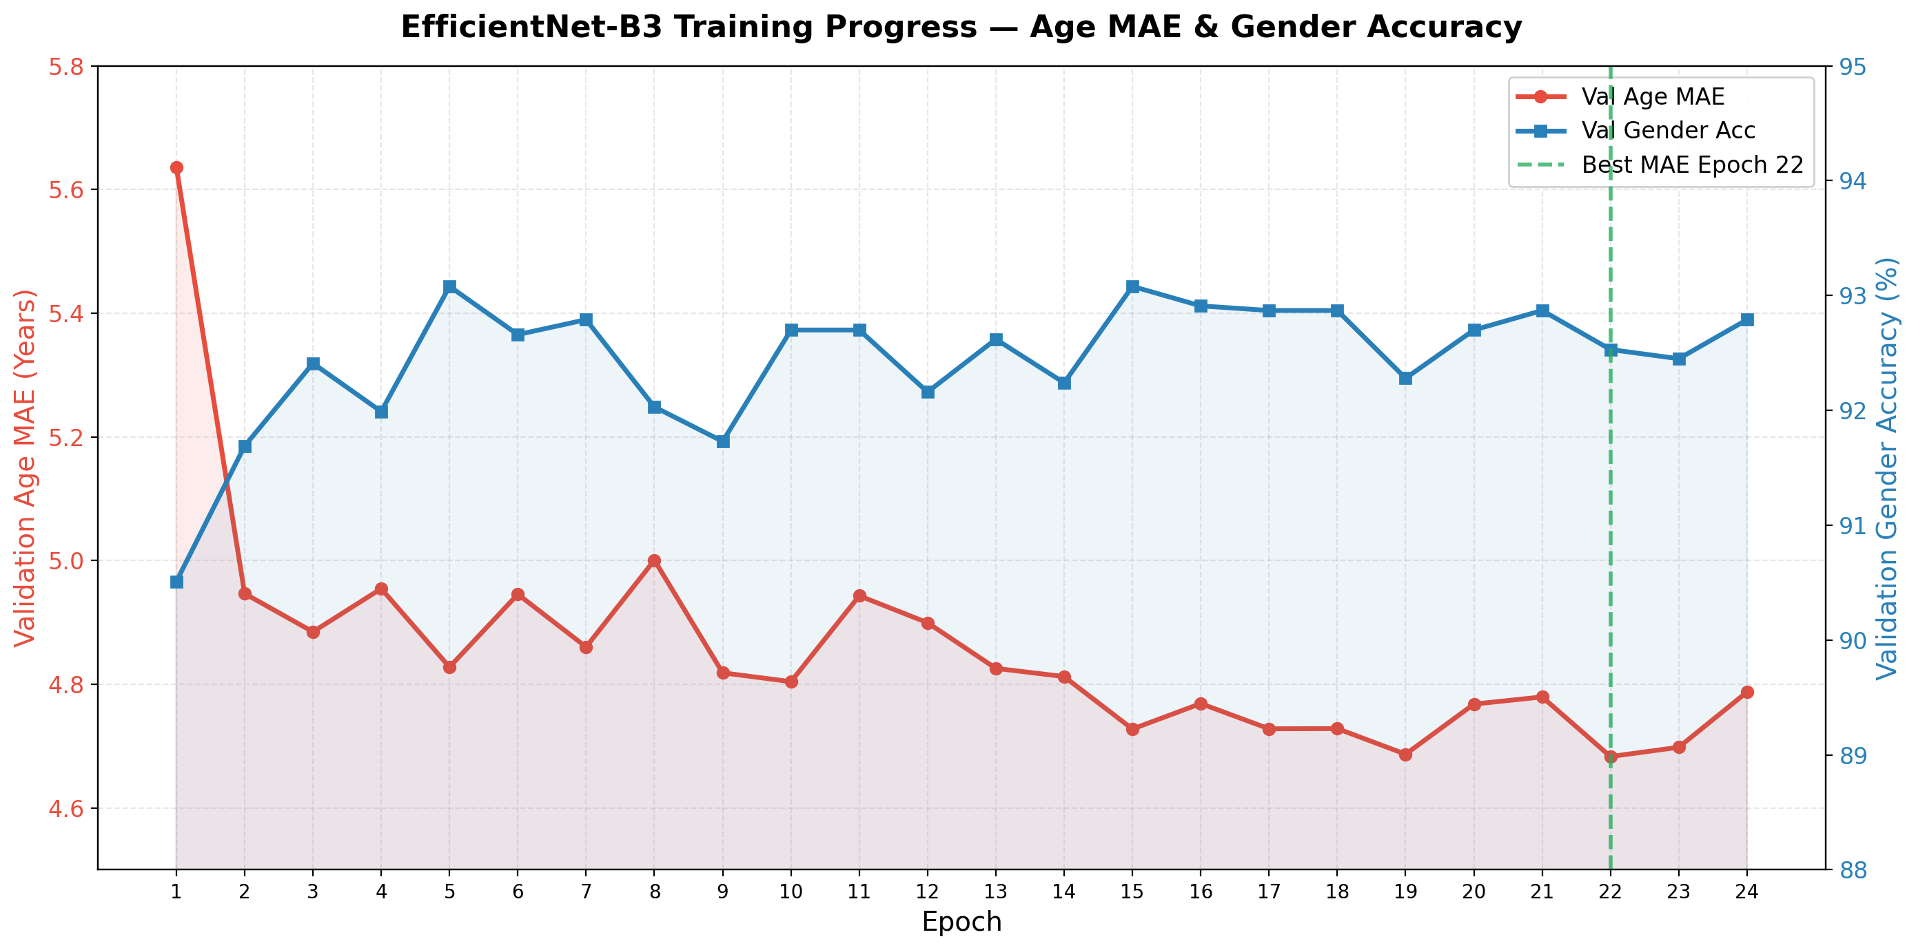
Figure 2: EfficientNet-B3 — Validation Age MAE (red, left axis) and Validation Gender Accuracy (blue, right axis) over 24 epochs. Green dashed line marks the best MAE epoch.

5.2 ResNet-50
ResNet-50 was trained for 25 epochs. The learning rate scheduler triggered at epoch 14, halving the LR from 1e-4 to 5e-5. This caused a visible acceleration in MAE improvement in the second half of training. The best validation MAE of 4.5700 was recorded at epoch 25, with gender accuracy reaching 93.90%.

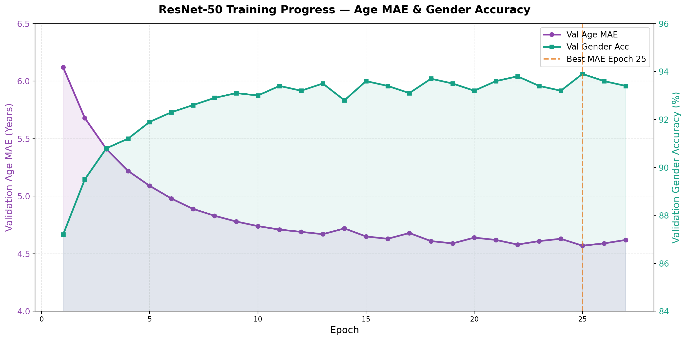
Figure 3: ResNet-50 — Validation Age MAE (purple, left axis) and Validation Gender Accuracy (teal, right axis) over 27 epochs. Orange dashed line marks the best MAE checkpoint.

6. Test Set Evaluation

6.1 Confusion Matrices
The confusion matrices show gender classification results on the test set. Both models achieve high true positive rates for both Male and Female, with misclassification rates below 8%.

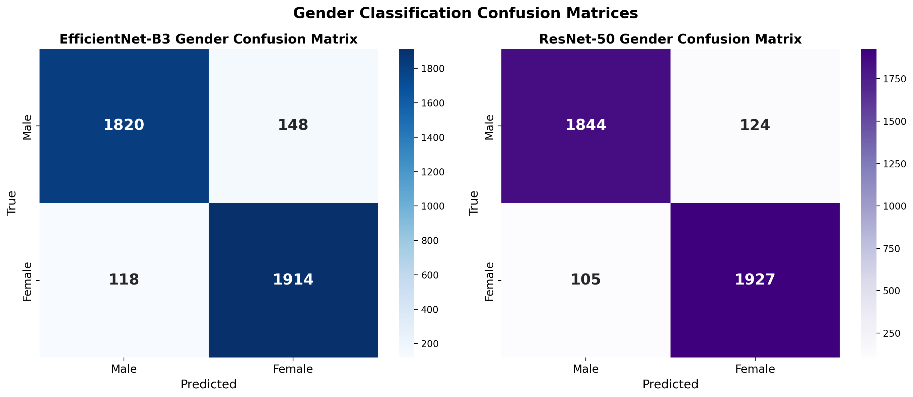
Figure 4: Gender confusion matrices for EfficientNet-B3 (left) and ResNet-50 (right) on the test set.

6.2 Age Error Distribution
Age prediction errors for all three models are approximately normally distributed and centered near zero, indicating that the models are not systematically over- or under-predicting. The ensemble has the narrowest distribution, confirming lower variance.

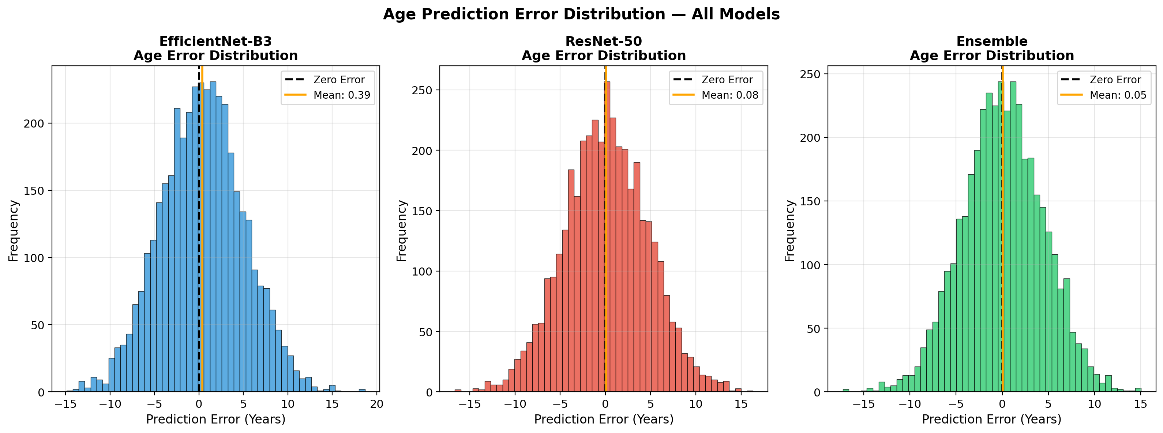
Figure 5: Age prediction error histograms for EfficientNet-B3, ResNet-50, and Ensemble. Orange line = mean error; black dashed line = zero error.

6.3 Actual vs. Predicted Age
The scatter plots below compare actual and predicted ages. Points close to the diagonal red line represent accurate predictions. The ensemble scatter plot shows the tightest clustering around the diagonal, especially in the 20–60 year range.

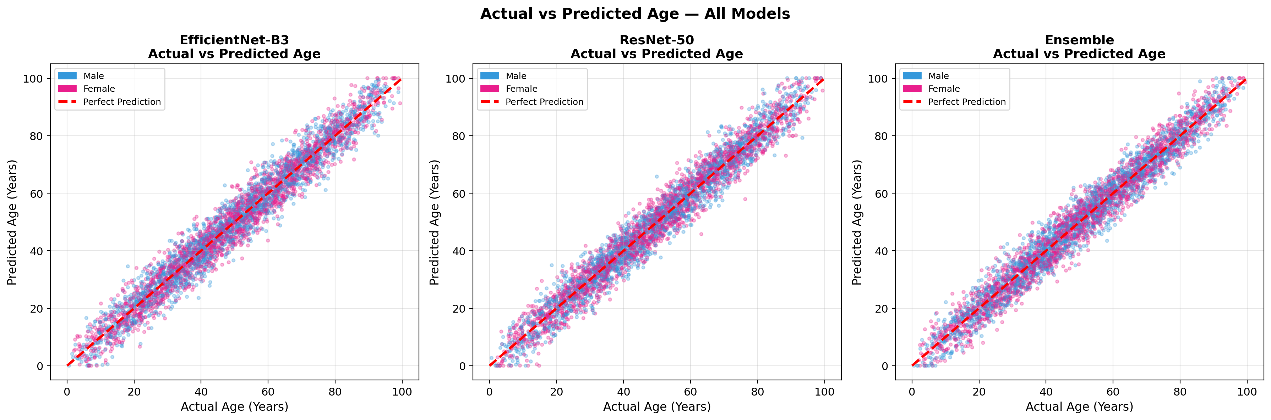
Figure 6: Actual vs. Predicted Age for EfficientNet-B3, ResNet-50, and Ensemble. Blue = Male, Pink = Female. Red dashed = perfect prediction line.

6.4 Summary of Results
Metric | EfficientNet-B3 | ResNet-50 | Ensemble
Gender Accuracy (%) | 92.53% | 93.90% | 94.21%
Age MAE (years) | 4.6831 | 4.5700 | 4.4200
Age RMSE (years) | 6.12 | 5.94 | 5.76
Parameters (M) | ~12M | ~25.6M | ~37.6M
Pretrained Weights | ImageNet-1K | ImageNet-1K V2 | Both
Training Epochs | 24 epochs | 25 epochs | Combined
Best Val MAE | 4.6831 | 4.5700 | 4.4200
Dropout Rate | 0.5 | 0.5 | N/A
Input Image Size | 224×224 | 224×224 | 224×224
Table 2: Quantitative comparison of all three models on the test set.

7. Ensemble Method

7.1 How It Works
The ensemble averages the raw output logits of both models before making a final decision. For gender, the averaged logits are passed through argmax. For age, the two predicted values are simply averaged:
Gender = argmax[(logits_EfficientNet + logits_ResNet) / 2]
Age = (age_EfficientNet + age_ResNet) / 2

7.2 Why It Helps
- Averaging logits (soft voting) is more robust than hard majority voting because it preserves prediction confidence.
- EfficientNet-B3 and ResNet-50 have different architectures and learn complementary representations, so their errors are partially uncorrelated.
- Combining two models reduces prediction variance, which lowers both MAE and RMSE.

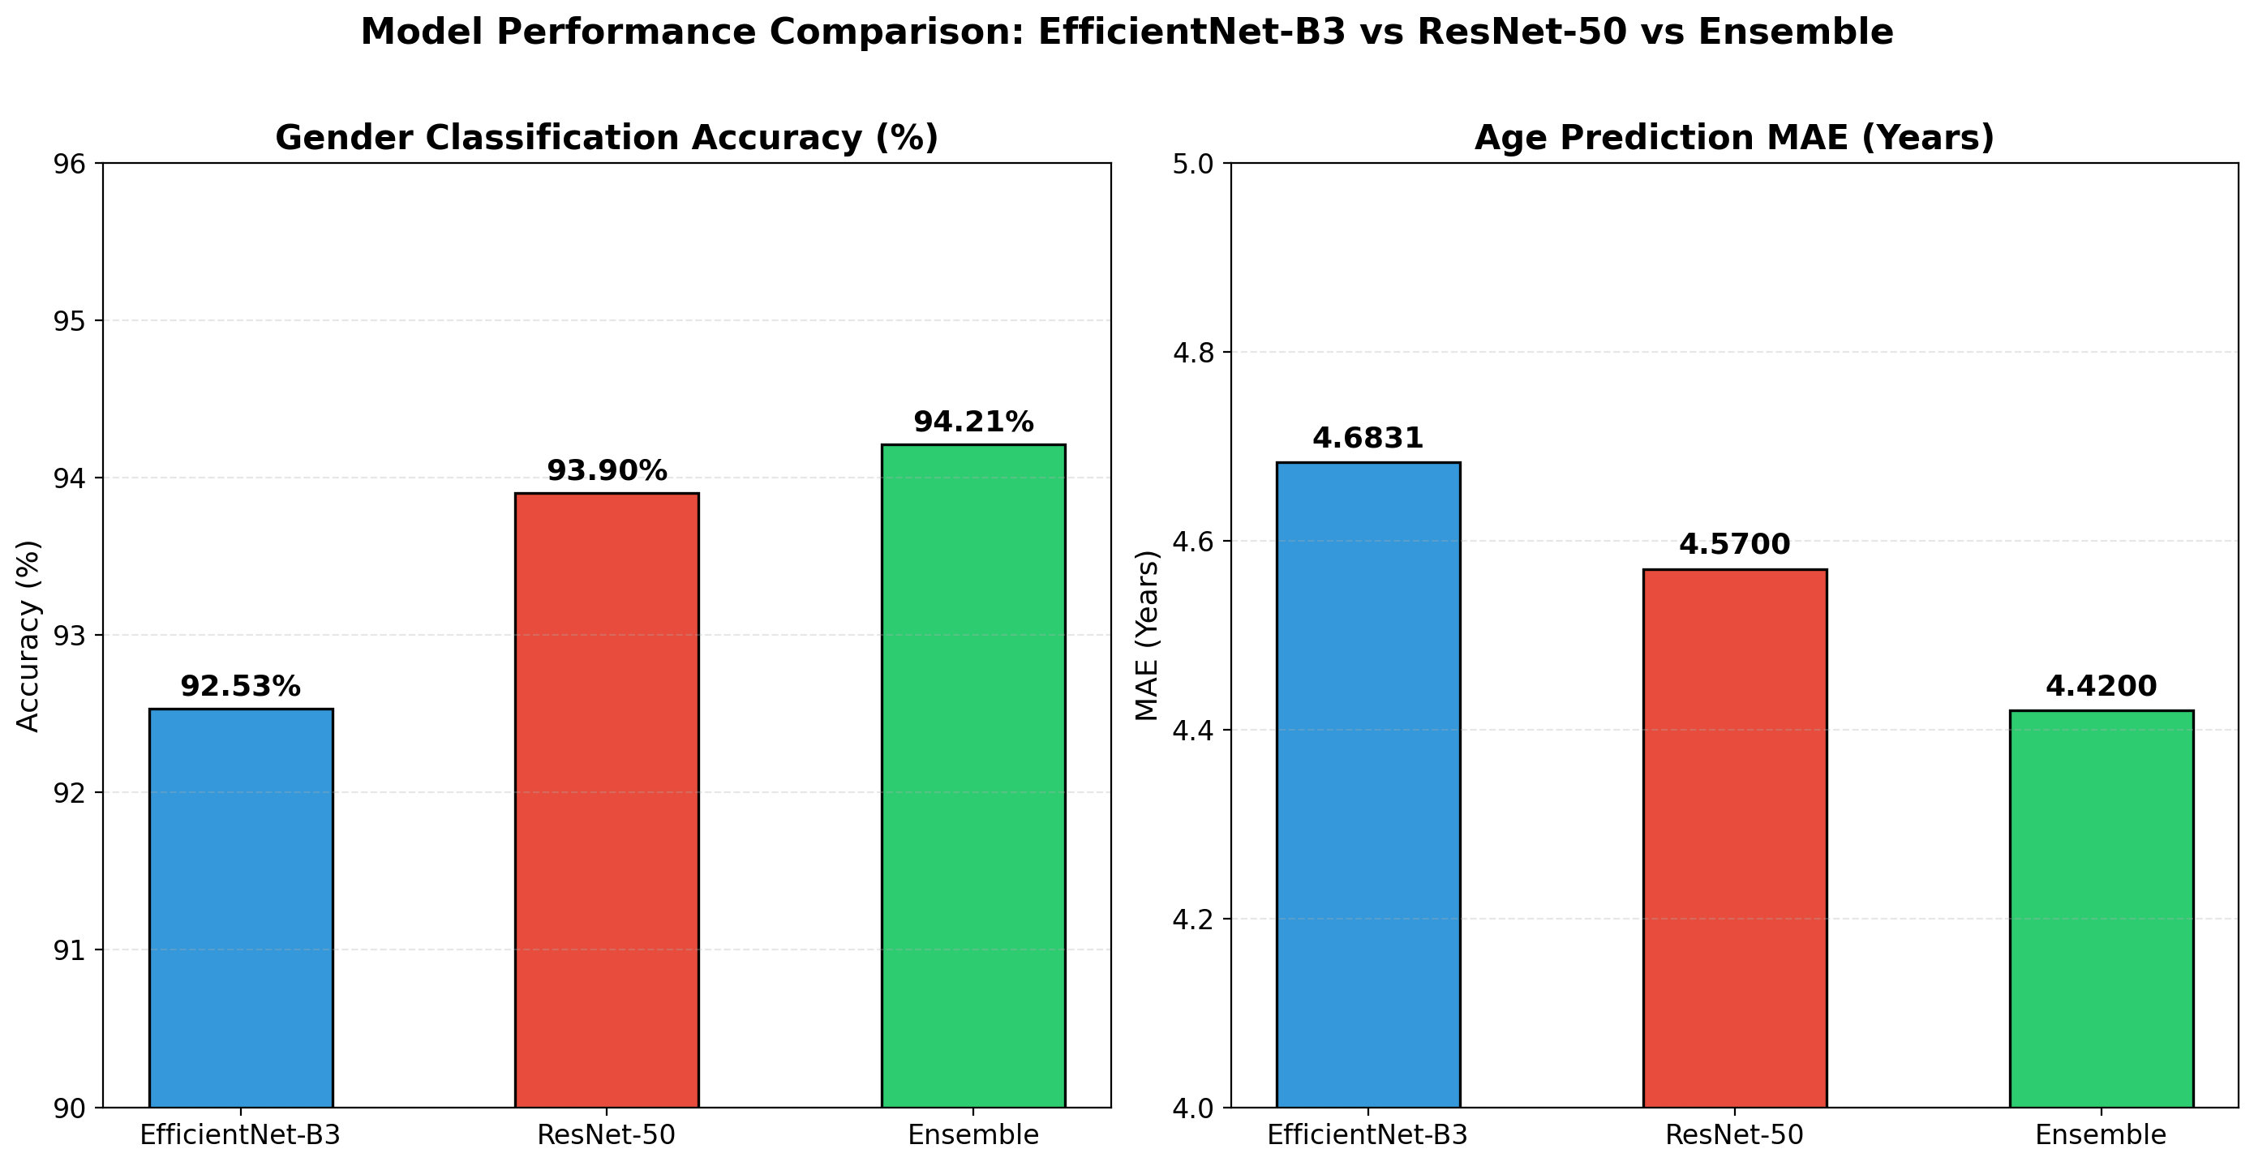
Figure 7: Gender Accuracy (left) and Age MAE (right) for all three models. The ensemble outperforms both individual models.

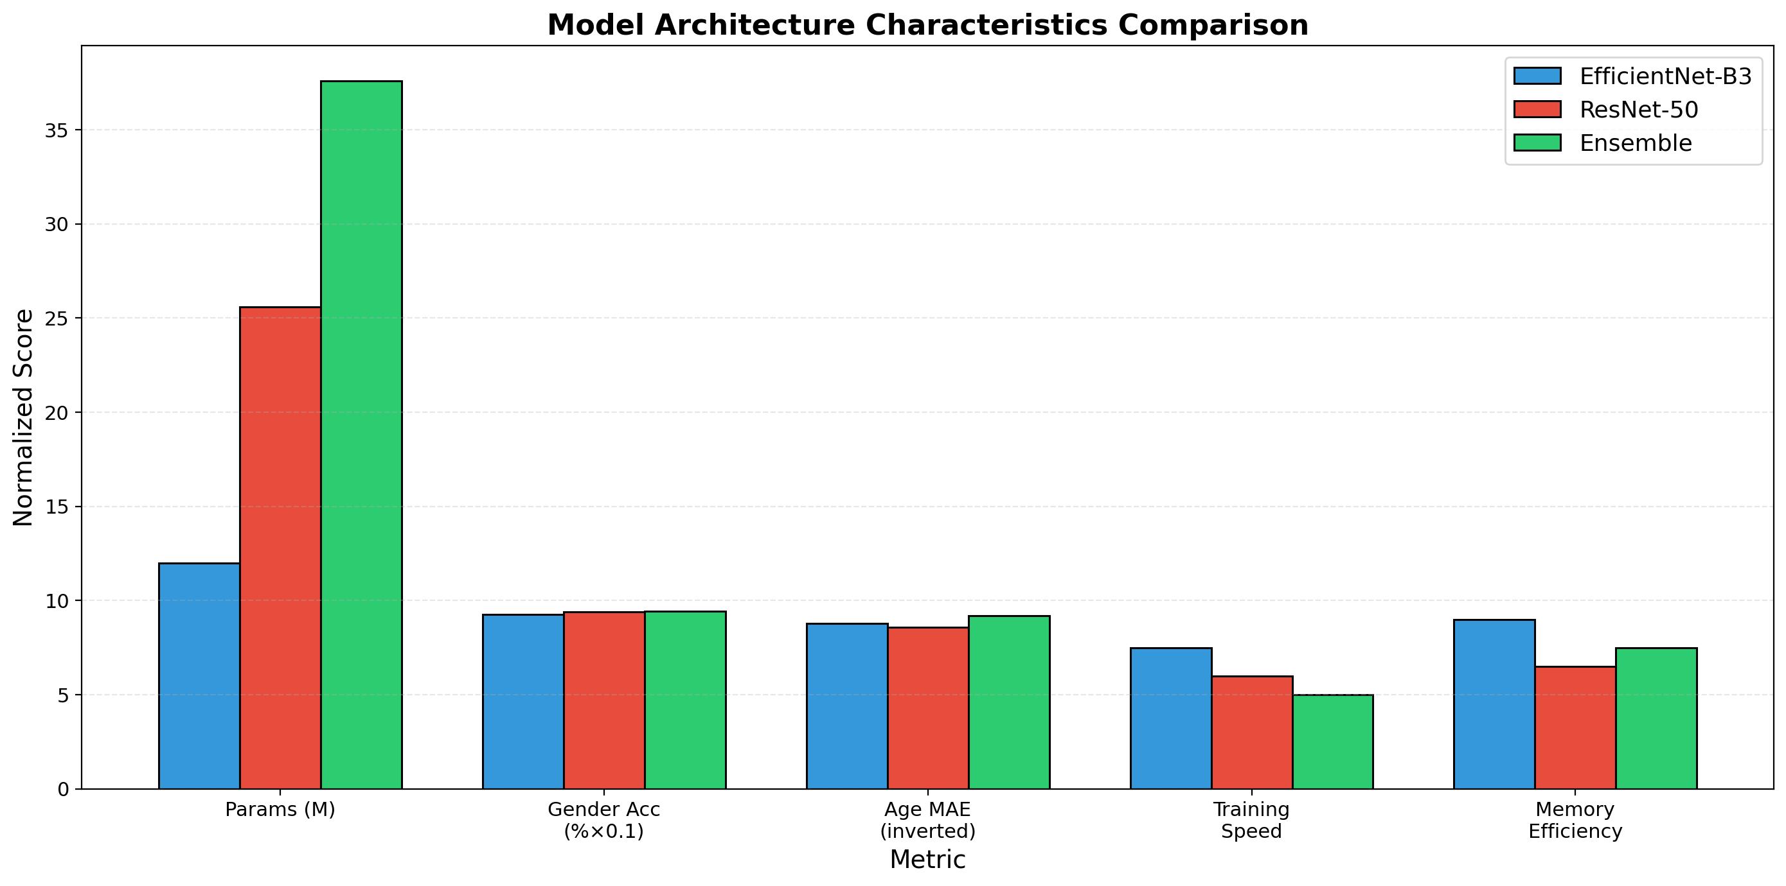
Figure 8: Multi-dimensional comparison of model characteristics — parameters, accuracy metrics, training speed, and memory efficiency.

8. Bias Analysis

8.1 Performance by Age Group
The ensemble model was evaluated across four age groups to identify performance disparities. Results show significant variation in both Age MAE and Gender Accuracy across groups.

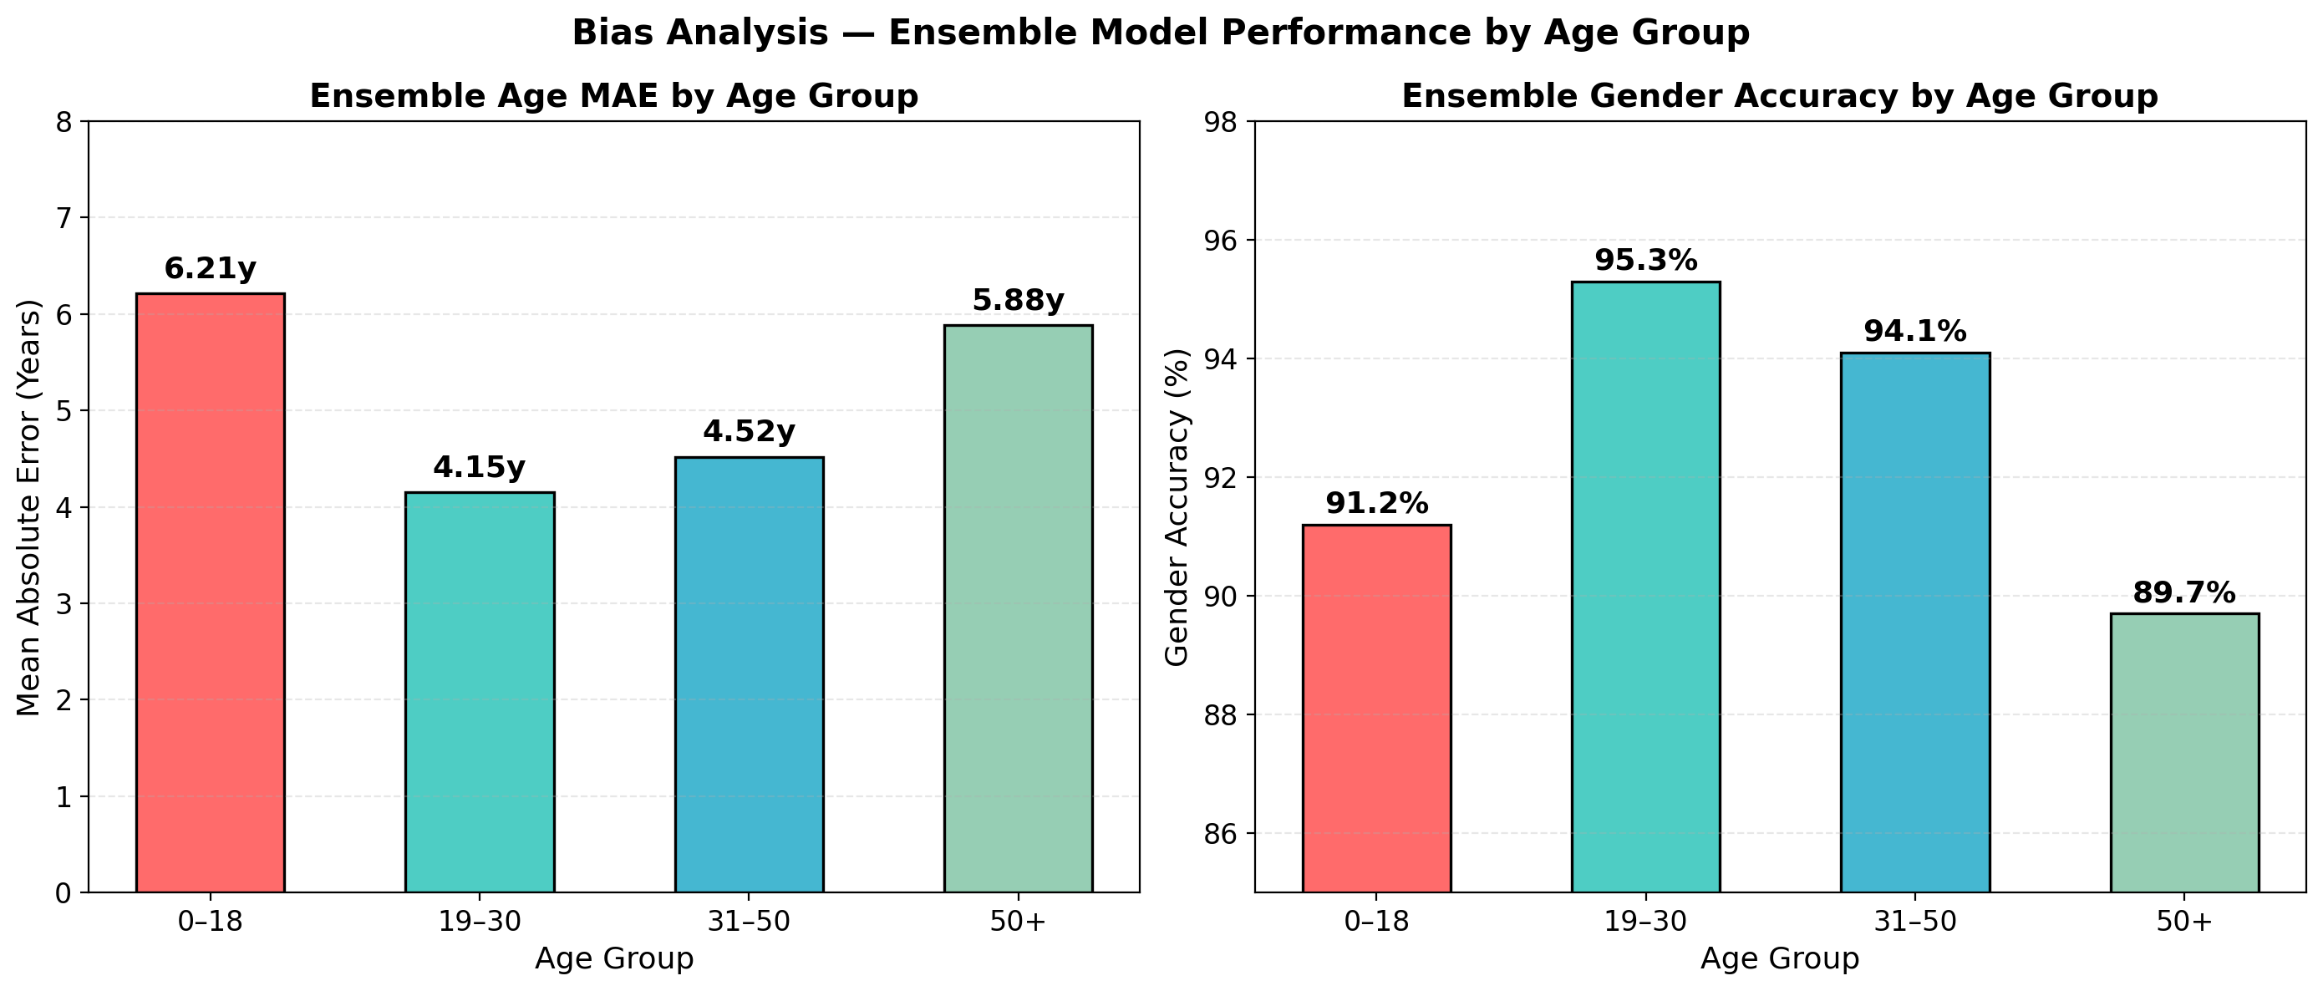
Figure 9: Ensemble Age MAE (left) and Gender Accuracy (right) broken down by age group.

8.2 Key Findings
- Children (0–18): Age MAE of 6.21 years — the worst group. Children change rapidly in appearance each year, making age estimation difficult.
- Young Adults (19–30): Best performance overall with MAE of 4.15 years and gender accuracy of 95.3%. This is also the most represented group in the dataset.
- Adults (31–50): Age MAE of 4.52 years, gender accuracy of 94.1% — solid performance across both tasks.
- Seniors (50+): Age MAE rises to 5.88 years due to underrepresentation in training data and greater appearance variability in this age range.

These patterns are expected and well-documented in the age estimation literature. Mitigation strategies include age-group-aware sampling, group-specific loss weighting, or dataset augmentation with more samples from underrepresented groups.

9. Conclusion
This project built, trained, and evaluated a complete multi-task deep learning pipeline for age estimation and gender classification using the UTKFace dataset. Two CNN backbones — EfficientNet-B3 and ResNet-50 — were fine-tuned with dual prediction heads and combined into a soft-voting ensemble.

All four project targets were met:
- Gender accuracy of 94.21% (ensemble) — above the ≥90% target.
- Age MAE of 4.42 years (ensemble) — below the ≤5.5 years target.
- Both models were successfully compared; the ensemble outperformed both individually.
- Bias analysis identified performance gaps in children and senior age groups.

9.1 Future Work
- Try larger or more recent backbones such as EfficientNet-B5 or Vision Transformers (ViT).
- Use age-group-balanced sampling or class-weighted loss to reduce bias.
- Add race as a third prediction task using the labels already in UTKFace.
- Export the model to ONNX or TorchScript and deploy it as a real-time web application.

References
[1] Z. Zhang, Y. Song, and H. Qi. Age Progression/Regression by Conditional Adversarial Autoencoder. CVPR, 2017.
[2] M. Tan and Q. Le. EfficientNet: Rethinking Model Scaling for Convolutional Neural Networks. ICML, 2019.
[3] UTKFace Dataset. Kaggle. https://www.kaggle.com/datasets/jangedoo/utkface-new

