SYED Burhan aLi

Logical and organized individual with a strong foundation in software engineering Ability to translate business requirements into innovative software solutions. Excellent in teamwork, interpersonal and communication skills. Looking to start a career as a Web Developer professional with a reputed IT company.

EDUCATION
Degree Title |BCs Computer Science
College Name: Govt, Alamdar Hussain Islamiyah College Multan
Division:
1st (2021 to 2023)
Degree Title| Inter
College Name: Govt, Science College Multan
Division: 1st (2017 to 2019)
Degree Title | Matric
School Name: Govt, Muslim High School Multan
Division: 2nd (2015 to 2016)

WORK EXPERIENCE

SOFTAGICS
March-2020 - Continue
Softagics build affordable solutions for Businesses, large & small. I am work as a:
Web Developer Front End and back End
Projects In Softagics
Link: https://ccm.jadeedems.com/
This project is Education Management System
Projects In Softagics
Link: https://jadeedbazar.com/
The project is a B2B E-commerce website.
Projects In Softagics
Link: https://hf24.jadeedmunshi.com/
The project is a point of sale website.

Free Lancing Project
Link: https://alazkadg.com/
The project is a Hotel Management System.

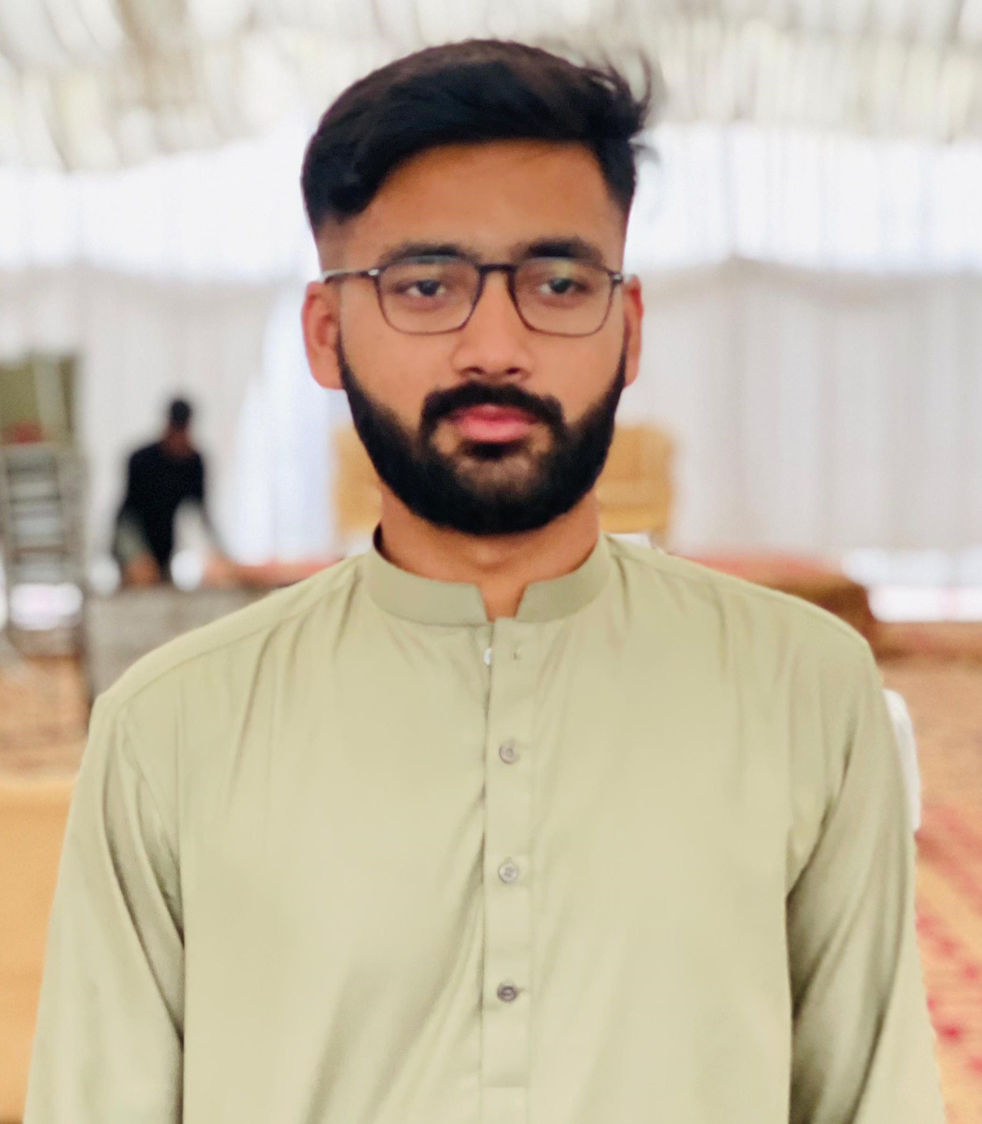

Contact
Address:
- Shah Faisal Colony Multan
Phone:
- 03136177353
Email:
syedburhanali23@gmai l.com

Skills

SKILLS

CSS
HTML
7/10

7/10

Bootstrap

8/10

JavaScript
4/10

jQuery

4/10

MYSQL
4/10

PHP

4/10

Laravel

7/10

React
3/10

Languages
- Urdu
- Saraiki
- English

Hobbies
- Cricket
- Bowler
- Watching Socialistic Things

Reference
- Reference will be provided on your demand.

