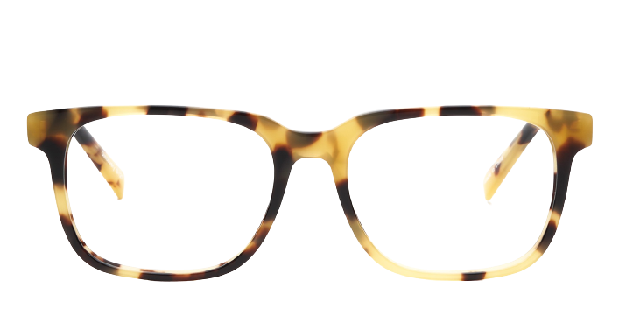 **Discovery**

**Product Information**

|  |  |
| --- | --- |
| **Brands** | kits |
| **Gender** | unisex |
| **Lenses** | Prescription lenses included |
| **Material** | acetate |

**Description**

**Feel confident in your eyewear choice when you wear the Discovery eyeglasses. The sleek, sophisticated glasses feature full rim frames, projecting a refined, self assured image. If you have an oval or round face, these rectangular eyeglasses will sharpen your softer features. Acetate frame material makes the glasses lightweight and hypoallergenic for long term comfort. Flexible and durable, this material is built to last. Please note these frames fit large and are best suited to those with wider faces.**

|  |
| --- |
| **What you'll get:**   * **Thin and light tinted prescription lenses.** * **Soft case and cleaning cloth.** * **Unconditional 30 days return policy.  Free return shipping.** |