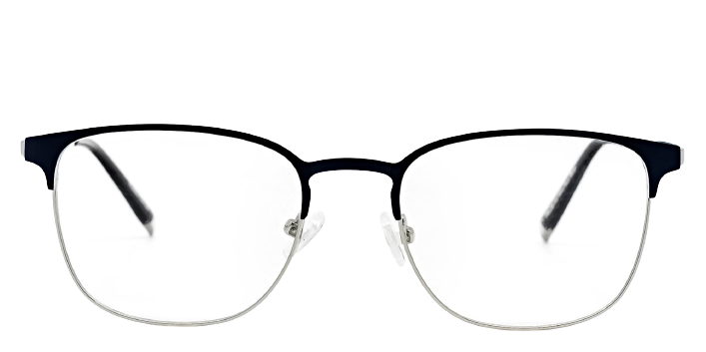 **Dunbar**

Product information

|  |  |
| --- | --- |
| **Brands** | Kits |
| **Gender** | Unisex |
| **Lenses** | Prescription lenses included |
| **Material** | Metal |

Description

**Add a note of maturity to your ensemble with the retro style Dunbar eyeglasses. These streamlined glasses have a high-grade, corrosion-resistant metal frame that is durable enough to hold up to your active lifestyle. The square lenses of these cutting-edge unisex eyeglasses complement oval or round face shapes. Please note these frames fit large and are best suited to those with wider faces**

|  |
| --- |
| What You’ll Get   * Thin and light tinted prescription lenses. * Soft case and cleaning cloth. * Unconditional 30 days return policy. Free return shipping. |