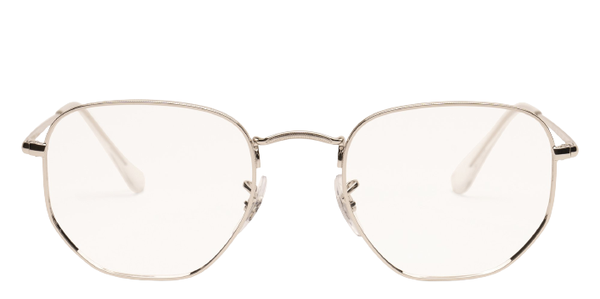 **Ray-ban_Rx6448**

Product information

|  |  |
| --- | --- |
| **Brands** | Ray-Ban |
| **Gender** | Unisex |
| **Lenses** | Prescription lenses included |
| **Material** | Eco Acetate |

Description

**Go for a designer, minimalist look wearing the Ray-Ban RX6448 eyeglasses. A prominent single bridge adds eye-catching flair to these geometric Ray-Ban eyeglasses, and the profile complements square or diamond-shaped faces. Sleek, lightweight metal frames provide comfort and reliability. Adjustable nose pads help you get a customized fit. Acetate details on the temples provide flexible, comfortable points of contact. Barrel hinges add sturdiness to Ray-Ban eyeglasses you'll want to wear for years.**

|  |
| --- |
| What You’ll Get   * **Thin and light tinted prescription lenses.** * **Soft case and cleaning cloth.** * **Unconditional 30 days return policy. Free return shipping.** |