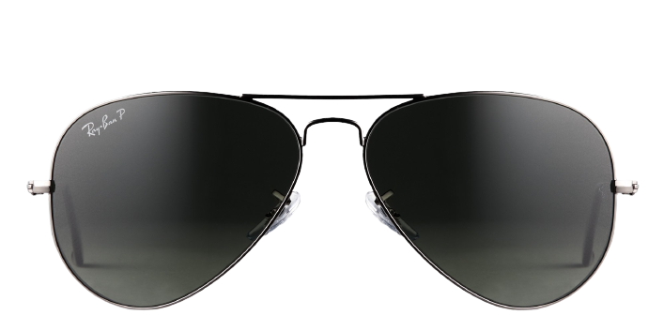 **Ray-ban_3025**

Product information

|  |  |
| --- | --- |
| **Brands** | Ray-Ban |
| **Gender** | Unisex |
| **Lenses** | Prescription lenses included |
| **Material** | Metal |

Description

**Find iconic, cool sunglasses in the Ray-Ban 0RB3025. The aviator has been popular for decades for its fusion of good looks and outstanding performance. The teardrop lenses provide a fantastic field of coverage against the sun’s harmful UV rays, and the double bridge adds stability without a lot of weight. The metal frames are strong and lightweight, and the barrel hinges are sturdy.**

|  |
| --- |
| What You’ll Get   * **Thin and light tinted prescription lenses.** * **Soft case and cleaning cloth.** * **Unconditional 30 days return policy. Free return shipping.** |