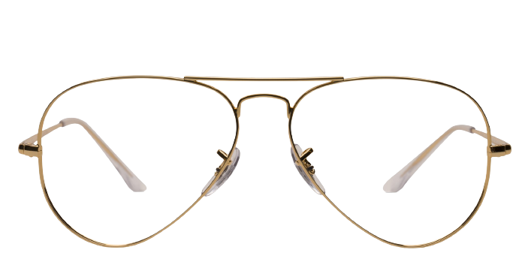 **Ray-ban_Rx-6489**

Product information

|  |  |
| --- | --- |
| **Brands** | Ray-Ban |
| **Gender** | Unisex |
| **Lenses** | Prescription lenses included |
| **Material** | metal |

Description

**The distinctive look of these 0RB3016 sunglasses by Ray-Ban recalls the bold style of the 1950s. This browline silhouette is currently enjoying a resurgence among fashion savvy wearers. Constructed with a top bar and contrasting metal bridge, the full rim frames are crafted from a combination of metal and acetate, and both materials are lightweight, hypoallergenic, and durable. Signature metal rivet accents on end-pieces and temples and small white Ray-ban logo on the right lens add an elegant touch. Enjoy a look that makes a classic statement with these sunglasses from Ray-Ban.**

|  |
| --- |
| What You’ll Get   * **Thin and light tinted prescription lenses.** * **Soft case and cleaning cloth.** * **Unconditional 30 days return policy. Free return shipping.** |