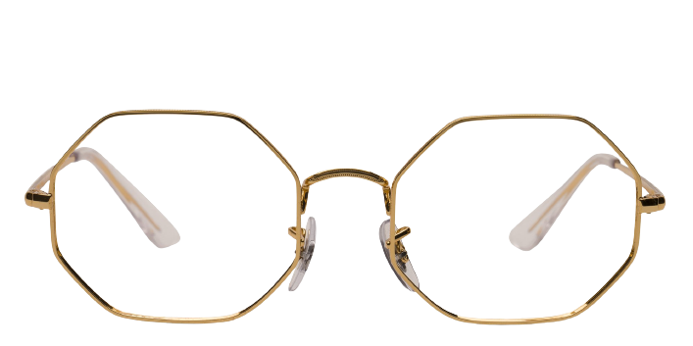 **Ray-ban_rx1972**

Product information

|  |  |
| --- | --- |
| **Brands** | Ray-Ban |
| **Gender** | Unisex |
| **Lenses** | Prescription lenses included |
| **Material** | Metal |

Description

**The RX1972 eyeglasses from Ray-Ban speak to the fashion savvy wearer who appreciates classic design with a modern flair. The full rim frames are made in a lightweight, corrosion-resistant metal, and feature angular rims resulting in a unique, head turning geometric shape. Comfortable temple socks are wider at the tips for added stability. The signature Ray-Ban logo on the slim temple and lens adds an elegant touch. Enjoy uncompromising quality and style wearing the RX6448 from Ray-Ban.**

|  |
| --- |
| What You’ll Get   * **Thin and light tinted prescription lenses.** * **Soft case and cleaning cloth.** * **Unconditional 30 days return policy. Free return shipping.** |