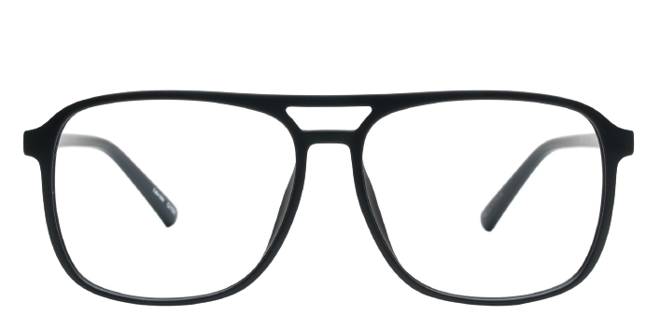 **Saturday**

Product information

|  |  |
| --- | --- |
| **Brands** | Kits |
| **Gender** | Unisex |
| **Lenses** | Prescription lenses included |
| **Material** | Acetate |

Description

**Kits delivers an urban influenced take on a classic aviator silhouette in these Saturday eyeglasses. The full rim frames are crafted from a lightweight metal alloy with thermal plastic inlay at the rims and temples for comfort and durability. The temples are coated at the tips for added grip behind the ears and feature the Kits logo at the temple end. Take a trip back in time with these retro styled Saturday glasses from Kits. Please note these frames fit large and are best suited to those with wider faces**

|  |
| --- |
| What You’ll Get   * Thin and light tinted prescription lenses. * Soft case and cleaning cloth. * Unconditional 30 days return policy. Free return shipping. |