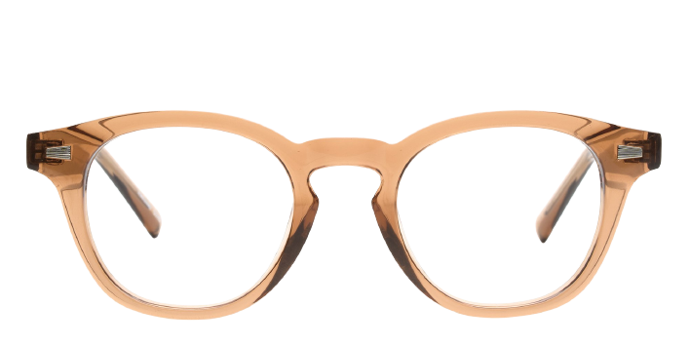 **Wednesday**

Product information

|  |  |
| --- | --- |
| **Brands** | Kits |
| **Gender** | Unisex |
| **Lenses** | Prescription lenses included |
| **Material** | Acetate |

Description

**Kits crafts the Wednesday eyeglasses in a vintage inspired style that adds sophistication to your look. The full rim frame is made from lustrous, lightweight acetate with a smaller size lens that works well with stronger prescriptions. A classic keyhole bridge distributes the weight of the frames evenly on the face, and it’s ideal for the wearer with a wide nose. Please note these frames fit large and are best suited to those with wider faces.**

|  |
| --- |
| What You’ll Get   * **Thin and light tinted prescription lenses.** * **Soft case and cleaning cloth.** * **Unconditional 30 days return policy. Free return shipping.** |